1 Two complex numbers are graphed below.

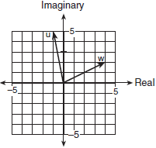

What is the sum of w and u, expressed in standard complex number form?
1)
2)
3)
4)

2 When the sum of and is graphed, in which quadrant does it lie?
1) | I
2) | II
3) | III
4) | IV

3 If and , in which quadrant does the graph of lie?
1) | I
2) | II
3) | III
4) | IV

4 On a graph, if point A represents and point B represents , which quadrant contains ?
1) | I
2) | II
3) | III
4) | IV

5 The graph of the product of and lies in which quadrant?
1) | I
2) | II
3) | III
4) | IV

6 On a stamp honoring the German mathematician Carl Gauss, several complex numbers appear. The accompanying graph shows two of these numbers. Express the sum of these numbers in form.

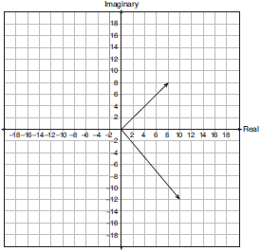

7 Find the sum of and . Graph the resultant on the accompanying set of axes.

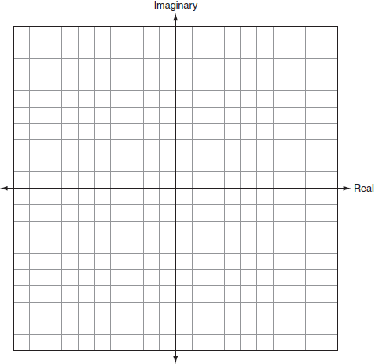

8 On the accompanying set of axes, graphically represent the sum of and .

9 Given the complex numbers and . Find and graph the result on the accompanying set of axes.

1 ANS: 2
.

REF: 080512b

2 ANS: 3

REF: 060906b

3 ANS: 4

REF: 010916b

4 ANS: 1

REF: 080906b

5 ANS: 4

REF: 061019b

6 ANS:
. The complex number in Quadrant I is The complex number in Quadrant IV is

REF: 060726b

7 ANS:
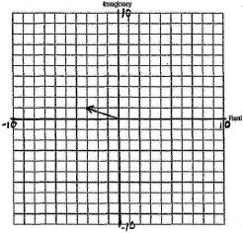

REF: 060621b

8 ANS:
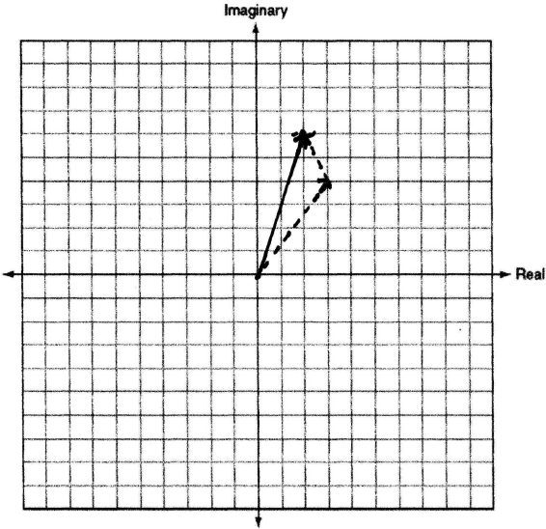

REF: 010724b

9 ANS:
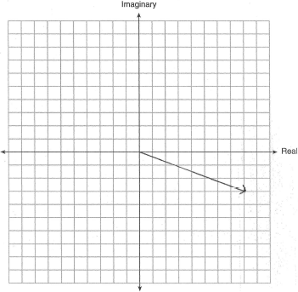

REF: 011023b

