1 Fractal geometry uses the complex number plane to draw diagrams, such as the one shown in the accompanying graph.

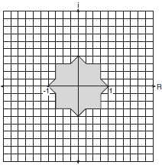

Which number is not included in the shaded area?
1) –0.5i 2) –0.5 – 0.5i 3) –0.9 4) –0.9 – 0.9i
1 ANS: 4
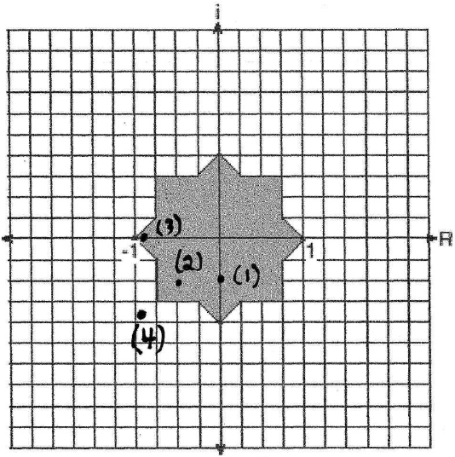

REF: 060108b

