1 What is the multiplicative inverse of 3i?
1) 2) 3) 4)

2 What is the multiplicative inverse of ?
1) 2) 3) 4)

3 The expression is equivalent to
1) 2) 3) 4)

4 Expressed in form, is equivalent to
1) 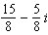 2) 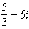 3) 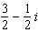 4)

5 The expression is equivalent to
1) 2) 3) 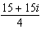 4)

6 The expression 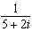 is equivalent to
1) 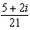 2) 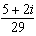 3) 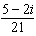 4) 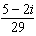

7 The expression 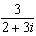 is equivalent to
1) 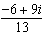 2) 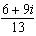 3) 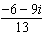 4) 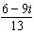

8 The expression 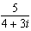 is equivalent to
1) 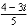 2) 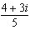 3) 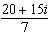 4) 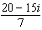

9 The expression is equivalent to
1) 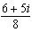 2) 3) 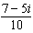 4)

10 Impedance measures the opposition of an electrical circuit to the flow of electricity. The total impedance in a particular circuit is given by the formula 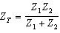. What is the total impedance of a circuit, , if and ?
1) 1 2) 0 3) 4)

11 Express in simplest form.
1 ANS: 4
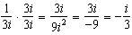

REF: 060614b

2 ANS: 4 REF: 068521siii

3 ANS: 3
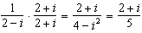. 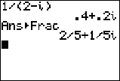

REF: 061014b

4 ANS: 3 REF: 069722siii

5 ANS: 1
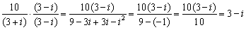

REF: 010811b

6 ANS: 4 REF: 019522siii

7 ANS: 4 REF: 019414siii

8 ANS: 1 REF: 010128siii

9 ANS: 4
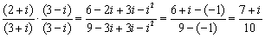

REF: 060513b

10 ANS: 3
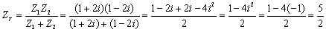

REF: 060509b

11 ANS:

REF: 089612siii

