1 What is the conjugate of ?
1)
2)
3)
4)

2 The conjugate of is
1)
2)
3)
4)

3 What is the conjugate of 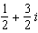?
1) | 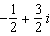
2) | 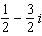
3) | 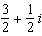
4) | 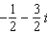

4 The conjugate of the complex expression is
1)
2)
3)
4)

5 What is the sum of and the conjugate of ?
1)
2)
3)
4)

6 When is multiplied by its conjugate, the result is
1)
2)
3) | 5
4) | 13

7 State the conjugate of expressed in simplest form.

8 Multiply by its conjugate, and express the product in simplest form.

9 Show that the product of a + bi and its conjugate is a real number.
1 ANS: 2 REF: 081024a2

2 ANS: 4 REF: 011111a2

3 ANS: 2 REF: 011213a2

4 ANS: 3 REF: 061219a2

5 ANS: 4
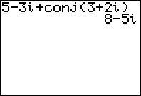

REF: 060810b

6 ANS: 4

REF: 011512a2

7 ANS:

REF: 011730a2

8 ANS:

REF: 061432a2

9 ANS:
. Since a and b are real, their squares are real and the sum of their squares is real.

REF: 080122b

