1 The expression is equivalent to
1)
2)
3)
4)

2 The expression is equivalent to
1)
2)
3)
4)

3 If , , and , where i is the imaginary unit, then equals
1)
2)
3)
4)

4 Given that i is the imaginary unit, the expression is equivalent to
1)
2)
3)
4)

5 Given i is the imaginary unit, in simplest form is
1)
2)
3)
4)

6 Which expression is equivalent to , where i is the imaginary unit?
1)
2)
3)
4)

7 The expression is equivalent to
1)
2)
3)
4)

8 Where i is the imaginary unit, the expression is equivalent to
1)
2)
3)
4)

9 Which expression is equivalent to where i is the imaginary unit and x is a real number?
1)
2)
3) | 2
4)

10 Expressed in simplest form, is
1)
2)
3)
4)

11 Which expression is equivalent to , where i is the imaginary unit?
1)
2)
3)
4)

12 Given i is the imaginary unit, which expression is equivalent to ?
1)
2)
3)
4)

13 If , the value of k is
1)
2)
3) | 3
4) | 6

14 Simplify , where i is the imaginary unit.

15 Given i is the imaginary unit, simplify as a polynomial in standard form.

16 Express 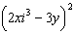 in simplest form.

17 Express in form.

18 Given x is a real number, write the expression in simplest form:

19 Write in form, where y is a real number.

20 Write 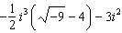 in simplest form.

21 Elizabeth tried to find the product of and , and her work is shown below.
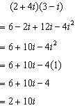
Identify the error in the process shown and determine the correct product of and .
1 ANS: 3

REF: 062307aii

2 ANS: 2

REF: 061704aii

3 ANS: 3

REF: 081815aii

4 ANS: 4

REF: 082202aii

5 ANS: 2

REF: 061603aii

6 ANS: 3

REF: 081702aii

7 ANS: 1

REF: 061915aii

8 ANS: 3

REF: 061805aii

9 ANS: 1
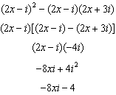

REF: 011911aii

10 ANS: 1

REF: 012022aii

11 ANS: 4

REF: 062223aii

12 ANS: 4

REF: 082415aii

13 ANS: 3
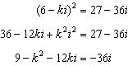
Set real part equal to real part: 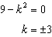 Set imaginary part equal to imaginary part: 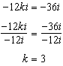

REF: 012308aii

14 ANS:

REF: 081627aii

15 ANS:

REF: 082329aii

16 ANS:
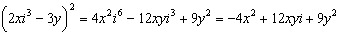

REF: 012431aii

17 ANS:

REF: 011725aii

18 ANS:

REF: 062425aii

19 ANS:
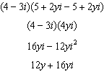

REF: spr1506aii

20 ANS:
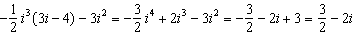

REF: 081927aii

21 ANS:
, and not 1;

REF: 011825aii

