1 An obtuse angle of a parallelogram has a measure of 150º. If the sides of the parallelogram measure 10 and 12 centimeters, what is the area of the parallelogram?
1)
2)
3)
4)

2 The sides of a parallelogram are 6 and 8, and the included angle is 150º. What is the area of the parallelogram?
1) | 24
2) | 48
3)
4)

3 What is the area of a parallelogram if two adjacent sides measure 4 and 5 and an included angle measures 60º?
1)
2)
3)
4)

4 What is the area of parallelogram ABCD if , , and ?
1) | 15
2) | 30
3)
4)

5 What is the area of a parallelogram that has sides measuring 8 cm and 12 cm and includes an angle of 120°?
1)
2)
3)
4)

6 The sides of a parallelogram measure 10 cm and 18 cm. One angle of the parallelogram measures 46 degrees. What is the area of the parallelogram, to the nearest square centimeter?
1) | 65
2) | 125
3) | 129
4) | 162

7 In the accompanying diagram of parallelogram ABCD, , , and . What is the area of parallelogram ABCD?

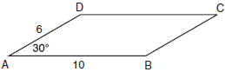

8 Two sides of a parallelogram are 24 feet and 30 feet. The measure of the angle between these sides is . Find the area of the parallelogram, to the nearest square foot.

9 The two sides and included angle of a parallelogram are 18, 22, and 60°. Find its exact area in simplest form.

10 Find, to the nearest tenth of a square foot, the area of a rhombus that has a side of 6 feet and an angle of 50°.

11 The area of a parallelogram is 594, and the lengths of its sides are 32 and 46. Determine, to the nearest tenth of a degree, the measure of the acute angle of the parallelogram.
1 ANS: 2 REF: 019734siii

2 ANS: 1 REF: 060231siii

3 ANS: 4 REF: 089733siii

4 ANS: 2
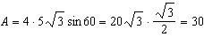

REF: 011713a2

5 ANS: 2
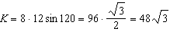

REF: 061508a2

6 ANS: 3

REF: 081021a2

7 ANS:
30.

REF: 010924b

8 ANS:

REF: 061034a2

9 ANS:
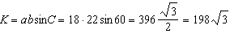

REF: 061234a2

10 ANS:

REF: 011429a2

11 ANS:
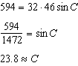

REF: 011535a2

