1 The accompanying diagram shows the peak of a roof that is in the shape of an isosceles triangle. A base angle of the triangle is 50° and each side of the roof is 20.4 feet. Determine, to the nearest tenth of a square foot, the area of this triangular region.

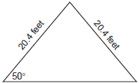

2 Gregory wants to build a garden in the shape of an isosceles triangle with one of the congruent sides equal to 12 yards. If the area of his garden will be 55 square yards, find, to the nearest tenth of a degree, the three angles of the triangle.

3 The accompanying diagram shows a triangular plot of land that is part of Fran's garden. She needs to change the dimensions of this part of the garden, but she wants the area to stay the same. She increases the length of side AC to 22.5 feet. If angle A remains the same, by how many feet should side AB be decreased to make the area of the new triangular plot of land the same as the current one?

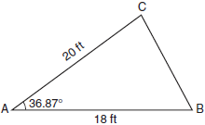

4 In , , , and 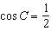. Find the area of to the nearest tenth of a square unit.

5 In the accompanying diagram of , , , and the side opposite vertex B is 7. Find the length of the side opposite vertex A, and find the area of .

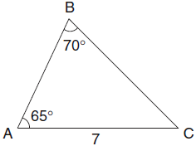

6 In the accompanying diagram of , centimeters, , and . Find the area of , to the nearest square centimeter.

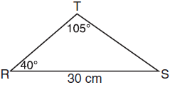

7 A ranch in the Australian Outback is shaped like triangle ACE, with , , and miles. Find the area of the ranch, to the nearest square mile.

8 A picnic table in the shape of a regular octagon is shown in the accompanying diagram. If the length of is 6 feet, find the length of one side of the table to the nearest tenth of a foot, and find the area of the table’s surface to the nearest tenth of a square foot.

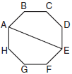
1 ANS:
204.9. Because the triangle is isosceles, both base angles are 50° and the included angle is 80°. 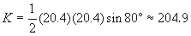

REF: 060825b

2 ANS:
49.8°, 65.1°, 65.1°. 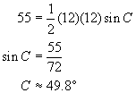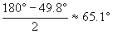

REF: 060121b

3 ANS:
2. 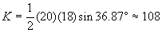. 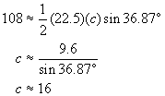Side AB should be decreased from 18 to 16, or by 2 feet.

REF: 080628b

4 ANS:
77.9. 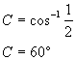 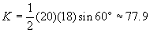

REF: 010723b

5 ANS:
6.75, 16.71. 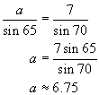. . 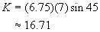

REF: 080131b

6 ANS:
172

REF: 011027b

7 ANS:
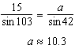. 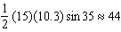

REF: 061337a2

8 ANS:
2.3, 25.5. If and are drawn, they also measure 6 feet each and intersect at point O, such that 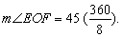 Since and each measures 3 feet, is an isosceles triangle. 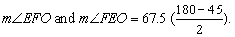 Use the Law of Sines to find the length of one side of the table: 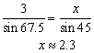. To find the area of 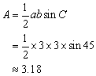. To find the area of the octagon, multiply the area of the triangle by 8, or about 25.5.

REF: 010330b

