1 In non-right triangle ABC shown below, , , and .

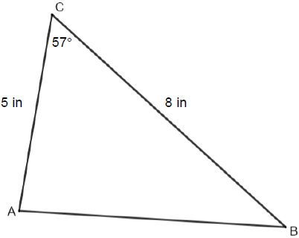

What is the area of , to the nearest tenth of a square inch?
1) | 10.9
2) | 16.8
3) | 21.8
4) | 33.5

2 In , , , and . What is the area of to the nearest square inch?
1) | 52
2) | 78
3) | 90
4) | 156

3 What is the best approximation for the area of a triangle with consecutive sides of 4 and 5 and an included angle of 59º?
1) | 5.0
2) | 8.6
3) | 10.0
4) | 17.1

4 In , , , and . What is the area of to the nearest tenth of a square unit?
1) | 90.7
2) | 181.4
3) | 256.5
4) | 362.7

5 Two sides of a triangular-shaped sandbox measure 22 feet and 13 feet. If the angle between these two sides measures 55°, what is the area of the sandbox, to the nearest square foot?
1) | 82
2) | 117
3) | 143
4) | 234

6 In parallelogram BFLO, , , and . If diagonal is drawn, what is the area of ?
1) | 11.4
2) | 14.1
3) | 22.7
4) | 28.1

7 The area of triangle ABC is 42. If and , the length of is approximately
1) | 5.1
2) | 9.2
3) | 12.0
4) | 21.7

8 Determine the area, to the nearest integer, of shown below.

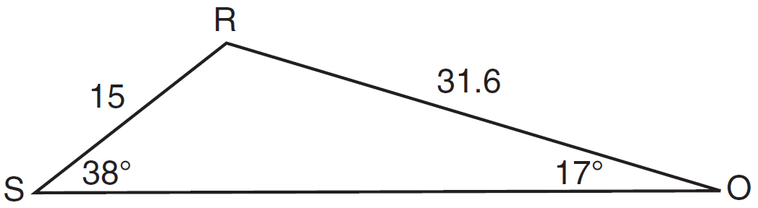

9 Find, to the nearest tenth, the area of if , , and .

10 In , , meters, and meters. Find the area of to the nearest tenth of a square meter.

11 In , , , and . Find the area of , to the nearest tenth.

12 The accompanying diagram shows the floor plan for a kitchen. The owners plan to carpet all of the kitchen except the “work space,” which is represented by scalene triangle ABC. Find the area of this work space to the nearest tenth of a square foot.

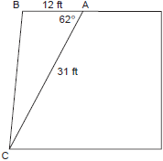

13 Two sides of a triangular-shaped pool measure 16 feet and 21 feet, and the included angle measures 58°. What is the area, to the nearest tenth of a square foot, of a nylon cover that would exactly cover the surface of the pool?

14 A landscape architect is designing a triangular garden to fit in the corner of a lot. The corner of the lot forms an angle of 70°, and the sides of the garden including this angle are to be 11 feet and 13 feet, respectively. Find, to the nearest integer, the number of square feet in the area of the garden.
1 ANS: 2
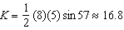

REF: spr2403geo

2 ANS: 2
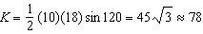

REF: fall0907a2

3 ANS: 2 REF: 010219siii

4 ANS: 2
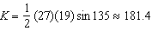

REF: 061602a2

5 ANS: 2
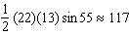

REF: 061403a2

6 ANS: 1
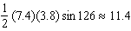

REF: 011218a2

7 ANS: 3
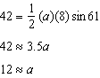

REF: 011316a2

8 ANS:
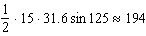

REF: 011633a2

9 ANS:
9.3

REF: 088909siii

10 ANS:
30.9

REF: 080216siii

11 ANS:
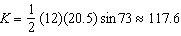

REF: 061022b

12 ANS:
164.2. 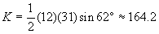

REF: 010225b

13 ANS:
142.5. 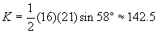

REF: 080226b

14 ANS:
67. 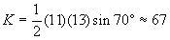

REF: 060525b

