1 The accompanying diagram shows a resultant force vector, R.

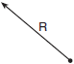

Which diagram best represents the pair of component force vectors, A and B, that combined to produce the resultant force vector R?
1) | 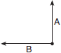
2)
3) | 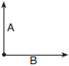
4) | 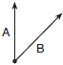

2 A tractor stuck in the mud is being pulled out by two trucks. One truck applies a force of 1,200 pounds, and the other truck applies a force of 1,700 pounds. The angle between the forces applied by the two trucks is 72º. Find the magnitude of the resultant force, to the nearest pound.

3 Forces of 40 pounds and 70 pounds act on a body at an angle measure 60º. Find the magnitude of the resultant of these forces to the nearest hundredth of a pound.

4 Two equal forces act on a body at an angle of 80°. If the resultant force is 100 newtons, find the value of one of the two equal forces, to the nearest hundredth of a newton.

5 The measures of the angles between the resultant and two applied forces are 65° and 42°, and the magnitude of the resultant is 24 pounds. Find, to the nearest pound, the magnitude of the larger force.

6 Two forces act on a body to produce a resultant force of 70 pounds. One of the forces is 50 pounds and forms an angle of with the resultant force. Find, to the nearest pound, the magnitude of the other force.

7 The measures of the angles between the resultant and two applied forces are 60° and 45°, and the magnitude of the resultant is 27 pounds. Find, to the nearest pound, the magnitude of each applied force.

8 Two tow trucks try to pull a car out of a ditch. One tow truck applies a force of 1,500 pounds while the other truck applies a force of 2,000 pounds. The resultant force is 3,000 pounds. Find the angle between the two applied forces, rounded to the nearest degree.

9 One force of 20 pounds and one force of 15 pounds act on a body at the same point so that the resultant force is 19 pounds. Find, to the nearest degree, the angle between the two original forces.

10 Two forces of 14 and 30 act on a body forming an obtuse angle with each other. If the resultant force has a magnitude of 20, find the angle between the two forces to the nearest degree.

11 Two forces of 130 and 150 pounds yield a resultant force of 170 pounds. Find, to the nearest ten minutes or nearest tenth of a degree, the angle between the original two forces.

12 Two forces of 80 pounds and 100 pounds yield a resultant force of 60 pounds. Find, to the nearest ten minutes or the nearest tenth of a degree, the angle between the two forces.

13 Two forces of 50 pounds and 69 pounds act on a body to produce a resultant of 70 pounds. Find, to the nearest tenth of a degree or nearest ten minutes, the angle formed between the resultant and the smaller force.

14 Two forces of 30 pounds and 40 pounds act upon a body, forming an acute angle with each other. The angle between the resultant and the 30-pound force is 35º10’. Find, to the nearest ten minutes, the angle between the two given forces.

15 Two forces of 40 pounds and 55 pounds act on a body, forming an acute angle with each other. The angle between the resultant and the 40-pound force is 22º20’. Find, to the nearest ten minutes, the angle between the two given forces.

16 Two forces of 42 pounds and 65 pounds act on a body at an acute angle with each other. The angle between the resultant force and the 42-pound force is 38º. Find, to the nearest degree, the angle formed by the 42-pound and the 65-pound forces.

17 Two forces of 25 newtons and 85 newtons acting on a body form an angle of 55°. Find the magnitude of the resultant force, to the nearest hundredth of a newton. Find the measure, to the nearest degree, of the angle formed between the resultant and the larger force.

18 Two forces of 40 pounds and 20 pounds, respectively, act simultaneously on an object. The angle between the two forces is 40°. Find the magnitude of the resultant, to the nearest tenth of a pound. Find the measure of the angle, to the nearest degree, between the resultant and the larger force.

19 A jet is flying at a speed of 526 miles per hour. The pilot encounters turbulence due to a 50-mile-per-hour wind blowing at an angle of 47°, as shown in the accompanying diagram.

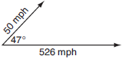

Find the resultant speed of the jet, to the nearest tenth of a mile per hour. Use this answer to find the measure of the angle between the resultant force and the wind vector, to the nearest tenth of a degree.

20 Two forces act on a body at an angle of 100º. The forces are 30 pounds and 40 pounds. Find the magnitude of the resultant force to the nearest tenth of a pound. Find the angle formed by the greater of the two forces and the resultant force to the nearest degree.

21 Two forces of 25 pounds and 38 pounds act on a body at an angle of 74.5º. Find, to the nearest tenth of a pound, the magnitude of the resultant force. Using this answer, find the angle between the resultant and the larger force to the nearest tenth of a degree.

22 Two forces of 35 pounds and 70 pounds act on a body. The angle between the two forces is 40º. Find the magnitude of the resultant force to the nearest tenth of a pound. Using this answer, determine, to the nearest degree, the angle between the resultant and the larger force.

23 Two forces act on an object. The first force has a magnitude of 85 pounds and makes an angle of with the resultant. The magnitude of the resultant is 130 pounds. Find the magnitude of the second force to the nearest tenth of a pound. Using this answer, find, to the nearest ten minutes or nearest tenth of a degree, the angle that the second force makes with the resultant.

24 Two forces are applied to an object. The measure of the angle between the 30.2-pound applied force and the 50.1-pound resultant is 25º. Find the magnitude of the second applied force to the nearest tenth of a pound. Using this answer, find the measure of the angle between the second applied force and the resultant to the nearest degree.

25 Gerardo and Bennie are pushing a box. Gerardo pushes with a force of 50 pounds in an easterly direction, and Bennie pushes with a force of 39 pounds in a northeasterly direction. The resultant force forms an angle of 32° with the 39-pound force. Find the angle between the 50-pound force and the 39-pound force, to the nearest tenth of a degree. Find the magnitude of the resultant force, to the nearest pound.

26 Two forces of 40 pounds and 28 pounds act on an object. The angle between the two forces is 65°. Find the magnitude of the resultant force, to the nearest pound. Using this answer, find the measure of the angle formed between the resultant and the smaller force, to the nearest degree.

27 Forces of 22 pounds and 43 pounds act on an object at an angle of 52°. Determine, to the nearest pound, the magnitude of the resultant force. Find, to the nearest degree, the angle between the smaller force and the resultant force.
1 ANS: 1 REF: 010808b

2 ANS:
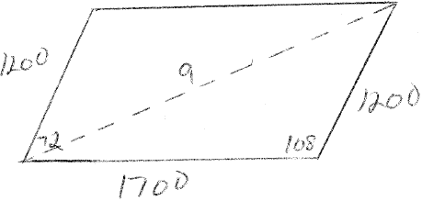 2364
REF: 011032b

3 ANS:
96.44
REF: 069842siii

4 ANS:
65.27. Because the forces are equal, the resultant bisects the angle between the forces. Use the Law of Sines to find the magnitude of one of the forces. 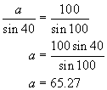 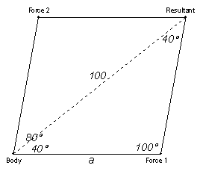
REF: 060428b

5 ANS:
23. 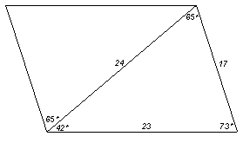 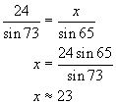
REF: 010827b

6 ANS:
69
REF: 088939siii

7 ANS:
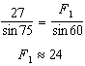. 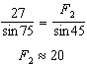. 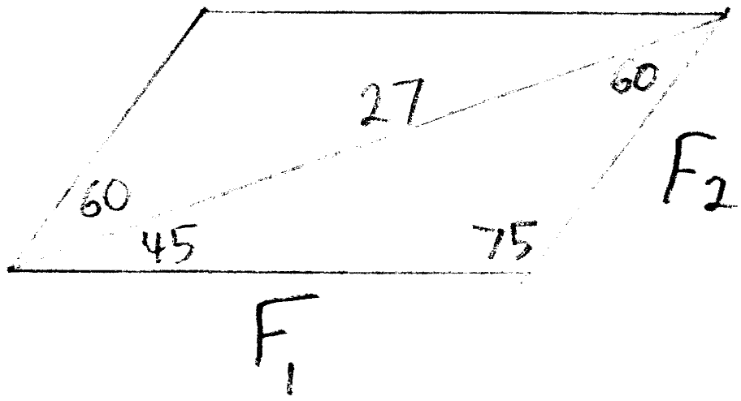
REF: 061238a2

8 ANS:
63°. Because the resultant is greater than both forces, the angle between the forces is acute. 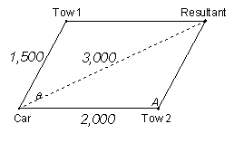 To find θ, the angle between the two applied forces, find its supplement, A, using the Law of Cosines. 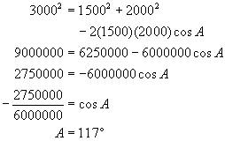
REF: 080228b

9 ANS:
116. Because the resultant is not greater than both forces, the angle between the forces is obtuse. 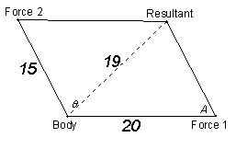To find θ, the angle between the two applied forces, find its supplement, A, using the Law of Cosines. 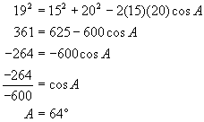
REF: 010430b

10 ANS:
146º
REF: 018738siii

11 ANS:
105.6º or 105º40’
REF: 080042siii

12 ANS:
143.1º or 143º10’
REF: 080239siii

13 ANS:
67.9º or 67º50’
REF: 060041siii

14 ANS:
60º50’
REF: 068141siii

15 ANS:
38º20’
REF: 088740siii

16 ANS:
61
REF: 069042siii

17 ANS:
101.43, 12. 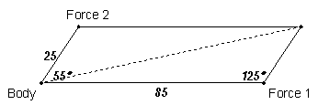 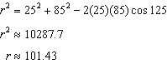. 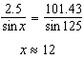
REF: fall0939a2

18 ANS:
56.8, 13. 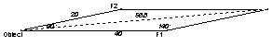 Use the Law of Cosines to find the magnitude of the resultant. 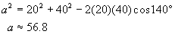 Use the Law of Sines to find the angle. 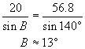
REF: 010734b

19 ANS:
561.3, 43.3. 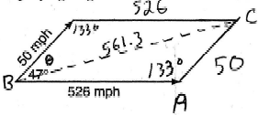 Use the Law of Cosines to find the magnitude of the resultant. 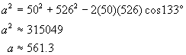Use the Law of Sines to find θ 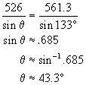
REF: 060734b

20 ANS:
45.6, 40
REF: 089640siii

21 ANS:
50.8, 28.3
REF: 060242siii

22 ANS:
99.4, 13
REF: 080337siii

23 ANS:
72.7, 37.7º or 37º40’
REF: 089740siii

24 ANS:
26.1, 29
REF: 080137siii

25 ANS:
56.4, 79. 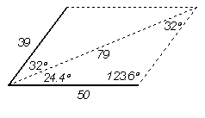 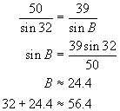 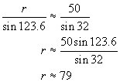
REF: 060834b

26 ANS:
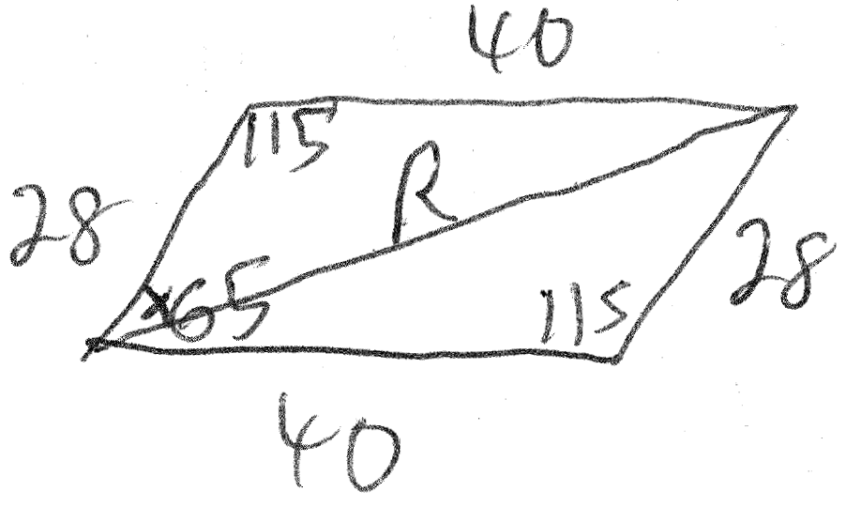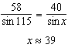
REF: 061439a2

27 ANS:
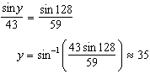
REF: 011739a2

