1 In the accompanying diagram of triangle RST, , , and .

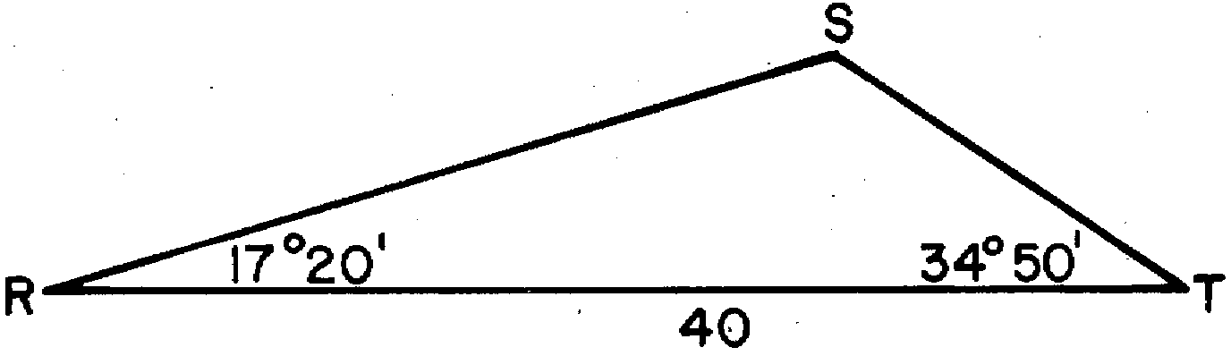

What is the length of to the nearest integer?

2 In the accompanying diagram of a streetlight, the light is attached to a pole at R and supported by a brace, , feet, feet, is an obtuse angle, and . Find the length of the brace, , to the nearest foot.

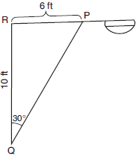

3 Carmen and Jamal are standing 5,280 feet apart on a straight, horizontal road. They observe a hot-air balloon between them directly above the road. The angle of elevation from Carmen is 60° and from Jamal is 75°. Draw a diagram to illustrate this situation and find the height of the balloon to the nearest foot.

4 Given: , , , , , , , , and

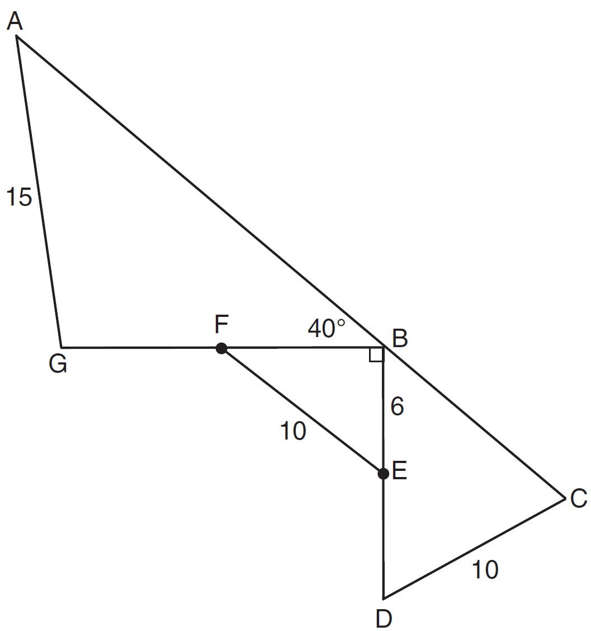

Find to the nearest tenth. Find BC to the nearest tenth.

5 The accompanying diagram shows the plans for a cell-phone tower that is to be built near a busy highway. Find the height of the tower, to the nearest foot.

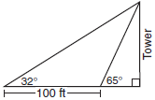
1 ANS: 29
REF: 088438siii

2 ANS: 12. 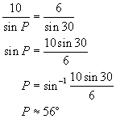 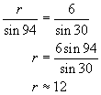
REF: 060728b

3 ANS: 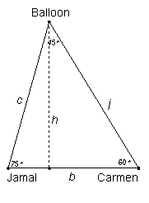 6,246. 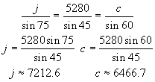 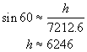 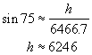
REF: 080233b

4 ANS: 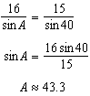 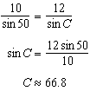 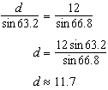
REF: 011639a2

5 ANS: 88. 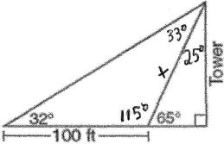 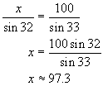 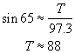
REF: 080527b

