1 In , , , and . Find b to the nearest integer.

2 In , , , and . Find the value of n to the nearest integer.

3 In , , , and . Find AC to the nearest tenth.

4 In , , , and side inches. Find the length of side b to the nearest tenth of an inch.

5 In , , , and meters. Find the length of to the nearest meter.

6 The Vietnam Veterans Memorial in Washington, D.C., is made up of two walls, each 246.75 feet long, that meet at an angle of 125.2°. Find, to the nearest foot, the distance between the ends of the walls that do not meet.

7 In the accompanying diagram of , , , and .

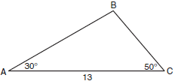

What is the length of side to the nearest tenth?
1) | 6.6
2) | 10.1
3) | 11.5
4) | 12.0

8 A ski lift begins at ground level 0.75 mile from the base of a mountain whose face has a 50° angle of elevation, as shown in the accompanying diagram. The ski lift ascends in a straight line at an angle of 20°. Find the length of the ski lift from the beginning of the ski lift to the top of the mountain, to the nearest hundredth of a mile.

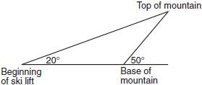

9 As shown in the accompanying diagram, two tracking stations, A and B, are on an east-west line 110 miles apart. A forest fire is located at F, on a bearing 42° northeast of station A and 15° northeast of station B. How far, to the nearest mile, is the fire from station A?

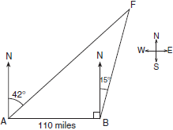

10 As shown in the diagram below, fire-tracking station A is 100 miles due west of fire-tracking station B. A forest fire is spotted at F, on a bearing 47° northeast of station A and 15° northeast of station B. Determine, to the nearest tenth of a mile, the distance the fire is from both station A and station B. [N represents due north.]

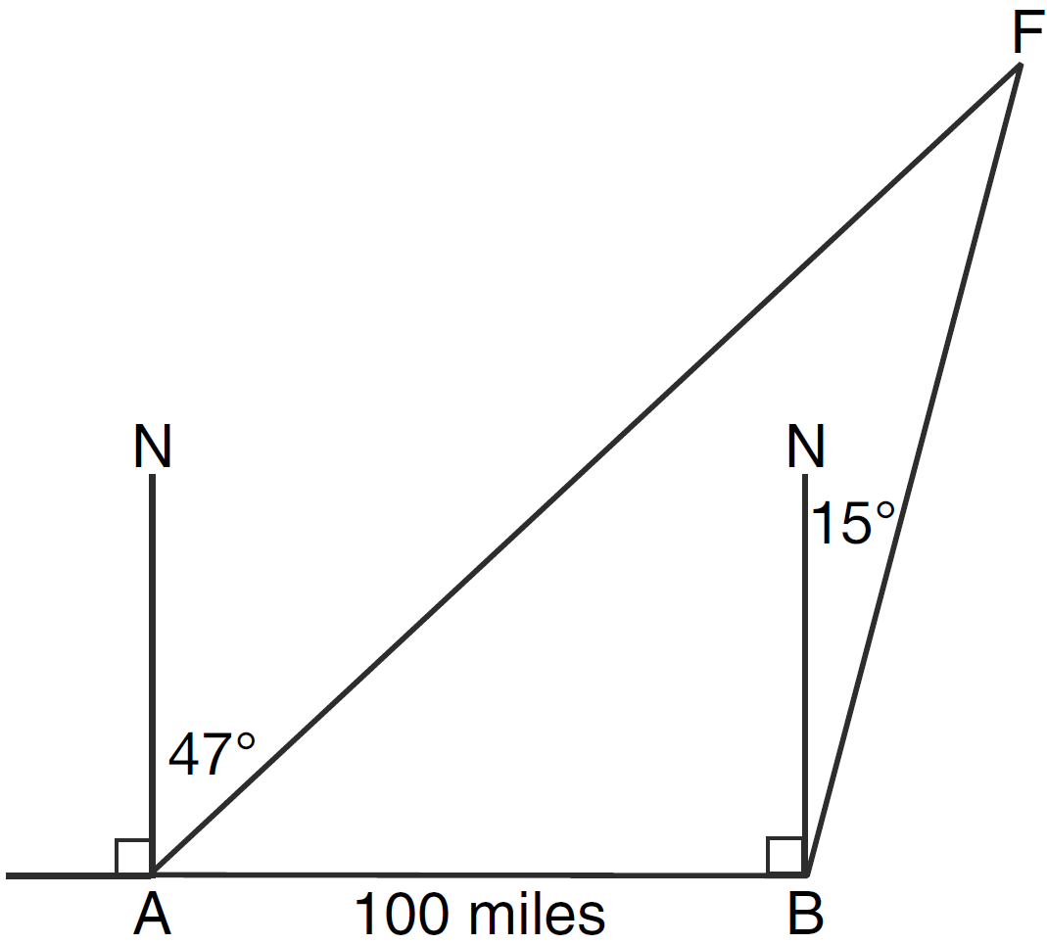

11 In , , , and centimeters. Find, to the nearest tenth of a centimeter, the measure of c.

12 In , , , and . Find to the nearest thousandth.

13 In , , , and . What is to the nearest degree?
1) | 41
2) | 43
3) | 44
4) | 48

14 In triangle ABC, , , and . Find the measure of angle A to the nearest degree.

15 In acute triangle ABC, side , side , and . Find to the nearest degree.

16 In , , , and . Find the measures of the missing angles and side of . Round each measure to the nearest tenth.
1 ANS:
3. 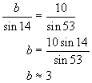
REF: 060622b

2 ANS:
8
REF: 010109siii

3 ANS:
18.1
REF: 060211siii

4 ANS:
6.9
REF: 080304siii

5 ANS:
7
REF: 010205siii

6 ANS:
438. 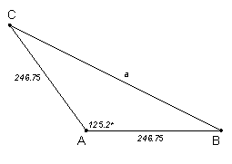 Because this is an isosceles triangle, B and C are both 27.4°. 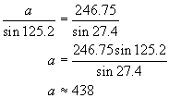
REF: 010631b

7 ANS: 2
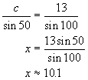
REF: 080214b

8 ANS:
1.15. 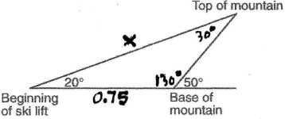 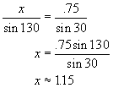
REF: 080421b

9 ANS:
234. 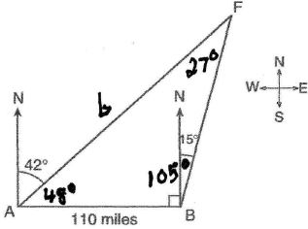 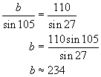
REF: 060527b

10 ANS:
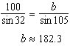. 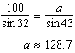
REF: 011338a2

11 ANS:
38.8
REF: 019504siii

12 ANS:
0.681
REF: 019911siii

13 ANS: 2
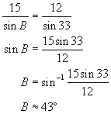
REF: 010212b

14 ANS:
48
REF: 068442siii

15 ANS:
53
REF: 010313siii

16 ANS:
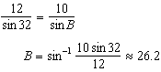. . 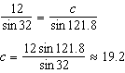
REF: 011137a2

