1 In , , , and . Which statement can be used to find the value of ?
1) 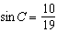 2) 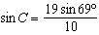 3) 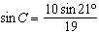 4) 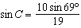

2 If , , and 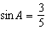 in , then equals
1) 2) 3) 4)

3 In , , , and . Find .

4 In , , , and 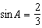. Find .

5 In , , , and 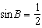. Find the value of .

6 In , , , and . Find the value of .

7 In , , , and 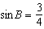. Find .

8 In , , , and 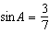. What is ?

9 In , , 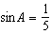, and . Find .

10 In , , , and . Find the value of .

11 In , , , and . Find .

12 In , , , and 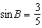. Find the number of degrees in acute angle A.

13 In triangle ABC, if , , and , then is
1) 2) 3) 4)

14 In , , , and . Find .

15 In , , , and . Find .

16 In , , , and . Find .

17 In , side , side , and . Find .

18 In , , , and . Which type of triangle is ?
1) acute 2) isosceles 3) obtuse 4) right
1 ANS: 4
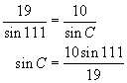. 111° is a Quadrant II angle with a reference angle of 69° in Quadrant I.

REF: 010407b

2 ANS: 4 REF: 069627siii

3 ANS:
0.42. 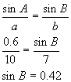

REF: 060922b

4 ANS:
1

REF: 018608siii

5 ANS:

REF: 068609siii

6 ANS:
0.5

REF: 018702siii

7 ANS:

REF: 089314siii

8 ANS:

REF: 068913siii

9 ANS:

REF: 089013siii

10 ANS:
0.2

REF: 019802siii

11 ANS:
0.3

REF: 089804siii

12 ANS:
30

REF: 068818siii

13 ANS: 1 REF: 068726siii

14 ANS:
0.7

REF: 019015siii

15 ANS:

REF: 069013siii

16 ANS:

REF: 089614siii

17 ANS:
90

REF: 010411siii

18 ANS: 3 REF: 060223siii

