1 The accompanying diagram shows the approximate linear distances traveled by a sailboat during a race. The sailboat started at point S, traveled to points E and A, respectively, and ended at point S.

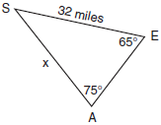

Based on the measures shown in the diagram, which equation can be used to find x, the distance from point A to point S?
1) 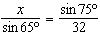 2) 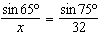 3) 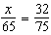 4) 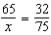

2 In , p equals
1) 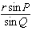 2) 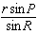 3) 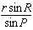 4) 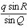

3 In , , , and . Which is a correct expression for a?
1) 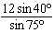 2) 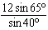 3) 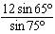 4) 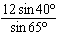

4 In , , and . What is the measure of side c?
1) 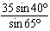 2) 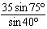 3) 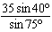 4) 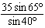

5 In , 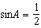 and 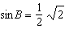. The value of is
1) 2) 2 3) 4) 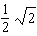

6 In triangle RST, what is the value of r in terms of R, T, and t?

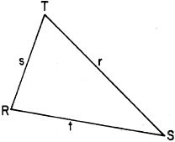
1) 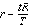 2) 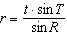 3) 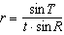 4) 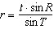

7 In triangle ABC, sinA = 0.8, sinB = 0.3, and a = 24. Find the length of side b.

8 In , , , and side . Find the length of side r.

9 In , 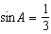, 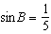, and . Find side a.

10 In triangle ABC, 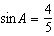, 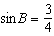, and . Find b.

11 In triangle ABC, , , and . Find b.

12 In triangle ABC, , , and . Find b.

13 In , 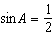, 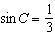, and . Find the length of side c.

14 In , , 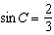, and . Find c.

15 In , , , and . Find c.

16 In , 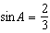, 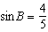, and side . Find side b.

17 In , , , and . Find b.

18 In , , , and 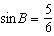. Find the length of side b.

19 In , , , and . Find the length of side a.

20 In , 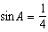, 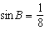, and . What is the length of a?

21 In , , 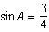, and 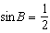. Find b.

22 In , side , , and 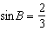. Find the length of side b.

23 In , . Find the value of c when .

24 In , , , and side . What is the length of side b?
1) 2) 3) 4)

25 In , , , and . What is the length of side a?
1) 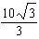 2) 10 3) 4)

26 In , , , and . What is the length of b?

27 In , 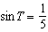, , and . What is the length of t?
1 ANS: 2
The Law of Sines may also be written as 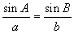

REF: 010702b

2 ANS: 2 REF: 061322a2

3 ANS: 4 REF: 068530siii

4 ANS: 4 REF: 069430siii

5 ANS: 3 REF: 019412siii

6 ANS: 4 REF: 088533siii

7 ANS:
9

REF: 068019siii

8 ANS:
24

REF: 068115siii

9 ANS:
10

REF: 018414siii

10 ANS:
15

REF: 068408siii

11 ANS:
8

REF: 088602siii

12 ANS:
16

REF: 088701siii

13 ANS:
8

REF: 018911siii

14 ANS:
15

REF: 089403siii

15 ANS:
8

REF: 089504siii

16 ANS:
24

REF: 019703siii

17 ANS:
4

REF: 069702siii

18 ANS:
2.5

REF: 010010siii

19 ANS:
4.5

REF: 060001siii

20 ANS:
40

REF: 060103siii

21 ANS:
16

REF: 080102siii

22 ANS:
16

REF: 060304siii

23 ANS:
15

REF: 069807siii

24 ANS: 1 REF: 089730siii

25 ANS: 3 REF: 069920siii

26 ANS:
18

REF: 089911siii

27 ANS:
6

REF: 080211siii

