1 In a triangle, two sides that measure 6 cm and 10 cm form an angle that measures . Find, to the nearest degree, the measure of the smallest angle in the triangle.

2 In a triangle, two sides that measure 8 centimeters and 11 centimeters form an angle that measures . To the nearest tenth of a degree, determine the measure of the smallest angle in the triangle.

3 Kieran is traveling from city A to city B. As the accompanying map indicates, Kieran could drive directly from A to B along County Route 21 at an average speed of 55 miles per hour or travel on the interstates, 45 miles along I-85 and 20 miles along I-64. The two interstates intersect at an angle of 150° at C and have a speed limit of 65 miles per hour. How much time will Kieran save by traveling along the interstates at an average speed of 65 miles per hour?

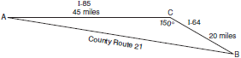

4 As shown in the accompanying diagram, a ship at sea is 75 miles from radio transmitter A and 120 miles from radio transmitter B. The angle between the signals sent to the ship by the two transmitters measures 135°.

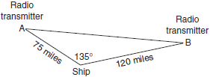

Find the distance between the transmitters to the nearest mile. Using this answer, find the measure of angle B to the nearest degree.

5 In , side , side , and . Find the length of side c to the nearest tenth. Using this answer, find to the nearest degree.

6 In , , , and . Find the length of to the nearest tenth. Using this length, find to the nearest degree.

7 In triangle RST, , , and . Find RT, to the nearest tenth. Using your value for RT, find , to the nearest degree.

8 In the accompanying diagram of , feet, feet, , and . Find AC to the nearest foot.

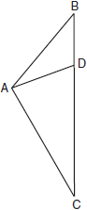

9 In parallelogram ABCD, , , and . Find, to the nearest tenth, the length of diagonal . Find to the nearest degree.

10 In , , , and the measure of angle C is 41º30’. Find the length of side c to the nearest integer. Find the area of to the nearest tenth.

11 In , , feet and inches. Find BC to the nearest tenth. [Indicate the unit of measure.] Find the area of to the nearest tenth. [Indicate the unit of measure.]

12 A surveyor is mapping a triangular plot of land. He measures two of the sides and the angle formed by these two sides and finds that the lengths are 400 yards and 200 yards and the included angle is 50°. What is the measure of the third side of the plot of land, to the nearest yard? What is the area of this plot of land, to the nearest square yard?

13 In , cm, cm, and cm. Find the measure of angle B to the nearest degree. Using this angle, find the area of to the nearest square centimeter.

14 The sides of a triangular plot of land are 50, 80, and 100 meters. Find, to the nearest degree, the measure of the largest angle of the triangle. Using this answer, find the area of the triangle to the nearest square meter.

15 Find, to the nearest degree, the measure of the largest angle of a triangle whose sides measure 22, 34, and 50. Find, to the nearest integer, the area of this triangle.

16 The sides of a triangle have lengths 58, 92, and 124. Find, to the nearest ten minutes, the largest angle of the triangle. Find, to the nearest integer, the area of the triangle.

17 The lengths of the sides of are 9.5, 12.8, and 13.7. Find, to the nearest hundredth of a degree or the nearest ten minutes, the measure of the smallest angle in the triangle. Find, to the nearest tenth, the area of .

18 In , , , and . Find the measure of angle A to the nearest ten minutes or nearest tenth of a degree. Using this measure, find the area of to the nearest tenth.

19 In , , , and . Find the measure of the largest angle to the nearest degree. Find the area of to the nearest integer.

20 A hiking trail is planned in the shape of a triangle with sides 2.3 miles, 8.1 miles, and 6.2 miles. Find, to the nearest tenth of a degree or the nearest ten minutes, the angle between the 2.3-mile side and the 6.2-mile side. Find the area of the triangle to the nearest tenth of a square mile.

21 Firefighters dug three trenches in the shape of a triangle to prevent a fire from completely destroying a forest. The lengths of the trenches were 250 feet, 312 feet, and 490 feet. Find, to the nearest degree, the smallest angle formed by the trenches. Find the area of the plot of land within the trenches, to the nearest square foot.

22 Two adjacent sides of a parallelogram are 10 and 12 centimeters. The angle included between these sides has a measure of . Find, to the nearest centimeter, the length of the shorter diagonal of the parallelogram. What is the area of the parallelogram to the nearest square centimeter?

23 In parallelogram ABCD, cm, cm, and . Find the length of the longer diagonal of the parallelogram to the nearest centimeter. Find the area of the parallelogram to the nearest square centimeter.

24 Two consecutive sides of a parallelogram are 8 centimeters and 10 centimeters, respectively. If the length of the longer diagonal of the parallelogram is 14 centimeters, find the measure of the largest angle of the parallelogram to the nearest degree. Using your answer, find the area of the parallelogram to the nearest square centimeter.

25 In parallelogram ABCD, , , and diagonal . Find to the nearest degree. Using this angle, find the area of parallelogram ABCD to the nearest tenth.
1 ANS:
33. . is opposite the shortest side. 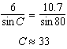

REF: 061039a2

2 ANS:
. The angle opposite the shortest side: 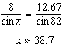

REF: 081536a2

3 ANS:
9 minutes. 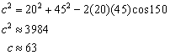. If Kieran drives from A to B along County Route 21, the trip will take 1.15 hours, 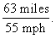 If she travels from A to B along the interstates, the trip will take 1 hour, 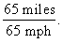 She will save 0.15 hours or 9 minutes by taking the interstates.

REF: 060232b

4 ANS:
181, 17

REF: 010442siii

5 ANS:
20.3, 31

REF: 060341siii

6 ANS:
15.1, 44

REF: 069741siii

7 ANS:
. 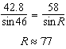

REF: 061033b

8 ANS:
16

REF: 010139siii

9 ANS:
30.4, 22

REF: 089840siii

10 ANS:
8, 39.8

REF: 018438siii

11 ANS:
16.2 in or 1.3 ft, 145.5 in² or 1.0 ft²

REF: 019538siii

12 ANS:
312, 30,642. 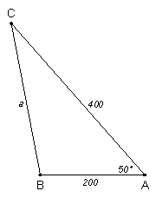 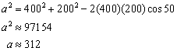 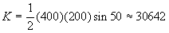

REF: 060434b

13 ANS:
16, 21

REF: 068539siii

14 ANS:
98, 1981

REF: 089040siii

15 ANS:
125, 306

REF: 069539siii

16 ANS:
, 2515

REF: 089541siii

17 ANS:
41.84º or 41º50’, 58.5

REF: 069642siii

18 ANS:
36.2 or , 20.7

REF: 019941siii

19 ANS:
100, 67

REF: 019940siii

20 ANS:
140.1º or 140º10’, 4.6

REF: 010340siii

21 ANS:
26 and 33,509 or 33,443. The smallest angle is opposite the smallest side, so let and find A. 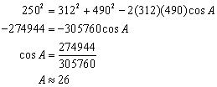. 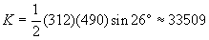

REF: 080934b

22 ANS:
11, 104

REF: 088541siii

23 ANS:
29, 184

REF: 068739siii

24 ANS:
102, 78

REF: 068039siii

25 ANS:
95, 95.6

REF: 010038siii

