1 In , , , and , as shown in the diagram below. What is the , to the nearest degree?

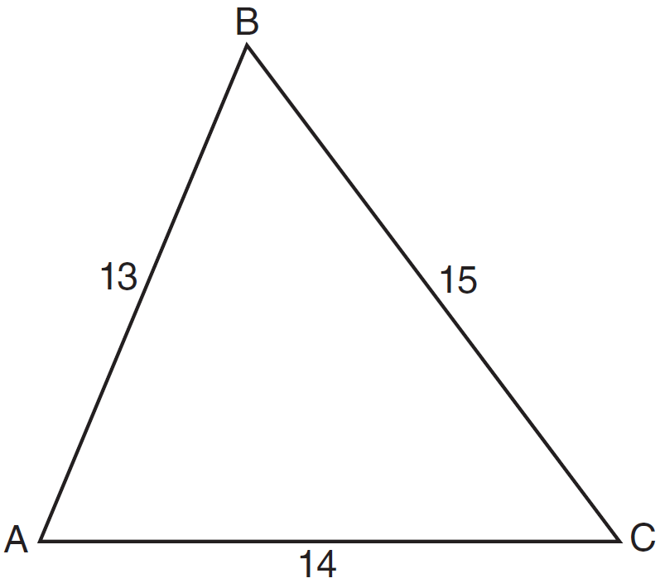
1) | 53
2) | 59
3) | 67
4) | 127

2 To the nearest degree, what is the measure of the largest angle in a triangle with sides measuring 10, 12, and 18 centimeters?
1) | 109
2) | 81
3) | 71
4) | 32

3 In , , , and . Find to the nearest tenth of a degree.

4 In , if side , side , and side , find to the nearest degree.

5 Find the measure of the smallest angle, to the nearest degree, of a triangle whose sides measure 28, 47, and 34.

6 Peter (P) and Jamie (J) have computer factories that are 132 miles apart. They both ship their completed computer parts to Diane (D). Diane is 72 miles from Peter and 84 miles from Jamie. Using points D, J, and P to form a triangle, find to the nearest ten minutes or nearest tenth of a degree.

7 The beam of a searchlight situated at an offshore point W sweeps back and forth between shore points A and B. Point W is located 12 kilometers from A and 25 kilometers from B. The distance between A and B is 29 kilometers. Find the measure of to the nearest ten minutes.

8 During a training exercise in the Mojave Desert, two military vehicles left the base camp at the same time, one traveling at an average speed of 25 miles per hour and the other at an average speed of 50 miles per hour. Each vehicle traveled along a level, straight route. If the exercise requires the two vehicles to be 65 miles apart after traveling for 1 hour, what must the angle between the two routes be, to the nearest degree?

9 In , the lengths of sides a, b, and c are in the ratio . Find the ratio of the cosine of to the cosine of .

10 The lengths of the sides of a triangle are 6 cm, 11 cm, and 7 cm. Determine, to the nearest tenth of a degree, the measure of the largest angle of the triangle.
1 ANS: 1
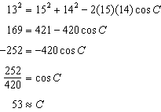

REF: 061110a2

2 ANS: 1 REF: 010233siii

3 ANS:
41.4. 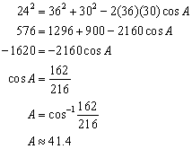

REF: 010929b

4 ANS:
57

REF: 060316siii

5 ANS:
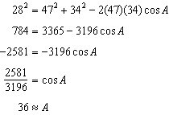

REF: 061536a2

6 ANS:
115.4º or 115º20’

REF: 060140siii

7 ANS:

REF: 068839siii

8 ANS:
116. 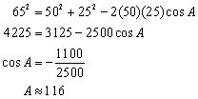

REF: 080828b

9 ANS:

REF: 088639siii

10 ANS:
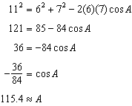

REF: 061636a2

