1 Al is standing 50 yards from a maple tree and 30 yards from an oak tree in the park. His position is shown in the accompanying diagram. If he is looking at the maple tree, he needs to turn his head 120° to look at the oak tree.

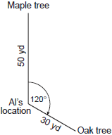

How many yards apart are the two trees?
1) | 58.3 | 3) | 70
2) | 65.2 | 4) | 75

2 Two straight roads, Elm Street and Pine Street, intersect creating a 40° angle, as shown in the accompanying diagram. John’s house is on Elm Street and is 3.2 miles from the point of intersection. Mary’s house is on Pine Street and is 5.6 miles from the intersection. Find, to the nearest tenth of a mile, the direct distance between the two houses.

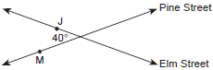

3 The Vietnam Veteran's Memorial in Washington, DC consists of two walls of black, polished granite, each 246.75 feet long, which meet at an angle of 125.2°. If extended, the west wall would reach to the Lincoln Memorial, 900 feet away from the end of the wall and the east wall would reach to the Washington Monument 3,500 feet away from the end of the wall. Find the distance between the Lincoln Memorial and the Washington Monument to the nearest foot.

4 A wooden frame is to be constructed in the form of an isosceles trapezoid, with diagonals acting as braces to strengthen the frame. The sides of the frame each measure 5.30 feet, and the longer base measures 12.70 feet. If the angles between the sides and the longer base each measure 68.4°, find the length of one brace to the nearest tenth of a foot.

5 A ship at sea is 70 miles from one radio transmitter and 130 miles from another. The angle between the signals sent to the ship by the transmitters is 117.4°. Find the distance between the two transmitters, to the nearest mile.

6 Main Street and Park Avenue intersect at an angle of 74°. Mr. Jones lives on Main Street, 50 meters from the intersection, and Mr. Smith lives on Park Avenue, 40 meters from the intersection. The triangle formed by the intersection and the houses is an acute triangle. Find, to the nearest meter, the distance between Mr. Jones’ house and Mr. Smith’s house.

7 The distance from A to C is 40 miles and the distance from C to B is 70 miles. If , find AB to the nearest mile.

8 The playground at a day-care center has a triangular-shaped sandbox. Two of the sides measure 20 feet and 14.5 feet and form an included angle of 45. Find the length of the third side of the sandbox to the nearest tenth of a foot.

9 To measure the distance through a mountain for a proposed tunnel, surveyors chose points A and B at each end of the proposed tunnel and a point C near the mountain. They determined that meters, meters, and . Draw a diagram to illustrate this situation and find the length of the tunnel, to the nearest meter.

10 Two sides of a parallelogram measure 27 cm and 32 cm. The included angle measures 48°. Find the length of the longer diagonal of the parallelogram, to the nearest centimeter.
1 ANS: 3
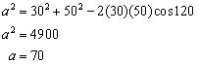

REF: 060817b

2 ANS:
3.8. 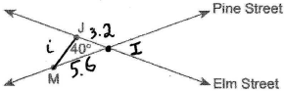. 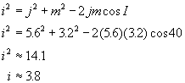

REF: 010227b

3 ANS:
4,506. 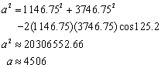

REF: fall9929b

4 ANS:
11.8. 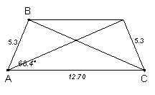 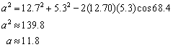

REF: 060127b

5 ANS:
174. 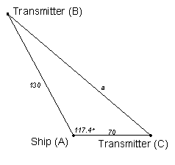 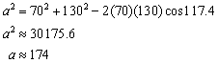

REF: 080329b

6 ANS:
55

REF: 018540siii

7 ANS:
92

REF: 068938siii

8 ANS:
14.1

REF: 010240siii

9 ANS:
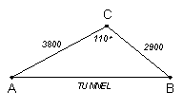 5,513. 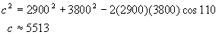

REF: 010528b

10 ANS:

REF: 011438a2

