1 Cassandra is calculating the measure of angle A in right triangle ABC, as shown in the accompanying diagram. She knows the lengths of and .

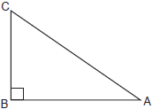

If she finds the measure of angle A by solving only one equation, which concept will be used in her calculations?
1) | Pythagorean theorem
2)
3)
4)

2 Which equation could be used to find the measure of angle D in the right triangle shown in the diagram below?

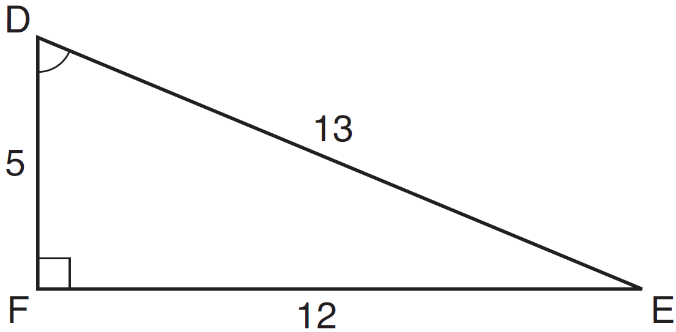
1) | 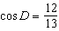
2) | 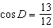
3) | 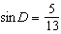
4) | 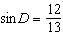

3 Which equation could be used to find the measure of one acute angle in the right triangle shown below?

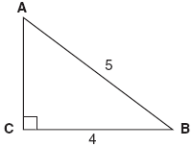
1) | 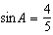
2) | 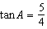
3) | 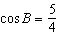
4) | 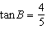

4 Which equation could be used to find the measure of one acute angle in the right triangle shown below?

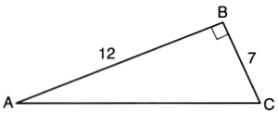
1) | 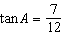
2) | 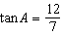
3) | 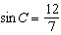
4) | 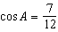

5 In the diagram of shown below, and .

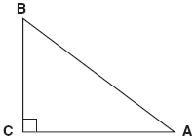

To the nearest tenth of a degree, what is the measure of the largest acute angle in the triangle?
1) | 32.0
2) | 38.7
3) | 51.3
4) | 90.0

6 In right triangle ABC shown below, and .

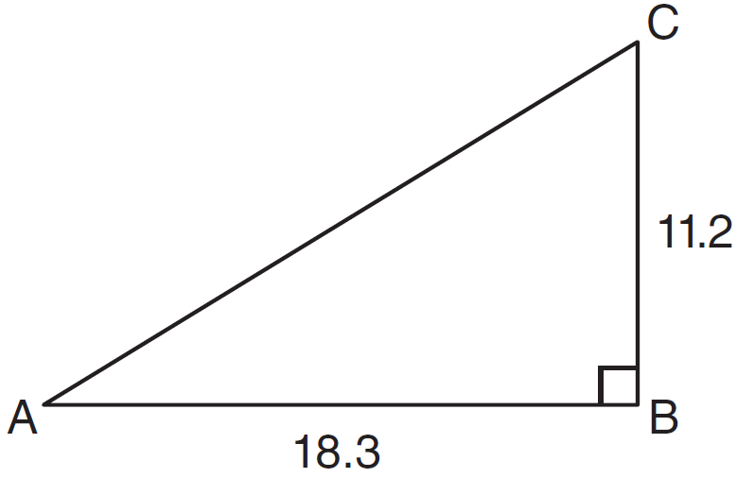

What is the measure of , to the nearest tenth of a degree?
1) | 31.5
2) | 37.7
3) | 52.3
4) | 58.5

7 The center pole of a tent is 8 feet long, and a side of the tent is 12 feet long as shown in the diagram below.
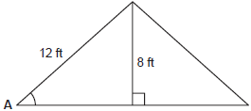
If a right angle is formed where the center pole meets the ground, what is the measure of angle A to the nearest degree?
1) | 34
2) | 42
3) | 48
4) | 56

8 The diagram below shows the path a bird flies from the top of a 9.5-foot-tall sunflower to a point on the ground 5 feet from the base of the sunflower.
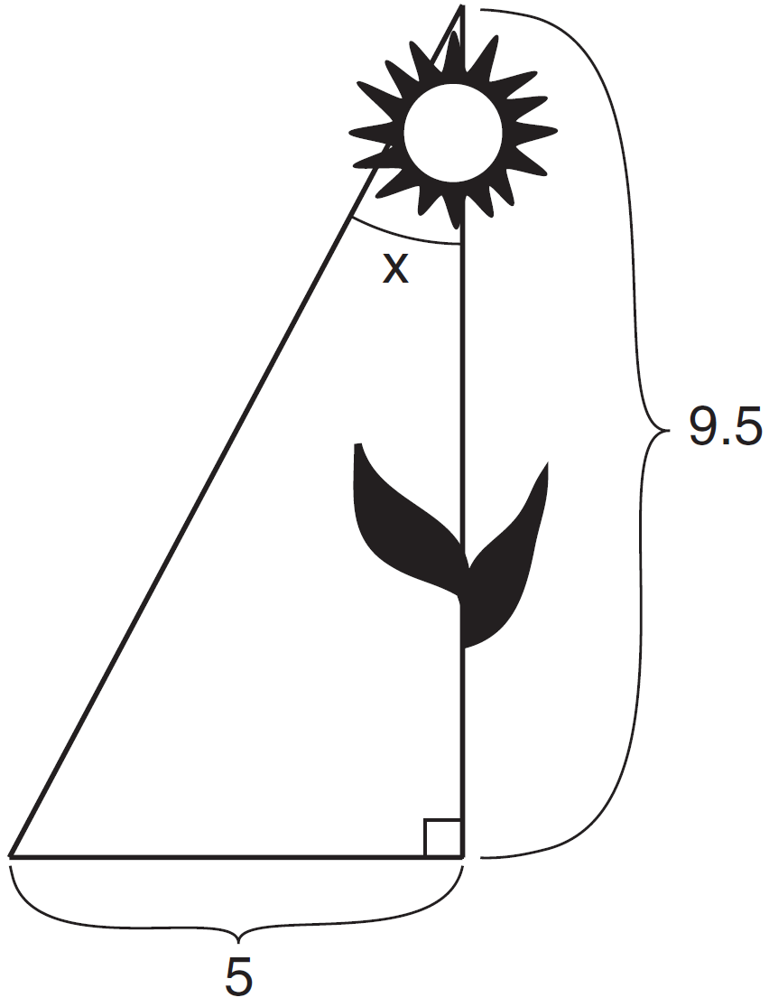
To the nearest tenth of a degree, what is the measure of angle x?
1) | 27.8
2) | 31.8
3) | 58.2
4) | 62.2

9 In right triangle EFD, , , and . What is the measure of angle E, to the nearest degree?
1) | 61
2) | 57
3) | 33
4) | 29

10 If a tree 28 meters tall casts a shadow 32 meters long, what is the angle of elevation of the Sun to the nearest degree?
1) | 29
2) | 41
3) | 50
4) | 61

11 In the diagram below of right triangle KTW, , , and .

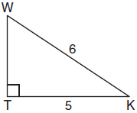

What is the measure of , to the nearest minute?
1)
2)
3)
4)

12 In the right triangle shown below, what is the measure of angle S, to the nearest minute?

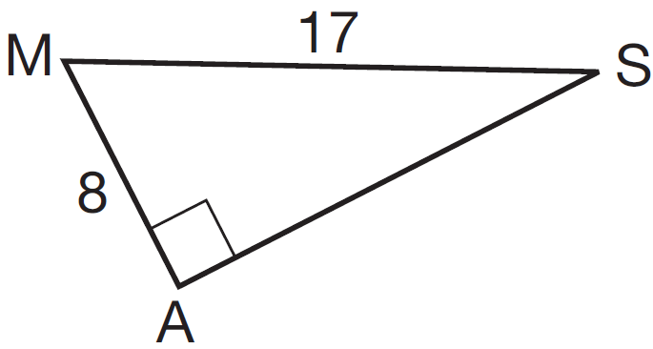
1)
2)
3)
4)

13 A support wire 20 meters long runs from the top of a utility pole to a point on the ground 17 meters from the base of the pole. What is the measure, to the nearest minute, of the angle formed by the pole and the wire?
1)
2)
3)
4)

14 A communications company is building a 30-foot antenna to carry cell phone transmissions. As shown in the diagram below, a 50-foot wire from the top of the antenna to the ground is used to stabilize the antenna.

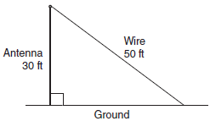

Find, to the nearest degree, the measure of the angle that the wire makes with the ground.

15 A person standing on level ground is 2,000 feet away from the foot of a 420-foot-tall building, as shown in the accompanying diagram. To the nearest degree, what is the value of x?

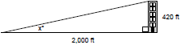

16 Ron and Francine are building a ramp for performing skateboard stunts, as shown in the accompanying diagram. The ramp is 7 feet long and 3 feet high. What is the measure of the angle, x, that the ramp makes with the ground, to the nearest tenth of a degree?

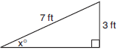

17 A trapezoid is shown below.

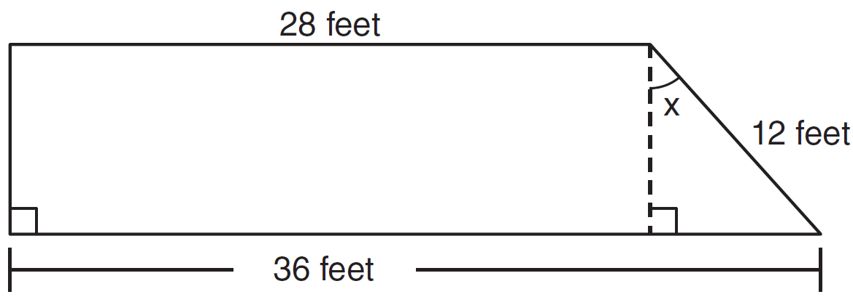

Calculate the measure of angle x, to the nearest tenth of a degree.

18 In right triangle ABC shown below, inches, inches, and . Find the number of degrees in the measure of angle BAC, to the nearest degree.

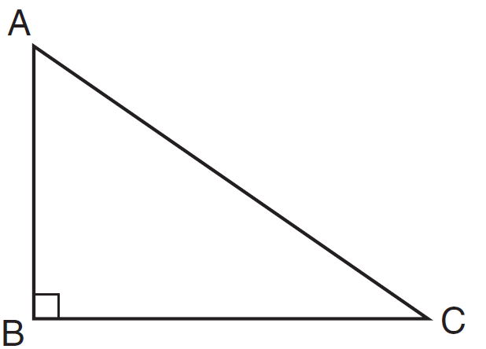

Find the length of to the nearest inch.

19 As seen in the accompanying diagram, a person can travel from New York City to Buffalo by going north 170 miles to Albany and then west 280 miles to Buffalo.

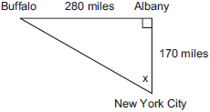

If an engineer wants to design a highway to connect New York City directly to Buffalo, at what angle, x, would she need to build the highway? Find the angle to the nearest degree. To the nearest mile, how many miles would be saved by traveling directly from New York City to Buffalo rather than by traveling first to Albany and then to Buffalo?

20 In the accompanying diagram, the base of a 15-foot ladder rests on the ground 4 feet from a 6-foot fence.

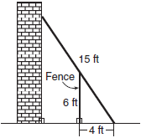

a If the ladder touches the top of the fence and the side of a building, what angle, to the nearest degree, does the ladder make with the ground?
b Using the angle found in part a, determine how far the top of the ladder reaches up the side of the building, to the nearest foot.

21 The accompanying diagram shows a flagpole that stands on level ground. Two cables, r and s, are attached to the pole at a point 16 feet above the ground. The combined length of the two cables is 50 feet. If cable r is attached to the ground 12 feet from the base of the pole, what is the measure of the angle, x, to the nearest degree, that cable s makes with the ground?

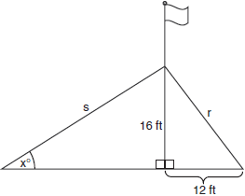

22 In right triangle ABC, , , , and . Find, to the nearest degree, the measure of .

23 A 28-foot ladder is leaning against a house. The bottom of the ladder is 6 feet from the base of the house. Find the measure of the angle formed by the ladder and the ground, to the nearest degree.

24 A man standing on level ground is 1000 feet away from the base of a 350-foot-tall building. Find, to the nearest degree, the measure of the angle of elevation to the top of the building from the point on the ground where the man is standing.
1 ANS: 4 REF: 060820a

2 ANS: 4
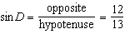
REF: 061325ia

3 ANS: 1 REF: 080824ia

4 ANS: 1
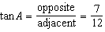
REF: 061619ia

5 ANS: 3
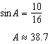 . A 90º angle is not acute.
REF: 080829ia

6 ANS: 1 REF: 061114ia

7 ANS: 2
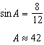
REF: 060816ia

8 ANS: 1
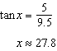
REF: 011525ia

9 ANS: 2
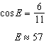
REF: 061523ia

10 ANS: 2 REF: 068533siii

11 ANS: 1
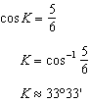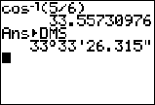
REF: 061023a2

12 ANS: 2
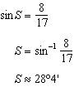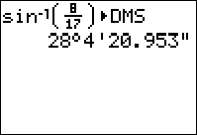
REF: 061311a2

13 ANS: 4
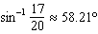
REF: 011725a2

14 ANS:
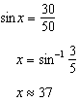
REF: 061033ia

15 ANS:
12. 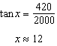
REF: 089927a

16 ANS:
25.4. 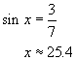
REF: 060735a

17 ANS:
41.8. 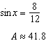
REF: 081135ia

18 ANS:
54, 23. 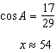.
REF: 081238ia

19 ANS:
59, 122. 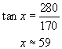. 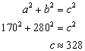. The trip from New York City to Buffalo via Albany is 450 (280 + 170) miles. Therefore traveling directly to Buffalo would save (450 – 328) 122 miles.
REF: 060231a

20 ANS:
56, 12. 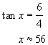. 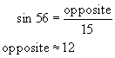
REF: 010438a

21 ANS:
32. 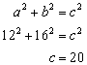. If the combined length of the two cables is 50 feet, then s is 30 (50 – 20) feet. 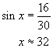
REF: 060539a

22 ANS:
53. 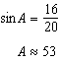
REF: 011032ia

23 ANS:
78. 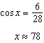
REF: 061235ia

24 ANS:
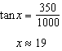
REF: 061335ia

