1 In the diagram of right triangle ABC shown below, and .

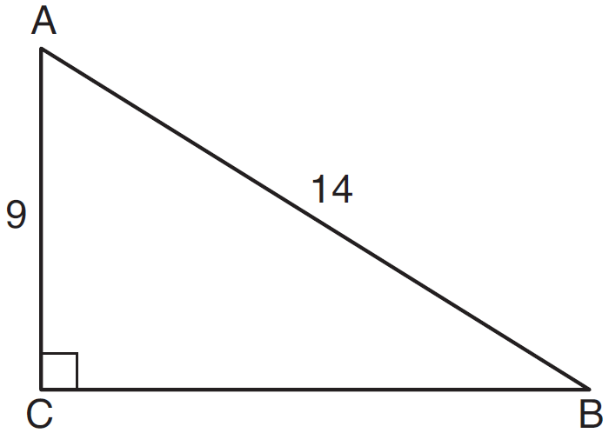

What is the measure of , to the nearest degree?
1) | 33
2) | 40
3) | 50
4) | 57

2 In the diagram of below, , , and .

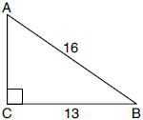

What is the measure of , to the nearest degree?
1) | 36°
2) | 39°
3) | 51°
4) | 54°

3 In the diagram of below, , , and .

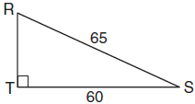

What is the measure of , to the nearest degree?
1) | 23º
2) | 43º
3) | 47º
4) | 67º

4 In the diagram below of right triangle SUN, where is a right angle, and .

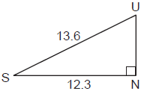

What is , to the nearest degree?
1) | 25°
2) | 42°
3) | 48°
4) | 65°

5 To build a handicapped-access ramp, the building code states that for every 1 inch of vertical rise in height, the ramp must extend out 12 inches horizontally, as shown in the diagram below.

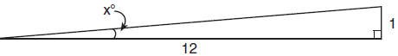

What is the angle of inclination, x, of this ramp, to the nearest hundredth of a degree?
1) | 4.76
2) | 4.78
3) | 85.22
4) | 85.24

6 Many roofs are slanted to prevent the buildup of snow. As modeled below, the length of a roof is 5.5 meters and it rises to a height of 2.5 meters.

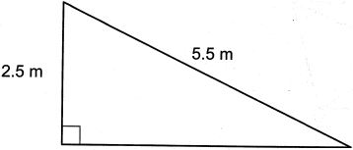

The angle of elevation of the roof, to the nearest degree, is
1) | 24º
2) | 25º
3) | 27º
4) | 28º

7 A 12-foot ladder leans against a building and reaches a window 10 feet above ground. What is the measure of the angle, to the nearest degree, that the ladder forms with the ground?
1) | 34
2) | 40
3) | 50
4) | 56

8 Zach placed the foot of an extension ladder 8 feet from the base of the house and extended the ladder 25 feet to reach the house. To the nearest degree, what is the measure of the angle the ladder makes with the ground?
1) | 18
2) | 19
3) | 71
4) | 72

9 In right triangle ABC, hypotenuse has a length of 26 cm, and side has a length of 17.6 cm. What is the measure of angle B, to the nearest degree?
1) | 48°
2) | 47°
3) | 43°
4) | 34°

10 A man who is 5 feet 9 inches tall casts a shadow of 8 feet 6 inches. Assuming that the man is standing perpendicular to the ground, what is the angle of elevation from the end of the shadow to the top of the man’s head, to the nearest tenth of a degree?
1) | 34.1
2) | 34.5
3) | 42.6
4) | 55.9

11 In the diagram below of and , angles H and N are right angles, and .
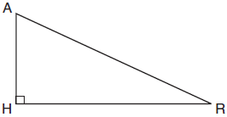

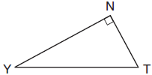
If and , what is the measure of angle Y, to the nearest degree?
1) | 23°
2) | 25°
3) | 65°
4) | 67°

12 Kayla was cutting right triangles from wood to use for an art project. Two of the right triangles she cut are shown below.

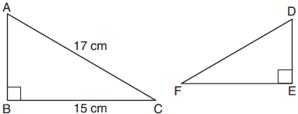

If , with right angles B and E, cm, and cm, what is the measure of , to the nearest degree?
1) | 28°
2) | 41°
3) | 62°
4) | 88°

13 In below, , , and .

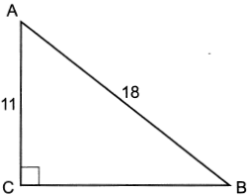

Determine and state the measure of angle A, to the nearest degree.

14 In the diagram below, and 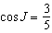.

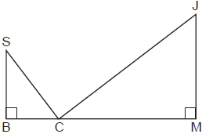

Determine and state , to the nearest degree.

15 The diagram below shows a ramp connecting the ground to a loading platform 4.5 feet above the ground. The ramp measures 11.75 feet from the ground to the top of the loading platform.

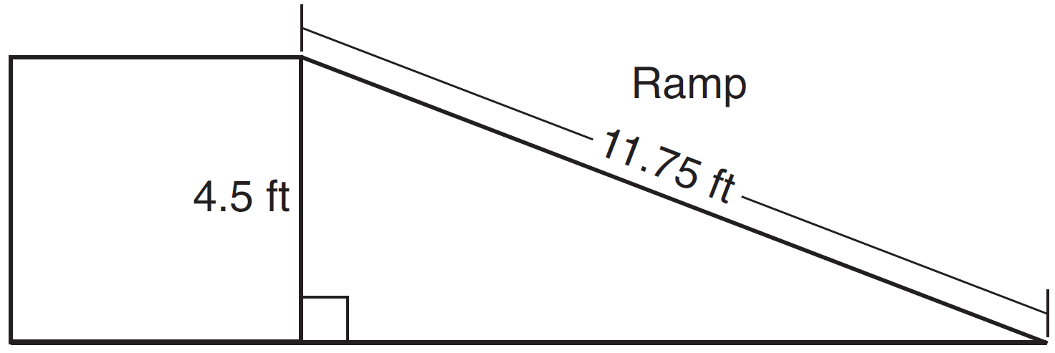

Determine and state, to the nearest degree, the angle of elevation formed by the ramp and the ground.

16 An airplane took off at a constant angle of elevation. After the plane traveled for 25 miles, it reached an altitude of 5 miles, as modeled below.

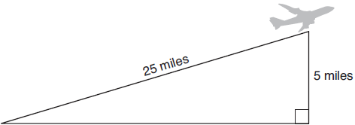

To the nearest tenth of a degree, what was the angle of elevation?

17 As shown in the diagram below, a symmetrical roof frame rises 4 feet above a house and has a width of 24 feet.

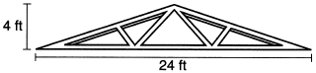

Determine and state, to the nearest degree, the angle of elevation of the roof frame.

18 A ladder leans against a building. The top of the ladder touches the building 10 feet above the ground. The foot of the ladder is 4 feet from the building. Find, to the nearest degree, the angle that the ladder makes with the level ground.

19 Bob places an 18-foot ladder 6 feet from the base of his house and leans it up against the side of his house. Find, to the nearest degree, the measure of the angle the bottom of the ladder makes with the ground.

20 As modeled below, a movie is projected onto a large outdoor screen. The bottom of the 60-foot-tall screen is 12 feet off the ground. The projector sits on the ground at a horizontal distance of 75 feet from the screen.

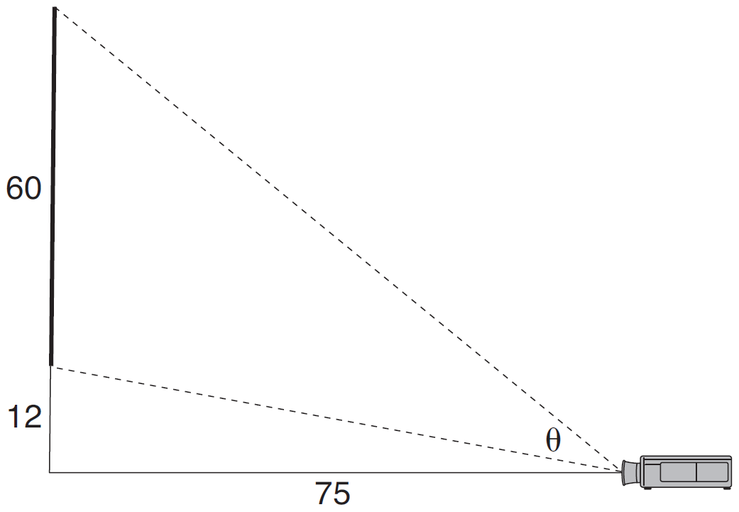

Determine and state, to the nearest tenth of a degree, the measure of , the projection angle.

21 As modeled below, a projector mounted on a ceiling is 3.74 m from a wall, where a whiteboard is displayed. The vertical distance from the ceiling to the top of the whiteboard is 0.41 m, and the height of the whiteboard is 1.17 m.

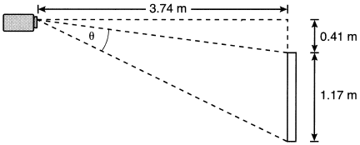

Determine and state the projection angle, , to the nearest tenth of a degree.
1 ANS: 3
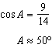

REF: 011616geo

2 ANS: 4
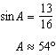

REF: 082207geo

3 ANS: 1
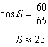

REF: 061713geo

4 ANS: 1
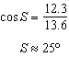

REF: 062304geo

5 ANS: 1
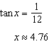

REF: 081715geo

6 ANS: 3
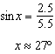

REF: 082406geo

7 ANS: 4
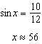

REF: 061922geo

8 ANS: 3
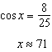

REF: 082303geo

9 ANS: 2
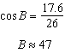

REF: 061806geo

10 ANS: 1
The man’s height, 69 inches, is opposite to the angle of elevation, and the shadow length, 102 inches, is adjacent to the angle of elevation. Therefore, tangent must be used to find the angle of elevation. 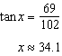

REF: fall1401geo

11 ANS: 1
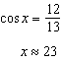

REF: 081809ai

12 ANS: 1
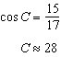

REF: 012007geo

13 ANS:
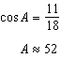

REF: 062425geo

14 ANS:
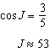

REF: 012431geo

15 ANS:
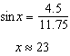

REF: 061528geo

16 ANS:
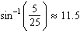

REF: 081926geo

17 ANS:
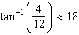

REF: 012327geo

18 ANS:
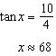

REF: 061630geo

19 ANS:
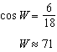

REF: 011831geo

20 ANS:
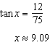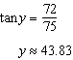

REF: 081634geo

21 ANS:
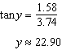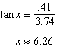

REF: 062232geo

