1 The accompanying diagram shows a ramp 30 feet long leaning against a wall at a construction site.

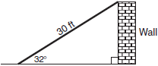

If the ramp forms an angle of 32° with the ground, how high above the ground, to the nearest tenth, is the top of the ramp?
1) 15.9 ft 2) 18.7 ft 3) 25.4 ft 4) 56.6 ft

2 In right triangle ABC, , , and 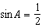. What is the length of the hypotenuse?
1) 2) 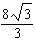 3) 8 4)

3 At Mogul’s Ski Resort, the beginner’s slope is inclined at an angle of 12.3°, while the advanced slope is inclined at an angle of 26.4°. If Rudy skis 1,000 meters down the advanced slope while Valerie skis the same distance on the beginner’s slope, how much longer was the horizontal distance that Valerie covered?
1) 81.3 m 2) 231.6 m 3) 895.7 m 4) 977.0 m

4 In the accompanying diagram of right triangle ABC, and .

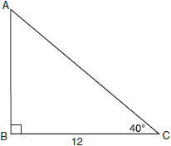

Which single function could be used to find AB?
1) 2) 3) 4)

5 In right triangle ABC, . Which equation is true for this triangle?

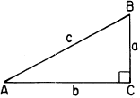
1) 2) 3) 4)

6 The angle of elevation from a point 25 feet from the base of a tree on level ground to the top of the tree is 30°. Which equation can be used to find the height of the tree?
1) 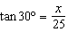 2) 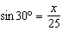 3) 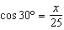 4)

7 In the accompanying diagram, a ladder leaning against a building makes an angle of 58º with level ground. If the distance from the foot of the ladder to the building is 6 feet, find, to the nearest foot, how far up the building the ladder will reach.

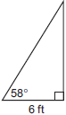

8 From a point on level ground 25 feet from the base of a tower, the angle of elevation to the top of the tower is 78°, as shown in the accompanying diagram. Find the height of the tower, to the nearest tenth of a foot.

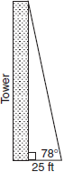

9 The tailgate of a truck is 2 feet above the ground. The incline of a ramp used for loading the truck is 11°, as shown below.

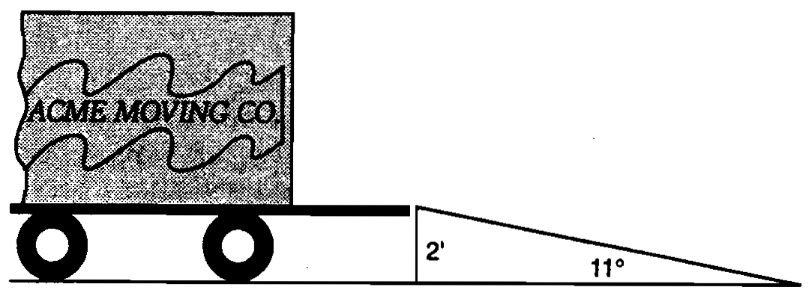

Find, to the nearest tenth of a foot, the length of the ramp.

10 A surveyor needs to determine the distance across the pond shown in the accompanying diagram. She determines that the distance from her position to point P on the south shore of the pond is 175 meters and the angle from her position to point X on the north shore is 32°. Determine the distance, PX, across the pond, rounded to the nearest meter.

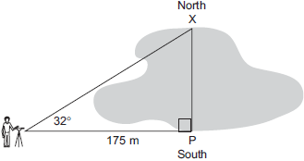

11 A tree casts a shadow that is 20 feet long. The angle of elevation from the end of the shadow to the top of the tree is 66°. Determine the height of the tree, to the nearest foot.

12 Joe is holding his kite string 3 feet above the ground, as shown in the accompanying diagram. The distance between his hand and a point directly under the kite is 95 feet. If the angle of elevation to the kite is 50°, find the height, h, of his kite, to the nearest foot.

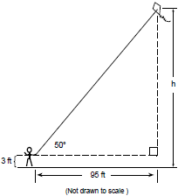

13 Find, to the nearest tenth of a foot, the height of the tree represented in the accompanying diagram.

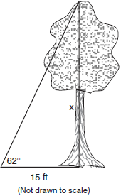

14 In the accompanying diagram, x represents the length of a ladder that is leaning against a wall of a building, and y represents the distance from the foot of the ladder to the base of the wall. The ladder makes a 60° angle with the ground and reaches a point on the wall 17 feet above the ground. Find the number of feet in x and y.

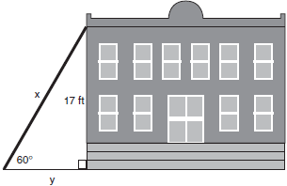

15 As shown in the accompanying diagram, a ladder is leaning against a vertical wall, making an angle of 70° with the ground and reaching a height of 10.39 feet on the wall. Find, to the nearest foot, the length of the ladder. Find, to the nearest foot, the distance from the base of the ladder to the wall.

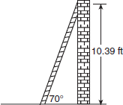

16 A lighthouse is built on the edge of a cliff near the ocean, as shown in the accompanying diagram. From a boat located 200 feet from the base of the cliff, the angle of elevation to the top of the cliff is 18° and the angle of elevation to the top of the lighthouse is 28°. What is the height of the lighthouse, x, to the nearest tenth of a foot?

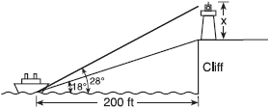

17 A ship at sea heads directly toward a cliff on the shoreline. The accompanying diagram shows the top of the cliff, D, sighted from two locations, A and B, separated by distance S. If , , and , what is the height of the cliff, to the nearest foot?

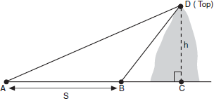

18 While sailing a boat offshore, Donna sees a lighthouse and calculates that the angle of elevation to the top of the lighthouse is 3°, as shown in the accompanying diagram. When she sails her boat 700 feet closer to the lighthouse, she finds that the angle of elevation is now 5°. How tall, to the nearest tenth of a foot, is the lighthouse?

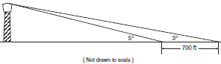

19 A machine part consists of a circular wheel with an inscribed triangular plate, as shown in the accompanying diagram. If , , and , find the length of to the nearest tenth.

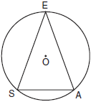

20 A 10-foot ladder is to be placed against the side of a building. The base of the ladder must be placed at an angle of 72° with the level ground for a secure footing. Find, to the nearest inch, how far the base of the ladder should be from the side of the building and how far up the side of the building the ladder will reach.

21 A ship on the ocean surface detects a sunken ship on the ocean floor at an angle of depression of 50°. The distance between the ship on the surface and the sunken ship on the ocean floor is 200 meters. If the ocean floor is level in this area, how far above the ocean floor, to the nearest meter, is the ship on the surface?

22 Draw and label a diagram of the path of an airplane climbing at an angle of 11° with the ground. Find, to the nearest foot, the ground distance the airplane has traveled when it has attained an altitude of 400 feet.

23 A person measures the angle of depression from the top of a wall to a point on the ground. The point is located on level ground 62 feet from the base of the wall and the angle of depression is 52°. How high is the wall, to the nearest tenth of a foot?

24 A parcel of land is in the shape of an isosceles triangle. The base has a length of 673 feet and the two equal legs meet at an angle of 43°. Find, to the nearest square foot, the area of the parcel of land.

25 A ship captain at sea uses a sextant to sight an angle of elevation of 37° to the top of a lighthouse. After the ship travels 250 feet directly toward the lighthouse, another sighting is made, and the new angle of elevation is 50°. The ship’s charts show that there are dangerous rocks 100 feet from the base of the lighthouse. Find, to the nearest foot, how close to the rocks the ship is at the time of the second sighting.

26 A sign 46 feet high is placed on top of an office building. From a point on the sidewalk level with the base of the building, the angle of elevation to the top of the sign and the angle of elevation to the bottom of the sign are 40° and 32°, respectively. Sketch a diagram to represent the building, the sign, and the two angles, and find the height of the building to the nearest foot.

27 In the accompanying diagram of a right triangle ACD, B lies on , is drawn such that , , and . Find AB to the nearest tenth.

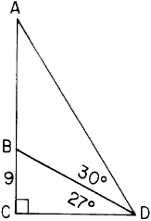

28 An airplane traveling at a level altitude of 2050 feet sights the top of a 50-foot tower at an angle of depression of 28º from point A. After continuing in level flight to point B, the angle of depression to the same tower is 34º. Find, to the nearest foot, the distance that the plane traveled from point A to point B.

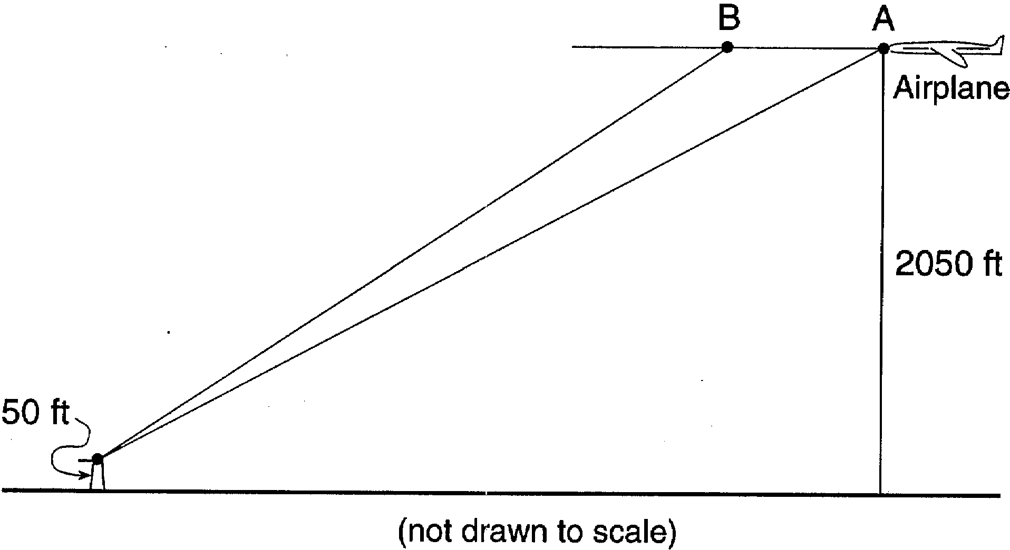

29 To determine the distance across a river, a surveyor marked three points on one riverbank: H, G, and F, as shown below. She also marked one point, K, on the opposite bank such that , , and . The distance between G and F is 45 meters. Find KH, the width of the river, to the nearest tenth of a meter.

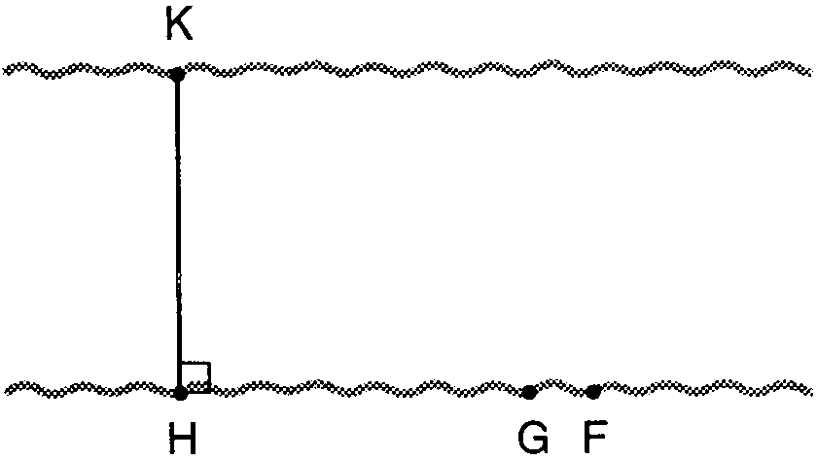
1 ANS: 1
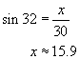

REF: 080724a

2 ANS: 3 REF: 088725siii

3 ANS: 1
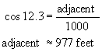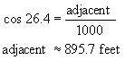

REF: 080108b

4 ANS: 1 REF: 010926a

5 ANS: 4 REF: 018933siii

6 ANS: 1 REF: 060419a

7 ANS:
10.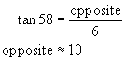

REF: 010531a

8 ANS:
117.6. 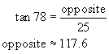

REF: 010735a

9 ANS:
10.5. 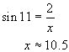

REF: spring9825a

10 ANS:
109. 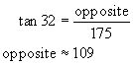

REF: 060030a

11 ANS:
45. 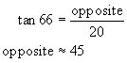

REF: 080536a

12 ANS:
116. 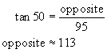

REF: 069934a

13 ANS:
28.2. 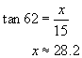

REF: 010135a

14 ANS:
. 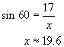 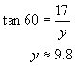

REF: 080231a

15 ANS:
Length of ladder = 11 and distance from the base of the ladder to the wall = 4. 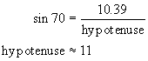. 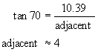

REF: 010638a

16 ANS:
41.4. 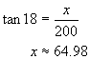 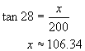

REF: 010838a

17 ANS:
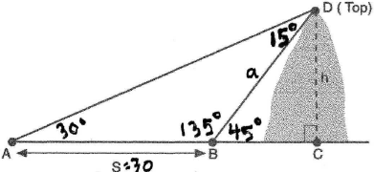 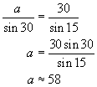 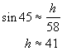 or 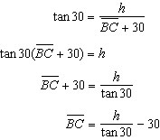 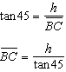 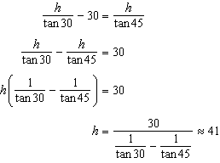

REF: 060231b

18 ANS:
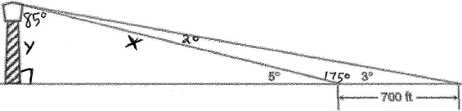. 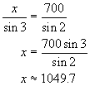. 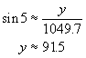 or 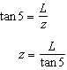 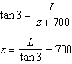 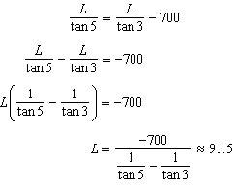

REF: 060332b

19 ANS:
6.8. Equal chords intercept equal arcs. If then And The measure of an inscribed angle is half that of its intercepted arc. So Draw altitude and use the cosine function to find the leg of the right triangle created, which is half the length of . 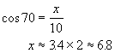. 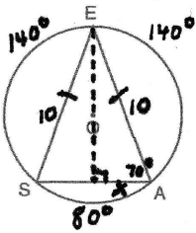

REF: 080629b

20 ANS:
114” and 37”. 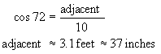. 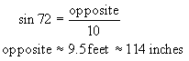

REF: 080033a

21 ANS:
153. 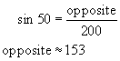

REF: 080133a

22 ANS:
2,058. 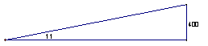 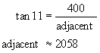

REF: 010235a

23 ANS:
79.4. 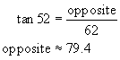

REF: 060639a

24 ANS:
287,457. 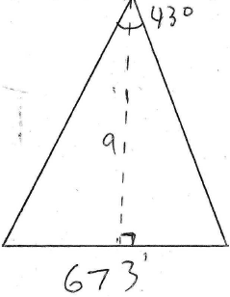 . 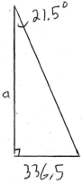. 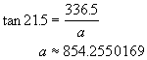 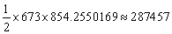

REF: 080829b

25 ANS:
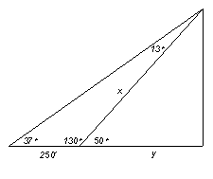. 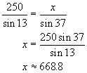 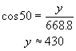 Because the rocks are 100 feet from the base, the ship is 330 (430-100) feet from the rocks at the second sighting. or 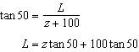 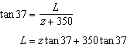 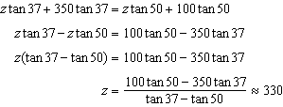

REF: 010334b

26 ANS:
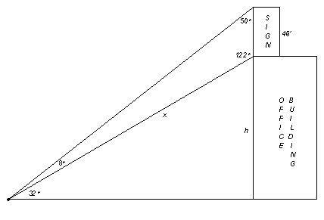 134. 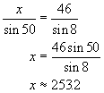 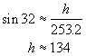 or 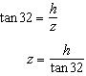 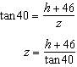 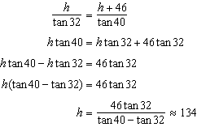

REF: 010534b

27 ANS:
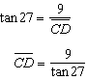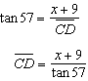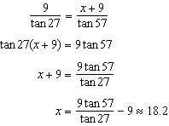

REF: 018938siii

28 ANS:
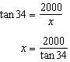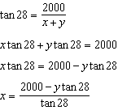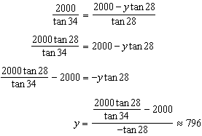

REF: 019642siii

29 ANS:
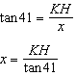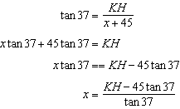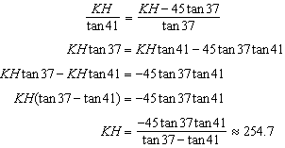

REF: 089941siii

