1 In the right triangle shown in the diagram below, what is the value of x to the nearest whole number?

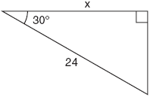
1) 12 2) 14 3) 21 4) 28

2 A tree casts a 25-foot shadow on a sunny day, as shown in the diagram below.

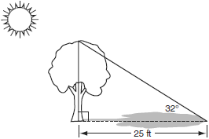

If the angle of elevation from the tip of the shadow to the top of the tree is 32°, what is the height of the tree to the nearest tenth of a foot?
1) 13.2 2) 15.6 3) 21.2 4) 40.0

3 An 8-foot rope is tied from the top of a pole to a stake in the ground, as shown in the diagram below.

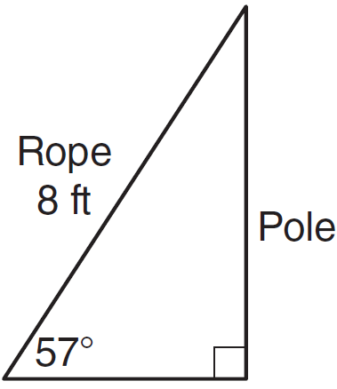

If the rope forms a 57° angle with the ground, what is the height of the pole, to the nearest tenth of a foot?
1) 4.4 2) 6.7 3) 9.5 4) 12.3

4 As shown in the diagram below, a building casts a 72-foot shadow on the ground when the angle of elevation of the Sun is 40°.
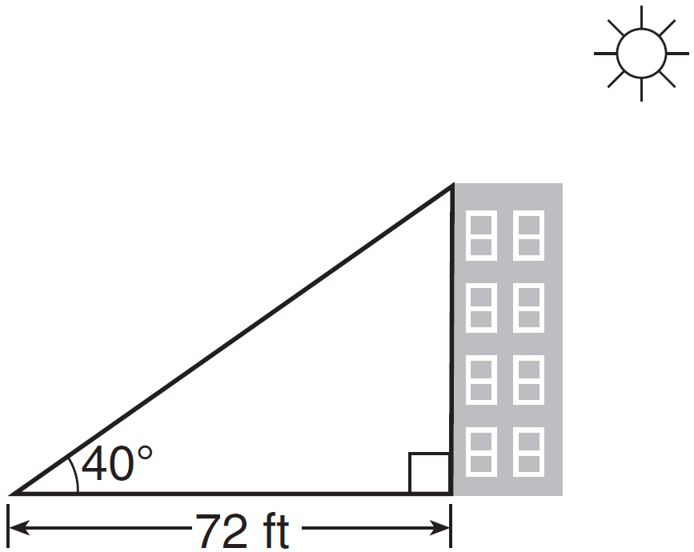

How tall is the building, to the nearest foot?
1) 46 2) 60 3) 86 4) 94

5 A right triangle contains a 38° angle whose adjacent side measures 10 centimeters. What is the length of the hypotenuse, to the nearest hundredth of a centimeter?
1) 7.88 2) 12.69 3) 12.80 4) 16.24

6 By law, a wheelchair service ramp may be inclined no more than 4.76°. If the base of a ramp begins 15 feet from the base of a public building, which equation could be used to determine the maximum height, h, of the ramp where it reaches the building’s entrance?
1) 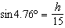 2) 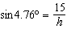 3) 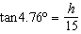 4) 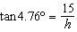

7 As shown in the diagram below, a ladder 5 feet long leans against a wall and makes an angle of 65° with the ground. Find, to the nearest tenth of a foot, the distance from the wall to the base of the ladder.

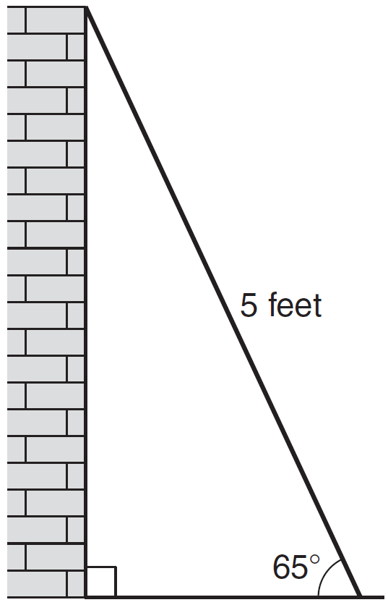

8 As shown in the diagram below, a ladder 12 feet long leans against a wall and makes an angle of 72° with the ground.

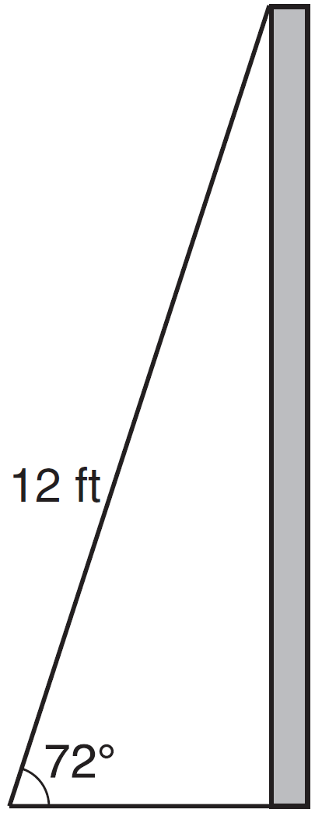

Find, to the nearest tenth of a foot, the distance from the wall to the base of the ladder.

9 A 12 foot ladder is placed against a wall. The ladder makes an angle of 73° with the floor. Determine, to the nearest tenth of a foot, how high up the wall the ladder will reach.

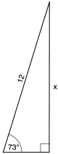

10 From the top of an apartment building, the angle of depression to a car parked on the street below is 38 degrees, as shown in the diagram below. The car is parked 80 feet from the base of the building. Find the height of the building, to the nearest tenth of a foot.

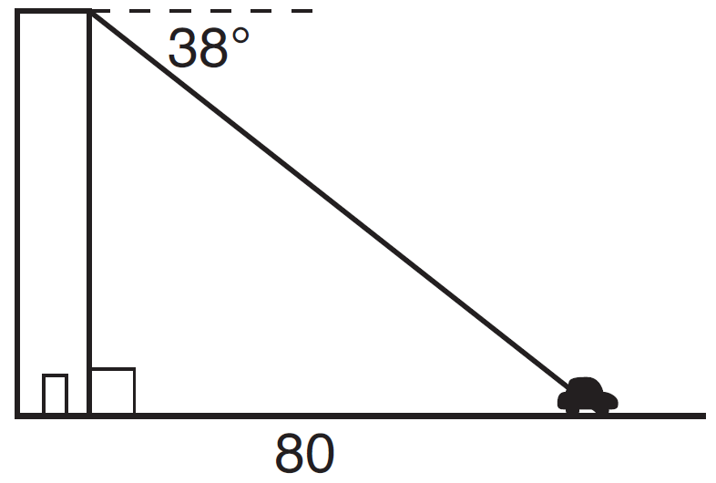

11 The top of a lighthouse, T, is 215 feet above sea level, L, as shown in the diagram below. The angle of depression from the top of the lighthouse to a boat, B, at sea is 26°. Determine, to the nearest foot, the horizontal distance, x, from the boat to the base of the lighthouse.
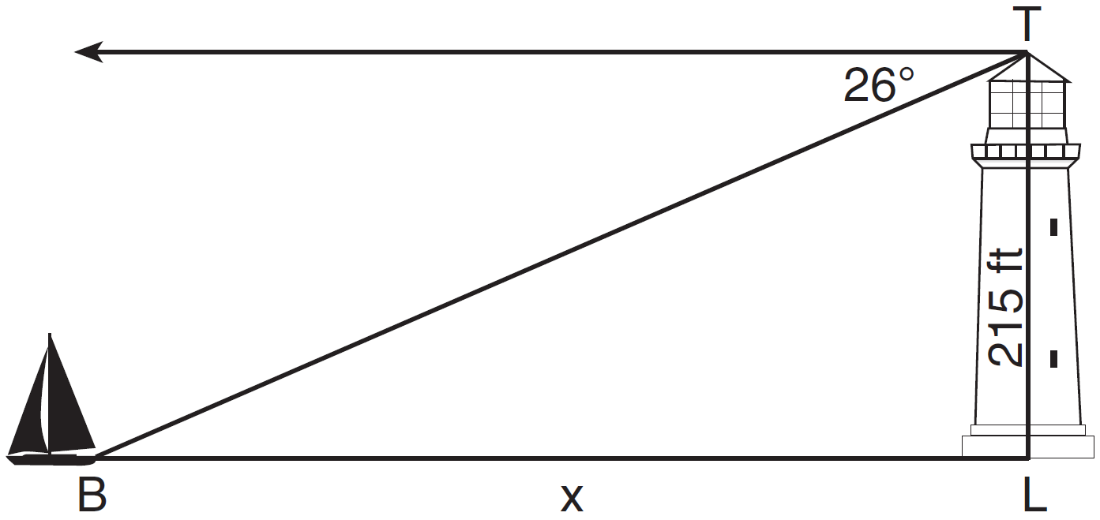

12 A stake is to be driven into the ground away from the base of a 50-foot pole, as shown in the diagram below. A wire from the stake on the ground to the top of the pole is to be installed at an angle of elevation of 52°.
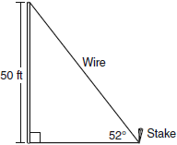

How far away from the base of the pole should the stake be driven in, to the nearest foot? What will be the length of the wire from the stake to the top of the pole, to the nearest foot?

13 A hot-air balloon is tied to the ground with two taut (straight) ropes, as shown in the diagram below. One rope is directly under the balloon and makes a right angle with the ground. The other rope forms an angle of 50º with the ground.
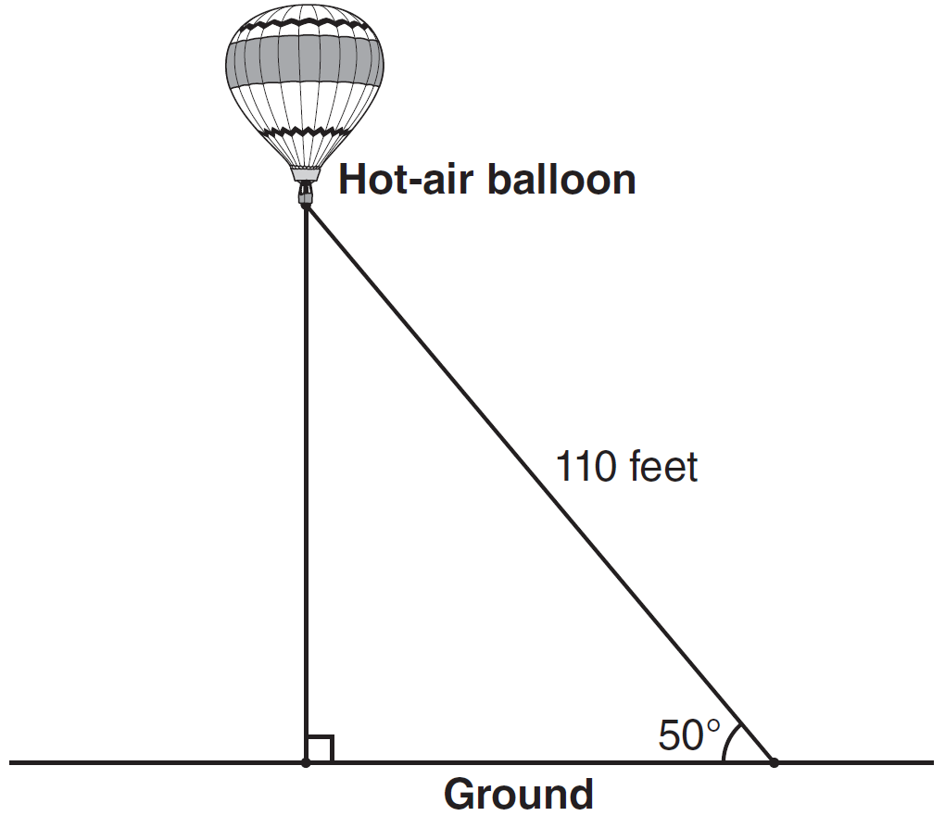

Determine the height, to the nearest foot, of the balloon directly above the ground. Determine the distance, to the nearest foot, on the ground between the two ropes.

14 A metal pipe is used to hold up a 9-foot fence, as shown in the diagram below. The pipe makes an angle of 48° with the ground.

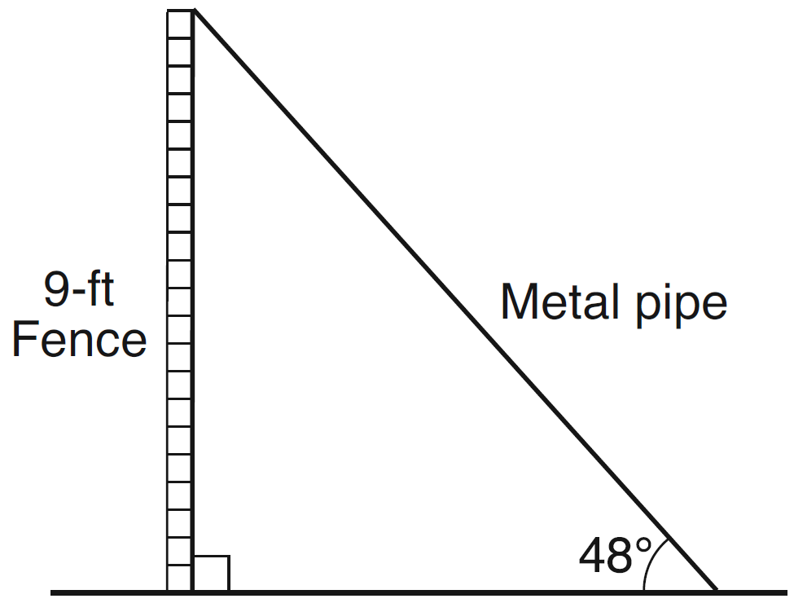

Determine, to the nearest foot, how far the bottom of the pipe is from the base of the fence. Determine, to the nearest foot, the length of the metal pipe.

15 The diagram below shows the plans for a cell phone tower. A guy wire attached to the top of the tower makes an angle of 65 degrees with the ground. From a point on the ground 100 feet from the end of the guy wire, the angle of elevation to the top of the tower is 32 degrees. Find the height of the tower, to the nearest foot.

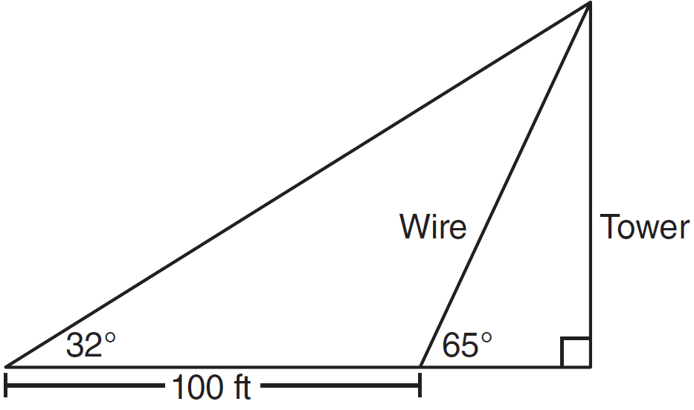
1 ANS: 3
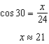

REF: 010912ia

2 ANS: 2
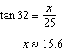

REF: 080914ia

3 ANS: 2
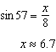

REF: 061108ia

4 ANS: 2
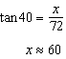

REF: 061516ia

5 ANS: 2
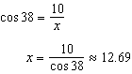

REF: 081126ia

6 ANS: 3 REF: 061514a2

7 ANS:
2.1. 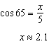

REF: 011133ia

8 ANS:
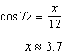

REF: 011531ia

9 ANS:
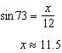

REF: 061632ia

10 ANS:
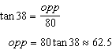

REF: 011436ia

11 ANS:
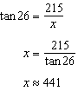

REF: 081434ia

12 ANS:
39, 63. 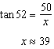. 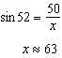

REF: 060937ia

13 ANS:
84, 71 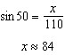 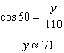

REF: 081039ia

14 ANS:
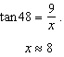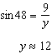

REF: 011338ia

15 ANS:
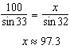. 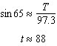 or 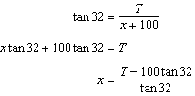 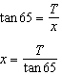 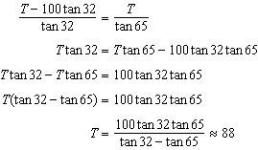

REF: 011236a2

