1 A wall is supported by a brace 10 feet long, as shown in the diagram below. If one end of the brace is placed 6 feet from the base of the wall, how many feet up the wall does the brace reach?

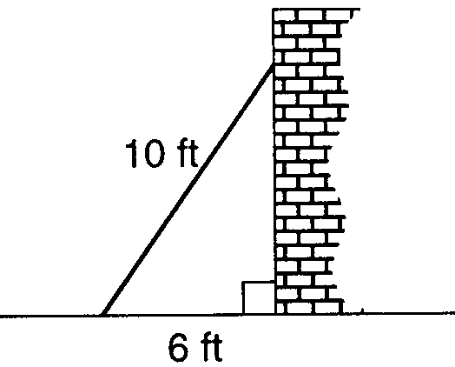

2 How many feet from the base of a house must a 39-foot ladder be placed so that the top of the ladder will reach a point on the house 36 feet from the ground?

3 An 18-foot ladder leans against the wall of a building. The base of the ladder is 9 feet from the building on level ground. How many feet up the wall, to the nearest tenth of a foot, is the top of the ladder?

4 The accompanying diagram shows a kite that has been secured to a stake in the ground with a 20-foot string. The kite is located 12 feet from the ground, directly over point X. What is the distance, in feet, between the stake and point X?

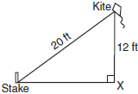

5 The "Little People" day care center has a rectangular, fenced play area behind its building. The play area is 30 meters long and 20 meters wide. Find, to the nearest meter, the length of a pathway that runs along the diagonal of the play area.

6 In the accompanying diagram of right triangles ABD and DBC, , , and . Find the length of , to the nearest tenth.

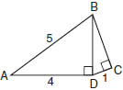

7 A 10-foot ladder is placed against the side of a building as shown in figure 1 below. The bottom of the ladder is 8 feet from the base of the building. In order to increase the reach of the ladder against the building, it is moved 4 feet closer to the base of the building as shown in figure 2.

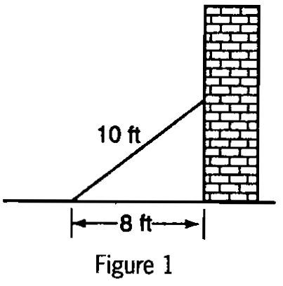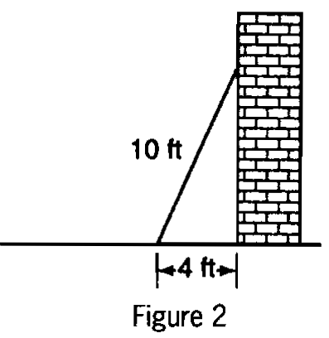

To the nearest foot, how much further up the building does the ladder now reach? Show how you arrived at your answer.
1 ANS:
8. 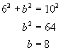 6, 8, 10 is a multiple of the 3, 4, 5 triangle.
REF: 010023a

2 ANS:
15. 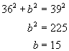. 15, 36, 39 is a multiple of the 5, 12, 13 triangle.
REF: 080122a

3 ANS:
15.6. 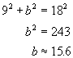
REF: 060832a

4 ANS:
16. 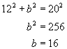. 12, 16, 20 is a multiple of the 3, 4, 5 triangle.
REF: 080531a

5 ANS:
36. 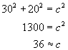
REF: 010933a

6 ANS:
2.8. 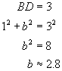
REF: 080633a

7 ANS:
3. Figure 1: . Figure 2: .
REF: spring9834a

