1 What is the value of x, in inches, in the right triangle below?

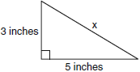
1)
2) | 8
3)
4) | 4

2 In the diagram below of , , , and .

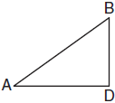

What is the length of ?
1)
2)
3)
4)

3 The end of a dog's leash is attached to the top of a 5-foot-tall fence post, as shown in the diagram below. The dog is 7 feet away from the base of the fence post.

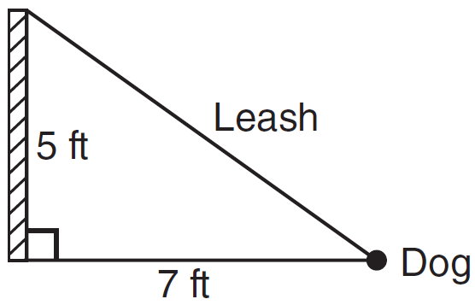

How long is the leash, to the nearest tenth of a foot?
1) | 4.9
2) | 8.6
3) | 9.0
4) | 12.0

4 Campsite A and campsite B are located directly opposite each other on the shores of Lake Omega, as shown in the diagram below. The two campsites form a right triangle with Sam’s position, S. The distance from campsite B to Sam’s position is 1,300 yards, and campsite A is 1,700 yards from his position.

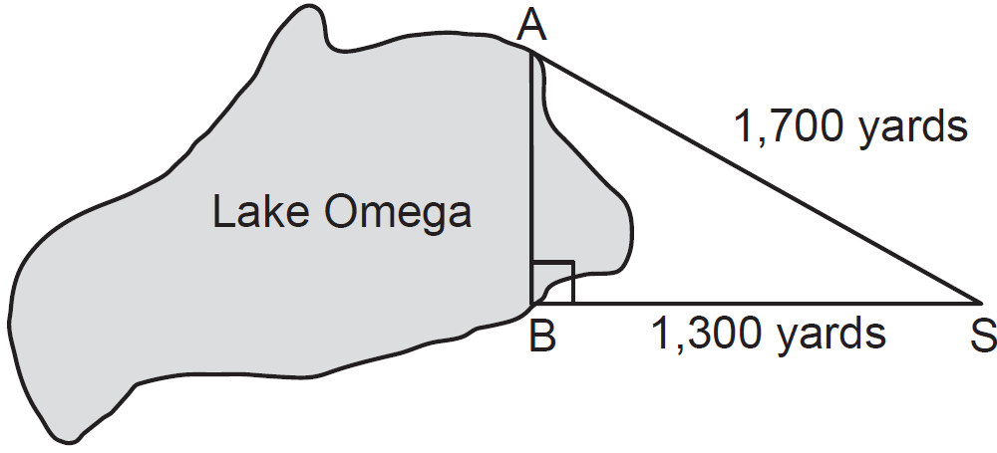

What is the distance from campsite A to campsite B, to the nearest yard?
1) | 1,095
2) | 1,096
3) | 2,140
4) | 2,141

5 The NuFone Communications Company must run a telephone line between two poles at opposite ends of a lake, as shown in the accompanying diagram. The length and width of the lake are 75 feet and 30 feet, respectively.

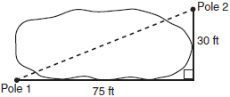

What is the distance between the two poles, to the nearest foot?
1) | 105
2) | 81
3) | 69
4) | 45

6 The diagram below shows a pennant in the shape of an isosceles triangle. The equal sides each measure 13, the altitude is , and the base is 2x.

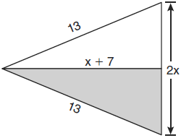

What is the length of the base?
1) | 5
2) | 10
3) | 12
4) | 24

7 The rectangle shown below has a diagonal of 18.4 cm and a width of 7 cm.

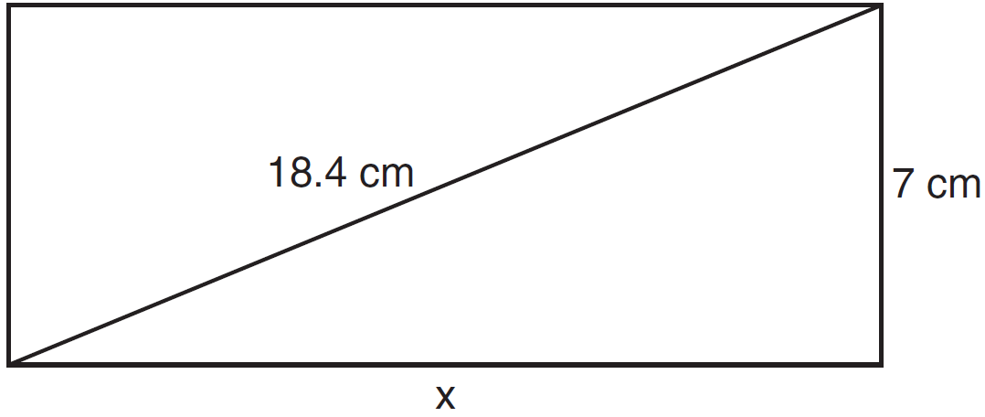

To the nearest centimeter, what is the length, x, of the rectangle?
1) | 11
2) | 17
3) | 20
4) | 25

8 Tanya runs diagonally across a rectangular field that has a length of 40 yards and a width of 30 yards, as shown in the diagram below.

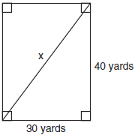

What is the length of the diagonal, in yards, that Tanya runs?
1) | 50
2) | 60
3) | 70
4) | 80

9 Nancy’s rectangular garden is represented in the diagram below.

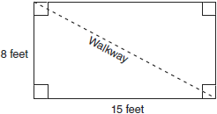

If a diagonal walkway crosses her garden, what is its length, in feet?
1) | 17
2) | 22
3)
4)

10 As shown in the diagram below, a kite needs a vertical and a horizontal support bar attached at opposite corners. The upper edges of the kite are 7 inches, the side edges are x inches, and the vertical support bar is inches.

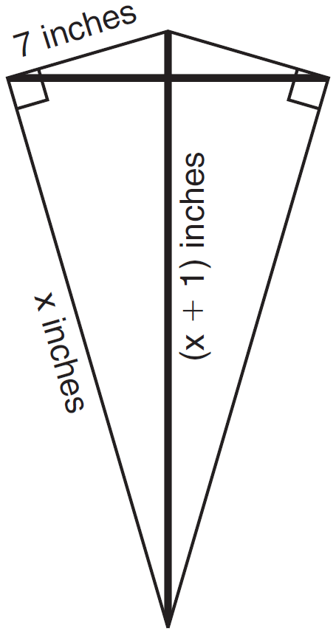

What is the measure, in inches, of the vertical support bar?
1) | 23
2) | 24
3) | 25
4) | 26

11 An overhead view of a revolving door is shown in the accompanying diagram. Each panel is 1.5 meters wide.

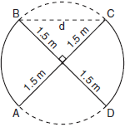

What is the approximate width of d, the opening from B to C?
1) | 1.50 m
2) | 1.73 m
3) | 3.00 m
4) | 2.12 m

12 Don placed a ladder against the side of his house as shown in the diagram below.

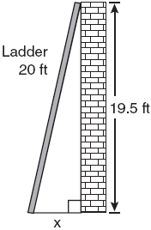

Which equation could be used to find the distance, x, from the foot of the ladder to the base of the house?
1)
2)
3)
4)

1 ANS: 3
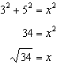

REF: 060909ia

2 ANS: 1
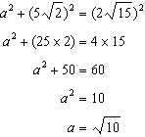

REF: 011016ge

3 ANS: 2

REF: 081004ia

4 ANS: 1

REF: 011221ia

5 ANS: 2
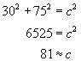

REF: 010508a

6 ANS: 2
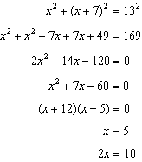

REF: 061024ge

7 ANS: 2

REF: 011107ia

8 ANS: 1
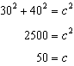. 30, 40, 50 is a multiple of 3, 4, 5.

REF: fall0711ia

9 ANS: 1
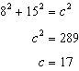

REF: 080906ia

10 ANS: 3
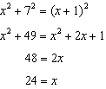

REF: 081127ge

11 ANS: 4
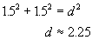

REF: 010403b

12 ANS: 3 REF: 060825ia

