1 In right triangle ABC below, , , and .

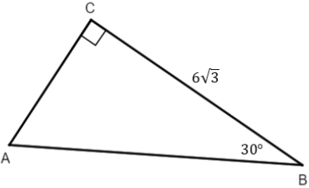

The length of is
1)
2) | 9
3) | 12
4)

2 In a right triangle where one of the angles measures 30º, what is the ratio of the length of the side opposite the 30º angle to the length of the side opposite the 90º angle?
1)
2)
3)
4)

3 The accompanying diagram shows two cables of equal length supporting a pole. Both cables are 14 meters long, and they are anchored to points in the ground that are 14 meters apart.

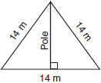

What is the exact height of the pole, in meters?
1) | 7
2)
3)
4) | 14

4 What is the length of the altitude of an equilateral triangle whose side has a length of 8?
1) | 32
2)
3)
4) | 4

5 An equilateral triangle has sides of length 20. To the nearest tenth, what is the height of the equilateral triangle?
1) | 10.0
2) | 11.5
3) | 17.3
4) | 23.1

6 What is the perimeter of an equilateral triangle whose height is ?
1) | 6
2) | 12
3)
4)

7 If the perimeter of an equilateral triangle is 18, the length of the altitude of this triangle is
1) | 6
2)
3) | 3
4)

8 The diagram shows rectangle ABCD, with diagonal .

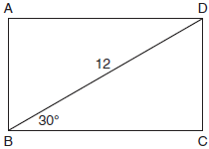

What is the perimeter of rectangle ABCD, to the nearest tenth?
1) | 28.4
2) | 32.8
3) | 48.0
4) | 62.4

9 The accompanying diagram shows a revolving door with three panels, each of which is 4 feet long. What is the width, w, of the opening between x and y, to the nearest tenth of a foot?

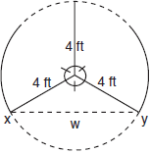
1 ANS: 3
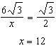

REF: spr2402geo

2 ANS: 2 REF: 011019b

3 ANS: 3
The altitude of an equilateral triangle is also a median. Therefore the distance from the pole to the anchor points in the ground is 7. Since each angle of an equilateral triangle is 60º, each of the smaller triangles is a 30-60-90 triangle. Since the hypotenuse is 14, the length of the pole is .

REF: 080504b

4 ANS: 3
The altitude of an equilateral triangle is also a median, and creates a 30-60-90 triangle. If the hypotenuse is 8, the altitude is .

REF: 080914b

5 ANS: 3

REF: 081608geo

6 ANS: 2
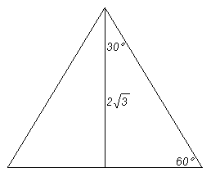An equilateral triangle bisected by an altitude (its height) creates two 30°-60°-90° triangles. In a 30°-60°-90° triangle, the longer leg and the hypotenuse are in the ratio Applying this ratio to the triangle, 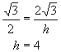. If one side of a triangle is 4, the perimeter is 12. Alternatively, 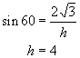

REF: 089920a

7 ANS: 4
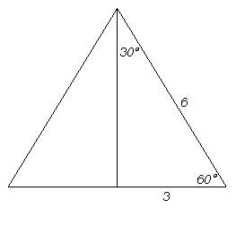 An equilateral triangle bisected by an altitude creates two 30°-60°-90° triangles. In a 30°-60°-90° triangle, the longer leg and the hypotenuse are in the ratio Applying this ratio to the triangle, 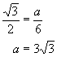. Alternatively, 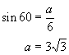. Alternatively, 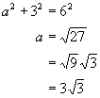

REF: 080613b

8 ANS: 2

REF: 011709geo

9 ANS:
If the center of the circle is labeled O, because the circle is divided into three equal parts. An altitude drawn from O to drawn creates a 30-60-90 triangle. Since the hypotenuse is 4, the longer leg is . Therefore

REF: 010722b

