1 If , then is equal to
1) | 6
2) | 36
3) | 45
4)

2 If , then is
1)
2) | 5
3) | 18
4) | 36

3 If , the number of degrees in the measure of angle is
1) | 30
2) | 60
3) | 90
4) | 120

4 Which is a value of x if ?
1) | 10º
2) | 20º
3) | 50º
4) | 60º

5 If , a measure of angle x is
1) | 15º
2) | 30º
3) | 45º
4) | 60º

6 If , the value of x is
1) | 35º
2) | 45º
3) | 55º
4) | 70º

7 If , then the value of x is
1)
2) | 17
3) | 35
4) | 71

8 If , then the value of x is
1)
2) | 26
3) | 29
4) | 64

9 Which value of x satisfies the equation ?
1) | 30
2) | 24
3) | 12
4) | 4

10 If , find the number of degrees in the measure of acute angle x.

11 If 3x is the measure of a positive acute angle and , find the value of x.

12 If x is a positive acute angle and , find the value of x.

13 If , find the value of x.

14 If , find x.

15 Find the value of acute angle A if 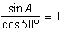.
1 ANS: 1
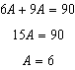. As originally written, distractor (3) was , also a correct response.

REF: 010320b

2 ANS: 3
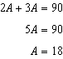

REF: 069621siii

3 ANS: 2
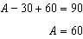

REF: 068025siii

4 ANS: 2
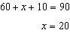

REF: 068717siii

5 ANS: 2
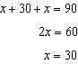

REF: 088622siii

6 ANS: 1
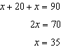

REF: 019729siii

7 ANS: 2
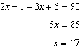

REF: 089633siii

8 ANS: 3
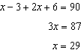

REF: 069825siii

9 ANS: 3
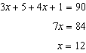
REF: 019428siii

10 ANS:
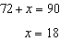
REF: 089704siii

11 ANS:
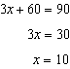
REF: 010404siii

12 ANS:
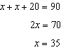
REF: 088415siii

13 ANS:
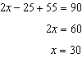
REF: 069912siii

14 ANS:
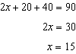
REF: 060310siii

15 ANS:
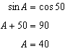
REF: 018712siii

