1 In below, the measure of , , , and .

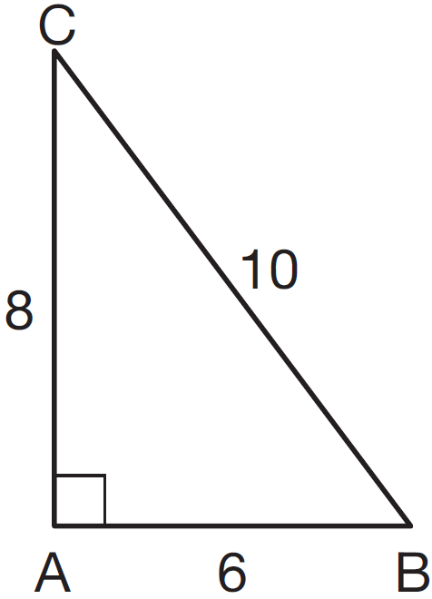

Which ratio represents the sine of ?
1)
2)
3)
4)

2 The diagram below shows right triangle UPC.

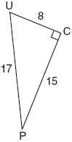

Which ratio represents the sine of ?
1)
2)
3)
4)

3 Which ratio represents in the right triangle shown below?

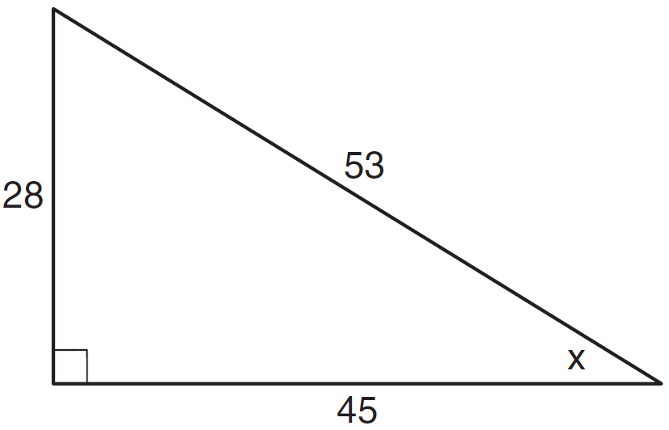
1)
2)
3)
4)

4 Which ratio represents the cosine of angle A in the right triangle below?

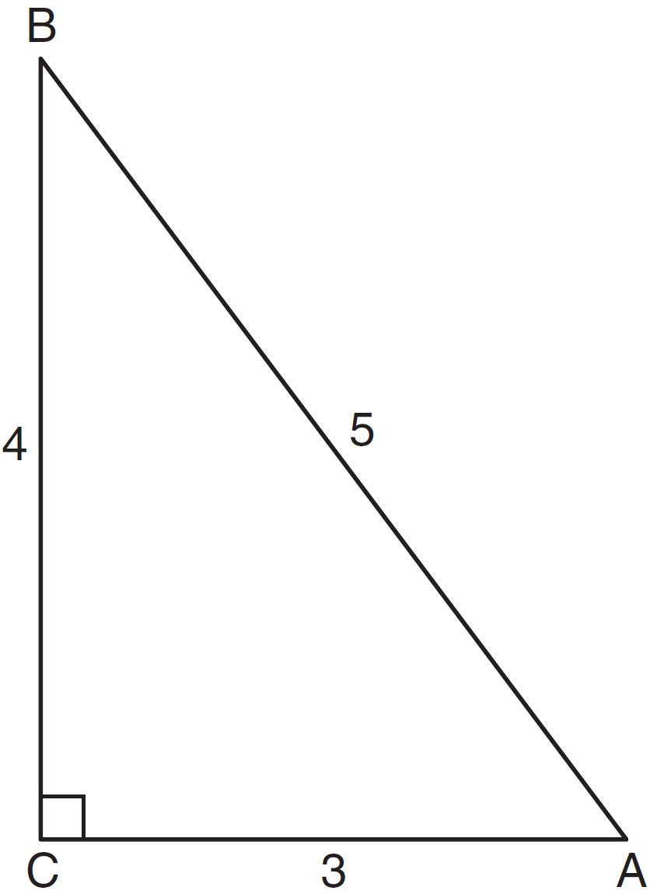
1)
2)
3)
4)

5 Which ratio represents in the accompanying diagram of ?

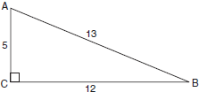
1)
2)
3)
4)

6 In right triangle shown below, what is the value of ?

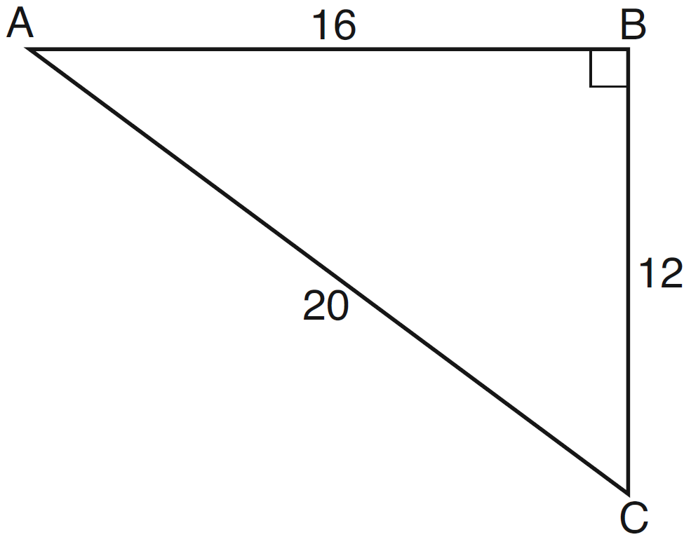
1)
2)
3)
4)

7 In right triangle LMN shown below, , , and .

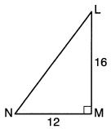
The ratio of is
1)
2)
3)
4)

8 In the accompanying diagram of right triangle ABC, , , , and .

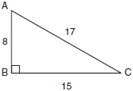

What is ?
1)
2)
3)
4)

9 The diagram below shows right triangle ABC.

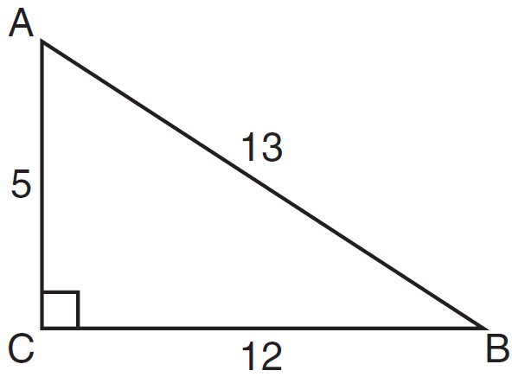

Which ratio represents the tangent of ?
1)
2)
3)
4)

10 The diagram below shows right triangle LMP.

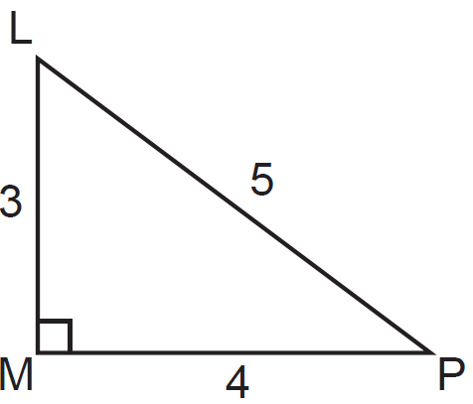

Which ratio represents the tangent of ?
1)
2)
3)
4)

11 Which equation shows a correct trigonometric ratio for angle A in the right triangle below?

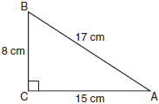
1) | 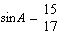
2) | 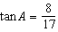
3) | 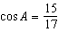
4) | 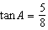

12 In the diagram below of right triangle ABC, , and .

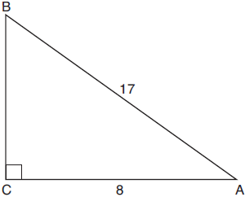

Which equation would determine the value of angle A?
1) | 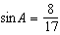
2) | 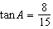
3)
4) | 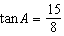

13 Right triangle ABC has legs of 8 and 15 and a hypotenuse of 17, as shown in the diagram below.

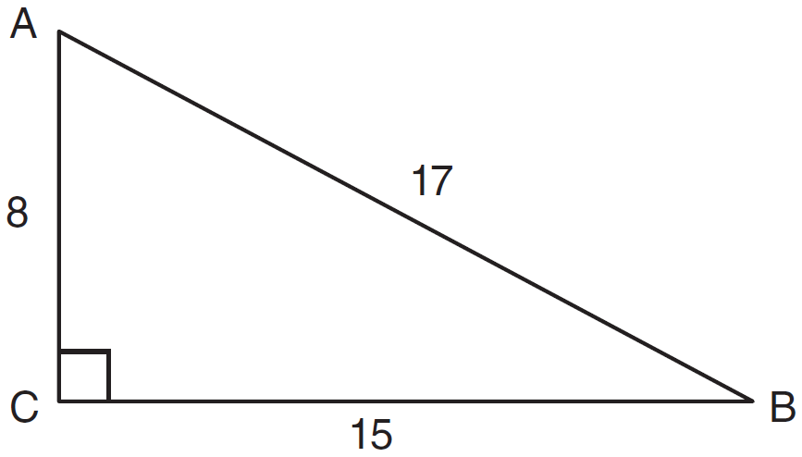

The value of the tangent of is
1) | 0.4706
2) | 0.5333
3) | 0.8824
4) | 1.8750

14 In triangle MCT, the measure of , , , and . Which ratio represents the sine of ?
1)
2)
3)
4)

15 In , the measure of , , and . Which ratio represents the tangent of ?
1)
2)
3)
4)

16 In right triangle ABC shown below, , , and .

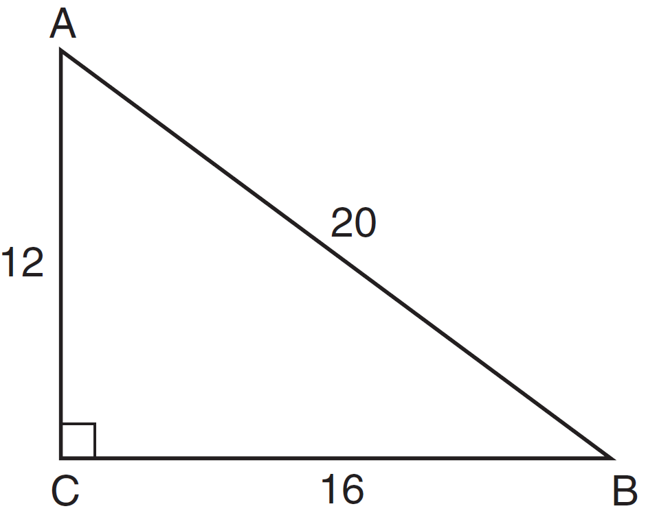

Which equation is not correct?
1) | 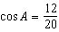
2) | 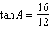
3) | 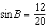
4) | 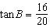

17 In right triangle JKL in the diagram below, , , , and .

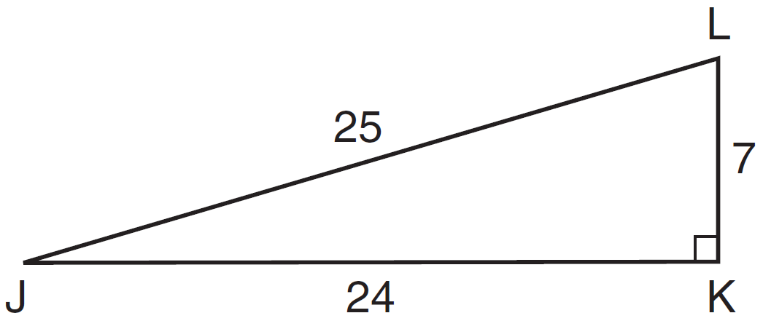

Which statement is not true?
1) | 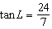
2) | 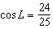
3) | 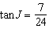
4) | 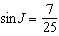

18 In , . If and , which statement is not true?
1) | 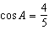
2) | 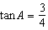
3) | 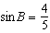
4) | 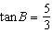

19 In the diagram of right triangle ADE below, .

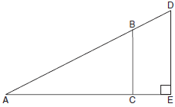

Which ratio is always equivalent to the sine of ?
1)
2)
3)
4)

20 In the diagram below, is the image of after a dilation of centered at C.

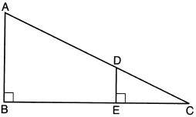

Which statement is always true?
1) | 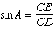
2) | 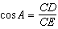
3) | 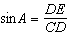
4) | 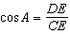

21 In the diagram below, .

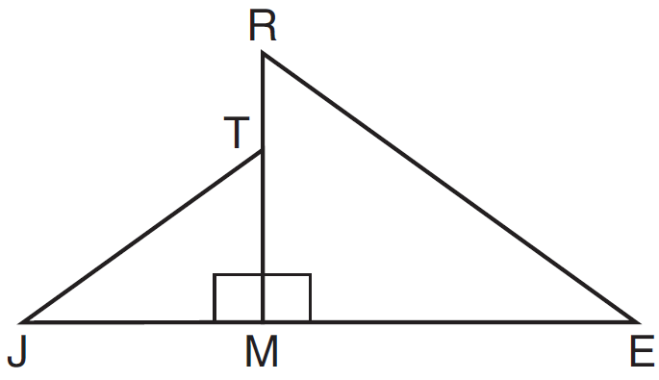

Which statement is always true?
1) | 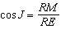
2) | 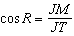
3) | 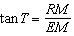
4) | 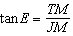

22 In the diagram below of right triangle ABC, altitude is drawn.

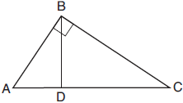

Which ratio is always equivalent to ?
1)
2)
3)
4)

1 ANS: 4
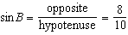

REF: 011518ia

2 ANS: 2
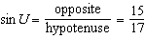

REF: 010919ia

3 ANS: 1
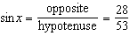

REF: 011109ia

4 ANS: 1
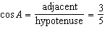

REF: 081329ia

5 ANS: 1
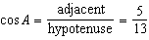

REF: 080414a

6 ANS: 2
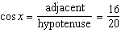

REF: 011307ia

7 ANS: 1
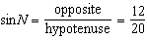

REF: 012307geo

8 ANS: 1
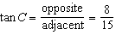

REF: 010316a

9 ANS: 2
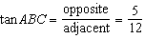

REF: 081112ia

10 ANS: 3
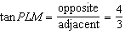

REF: 011226ia

11 ANS: 3
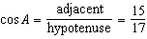

REF: 011008ia

12 ANS: 4
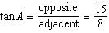

REF: 011917geo

13 ANS: 2
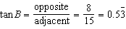

REF: 081026ia

14 ANS: 1
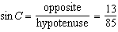
REF: fall0721ia

15 ANS: 2
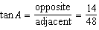
REF: 061009ia

16 ANS: 4 REF: 061417ia

17 ANS: 2 REF: 081418ia

18 ANS: 4
If , then is the hypotenuse, and the triangle is a 3-4-5 triangle.
REF: 061224ia

19 ANS: 3 REF: 011714geo

20 ANS: 1
A dilation preserves angle measure, so .
REF: 062203geo

21 ANS: 4 REF: 061615geo

22 ANS: 2
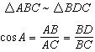
REF: 012023geo

