1 Given: and intersect at point C
and are drawn
Prove:

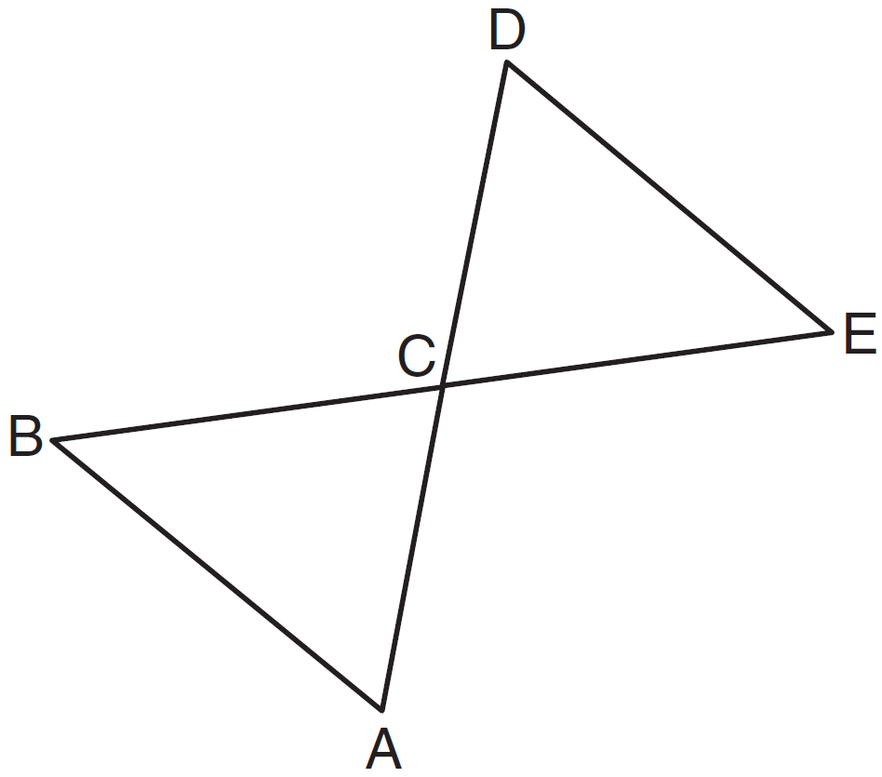

2 In the diagram below, .

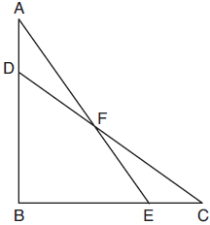

Prove:

3 Given: and , , , ,

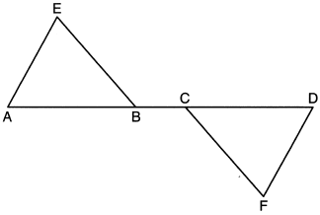

Prove:

4 Given: , , , , , and

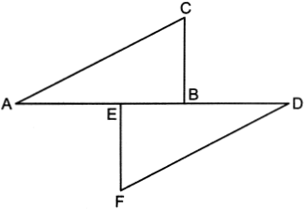

Prove:

5 In the diagram of below, and medians and are drawn.
Prove:

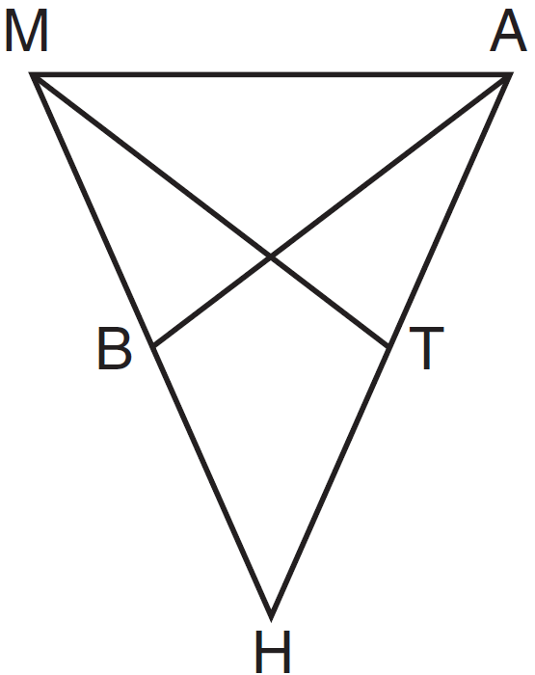

6 Complete the partial proof below for the accompanying diagram by providing reasons for steps 3, 6, 8, and 9.

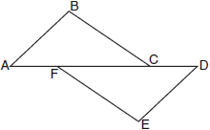

Given: , , , ,
Prove:

Statements | Reasons
1 | 1 Given
2 , | 2 Given
3 and are right angles. | 3
4 | 4 All right angles are congruent.
5 | 5 Given
6 | 6
7 | 7 Given
8 | 8
9 | 9

7 Given: , , with , and
Prove: is the perpendicular bisector of

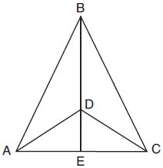

Fill in the missing statement and reasons below.

Statements | Reasons
1 , , with , and | 1 Given
2 | 2
3 and are supplementary. and are supplementary. | 3 Linear pairs of angles are supplementary.
4 | 4 Supplements of congruent angles are congruent.
5 | 5 ASA
6 , | 6
7 is the perpendicular bisector of . | 7

8 Given: , bisects ,
Prove:

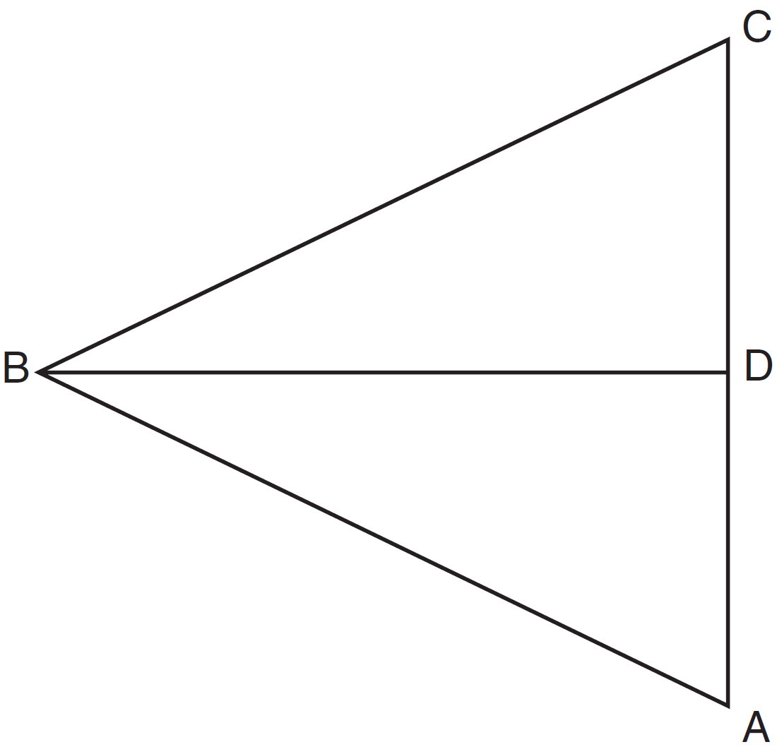

9 Given: bisects at E.
Prove:

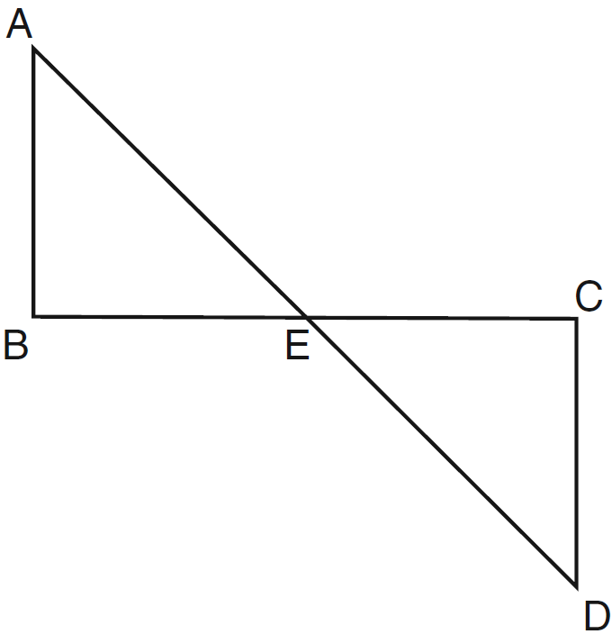

10 Given: and , C is the midpoint of and
Prove:

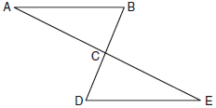

11 Given: and bisect each other at point X
and are drawn

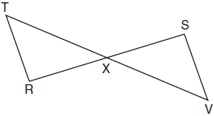

Prove:

12 Given: and intersect at B, , and bisects .

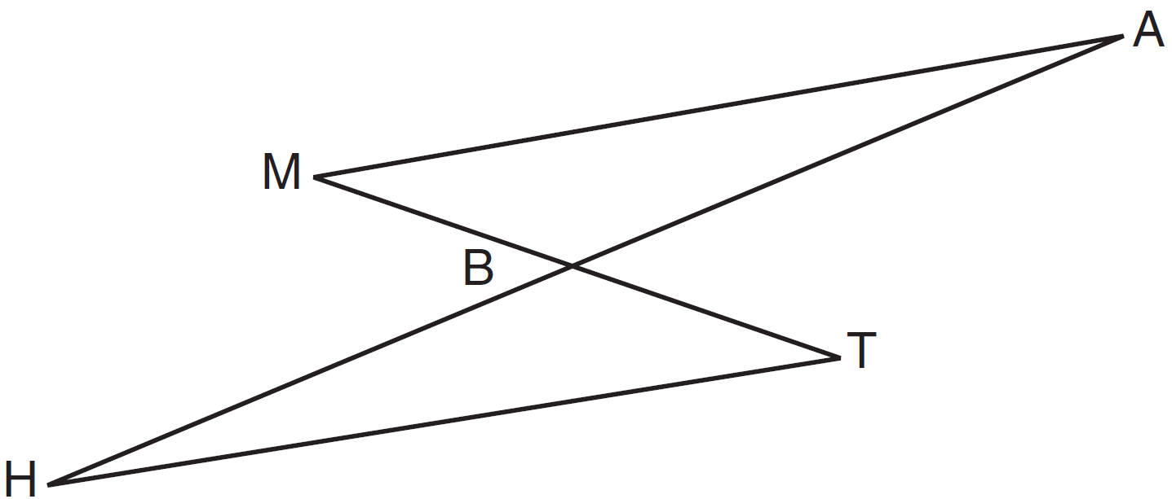

Prove:
1 ANS:
and intersect at point C, , , and are drawn (Given). (Vertical Angles). (SAS).

REF: 011529ge

2 ANS:
(given); (CPCTC); (vertical angles are congruent); , (CPCTC); (segment subtraction); (AAS)

REF: 081933geo

3 ANS:
and , , , , (given); (Alternate interior angles formed by parallel lines and a transversal are congruent); (Alternate exterior angles formed by parallel lines and a transversal are congruent); (reflexive); (segment subtraction); (ASA)

REF: 012333geo

4 ANS:
, , , , , and (Given); (Perpendicular lines form congruent angles); (Parallel lines cut by a transversal form congruent alternate interior angles); (Symmetric Property); 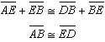 (Segment Addition); (ASA)

REF: 062433geo

5 ANS:
, and medians and are given. (reflexive property). is an isosceles triangle (definition of isosceles triangle). (isosceles triangle theorem). B is the midpoint of and T is the midpoint of (definition of median). 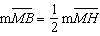 and 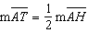 (definition of midpoint). (multiplication postulate). (SAS). (CPCTC).

REF: 061338ge

6 ANS:
3 Perpendicular line segments form right angles; 6 If two parallel lines are cut by a transversal, the alternate interior angles are congruent; 8 AAS; 9 CPCTC. 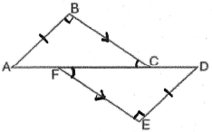

REF: 060229b

7 ANS:
2 Reflexive; 4 ; 6 CPCTC; 7 If points B and D are equidistant from the endpoints of , then B and D are on the perpendicular bisector of .

REF: 081832geo

8 ANS:
, bisects , (Given). (Definition of angle bisector). (Reflexive property). and are right angles (Definition of perpendicular). (All right angles are congruent). (SAS). (CPCTC).

REF: 081335ge

9 ANS:
and are right angles because perpendicular lines form right angles. because all right angles are congruent. because vertical angles are congruent. because of ASA. because CPCTC.

REF: 061235ge

10 ANS:
and because of the definition of midpoint. because of vertical angles. because of SAS. because of CPCTC. is a transversal intersecting and . Therefore because and are congruent alternate interior angles. 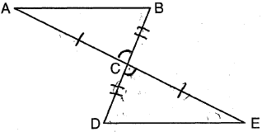

REF: 060938ge

11 ANS:
and bisect each other at point X; and are drawn (given); and (segment bisectors create two congruent segments); (vertical angles are congruent); (SAS); (CPCTC); (a transversal that creates congruent alternate interior angles cuts parallel lines).

REF: 061733geo

12 ANS:
and intersect at B, , and bisects (Given). (Vertical Angles). (Alternate Interior Angles). (The bisection of a line segment creates two congruent segments). (ASA). (CPCTC).

REF: 081435ge

