1 In the diagram below, .

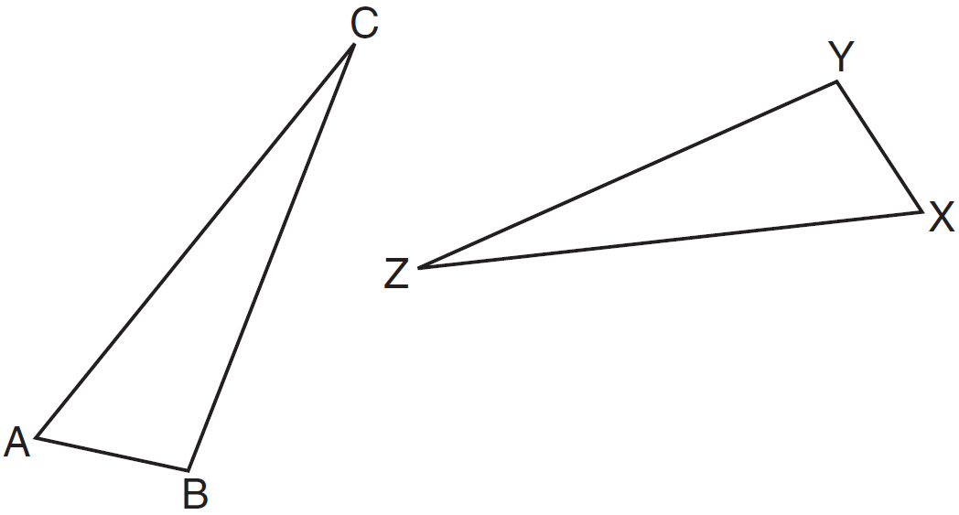

Which statement must be true?
1)
2)
3)
4)

2 In the diagram below, .

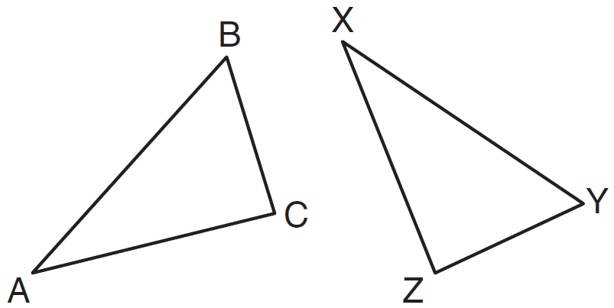

Which two statements identify corresponding congruent parts for these triangles?
1)
2)
3)
4)

3 The diagram below shows a pair of congruent triangles, with and .

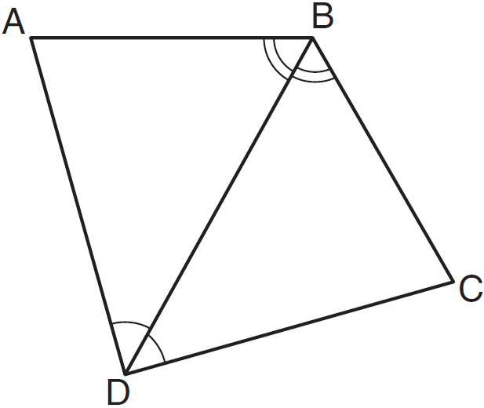

Which statement must be true?
1)
2)
3)
4)

4 In the diagram below of quadrilateral ADBE, is the perpendicular bisector of .

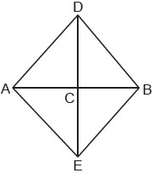

Which statement is always true?
1)
2)
3)
4)

5 In the diagram of trapezoid ABCD below, diagonals and intersect at E and .

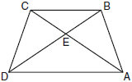

Which statement is true based on the given information?
1)
2)
3)
4)

6 In shown below with , , , and , .

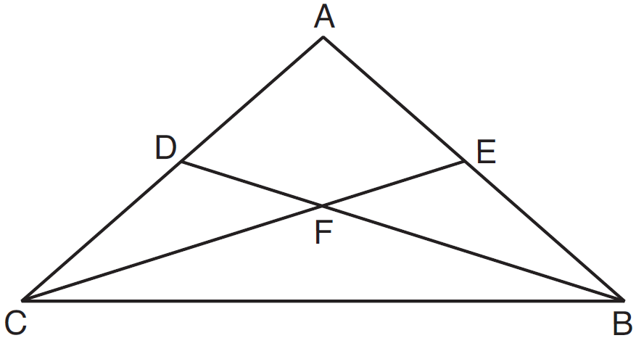

Which statement must be true?
1)
2)
3)
4)

7 In the diagram below, .

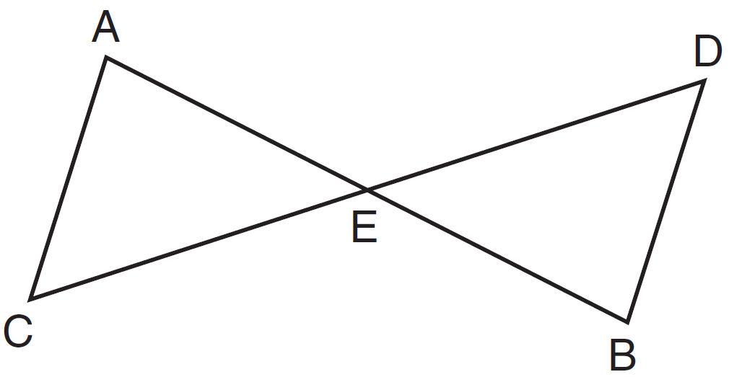

Which statement is not always true?
1)
2)
3)
4)

8 In the diagram below, .

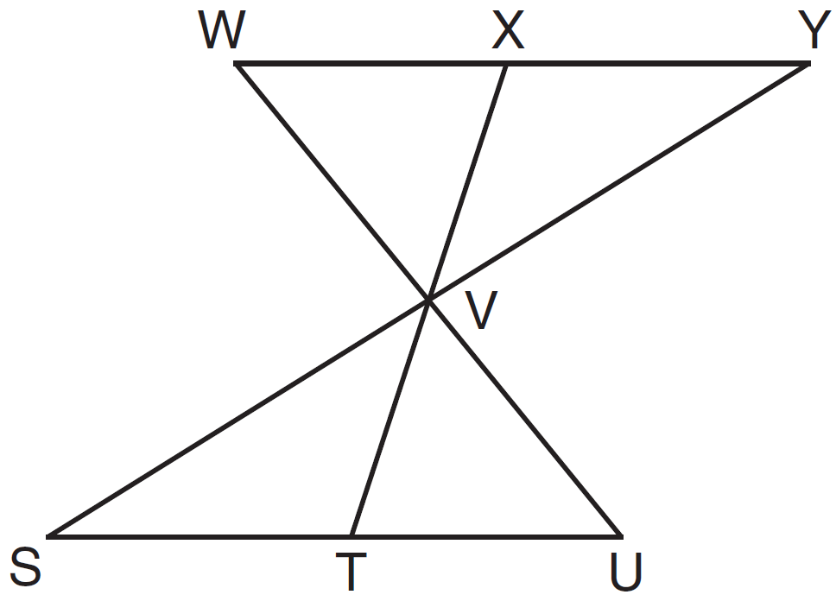

Which statement can not be proven?
1)
2)
3)
4)

9 Triangle HUS is shown below.

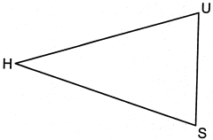

If point G is located on and is drawn, which additional information is sufficient to prove by SAS?
1) | bisects
2) | is an altitude
3) | bisects
4) | is the perpendicular bisector of

10 If , which statement is always true?
1)
2)
3)
4)

11 If and is the shortest side of , what is the shortest side of ?
1)
2)
3)
4)

12 If , then must be congruent to
1)
2)
3)
4)

13 Which statement is not always true when .
1)
2)
3)
4)

14 Given , which statement is not always true?
1)
2)
3) | area of area of
4) | perimeter of perimeter of

15 Given the information marked on the diagrams below, which pair of triangles can not always be proven congruent?
1) | 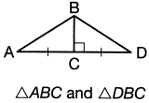
2) | 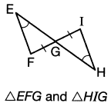
3) | 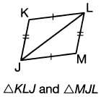
4) | 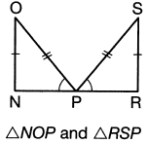

16 Skye says that the two triangles below are congruent. Margaret says that the two triangles are similar.

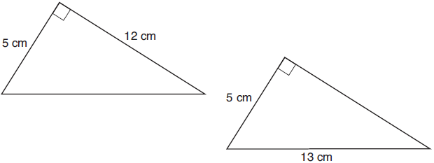

Are Skye and Margaret both correct? Explain why.
1 ANS: 2 REF: 081102ge

2 ANS: 4
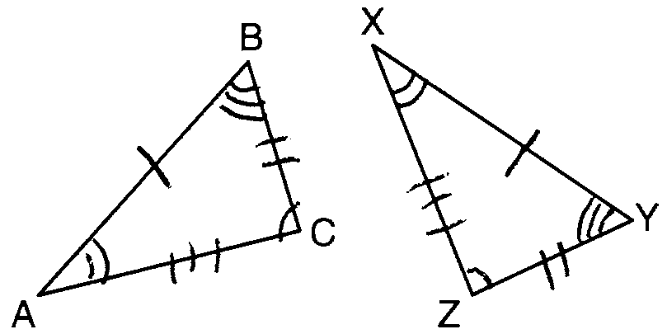

REF: 081001ge

3 ANS: 4 REF: 011216ge

4 ANS: 1
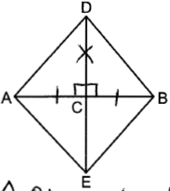 by SAS

REF: 082316geo

5 ANS: 4 REF: 080905ge

6 ANS: 4 REF: 081501ge

7 ANS: 4 REF: 061410ge

8 ANS: 2
(1) is true because of vertical angles. (3) and (4) are true because CPCTC.

REF: 061302ge

9 ANS: 4 REF: 082410geo

10 ANS: 3 REF: 061102ge

11 ANS: 1 REF: 011301ge

12 ANS: 3 REF: 081309ge

13 ANS: 2 REF: 011624ge

14 ANS: 1 REF: 011703geo

15 ANS: 4
1) SAS; 2) AAS; 3) SSS

REF: 062216geo

16 ANS:
Yes. The triangles are congruent because of SSS . All congruent triangles are similar.

REF: 061830geo

