1 In the diagram below, .

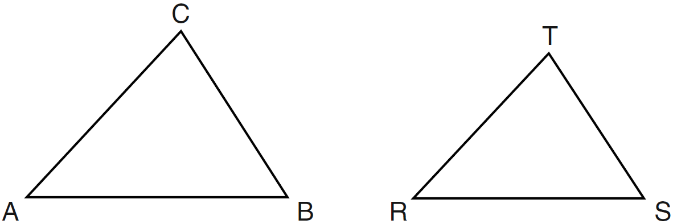

Which statement is not true?
1)
2) | 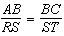
3) | 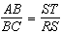
4) | 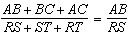

2 Scalene triangle ABC is similar to triangle DEF. Which statement is false?
1)
2)
3)
4)

3 The accompanying diagram shows two similar triangles.

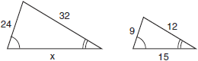

Which proportion could be used to solve for x?
1) | 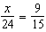
2) | 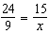
3) | 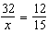
4) | 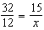

4 If , , and , what is ?
1) | 30
2) | 50
3) | 80
4) | 100

5 As shown in the diagram below, , , , , and .

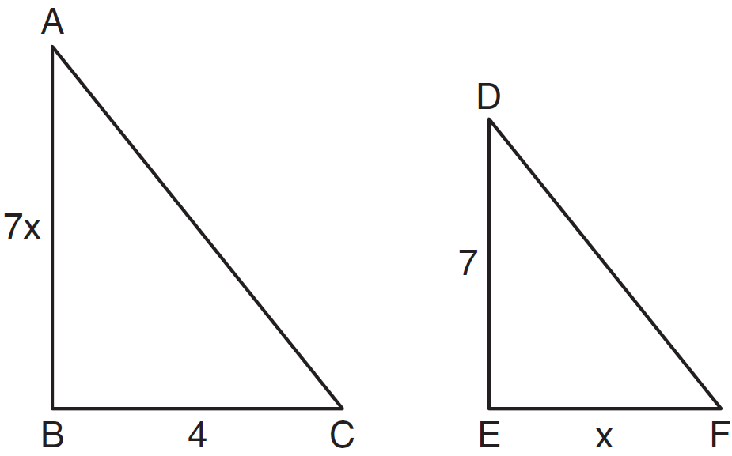

What is the length of ?
1) | 28
2) | 2
3) | 14
4) | 4

6 A triangle has sides whose lengths are 5, 12, and 13. A similar triangle could have sides with lengths of
1) | 3, 4, and 5
2) | 6, 8, and 10
3) | 7, 24, and 25
4) | 10, 24, and 26

7 In the diagram below, , , and . Determine the value of x.

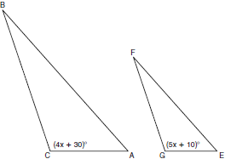

8 If , , , and , find . [Only an algebraic solution can receive full credit.]

9 In the diagram below, , , , , and . Determine the length of . [Only an algebraic solution can receive full credit.]

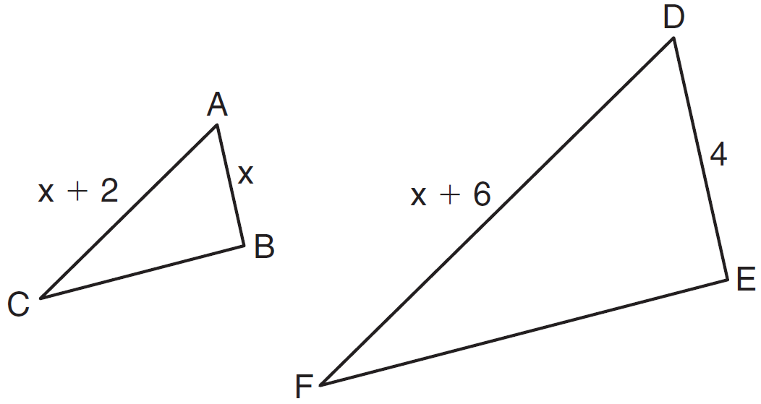

10 In the accompanying diagram, is similar to , , , , and . What is the length of ?

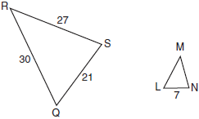

11 In the accompanying diagram, triangle A is similar to triangle B. Find the value of n.

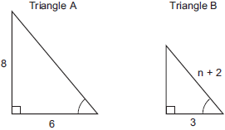

12 The sides of a triangle measure 7, 4, and 9. If the longest side of a similar triangle measures 36, determine and state the length of the shortest side of this triangle.

13 The Rivera family bought a new tent for camping. Their old tent had equal sides of 10 feet and a floor width of 15 feet, as shown in the accompanying diagram.

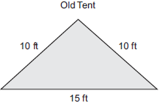

If the new tent is similar in shape to the old tent and has equal sides of 16 feet, how wide is the floor of the new tent?

14 The accompanying diagram shows a section of the city of Tacoma. High Road, State Street, and Main Street are parallel and 5 miles apart. Ridge Road is perpendicular to the three parallel streets. The distance between the intersection of Ridge Road and State Street and where the railroad tracks cross State Street is 12 miles. What is the distance between the intersection of Ridge Road and Main Street and where the railroad tracks cross Main Street?

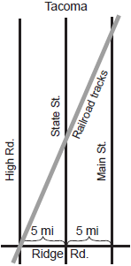

1 ANS: 3 REF: 061224ge

2 ANS: 4 REF: 081216ge

3 ANS: 3 REF: 010410a

4 ANS: 4

REF: 081006ge

5 ANS: 3
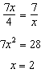.

REF: 061120ge

6 ANS: 4 REF: 060307a

7 ANS:
20. 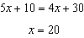

REF: 060934ge

8 ANS:
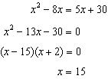.

REF: 061337ge

9 ANS:
2 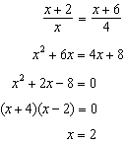

REF: 081137ge

10 ANS:
10. 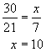

REF: 010931a

11 ANS:
3. Triangle A is a multiple of the 3, 4, 5 triangle. Triangle B is the 3, 4, 5 triangle. 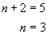

REF: 060230a

12 ANS:
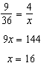

REF: 011629ge

13 ANS:
24. 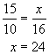

REF: 060024a

14 ANS:
24.

REF: 080021a

