1 Triangle is similar to triangle . Which statement is not always true?
1)
2)
3)
4)

2 In the diagram below, and intersect at E, and and are drawn.

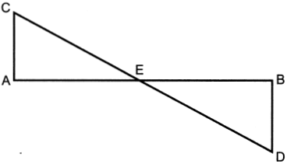

If , which statement is always true?
1)
2)
3)
4)

3 Given right triangle ABC with a right angle at C, . Given right triangle RST with a right angle at T, .

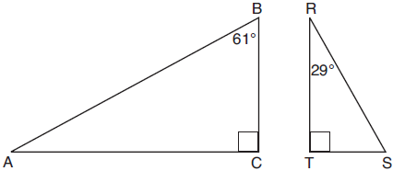

Which proportion in relation to and is not correct?
1) | 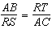
2) | 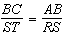
3) | 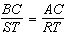
4) | 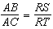

4 As shown in the diagram below, and intersect at E, and .

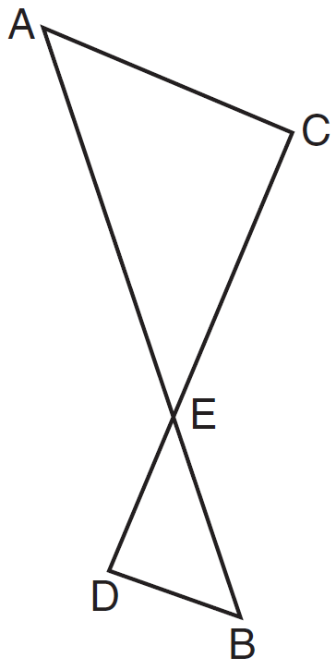

Given , which equation is true?
1) | 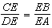
2) | 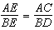
3) | 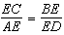
4) | 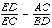

5 In the diagram below of isosceles triangle AHE with the vertex angle at H, and .

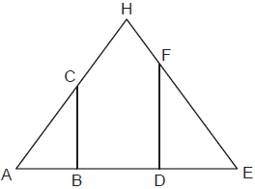

Which statement is always true?
1) | 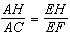
2) | 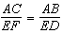
3) | 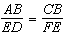
4) | 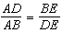

6 In the diagram below of , X and Y are points on and , respectively, such that .

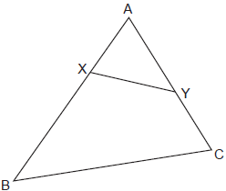

Which statement is not always true?
1) | 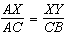
2) | 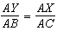
3)
4)

7 In the diagram below, and intersect at Z. Segments XY and RS are drawn perpendicular to to form triangles XYZ and SRZ.

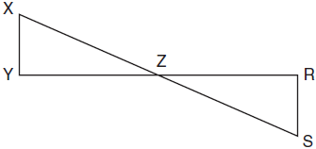

Which statement is always true?
1)
2)
3)
4) | 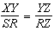

8 Triangles ABC and DEF are drawn below.

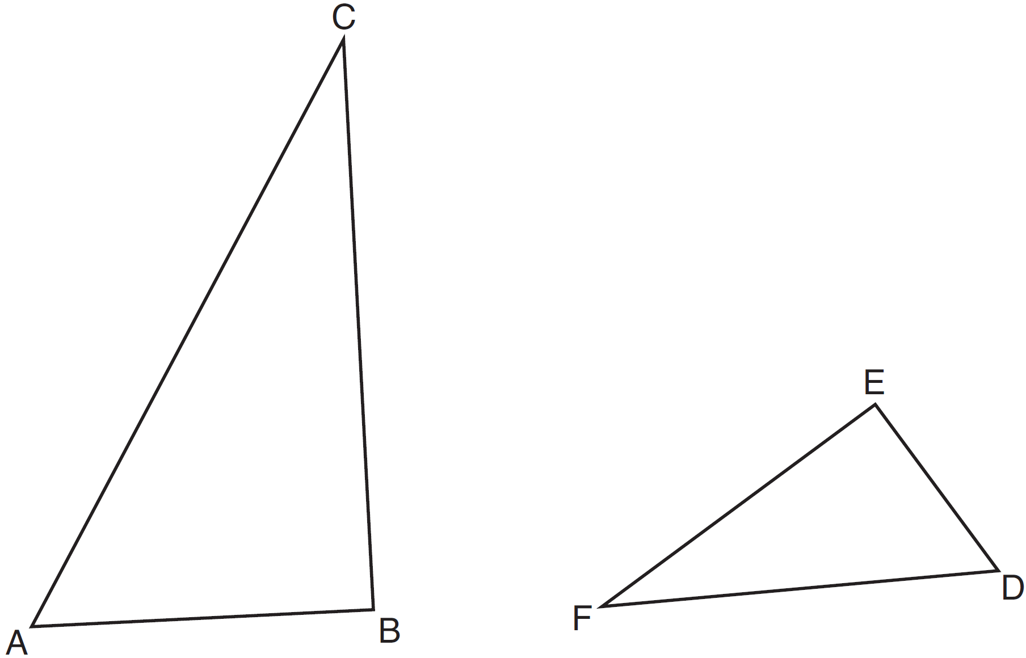

If , , 6, , and , which statement is true?
1)
2) | 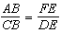
3)
4) | 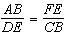

9 In the diagram below, .

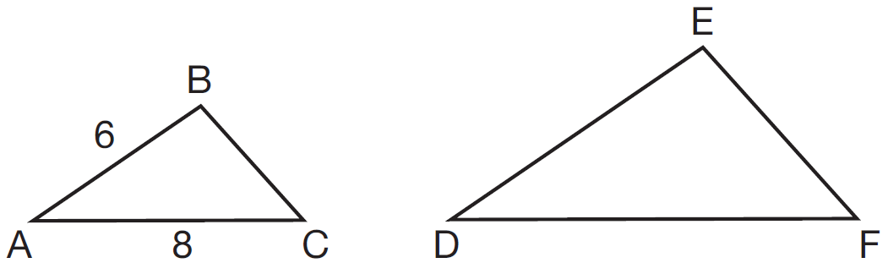

If and , which statement will justify similarity by SAS?
1) | , , and
2) | , , and
3) | , , and
4) | , , and

10 In the diagram below, and .

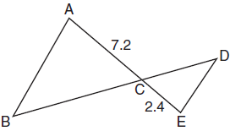

Which statement is not sufficient to prove ?
1)
2) | and
3) | and
4) | , , , and

11 Using the information given below, which set of triangles can not be proven similar?
1) | 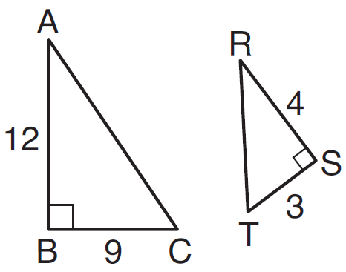
2) | 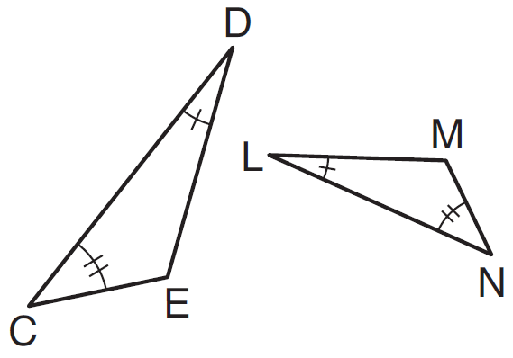
3) | 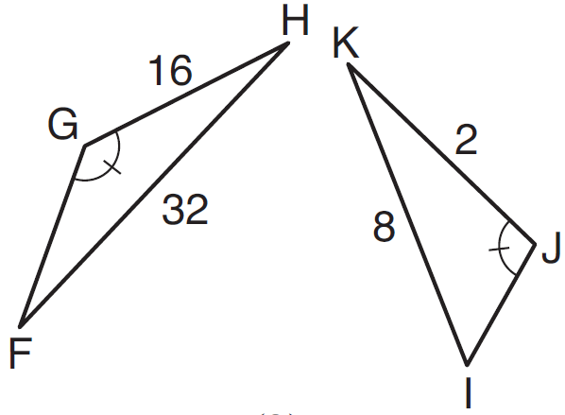
4) | 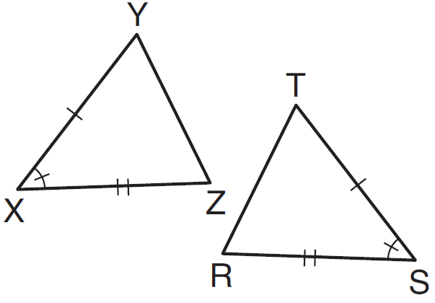

12 In the diagram below, intersects at C, and .

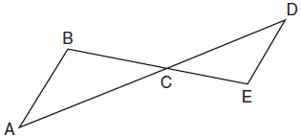

If cm, cm, cm, and cm, what is the length of , to the nearest hundredth of a centimeter?
1) | 2.70
2) | 3.34
3) | 5.28
4) | 8.25

13 In the diagram below, intersects at J, , and .
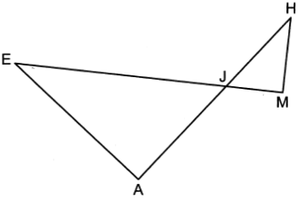
If , , , and , what is the length of , to the nearest hundredth?
1) | 2.47
2) | 2.63
3) | 4.11
4) | 4.39

14 In shown below, points T and O are on and , respectively. Segment OT is drawn so that .
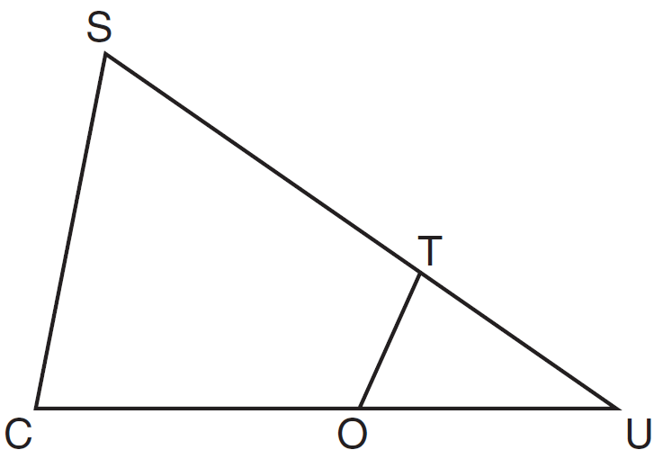
If , , and , what is the length of ?
1) | 5.6
2) | 8.75
3) | 11
4) | 15

15 In triangle CHR, O is on , and D is on so that .

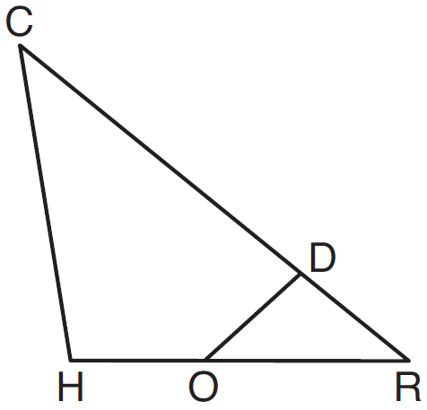

If , , and , what is the length of ?
1)
2)
3) | 11
4) | 15

16 In shown below, is a right angle, E is a point on , and is drawn perpendicular to hypotenuse .

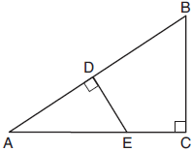

If , , and , what is the length of ?
1) | 5
2) | 6
3) | 7
4) | 8

17 In the diagram below, , and intersect at C, and and are drawn such that , , , , and .

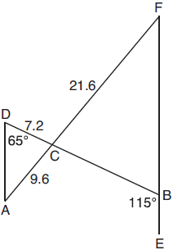

What is the length of ?
1) | 3.2
2) | 4.8
3) | 16.2
4) | 19.2

18 In the diagram below, , , , , and .
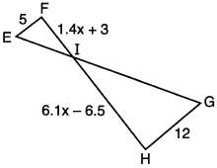
What is the length of ?
1) | 1
2) | 5
3) | 10
4) | 24

19 The ratio of similarity of to is . If and , then the length of is
1) | 5
2) | 7
3) | 10
4) | 20

20 Triangles RST and XYZ are drawn below. If , , , , and , is similar to ? Justify your answer.
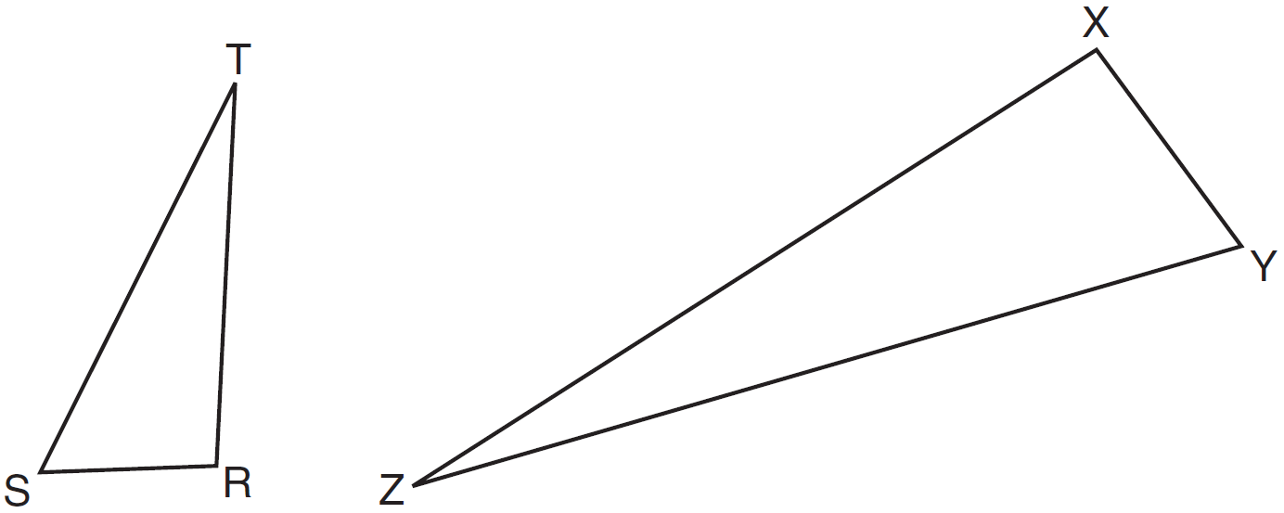

21 In below, is drawn such that , , , and .

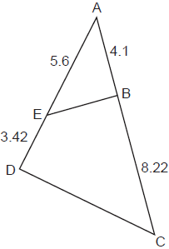

Is similar to ? Explain why.

22 In the diagram below, .

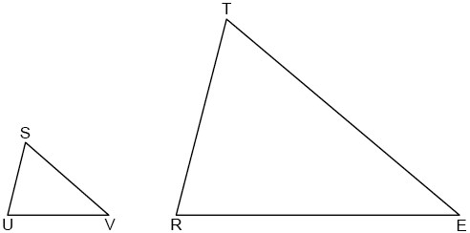

If , , , and , determine and state the length of .

23 In the diagram below, .

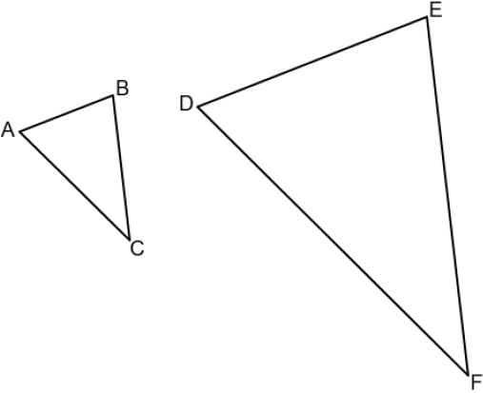

If , , , and , determine and state the length of .

24 To find the distance across a pond from point B to point C, a surveyor drew the diagram below. The measurements he made are indicated on his diagram.

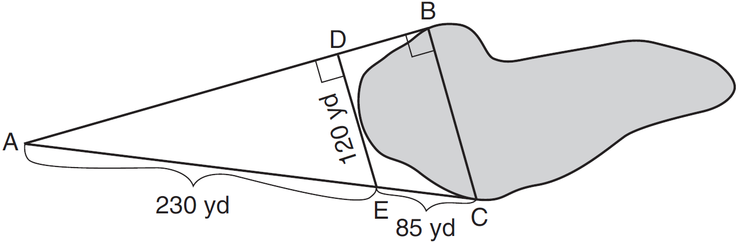

Use the surveyor's information to determine and state the distance from point B to point C, to the nearest yard.

25 A flagpole casts a shadow 16.60 meters long. Tim stands at a distance of 12.45 meters from the base of the flagpole, such that the end of Tim's shadow meets the end of the flagpole's shadow. If Tim is 1.65 meters tall, determine and state the height of the flagpole to the nearest tenth of a meter.

26 The aspect ratio (the ratio of screen width to height) of a rectangular flat-screen television is . The length of the diagonal of the screen is the television's screen size. Determine and state, to the nearest inch, the screen size (diagonal) of this flat-screen television with a screen height of 20.6 inches.

27 In the model below, a support wire for a telephone pole is attached to the pole and anchored to a stake in the ground 15 feet from the base of the telephone pole. Jamal places a 6-foot wooden pole under the support wire parallel to the telephone pole, such that one end of the pole is on the ground and the top of the pole is touching the support wire. He measures the distance between the bottom of the pole and the stake in the ground.

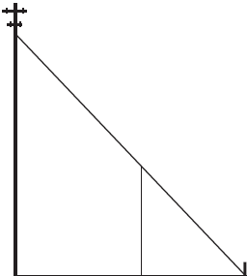

Jamal says he can approximate how high the support wire attaches to the telephone pole by using similar triangles. Explain why the triangles are similar.

1 ANS: 2 REF: 012003geo

2 ANS: 3 REF: 062419geo

3 ANS: 1

REF: 011908geo

4 ANS: 2 REF: 081519geo

5 ANS: 2
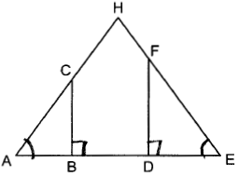

REF: 062314geo

6 ANS: 4
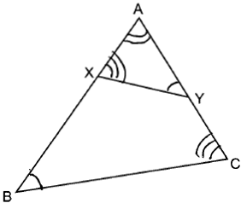

REF: 082324geo

7 ANS: 4 REF: 011817geo

8 ANS: 3
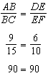

REF: 061515geo

9 ANS: 1
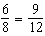

REF: 011613geo

10 ANS: 2
(1) AA; (3) SAS; (4) SSS. NYSED has stated that all students should be awarded credit regardless of their answer to this question.

REF: 061724geo

11 ANS: 3
1) 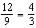 2) AA 3) 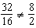 4) SAS

REF: 061605geo

12 ANS: 4
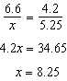

REF: 081705geo

13 ANS: 1
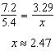

REF: 062405geo

14 ANS: 3
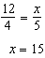

REF: 011624geo

15 ANS: 3
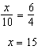

REF: 081612geo

16 ANS: 2
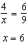

REF: 061915geo

17 ANS: 3
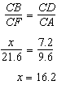

REF: 061804geo

18 ANS: 4
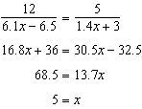

REF: 062211geo

19 ANS: 4
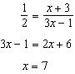

REF: 011620geo

20 ANS:
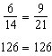 SAS

REF: 081529geo

21 ANS:
Yes, because of SAS. 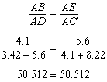

REF: 012429geo

22 ANS:
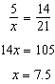

REF: 082425geo

23 ANS:
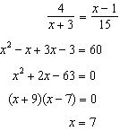

REF: spr2407geo

24 ANS:
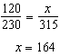

REF: 081527geo

25 ANS:
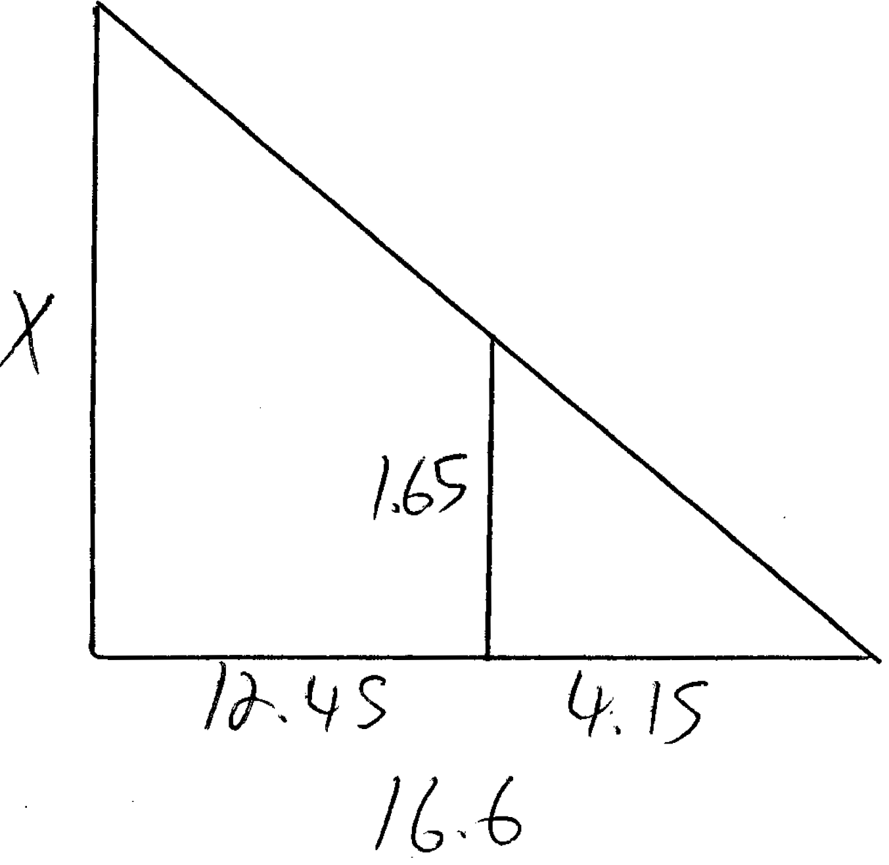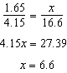

REF: 061531geo

26 ANS:
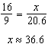

REF: 011632geo

27 ANS:
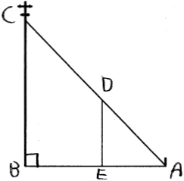 by AA. because they are the same . because they are both right s.

REF: 081829geo

