1 In the diagram below of , .

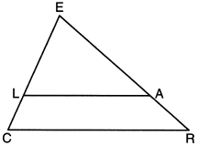

If , , and , what is the length of , to the nearest tenth?
1) | 5.5
2) | 4.4
3) | 3.0
4) | 2.8

2 In right triangle ABC shown below, point D is on and point E is on such that .

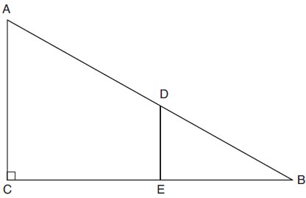

If , , and , what is the length of ?
1) | 8.75
2) | 6.25
3) | 5
4) | 4

3 In triangle ABC below, D is a point on and E is a point on , such that .

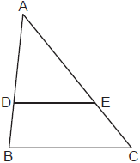

If , , and , what is the length of ?
1) | 15
2) | 22
3) | 24
4) | 25

4 In the diagram below of , is drawn parallel to , , , and .

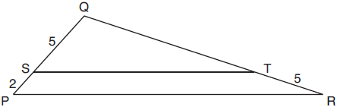

What is the length of ?
1) | 7
2) | 2
3)
4)

5 In the diagram below of , L is a point on , and M is a point on , such that .

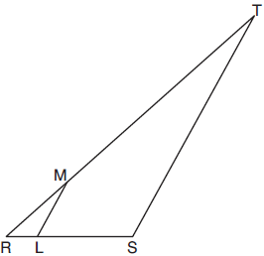

If , , , and , what is the length of ?
1) | 10
2) | 12
3) | 14
4) | 16

6 In the diagram of below, , , , and .

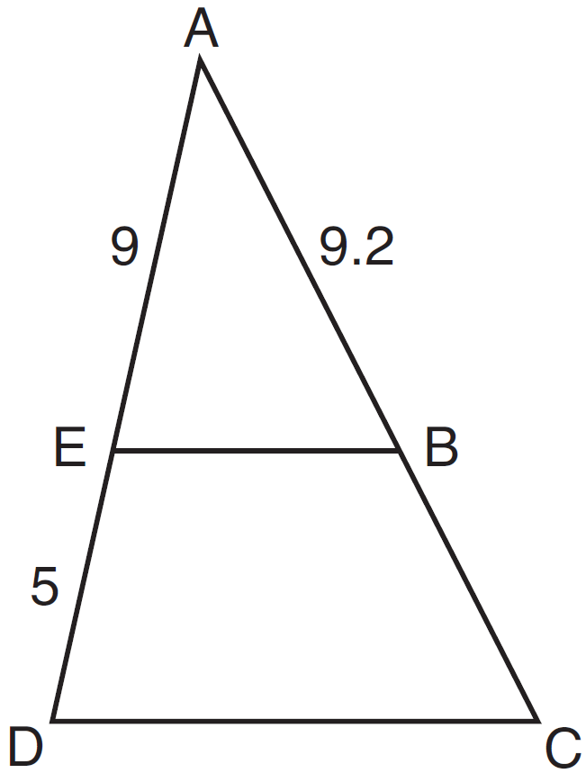

What is the length of , to the nearest tenth?
1) | 5.1
2) | 5.2
3) | 14.3
4) | 14.4

7 In the diagram of below, is parallel to , , , and .
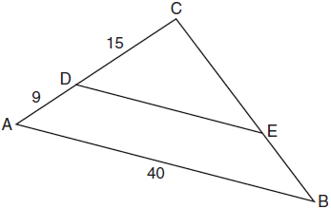
The length of is
1) | 15
2) | 24
3) | 25
4) | 30

8 In the diagram below, triangle ACD has points B and E on sides and , respectively, such that , , , and

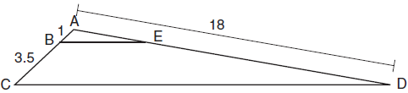

What is the length of , to the nearest tenth?
1) | 14.0
2) | 5.1
3) | 3.3
4) | 4.0

9 In the diagram of , points D and E are on and , respectively, such that .
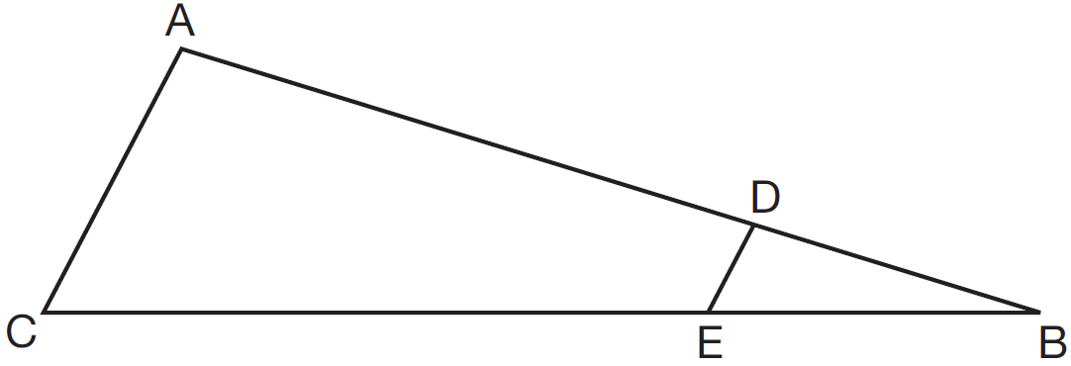

If , , and , what is the length of ?
1) | 8
2) | 12
3) | 16
4) | 72

10 In the diagram of below, points D and E are on sides and respectively, such that .

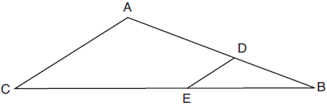

If EB is 3 more than DB, , and , what is the length of ?
1) | 6
2) | 8
3) | 9
4) | 12

11 In triangle ABC, points D and E are on sides and , respectively, such that , and .

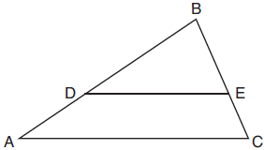

If and , what is the length of , to the nearest tenth?
1) | 3.8
2) | 5.6
3) | 5.9
4) | 15.7

12 In the diagram below of , D is a point on , E is a point on , and is drawn.

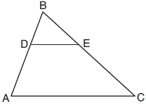

If , , and , what is the length of so that ?
1) | 23.8
2) | 16.8
3) | 15.6
4) | 8.6

13 In the diagram of below, is drawn such that .

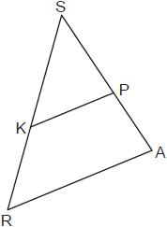

If , , and , what is the length of , to the nearest tenth?
1) | 4.8
2) | 7.5
3) | 8.0
4) | 13.3

14 In the diagram below, connects points B and C on the congruent sides of isosceles triangle ADE, such that is isosceles with vertex angle A.

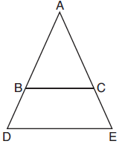

If , , and , what is the length of ?
1) | 6
2) | 7
3) | 8
4) | 9

15 Given shown below, with trapezoid PTRO, , , and .

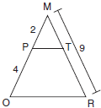

What is the length of ?
1) | 4.5
2) | 5
3) | 3
4) | 6

16 In below, .
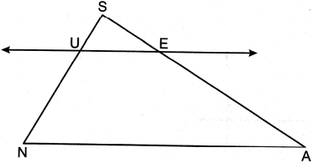
If , , and , what is the length of , to the nearest tenth?
1) | 2.5
2) | 3.5
3) | 4.9
4) | 17.9

17 In the diagram below of , intersects and at points T and V respectively, and .
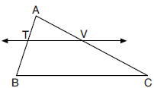

If , , , and , what is the perimeter of quadrilateral TBCV?
1) | 38.5
2) | 39.5
3) | 40.5
4) | 44.9

18 In the diagram below, .
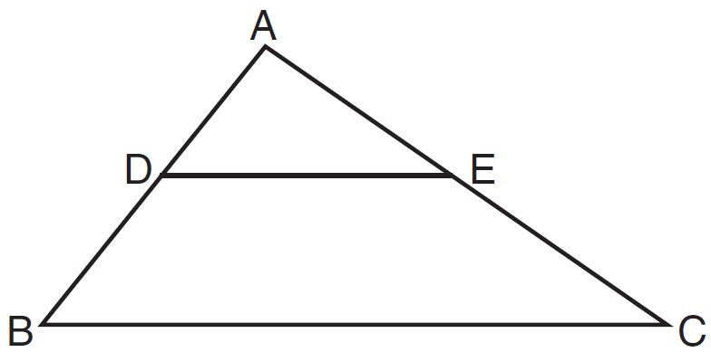

Which measurements are justified by this similarity?
1) | , , , and
2) | , , , and
3) | , , , and
4) | , , , and

19 In the diagram below of , is drawn parallel to such that E is on and S is on .

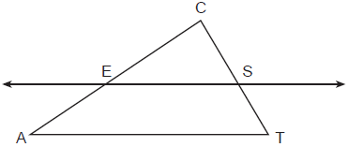

Which statement is always true?
1) | 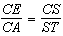
2) | 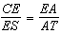
3) | 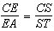
4) | 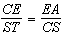

20 In below, is drawn such that D and E are on and , respectively.

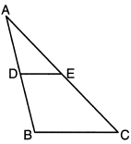

If , which equation will always be true?
1) | 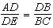
2) | 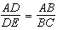
3) | 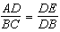
4) | 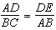

21 The diagram below shows triangle ABC with point X on side and point Y on side .

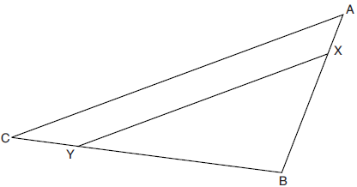

Which information is sufficient to prove that ?
1) | is a right angle.
2) | is parallel to .
3) | is isosceles.
4)

22 In the diagram below of right triangle AED, .

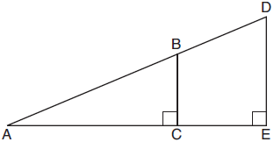

Which statement is always true?
1) | 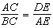
2) | 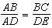
3) | 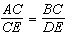
4) | 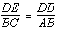

23 In triangle ABC below, D is a point on and E is a point on , such that .

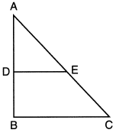

Which statement is always true?
1) | and are right angles.
2)
3) | 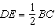
4)

24 Triangle ADF is drawn and .

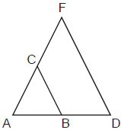

Which statement must be true?
1) | 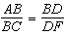
2) | 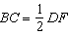
3)
4)

25 In as shown below, points A and B are located on sides and , respectively. Line segment AB is drawn such that , , , and .

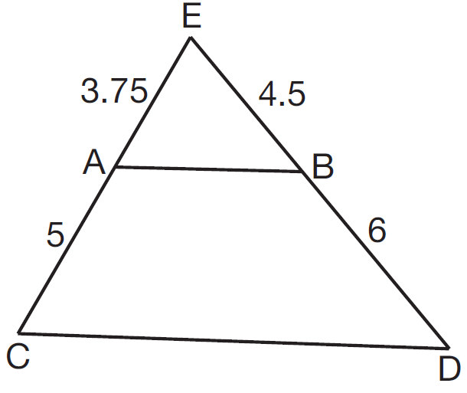

Explain why is parallel to .

26 In the diagram below, , , , and .

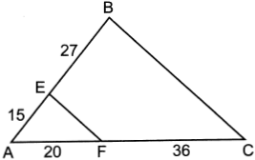

Explain why .

1 ANS: 2
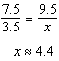

REF: 012303geo

2 ANS: 2
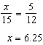

REF: 011906geo

3 ANS: 4
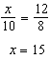

REF: 082314geo

4 ANS: 4
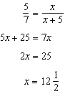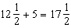

REF: 061821geo

5 ANS: 4
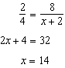

REF: 012024geo

6 ANS: 3
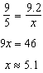

REF: 061511geo

7 ANS: 3
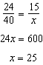

REF: 011813geo

8 ANS: 4
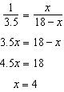

REF: 081707geo

9 ANS: 2
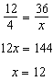

REF: 061621geo

10 ANS: 2
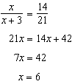

REF: 081812geo

11 ANS: 3
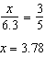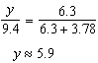

REF: 081816geo

12 ANS: 1
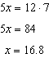

REF: 061911geo

13 ANS: 2
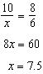

REF: 012402geo

14 ANS: 3
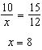

REF: 081918geo

15 ANS: 4
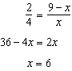

REF: 061705geo

16 ANS: 3
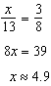

REF: 082405geo

17 ANS: 4
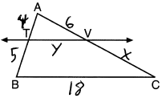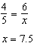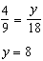

REF: 082222geo

18 ANS: 4
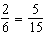

REF: 081517geo

19 ANS: 3 REF: 062307geo

20 ANS: 2

REF: 012308geo

21 ANS: 2
If (2) is true, and .

REF: 082202geo

22 ANS: 2

REF: 061811geo

23 ANS: 2
and

REF: 062214geo

24 ANS: 4 REF: 062321geo

25 ANS:
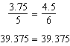 is parallel to because divides the sides proportionately.

REF: 061627geo

26 ANS:
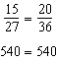 is parallel to because divides the sides proportionately.

REF: 062431geo

