1 Given that ABCD is a parallelogram, a student wrote the proof below to show that a pair of its opposite angles are congruent.

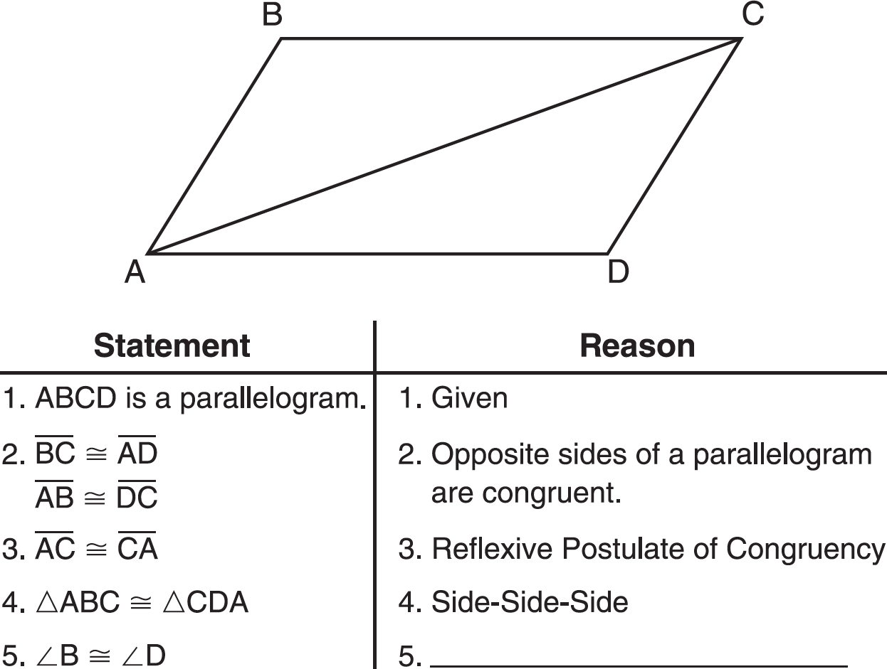

What is the reason justifying that ?
1) | Opposite angles in a quadrilateral are congruent.
2) | Parallel lines have congruent corresponding angles.
3) | Corresponding parts of congruent triangles are congruent.
4) | Alternate interior angles in congruent triangles are congruent.

2 Given: Parallelogram ABCD with diagonal drawn

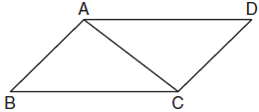

Prove:

3 Given: Quadrilateral ABCD, diagonal , , , ,
Prove: ABCD is a parallelogram.

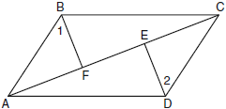

4 In the diagram below of quadrilateral ABCD, and . Line segments AC, DB, and FG intersect at E. Prove:

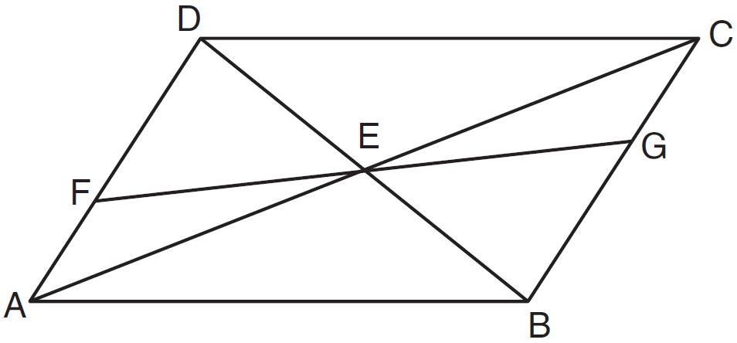

5 Given: parallelogram FLSH, diagonal , ,

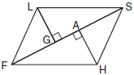

Prove:

6 The accompanying diagram shows quadrilateral BRON, with diagonals and , which bisect each other at X.

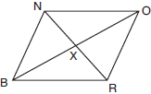

Prove:

7 Given: Parallelogram ANDR with and bisecting and at points W and E, respectively
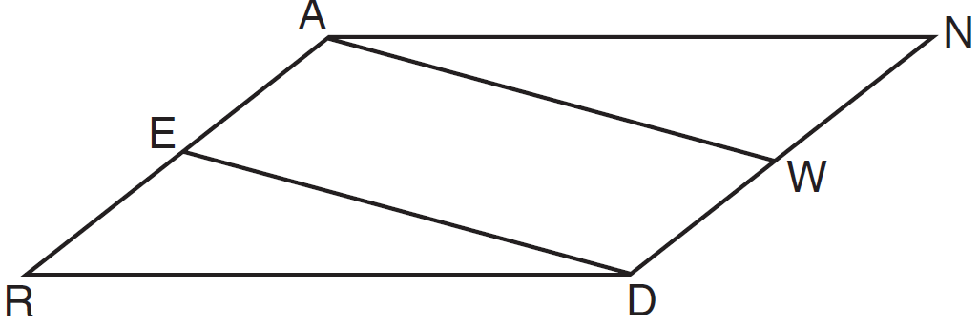
Prove that . Prove that quadrilateral AWDE is a parallelogram.

8 Given: Quadrilateral ABCD is a parallelogram with diagonals and intersecting at E
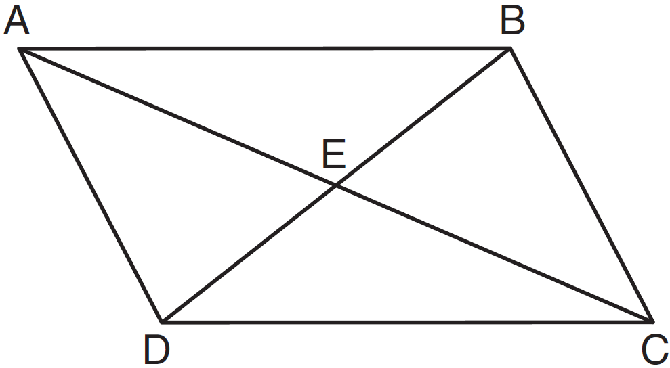
Prove:
Describe a single rigid motion that maps onto .

9 Given: Quadrilateral ABCD, , , diagonal intersects at G, and
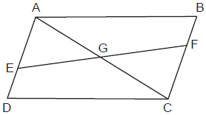
Prove: G is the midpoint of

10 The diagram below shows rectangle ABCD with points E and F on side . Segments and intersect at G, and . Prove:
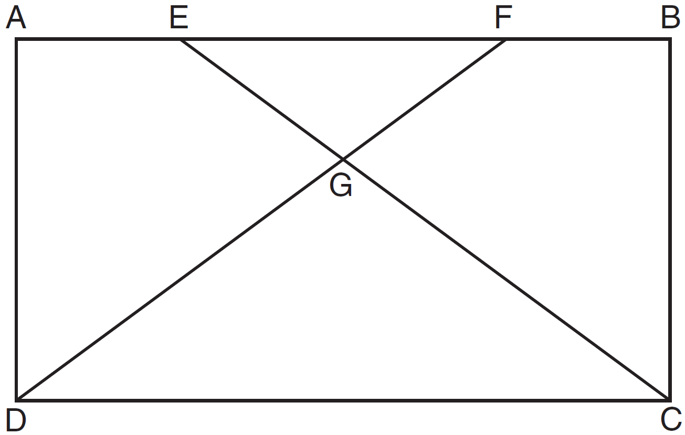

11 The diagram below shows square ABCD where E and F are points on such that , and segments AF and DE are drawn. Prove that .

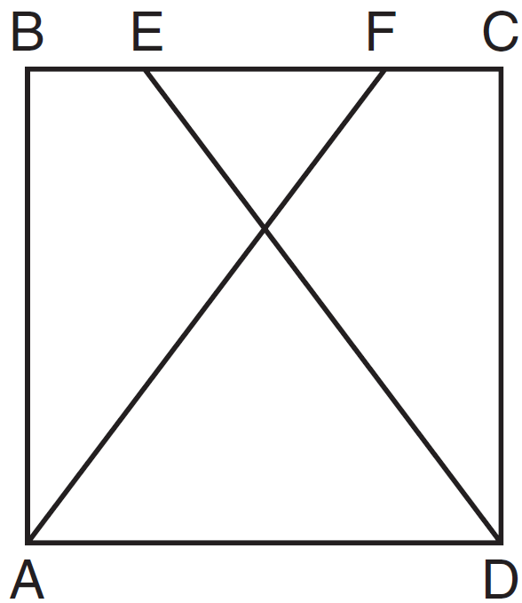

12 Given: Parallelogram DEFG, K and H are points on such that and and are drawn.

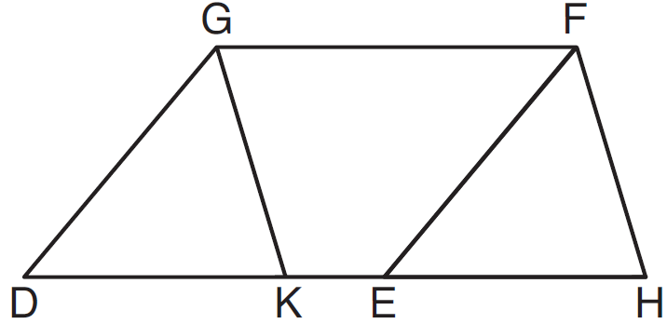

Prove:

13 In quadrilateral ABCD, , , and and are perpendicular to diagonal at points F and E.

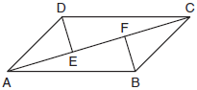

Prove:

14 In quadrilateral HOPE below, , , , and and are perpendicular to diagonal at points G and J, respectively.

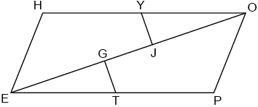

Prove that .

15 In the diagram of quadrilateral ABCD with diagonal shown below, segments GH and EF are drawn, , , , and .

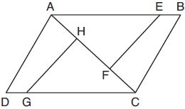

Prove:

16 In the diagram of quadrilateral ABCD below, , and . Segments CE and AF are drawn to diagonal such that .

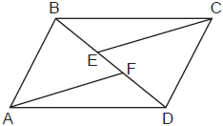`

Prove:

17 Given: PROE is a rhombus, , ,

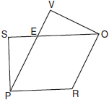

Prove:

18 In quadrilateral ABCD, E and F are points on and , respectively, and and are drawn such that , , and .

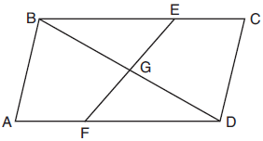

Prove:

19 Given: Parallelogram PQRS, ,

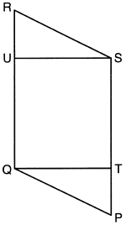

Prove:

20 Given: Quadrilateral MATH, , , , and

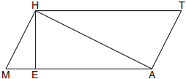

Prove:

21 Given: Quadrilateral ABCD, and intersect at H, , , and .

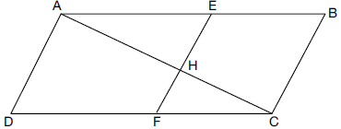

Prove:

22 In the diagram of parallelogram ABCD below, , , .

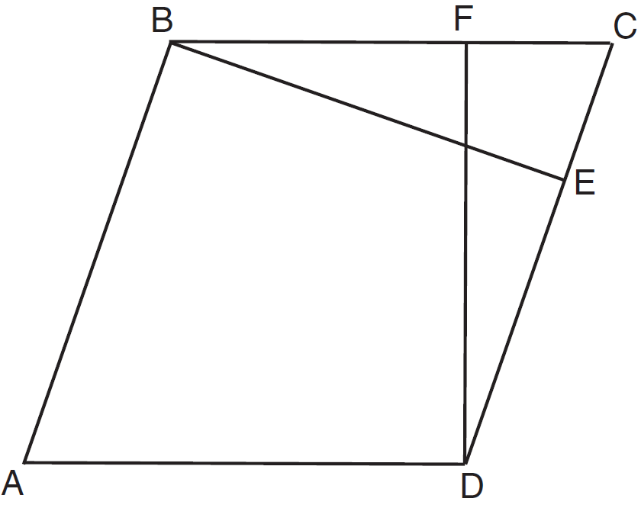

Prove ABCD is a rhombus.

23 Isosceles trapezoid ABCD has bases and with nonparallel legs and . Segments AE, BE, CE, and DE are drawn in trapezoid ABCD such that , , and .

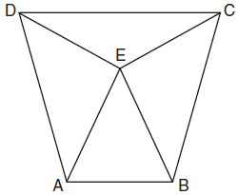

Prove and prove is an isosceles triangle.

24 Given: Quadrilateral ABCD with , , and diagonal is drawn
Prove:

25 Prove that the diagonals of a parallelogram bisect each other.

26 A tricolored flag is made out of a rectangular piece of cloth whose corners are labeled A, B, C, and D. The colored regions are separated by two line segments, and , that meet at point M, the midpoint of side . Prove that the two line segments that separate the regions will always be equal in length, regardless of the size of the flag.

1 ANS: 3 REF: 081208ge

2 ANS:
Parallelogram ABCD with diagonal drawn (given). (reflexive property). and (opposite sides of a parallelogram are congruent). (SSS).

REF: 011825geo

3 ANS:
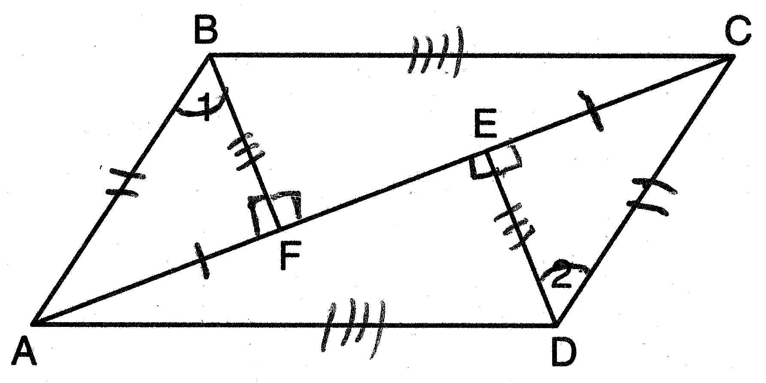 (Reflexive Property); (Line Segment Subtraction Theorem); (Substitution); (All right angles are congruent); (AAS); and (CPCTC); (All right angles are congruent); (SAS); (CPCTC); ABCD is a parallelogram (opposite sides of quadrilateral ABCD are congruent)

REF: 080938ge

4 ANS:
Quadrilateral ABCD, and are given. because if two lines are cut by a transversal so that a pair of alternate interior angles are congruent, the lines are parallel. ABCD is a parallelogram because if one pair of opposite sides of a quadrilateral are both congruent and parallel, the quadrilateral is a parallelogram. because the diagonals of a parallelogram bisect each other. as vertical angles. by ASA.

REF: 011238ge

5 ANS:
Because FLSH is a parallelogram, . Because FLSH is a parallelogram, and since is a transversal, and are alternate interior angles and congruent. Therefore by AAS. 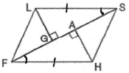

REF: 010634b

6 ANS:
Because diagonals and bisect each other, and . and are congruent vertical angles. Therefore by SAS. 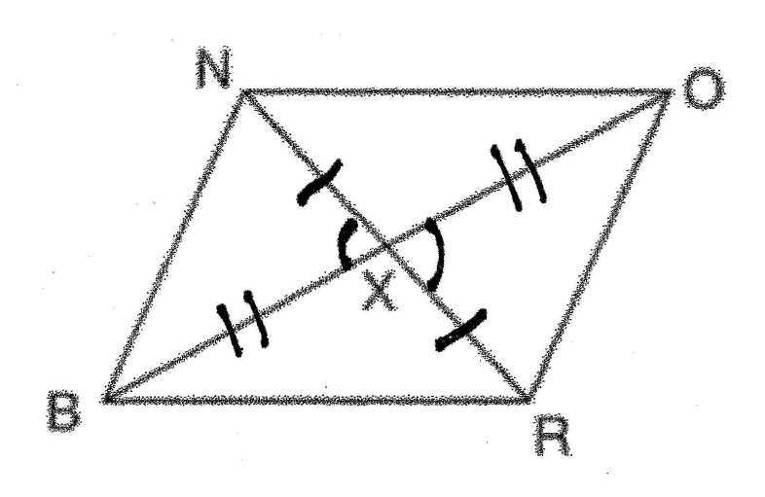

REF: 080731b

7 ANS:
Parallelogram ANDR with and bisecting and at points W and E (Given). , (Opposite sides of a parallelogram are congruent). 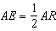, 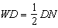, so (Definition of bisect and division property of equality). (Opposite sides of a parallelogram are parallel). AWDE is a parallelogram (Definition of parallelogram). 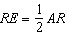, 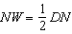, so (Definition of bisect and division property of equality). (Opposite sides of a parallelogram are congruent). (SSS).

REF: 011635geo

8 ANS:
Quadrilateral ABCD is a parallelogram with diagonals and intersecting at E (Given). (Opposite sides of a parallelogram are congruent). (Vertical angles are congruent). (Definition of parallelogram). (Alternate interior angles are congruent). (AAS). 180° rotation of around point E.

REF: 061533geo

9 ANS:
Quadrilateral ABCD, , , diagonal intersects at G, and (given); ABCD is a parallelogram (a quadrilateral with a pair of opposite sides is a parallelogram); (opposite side of a parallelogram are congruent); (subtraction postulate); (opposite side of a parallelogram are parallel); (if parallel sides are cut by a transversal, the alternate interior angles are congruent); (vertical angles); (AAS); (CPCTC): G is the midpoint of (since G divides into two equal parts, G is the midpoint of ).

REF: 062335geo

10 ANS:
Rectangle ABCD with points E and F on side , segments and intersect at G, and are given. because opposite sides of a rectangle are congruent. and are right angles and congruent because all angles of a rectangle are right and congruent. by ASA. per CPCTC. under the Reflexive Property. using the Subtraction Property of Segments. because of the Definition of Segments.

REF: 011338ge

11 ANS:
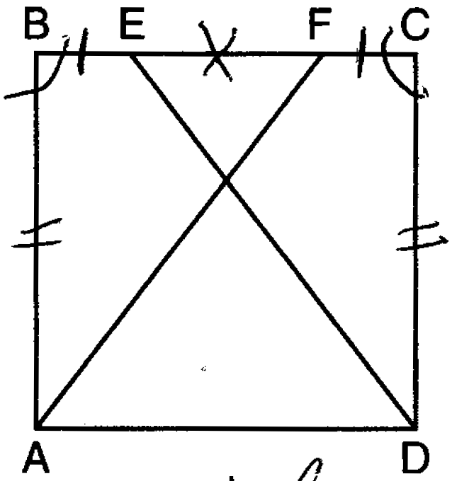 Square ABCD; E and F are points on such that ; and drawn (Given). (All sides of a square are congruent). (All angles of a square are equiangular). (Reflexive property). (Additive property of line segments). (Angle addition). (SAS). (CPCTC).

REF: 061538ge

12 ANS:
Parallelogram DEFG, K and H are points on such that and and are drawn (given). (opposite sides of a parallelogram are congruent). (opposite sides of a parallelogram are parallel). (corresponding angles formed by parallel lines and a transversal are congruent). (ASA). (CPCTC). 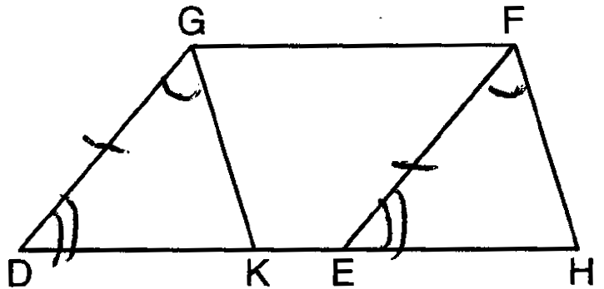

REF: 081538ge

13 ANS:
Quadrilateral ABCD, , , and and are perpendicular to diagonal at points F and E (given). and are right angles (perpendicular lines form right angles). (All right angles are congruent). ABCD is a parallelogram (A quadrilateral with one pair of sides congruent and parallel is a parallelogram). (Opposite sides of a parallelogram are parallel). (Parallel lines cut by a transversal form congruent alternate interior angles). (Opposite sides of a parallelogram are congruent). (AAS). (CPCTC).

REF: 011735geo

14 ANS:
Quad HOPE, , , , and (Given); HOPE is a parallelogram (Both pairs of opposite sides are parallel); (Opposite sides of a parallelogram are parallel); (Parallel lines cut by a transversal form congruent alternate interior angles); (Reflexive); (Subtraction); and are right angles (Perpendicular lines form right angles); (All right angles are congruent); (ASA); (CPCTC).

REF: 082435geo

15 ANS:
Quadrilateral ABCD with diagonal , segments GH and EF, , , , and (given); , (reflexive property); 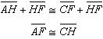, 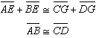 (segment addition); (SSS); (CPCTC); (SAS); (CPCTC).

REF: 011935geo

16 ANS:
In quadrilateral ABCD, and , segments CE and AF are drawn to diagonal such that (Given); (Parallel lines cut by a transversal form congruent interior angles); (Reflexive); 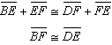 (Addition); (SAS); (CPCTC).

REF: 012434geo

17 ANS:
Because PROE is a rhombus, . are congruent vertical angles. because opposite angles of a rhombus are congruent. because of the Angle Subtraction Theorem. because of ASA. because of CPCTC. 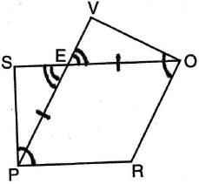

REF: 010934b

18 ANS:
Quadrilateral ABCD, E and F are points on and , respectively, and and are drawn such that , , and (given); (reflexive); (SAS); (CPCTC); (segment addition); (segment subtraction); (vertical angles are congruent); (CPCTC); (AAS); (CPCTC).

REF: 012035geo

19 ANS:
Parallelogram PQRS, , (given); (opposite sides of a parallelogram are parallel; Quadrilateral QUST is a rectangle (quadrilateral with parallel opposite sides and opposite right angles is a rectangle); (opposite sides of a rectangle are congruent); (opposite sides of a parallelogram are congruent); and are right angles (the supplement of a right angle is a right angle), (HL); (CPCTC)

REF: 062233geo

20 ANS:
Quadrilateral MATH, , , , and (given); and are right angles (perpendicular lines form right angles); (all right angles are congruent); MATH is a parallelogram (a quadrilateral with two pairs of congruent opposite sides is a parallelogram); (opposite sides of a parallelogram are parallel); (alternate interior angles of parallel lines and a transversal are congruent); (AA); 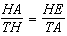 (corresponding sides of similar triangles are in proportion); (product of means equals product of extremes).

REF: 061935geo

21 ANS:
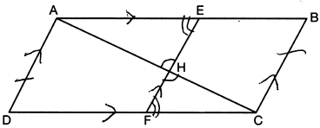 1) Quadrilateral ABCD, and intersect at H, , , and (Given); 2) (Vertical angles are congruent); 3) (Transitive property of parallel lines); 4) ABCD is a parallelogram (Quadrilateral with a pair of sides both parallel and congruent); 5) (Opposite sides of a parallelogram); 6) (Alternate interior angles formed by parallel lines and a transversal); 7) (AA); 8) 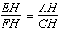 (Corresponding sides of similar triangles are proportional); 8) (Product of means equals product of extremes).

REF: 082235geo

22 ANS:
Parallelogram ABCD, , , (given). (perpendicular lines form right angles, which are congruent). (reflexive property). (ASA). (CPCTC). ABCD is a rhombus (a parallelogram with consecutive congruent sides is a rhombus).

REF: 081535geo

23 ANS:
Isosceles trapezoid ABCD, , , and (given); (congruent legs of isosceles trapezoid); and are right angles (perpendicular lines form right angles); (all right angles are congruent); (base angles of an isosceles trapezoid are congruent); 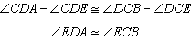 (subtraction postulate); (AAS); (CPCTC); is an isosceles triangle (an isosceles triangle has two congruent sides).

REF: 081735geo

24 ANS:
(Reflexive Property); (SSS); (CPCTC). 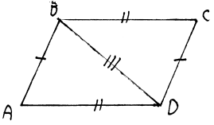

REF: 061035ge

25 ANS:
Assume parallelogram JMAP with diagonals intersecting at O. Opposite sides of a parallelogram are congruent, so . and are congruent vertical angles. Because JMAP is a parallelogram, and since is a transversal, and are alternate interior angles and congruent. Therefore by AAS. Corresponding parts of congruent triangles are congruent. Therefore and and the diagonals of a parallelogram bisect each other. 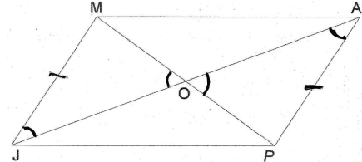

REF: 010233b

26 ANS:
, because opposite sides of a rectangle are congruent. , because of the definition of midpoint. and are right angles because a rectangle has four right angles. , because all right angles are congruent. , because of SAS. because of CPCTC. 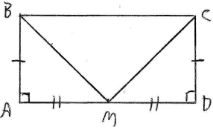

REF: 080834b

