1 In the diagram below of , H is a point on , , , and . Determine whether is an isosceles triangle and justify your answer.

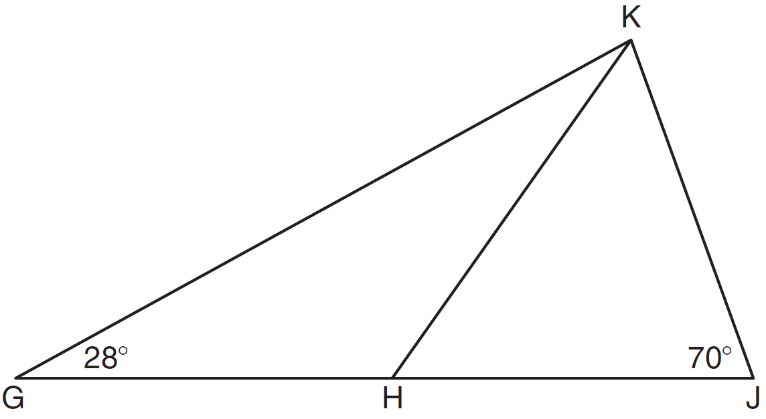

2 In the diagram below of , B is a point on such that is an equilateral triangle, and is an isosceles triangle with . Find .

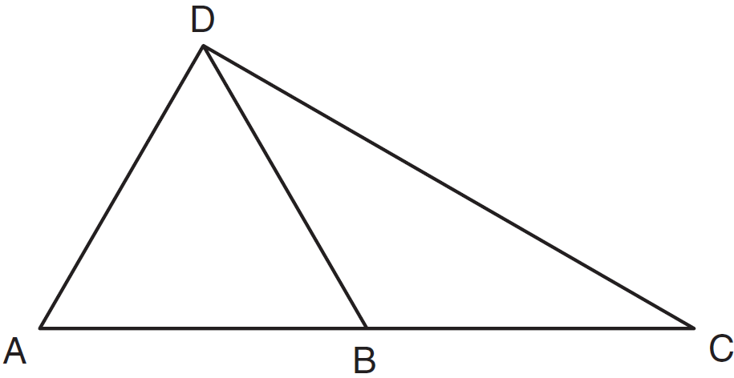

3 In the diagram of shown below, is drawn from vertex B to point A on , such that .

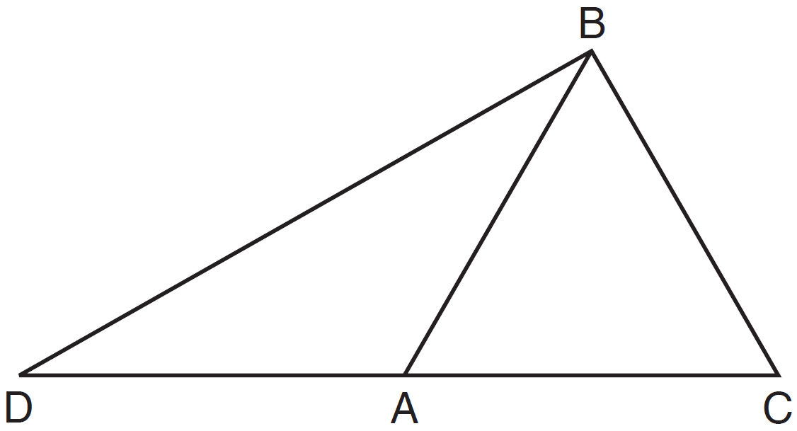

In , , , and . In , and . [Only algebraic solutions can receive full credit.] Find . Find . Find the length of . Find the length of .

4 In the accompanying diagram, and are isosceles triangles with and . If and , what is ?

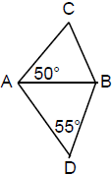

5 In the accompanying diagram, isosceles , , and . Find and .

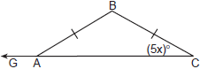

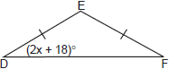

6 In , and . Find .

7 In triangle CEM, , , and . Determine and state the value of x that would make CEM an isosceles triangle with the vertex angle at E.

8 Vertex angle A of isosceles triangle ABC measures 20° more than three times . Find .

9 The perimeter of an isosceles triangle is 71 centimeters. The measure of one of the sides is 22 centimeters. What are all the possible measures of the other two sides?

10 Hersch says if a triangle is an obtuse triangle, then it cannot also be an isosceles triangle. Using a diagram, show that Hersch is incorrect, and indicate the measures of all the angles and sides to justify your answer.

11 Dylan says that all isosceles triangles are acute triangles. Mary Lou wants to prove that Dylan is not correct. Sketch an isosceles triangle that Mary Lou could use to show that Dylan’s statement is not true. In your sketch, state the measure of each angle of the isosceles triangle.

1 ANS:
No, is not congruent to . 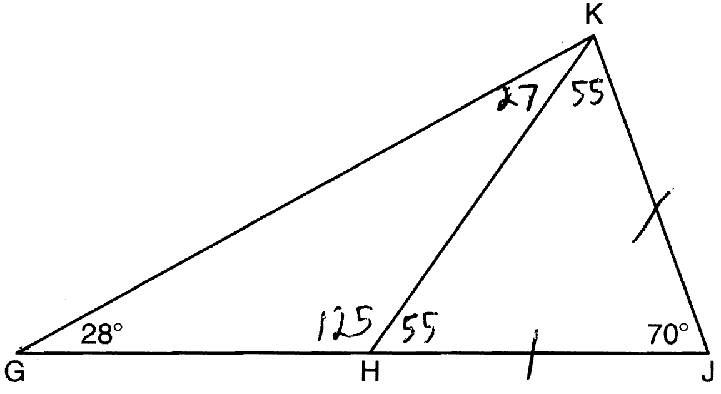

REF: 081135ge

2 ANS:
30. 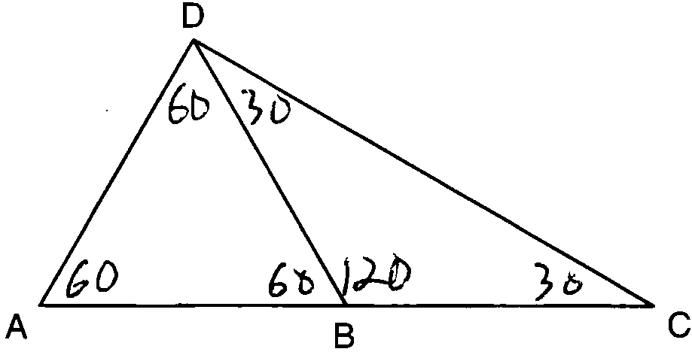

REF: 011129ge

3 ANS:
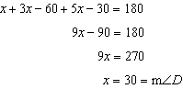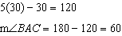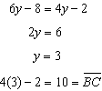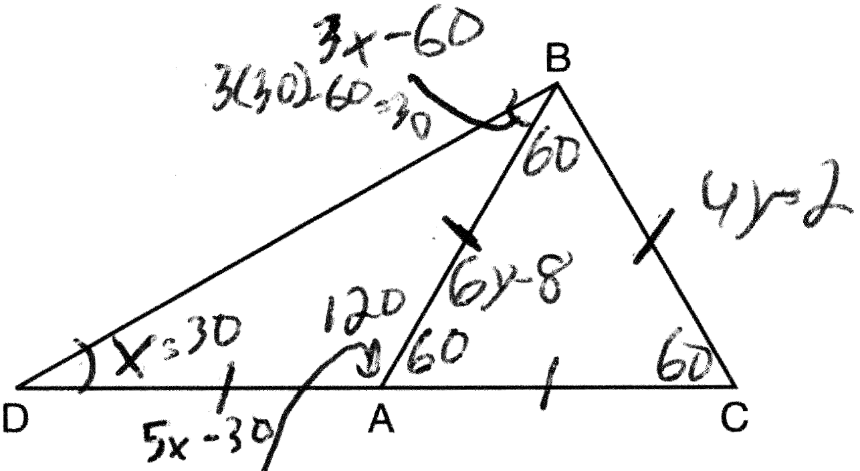

REF: 011435ge

4 ANS:
135. 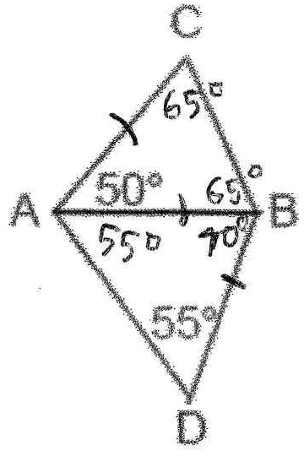 m∠CBD = 65° + 70° = 135°

REF: 069930a

5 ANS:
and . 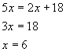. Therefore the triangles’ congruent angles are 30°.

REF: 060838a

6 ANS:
67. 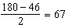

REF: 011029ge

7 ANS:
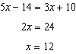

REF: 082326geo

8 ANS:
32. 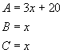. 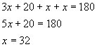

REF: 010223a

9 ANS:
If the measure of the second side is also 22, the measure of the third side is 27 (71 – (22 + 22)). If the second and third sides are equal, their measures are 24.5 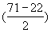 each.
REF: 060733a

10 ANS:
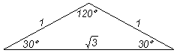
REF: 060027a

11 ANS:
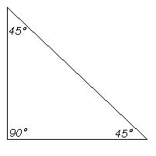
REF: 080433a

