1 In the diagram of below, . The measure of is 40°.

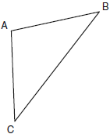

What is the measure of ?
1) | 40°
2) | 50°
3) | 70°
4) | 100°

2 The accompanying diagram shows the roof of a house that is in the shape of an isosceles triangle. The vertex angle formed at the peak of the roof is 84°.

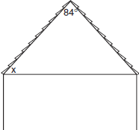

What is the measure of x?
1) | 138°
2) | 96°
3) | 84°
4) | 48°

3 Tina wants to sew a piece of fabric into a scarf in the shape of an isosceles triangle, as shown in the accompanying diagram.

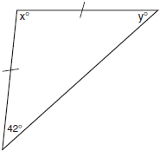

What are the values of x and y?
1)
2)
3)
4)

4 In the diagram below of , , , and .

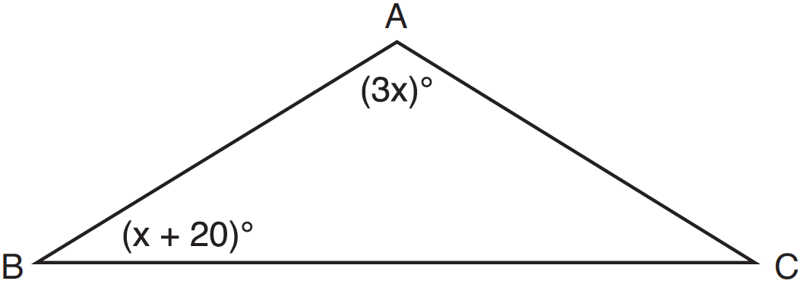

What is the value of x?
1) | 10
2) | 28
3) | 32
4) | 40

5 In the diagram below, is isosceles with .

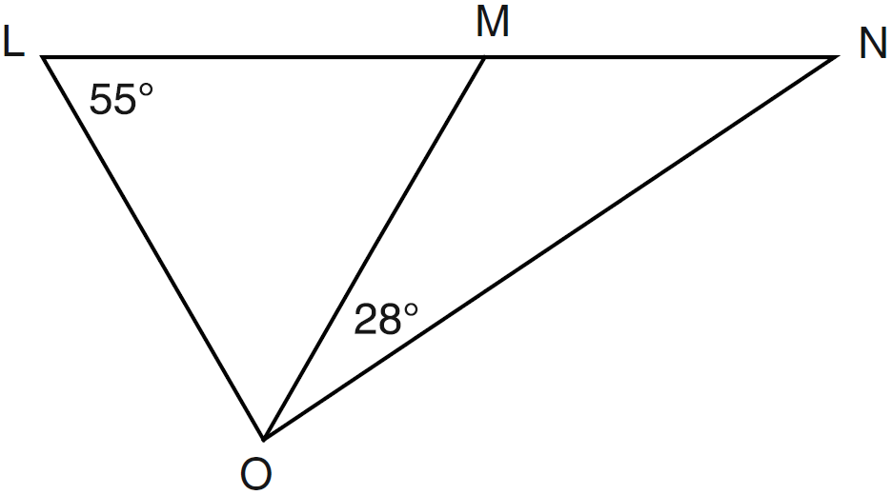

If and , what is ?
1) | 27
2) | 28
3) | 42
4) | 70

6 In the diagram below of isosceles , the measure of vertex angle B is 80°. If extends to point D, what is ?

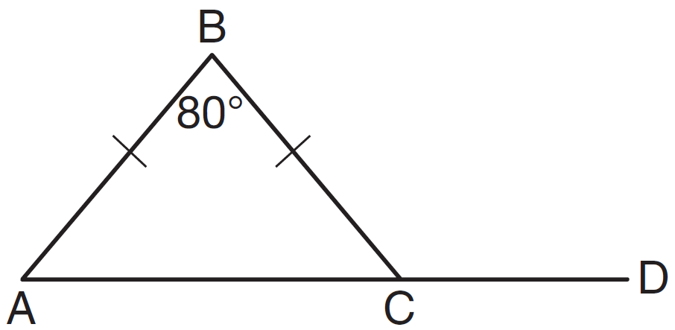
1) | 50
2) | 80
3) | 100
4) | 130

7 In , . If , then is
1) | 61
2) | 64
3) | 116
4) | 122

8 In , , , , and . The length of is
1) | 20
2) | 40
3) | 60
4) | 80

9 The vertex angle of an isosceles triangle measures 15 degrees more than one of its base angles. How many degrees are there in a base angle of the triangle?
1) | 50
2) | 55
3) | 65
4) | 70

10 In the diagram below of and , .

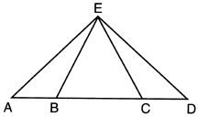

Which statement is always true?
1)
2)
3)
4)

11 In , . An altitude is drawn from B to and intersects at D. Which conclusion is not always true?
1)
2)
3)
4)

12 In isosceles triangle ABC, . Which statement will always be true?
1)
2)
3)
4)

13 If the vertex angles of two isosceles triangles are congruent, then the triangles must be
1) | acute
2) | congruent
3) | right
4) | similar

14 In isosceles triangle DOG, the measure of the vertex angle is three times the measure of one of the base angles. Which statement about is true?
1) | is a scalene triangle.
2) | is an acute triangle.
3) | is a right triangle.
4) | is a obtuse triangle.

1 ANS: 4

REF: 080903ge

2 ANS: 4
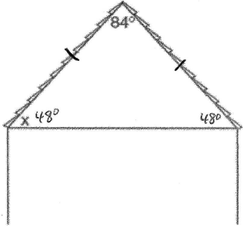

REF: 060615a

3 ANS: 4
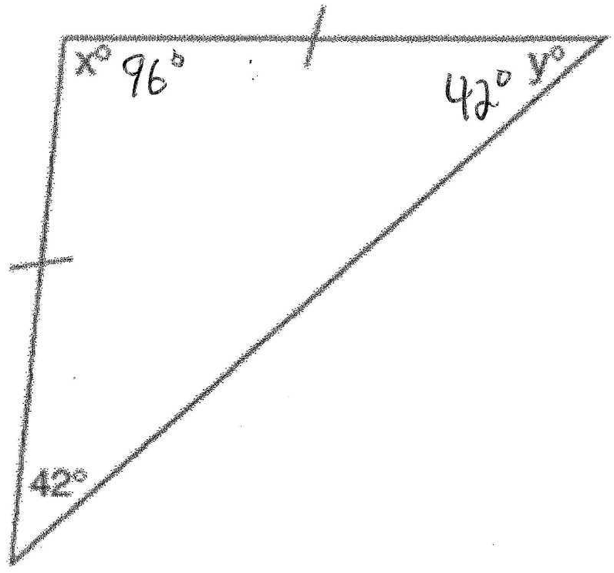

REF: 060510a

4 ANS: 2
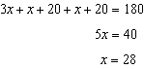

REF: 081222ge

5 ANS: 1
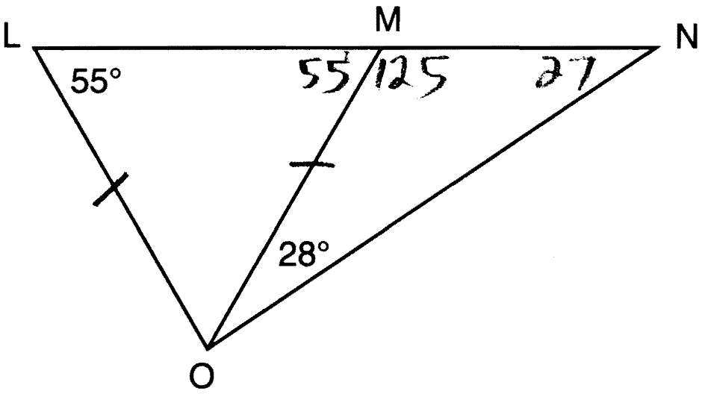

REF: 061211ge

6 ANS: 4
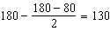

REF: 011508ge

7 ANS: 2

REF: 081510ge

8 ANS: 3
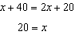

REF: 081416ge

9 ANS: 2
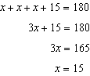

REF: 061407ge

10 ANS: 4
Isosceles triangle theorem.

REF: 062207geo

11 ANS: 3 REF: 011007ge

12 ANS: 3 REF: 061004ge

13 ANS: 4 REF: 061124ge

14 ANS: 4
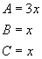 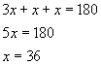The vertex angle is .

REF: 060107a

