1 In the accompanying diagram, , , and is the diameter of circle O. Write an explanation or a proof that shows and are congruent.

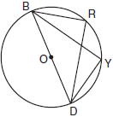

2 In the diagram below, quadrilateral ABCD is inscribed in circle O, , and diagonals and are drawn. Prove that .

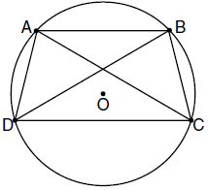

3 In the accompanying diagram of circle O, diameter is drawn, tangent is drawn to the circle at B, E is a point on the circle, and .
Prove:

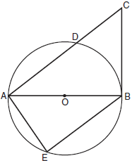

4 In the accompanying diagram of circle O, is a diameter with parallel to chord , chords and are drawn, and chords and intersect at E.
Prove:

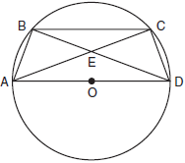

5 Given: circle O, is tangent to the circle at B, and are chords, and C is the midpoint of .

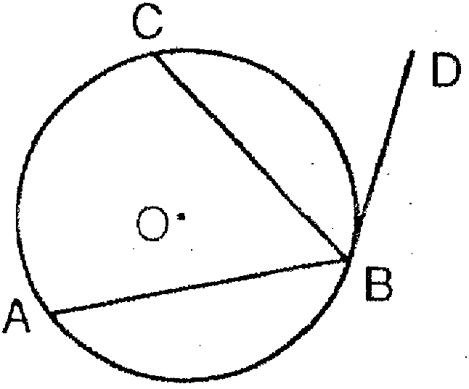

Prove:

6 In the diagram below, and are tangent to circle O, and are radii, and intersects the circle at C. Prove:

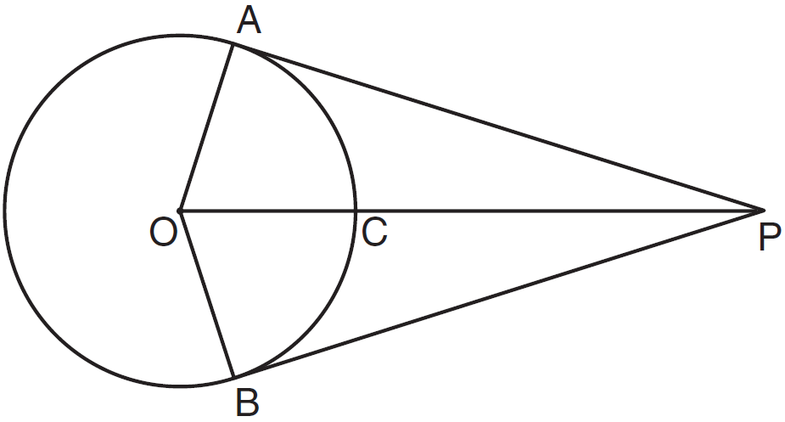

7 In the diagram of circle O below, diameter , chord , tangent , and secant are drawn.

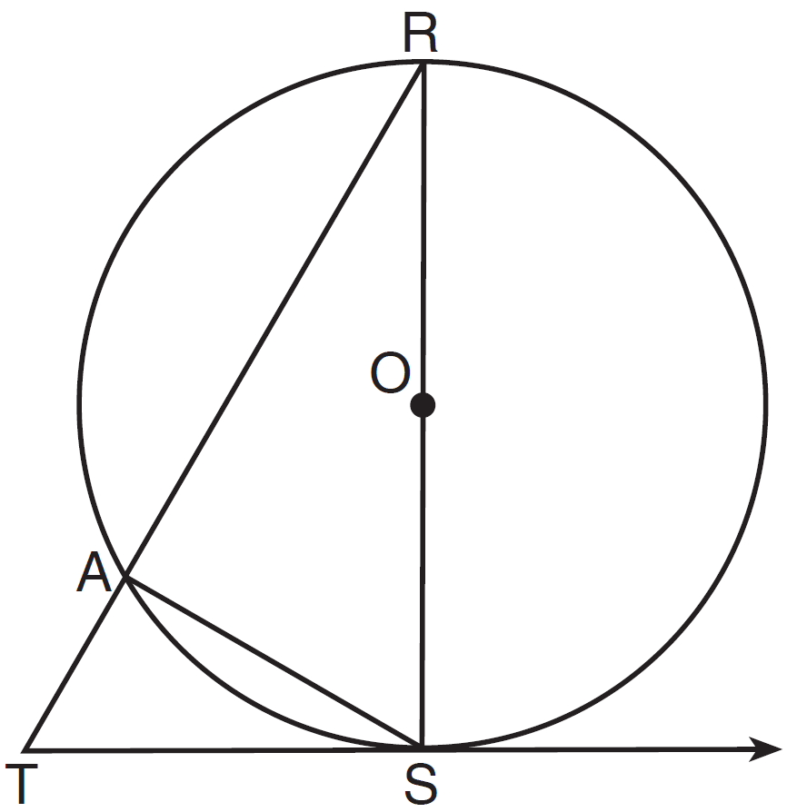

Complete the following proof to show

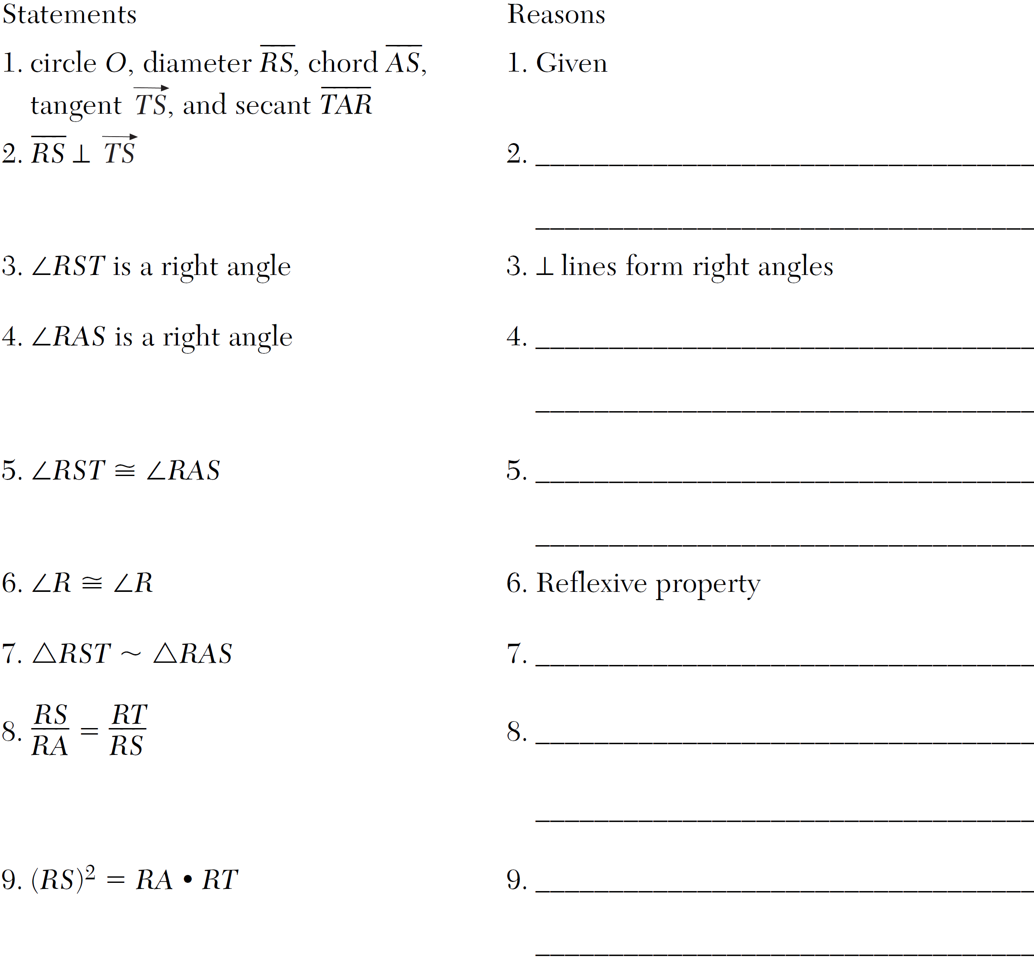

8 Given: chords and of circle O intersect at E, an interior point of circle O; chords and are drawn.

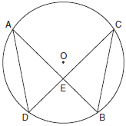

Prove:

9 Given: Circle O, chords and intersect at E

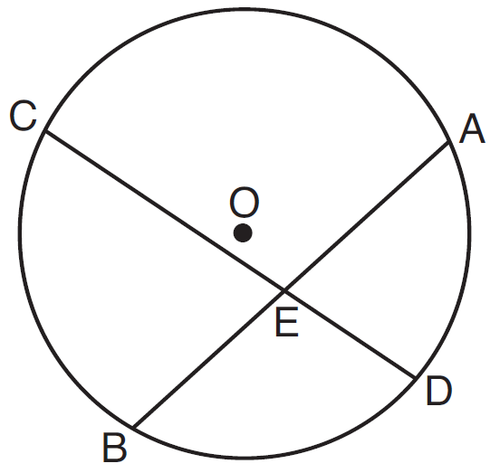

Theorem: If two chords intersect in a circle, the product of the lengths of the segments of one chord is equal to the product of the lengths of the segments of the other chord. Prove this theorem by proving .

10 In the diagram below, secant and tangent are drawn from external point A to circle O.

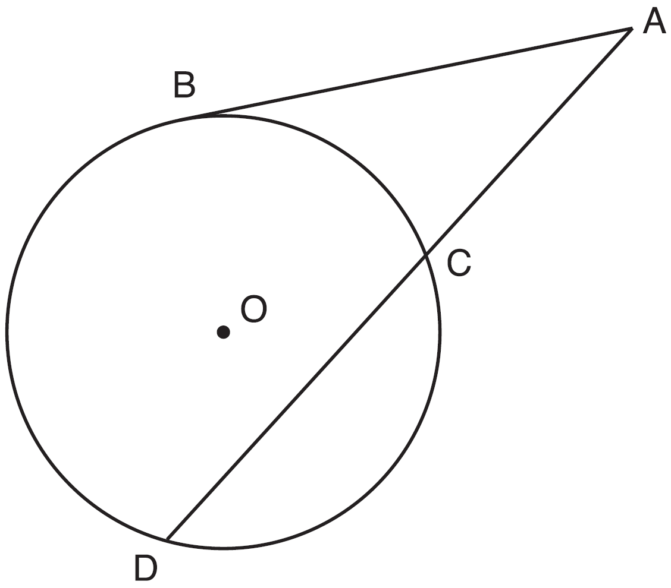

Prove the theorem: If a secant and a tangent are drawn to a circle from an external point, the product of the lengths of the secant segment and its external segment equals the length of the tangent segment squared.

11 In the diagram below of circle O, tangent is drawn to diameter . Chord is parallel to secant , and chord is drawn.

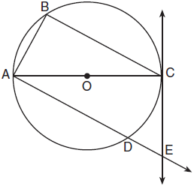

Prove: 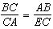

1 ANS:
The measure of an inscribed angle is half that of its intercepted arc. Therefore . Because and intercept a semicircle, they are both right angles. from the reflexive property. Therefore because of AAS. Alternatively, because congruent chords intersect congruent arcs, and HL applies.

REF: 010732b

2 ANS:
Because , since parallel chords intersect congruent arcs. because inscribed angles that intercept congruent arcs are congruent. since congruent chords intersect congruent arcs. because inscribed angles that intercept the same arc are congruent. Therefore, because of AAS.

REF: fall0838ge

3 ANS:
, the angle formed by tangent and diameter is a right angle. The measure of an inscribed angle is half that of its intercepted arc. Because intercepts a semicircle, is also a right angle. Since , and are alternate interior angles and congruent. Therefore by AA. 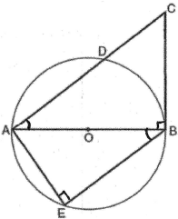

REF: 080627b

4 ANS:
because parallel lines intercept congruent arcs. because congruent chords intercept congruent arcs. and are congruent vertical angles. and are congruent inscribed angles intercepting the same arc. because of AAS. because of CPCTC. 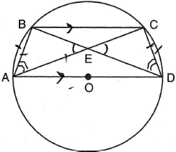

REF: 060934b

5 ANS:
because of the definition of midpoint; 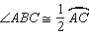 as the measure of an inscribed angle is one-half the measure of its intercepted arc; 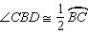 as the measure of an angle formed by a tangent and a chord that intersect at the point of tangency is one-half the measure of the intercepted arc; 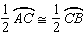 because of the multiplication property of equalities; and because of substitution.

REF: 019439siii

6 ANS:
because all radii are equal. because of the reflexive property. and because tangents to a circle are perpendicular to a radius at a point on a circle. and are right angles because of the definition of perpendicular. because all right angles are congruent. because of HL. because of CPCTC.

REF: 061138ge

7 ANS:
2. The diameter of a circle is to a tangent at the point of tangency. 4. An angle inscribed in a semicircle is a right angle. 5. All right angles are congruent. 7. AA. 8. Corresponding sides of congruent triangles are in proportion. 9. The product of the means equals the product of the extremes.

REF: 011438ge

8 ANS:
and are congruent vertical angles. Because and intercept the same arc, they are congruent. by AA. Because corresponding sides of similar triangles are in proportion, 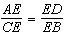. Cross-multiplying, . 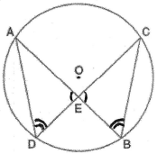

REF: 060133b

9 ANS:
Circle O, chords and intersect at E (Given); Chords and are drawn (auxiliary lines drawn); (vertical angles); (Inscribed angles that intercept the same arc are congruent); (AA); (Corresponding sides of similar triangles are proportional); (The product of the means equals the product of the extremes).

REF: 081635geo

10 ANS:
Circle O, secant , tangent (Given). Chords and are drawn (Auxiliary lines). , (Reflexive property). 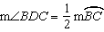 (The measure of an inscribed angle is half the measure of the intercepted arc). 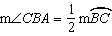 (The measure of an angle formed by a tangent and a chord is half the measure of the intercepted arc). (Angles equal to half of the same arc are congruent). (AA). 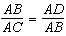 (Corresponding sides of similar triangles are proportional). (In a proportion, the product of the means equals the product of the extremes).

REF: spr1413geo

11 ANS:
Circle O, tangent to diameter , chord secant , and chord (given); is a right angle (an angle inscribed in a semi-circle is a right angle); (a radius drawn to a point of tangency is perpendicular to the tangent); is a right angle (perpendicular lines form right angles); (all right angles are congruent); (the transversal of parallel lines creates congruent alternate interior angles); (AA); (Corresponding sides of similar triangles are in proportion).

REF: 081733geo

