1 If the dilation is an isometry, what must be the value of k?
1) | 1
2) | 2
3)
4) | 0

2 What are the coordinates of the point under the dilation ?
1)
2)
3)
4)

3 What are the coordinates of point under dilation ?
1)
2)
3)
4)

4 Find the image of under the dilation .

5 What is the image of point after a dilation with the center at the origin and a scale factor of 4?

6 If is transformed under the dilation , what is the image of ?

7 Find the image of under a dilation with the center at the origin and a scale factor of .

8 In which quadrant would the image of point fall after a dilation using a factor of ?
1) | I
2) | II
3) | III
4) | IV

9 In which quadrant will the image of lie after dilation ?

10 The image of point A after a dilation of 3 is . What was the original location of point A?
1)
2)
3)
4)

11 If the image of A after a dilation of is , what are the coordinates of A?
1)
2)
3)
4)

12 The point maps onto under a dilation with respect to the origin. What is the constant of dilation?
1)
2)
3) | 3
4)

13 Under a dilation with respect to the origin, the image of is . What is the constant of dilation?
1)
2)
3) | 3
4) | 10

14 If the dilation equals , the scale factor k is equal to
1)
2) | 2
3)
4)

15 Under a dilation where the center of dilation is the origin, the image of is . What are the coordinates of , the image of under the same dilation?
1)
2)
3)
4)

16 Triangle is the image of under a dilation such that . Triangles and are
1) | congruent but not similar
2) | similar but not congruent
3) | both congruent and similar
4) | neither congruent nor similar

17 Triangle is the image of after a dilation of 2. Which statement is true?
1)
2)
3)
4) | 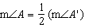

18 Triangle ABC has vertices , , and . State and label the coordinates of , the image of after a dilation of .

19 The graph of the function is shown on the accompanying set of axes. On the same set of axes, sketch the image of under the transformation .
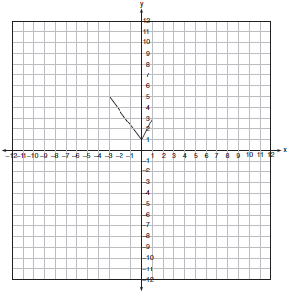

20 On the accompanying set of axes, graph with coordinates , , and . Then graph , the image of after a dilation of 2.
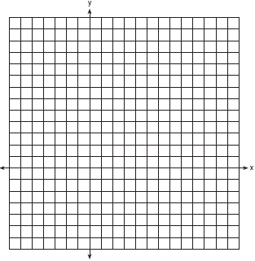

21 Triangle ABC has coordinates , , and . On the set of axes below, graph and label , the image of after a dilation of 2.

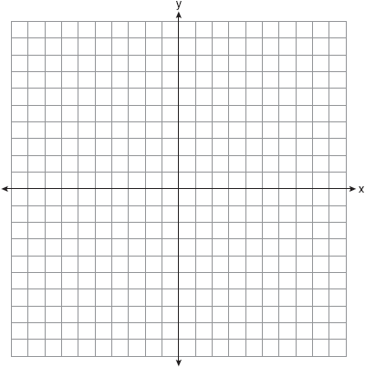

22 Triangle ABC has coordinates , , and . On the set of axes below, graph and label , the image of after a dilation of .

23 On the accompanying grid, graph and label quadrilateral ABCD, whose coordinates are , , , and . Graph, label, and state the coordinates of , the image of ABCD under a dilation of 2, where the center of dilation is the origin.



24 Given: quadrilateral ABCD with vertices , , , and . State the coordinates of , the image of quadrilateral ABCD under a dilation of factor . Prove that is a parallelogram. [The use of the grid is optional.]

25 Using a drawing program, a computer graphics designer constructs a circle on a coordinate plane on her computer screen. She determines that the equation of the circle’s graph is . She then dilates the circle with the transformation . After this transformation, what is the center of the new circle?
1)
2)
3)
4)

26 The engineering office in the village of Whitesboro has a map of the village that is laid out on a rectangular coordinate system. A traffic circle located on the map is represented by the equation . The village planning commission asks that the transformation be applied to produce a new traffic circle, where the center of dilation is at the origin. Find the coordinates of the center of the new traffic circle. Find the length of the radius of the new traffic circle.

1 ANS: 1 REF: 080916b

2 ANS: 4 REF: 069017siii

3 ANS: 2 REF: 060318siii

4 ANS:

REF: 068506siii

5 ANS:

REF: 080202siii

6 ANS:

REF: 019014siii

7 ANS:

REF: 069806siii

8 ANS: 2
falls in Quadrant II.

REF: 010311b

9 ANS:
II

REF: 060106siii

10 ANS: 1 REF: 010725a

11 ANS: 1 REF: 019918siii

12 ANS: 1 REF: 061003b

13 ANS: 2
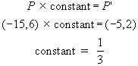

REF: 080711b

14 ANS: 3 REF: 019416siii

15 ANS: 2
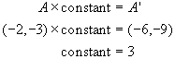.

REF: 010803b

16 ANS: 2 REF: 010302a

17 ANS: 3 REF: 011524ge

18 ANS:

REF: 081329ge

19 ANS:
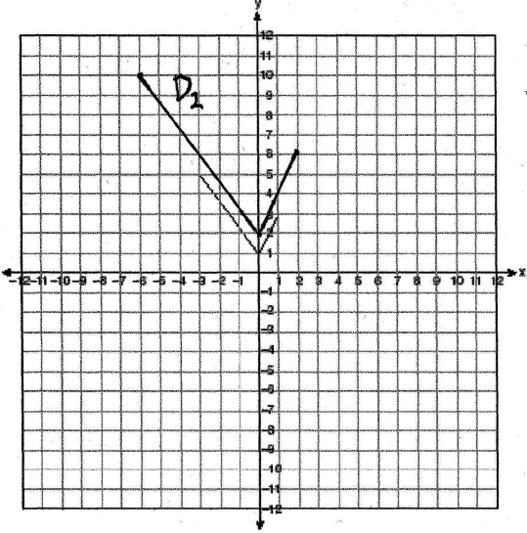

REF: 060521b

20 ANS:
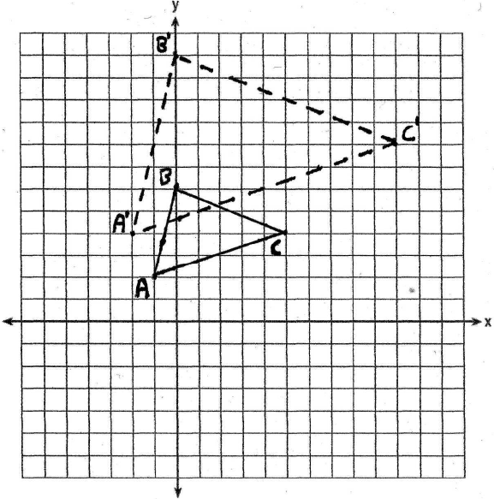

REF: 080128a

21 ANS:
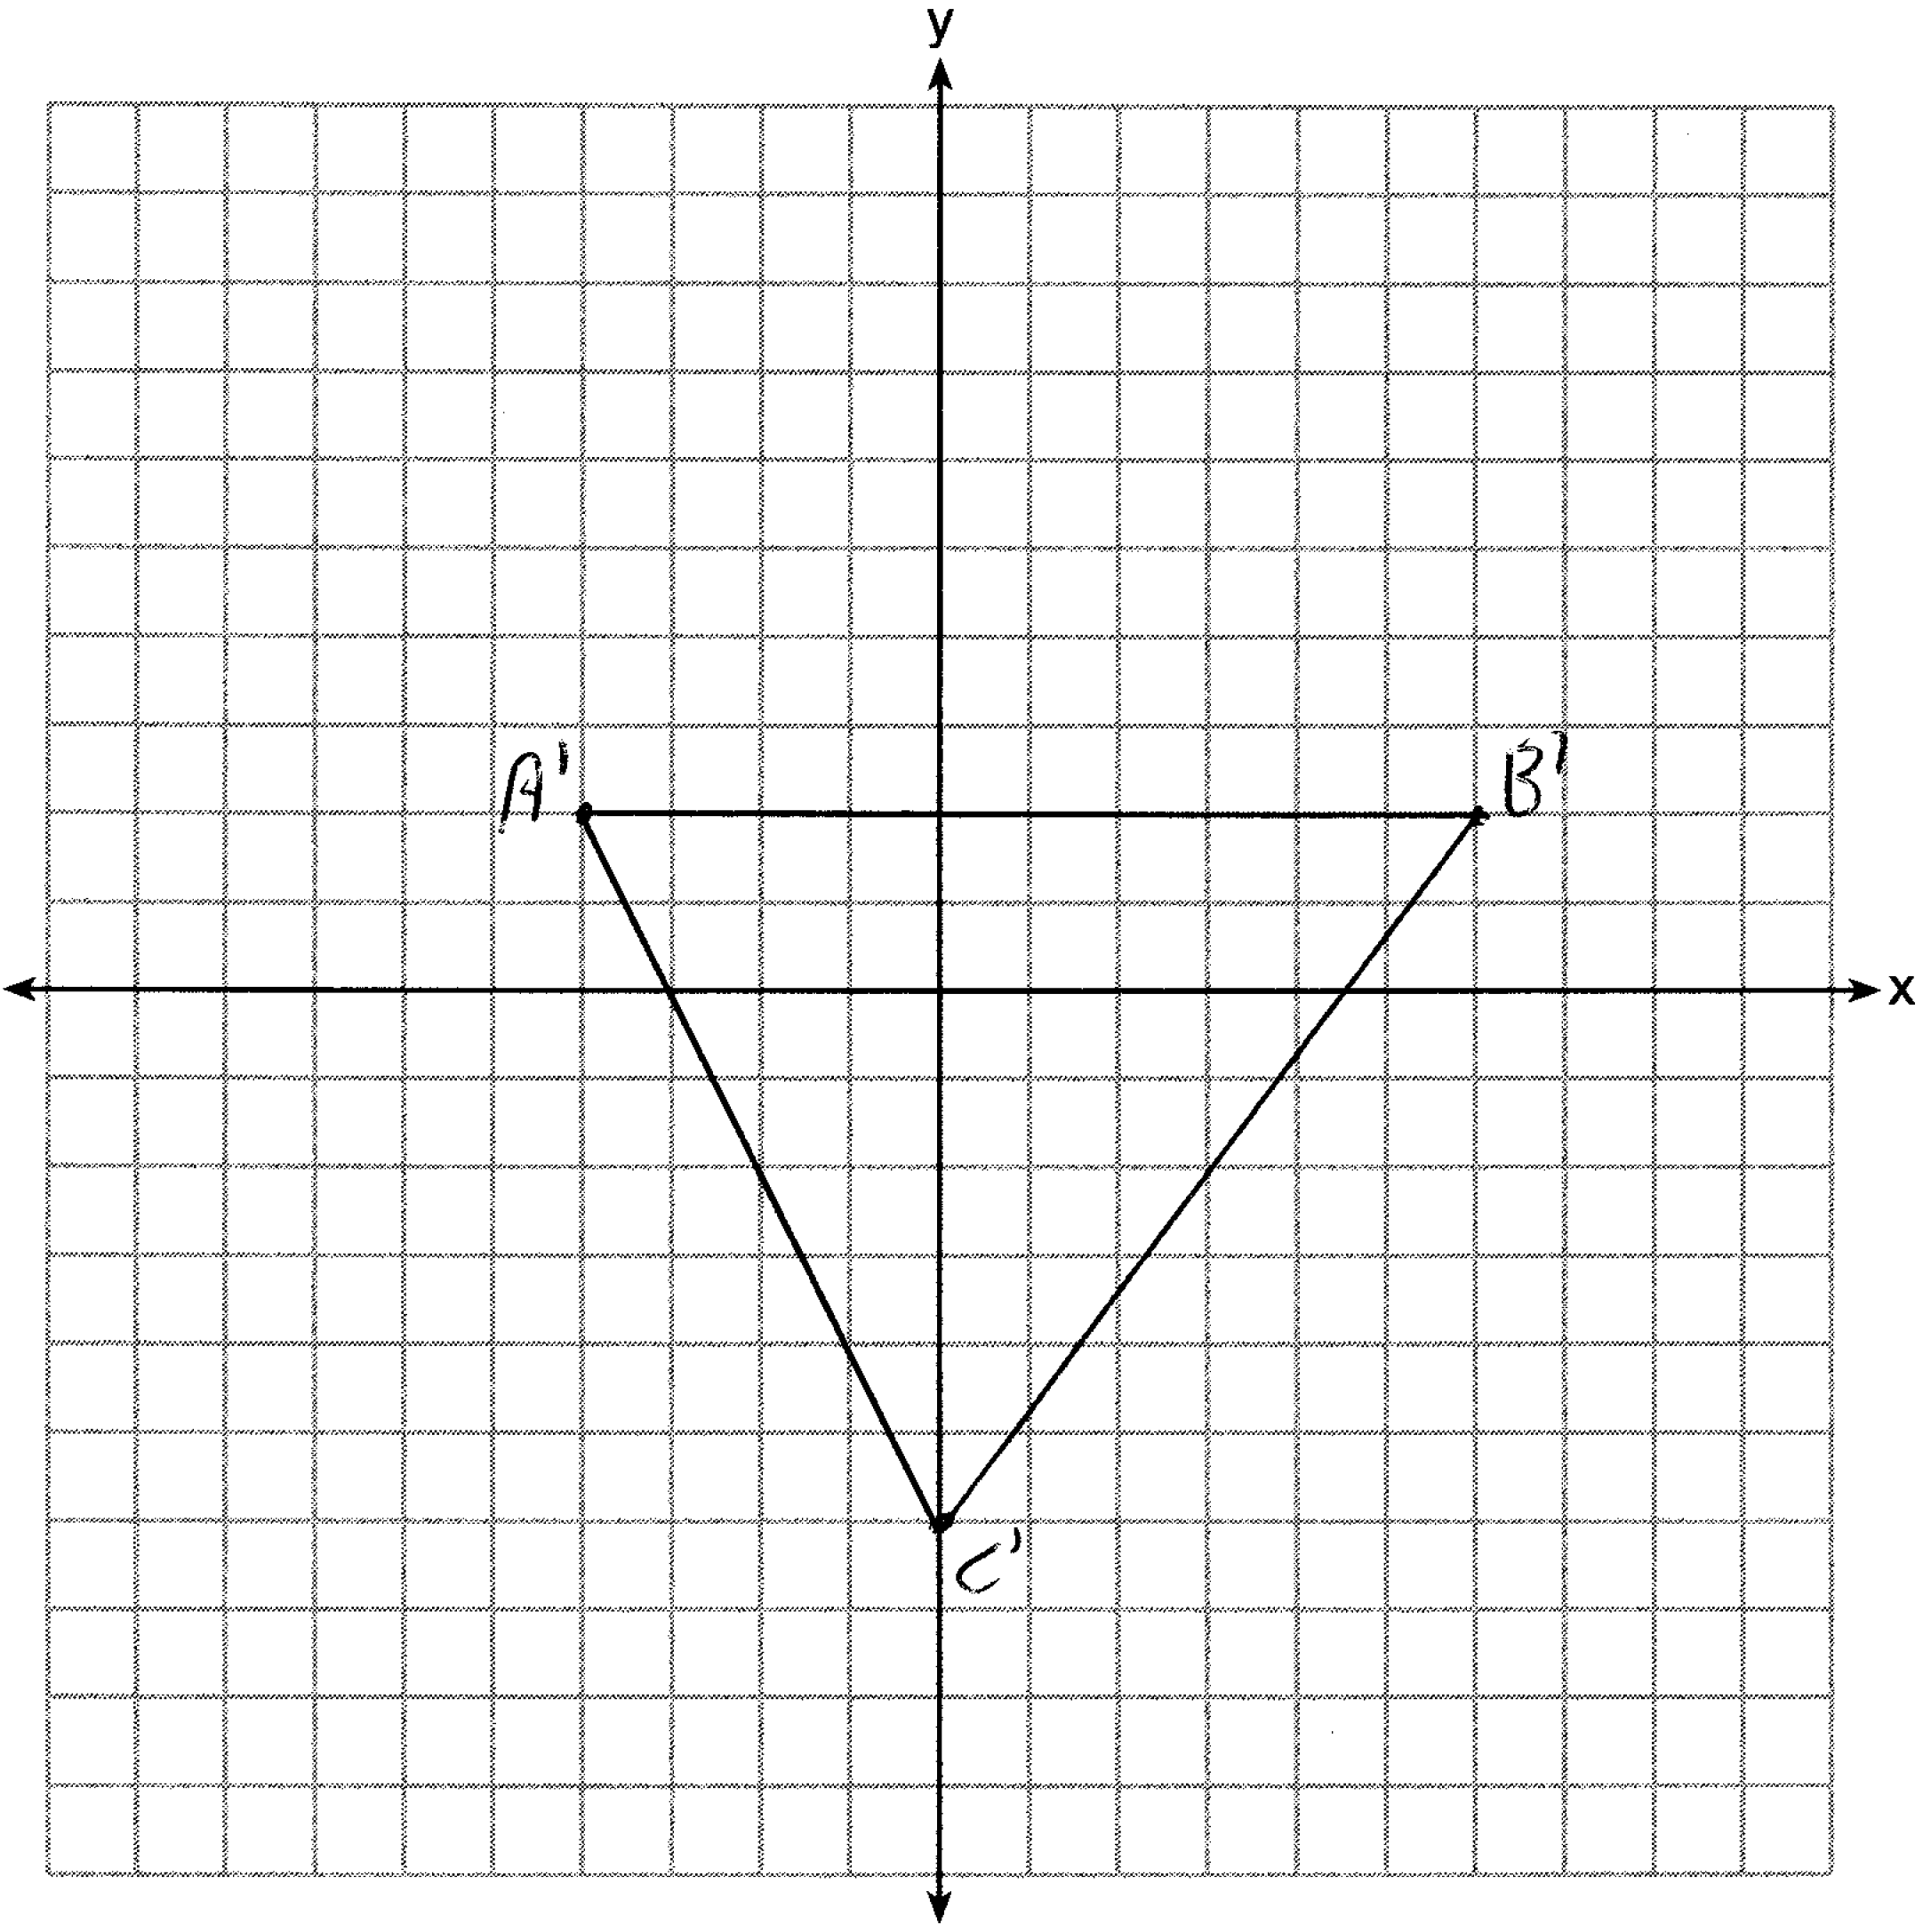

REF: 081429ge

22 ANS:
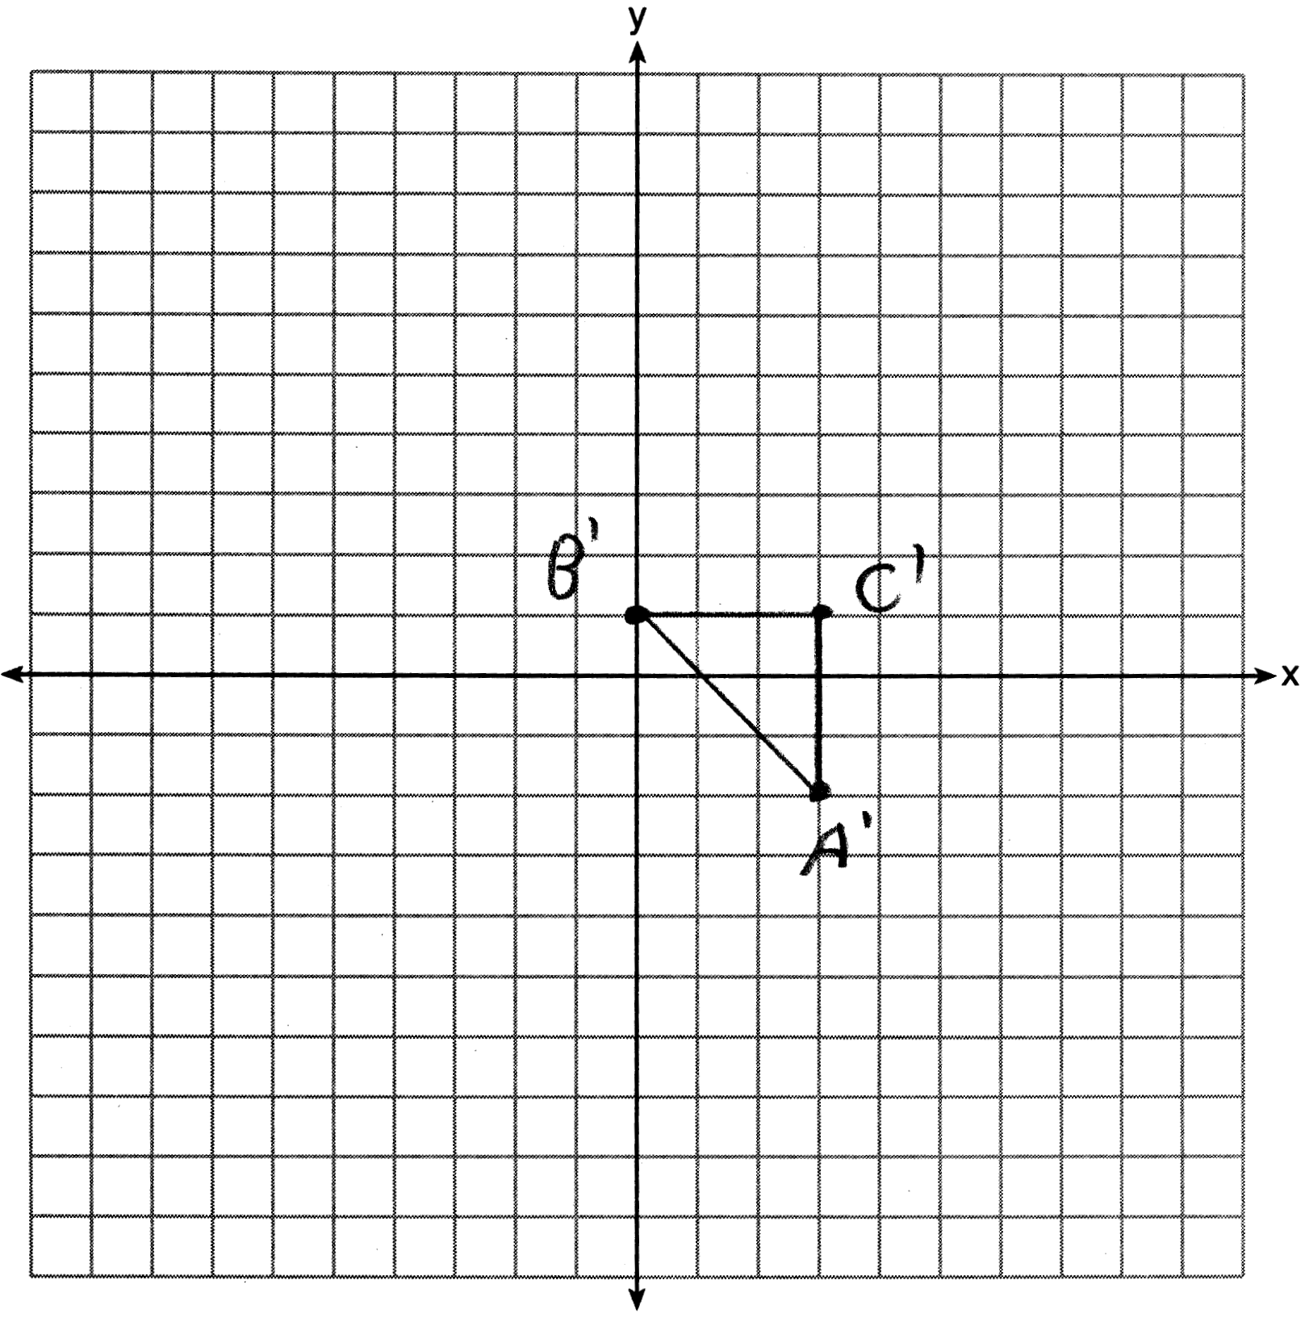

REF: 011630ge

23 ANS:
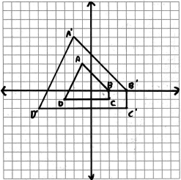 , , ,

REF: 010937a

24 ANS:
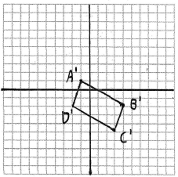. The coordinates of , the image of quadrilateral ABCD under a dilation of factor are A'(-1,1), B'(4,-2), C'(3,-5) and D'(-2,-2). To prove that is a parallelogram, show that both pairs of opposite sides of the parallelogram are parallel by showing the opposite sides have the same slope: 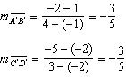 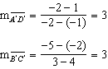.

REF: 060733b

25 ANS: 3
The center of the circle before the dilation is (3,-2).

REF: 060911b

26 ANS:
, 18. Before, the center is and the radius is 9.

REF: 060831b

