1 In the diagram below, is dilated by a scale factor of centered at point B to map onto .
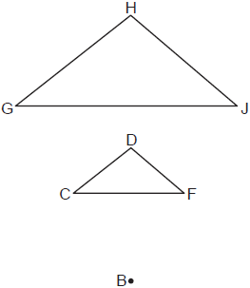
If , what is ?
1) | 20º
2) | 40º
3) | 60º
4) | 80º

2 Triangle A'B'C' is the image of after a dilation centered at the origin. The coordinates of the vertices of are , , and .
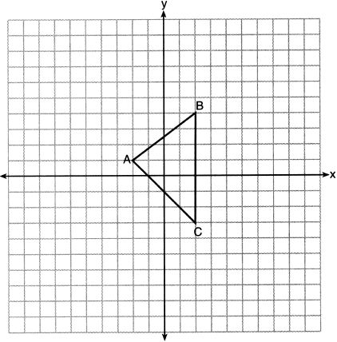
If the coordinates of are , the coordinates of are
1)
2)
3)
4)

3 If is dilated by a scale factor of 0.5, which statement about the image, , is true?
1) | 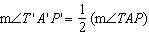
2)
3)
4) | 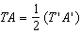

4 If is dilated by a scale factor of 3, which statement is true of the image ?
1)
2)
3)
4)

5 The image of after a dilation of scale factor k centered at point A is , as shown in the diagram below.

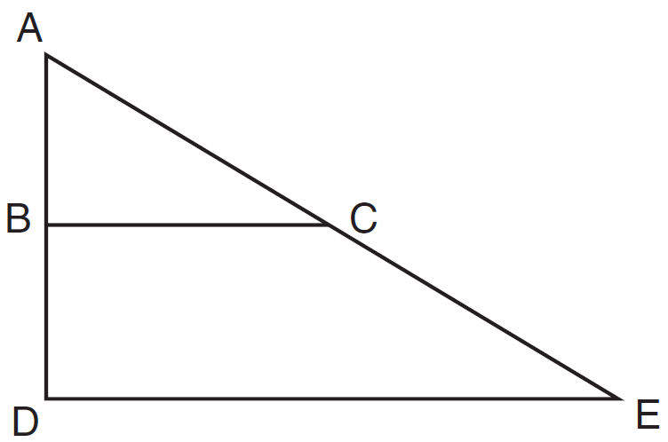

Which statement is always true?
1)
2)
3)
4)

6 Triangle KLM is dilated by a scale factor of 3 to map onto triangle DRS. Which statement is not always true?
1)
2) | 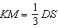
3) | The area of is 3 times the area of .
4) | The perimeter of is 3 times the perimeter of .

7 A triangle is dilated by a scale factor of 3 with the center of dilation at the origin. Which statement is true?
1) | The area of the image is nine times the area of the original triangle.
2) | The perimeter of the image is nine times the perimeter of the original triangle.
3) | The slope of any side of the image is three times the slope of the corresponding side of the original triangle.
4) | The measure of each angle in the image is three times the measure of the corresponding angle of the original triangle.

8 Rectangle A'B'C'D' is the image of rectangle ABCD after a dilation centered at point A by a scale factor of . Which statement is correct?
1) | Rectangle A'B'C'D' has a perimeter that is the perimeter of rectangle ABCD.
2) | Rectangle A'B'C'D' has a perimeter that is the perimeter of rectangle ABCD.
3) | Rectangle A'B'C'D' has an area that is the area of rectangle ABCD.
4) | Rectangle A'B'C'D' has an area that is the area of rectangle ABCD.

9 Triangle RJM has an area of 6 and a perimeter of 12. If the triangle is dilated by a scale factor of 3 centered at the origin, what are the area and perimeter of its image, triangle R'J'M'?
1) | area of 9 and perimeter of 15
2) | area of 18 and perimeter of 36
3) | area of 54 and perimeter of 36
4) | area of 54 and perimeter of 108

10 Given square RSTV, where cm. If square RSTV is dilated by a scale factor of 3 about a given center, what is the perimeter, in centimeters, of the image of RSTV after the dilation?
1) | 12
2) | 27
3) | 36
4) | 108

11 A rectangle has a width of 3 and a length of 4. The rectangle is dilated by a scale factor of 1.8. What is the area of its image, to the nearest tenth?
1) | 3.7
2) | 6.7
3) | 21.6
4) | 38.9

12 In the diagram below, is the image of after a dilation centered at the origin. The coordinates of the vertices are , , , , and .

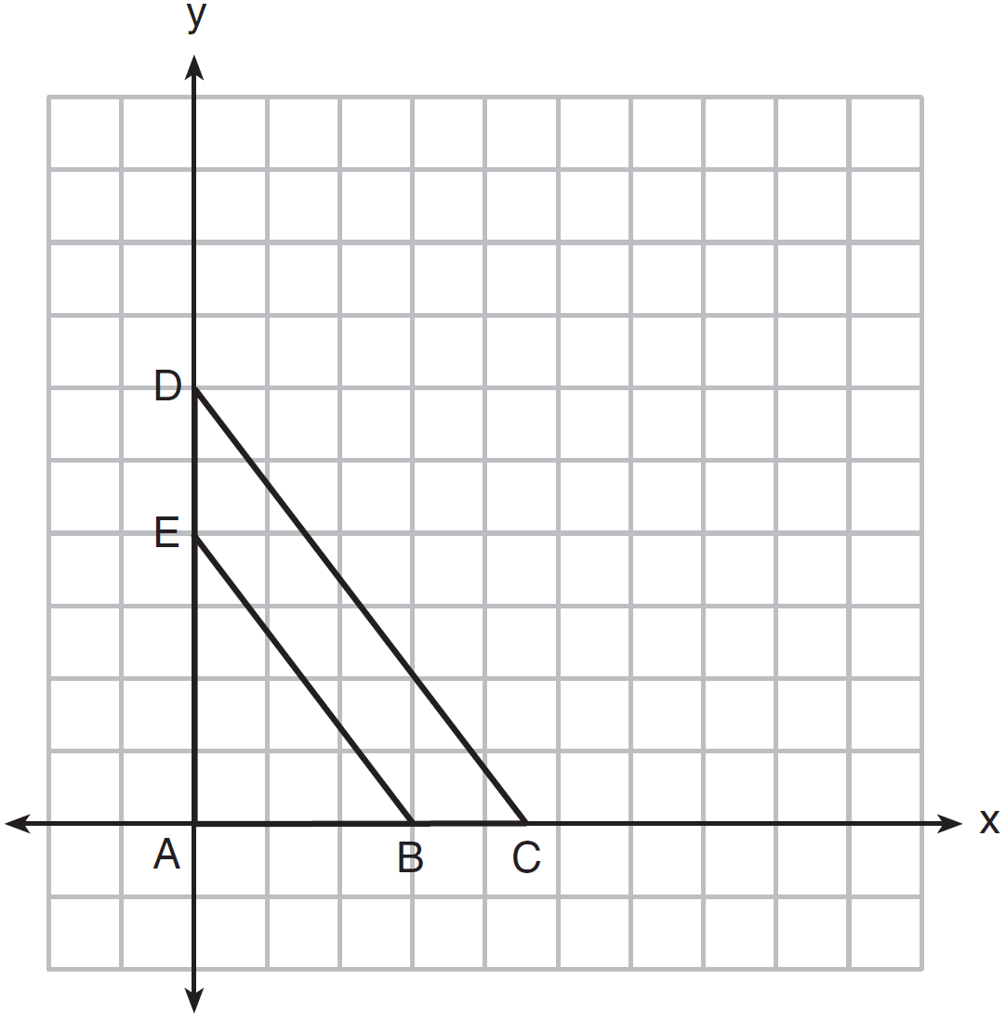

The ratio of the lengths of to is
1)
2)
3)
4)

13 On the set of axes below, is the image of after a dilation centered at point P.
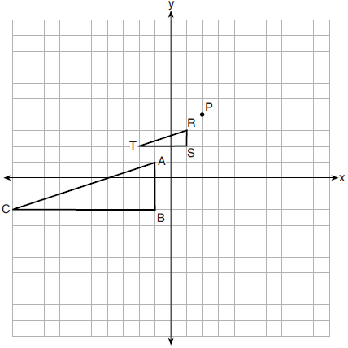
The scale factor of the dilation that maps onto is
1)
2) | 2
3) | 3
4)

14 On the set of axes below, is the image of after a dilation of scale factor .
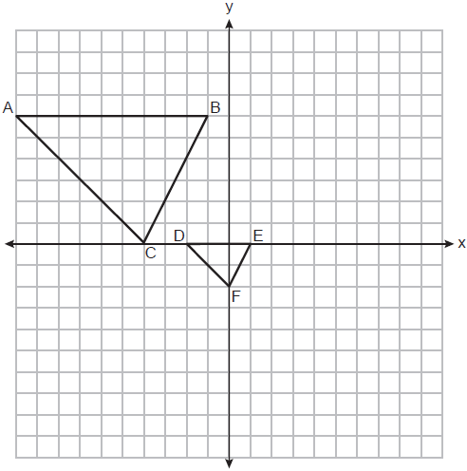
The center of dilation is at
1)
2)
3)
4)

15 Triangle A'B'C' is the image of triangle ABC after a dilation with a scale factor of and
centered at point A. Is triangle ABC congruent to triangle A'B'C'? Explain your answer.

16 Triangle QRS is graphed on the set of axes below.

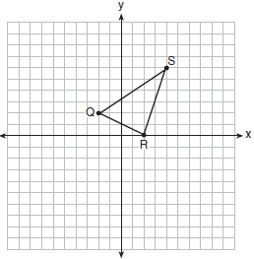

On the same set of axes, graph and label , the image of after a dilation with a scale factor of centered at the origin. Use slopes to explain why .

17 Triangle ABC and triangle ADE are graphed on the set of axes below.

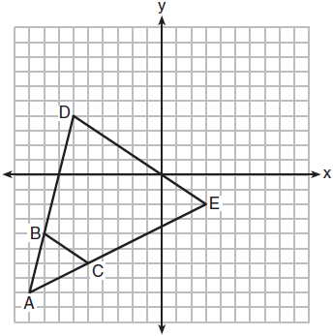

Describe a transformation that maps triangle ABC onto triangle ADE. Explain why this transformation makes triangle ADE similar to triangle ABC.

18 Triangle ABC and point are graphed on the set of axes below.

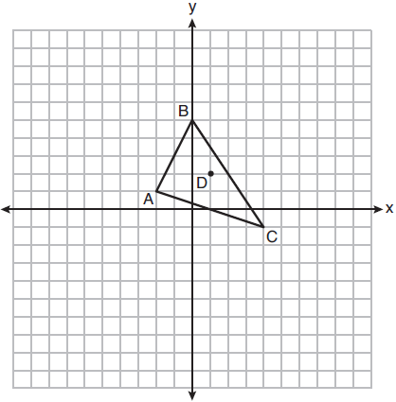

Graph and label , the image of , after a dilation of scale factor 2 centered at point D.

1 ANS: 2 REF: 012409geo

2 ANS: 2
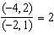

REF: 062201geo

3 ANS: 3
(1) and (2) are false as dilations preserve angle measure. (4) would be true if the scale factor was 2.

REF: 082323geo

4 ANS: 2 REF: 061516geo

5 ANS: 4 REF: 081506geo

6 ANS: 3 REF: 062414geo

7 ANS: 1

REF: 081520geo

8 ANS: 1 REF: 011811geo

9 ANS: 3

REF: 081823geo

10 ANS: 4
,

REF: 061805geo

11 ANS: 4

REF: 082420geo

12 ANS: 1
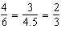

REF: 081523geo

13 ANS: 1
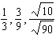

REF: 082206geo

14 ANS: 2
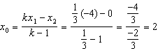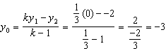

REF: 062313geo

15 ANS:
No, because dilations do not preserve distance.

REF: 061925geo

16 ANS:
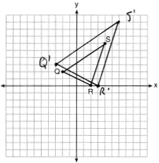 A dilation preserves slope, so the slopes of and are equal. Because the slopes are equal, .

REF: 011732geo

17 ANS:
A dilation of 3 centered at A. A dilation preserves angle measure, so the triangles are similar.

REF: 011832geo

18 ANS:
, ,

REF: 061826geo

