1 In the diagram below, is the image of after a clockwise rotation of 180° and a dilation where , , , , , and .

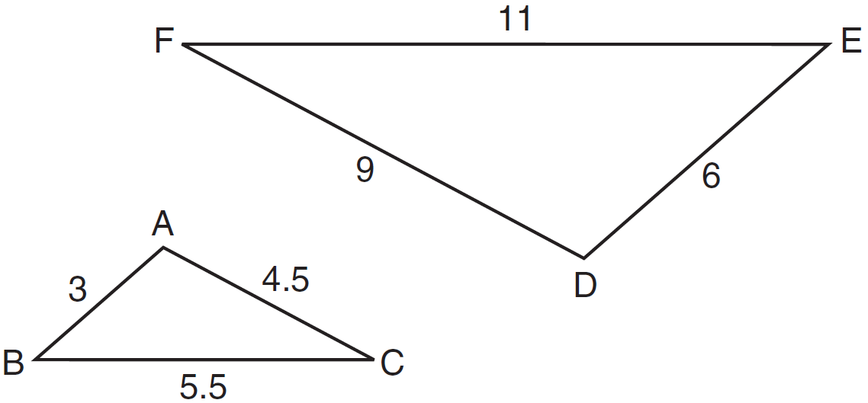

Which relationship must always be true?
1) | 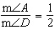
2) | 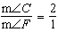
3) | 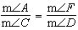
4) | 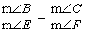

2 In the diagram below, is the image of after a reflection over the line AC followed by a dilation of scale factor centered at point A.

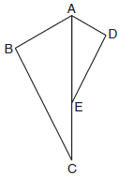

Which statement must be true?
1)
2)
3) | 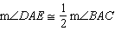
4) | 

3 Which sequence of transformations will map onto ?

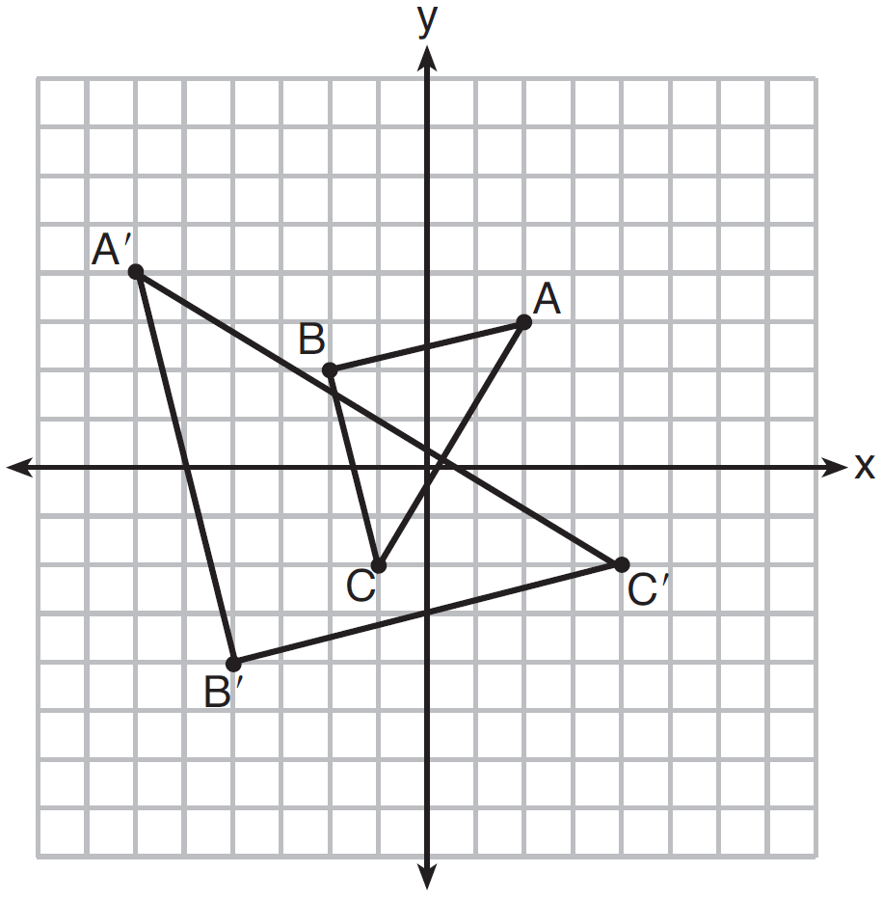
1) | reflection and translation
2) | rotation and reflection
3) | translation and dilation
4) | dilation and rotation

4 Given: , , and

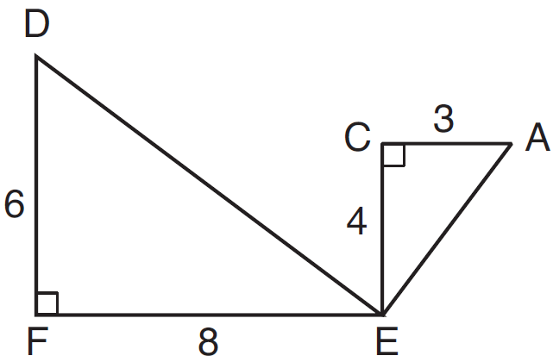

What is a correct sequence of similarity transformations that shows ?
1) | a rotation of 180 degrees about point E followed by a horizontal translation
2) | a counterclockwise rotation of 90 degrees about point E followed by a horizontal translation
3) | a rotation of 180 degrees about point E followed by a dilation with a scale factor of 2 centered at point E
4) | a counterclockwise rotation of 90 degrees about point E followed by a dilation with a scale factor of 2 centered at point E

5 On the set of axes below, has vertices at , , , and has vertices at , , .
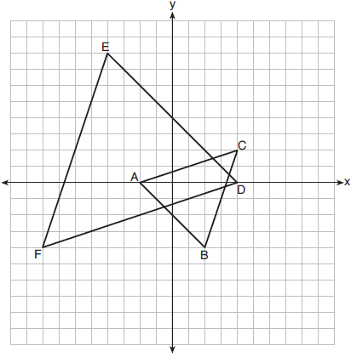
Which sequence of transformations will map onto ?
1) | a dilation of by a scale factor of 2 centered at point A
2) | a dilation of by a scale factor of centered at point A
3) | a dilation of by a scale factor of 2 centered at the origin, followed by a rotation of 180° about the origin
4) | a dilation of by a scale factor of centered at the origin, followed by a rotation of 180° about the origin

6 After a composition of transformations, the coordinates , , and become , , and , as shown on the set of axes below.
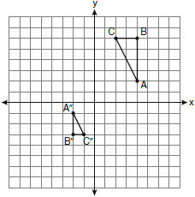
Which composition of transformations was used?
1)
2)
3)
4)

7 In the diagram below, triangles XYZ and UVZ are drawn such that and .

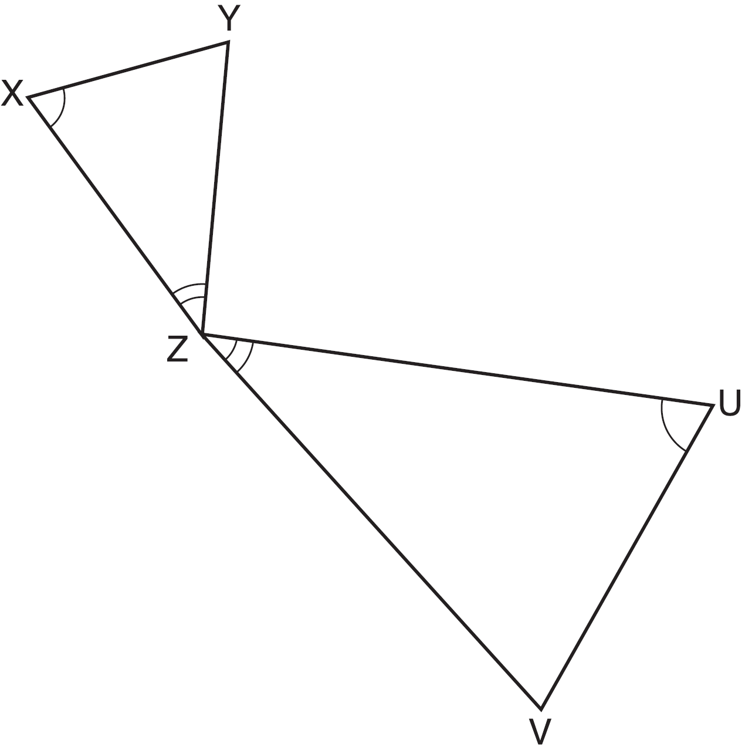

Describe a sequence of similarity transformations that shows is similar to .

8 As shown on the set of axes below, has vertices , , and . Graph and state the coordinates of , the image of after the transformation .

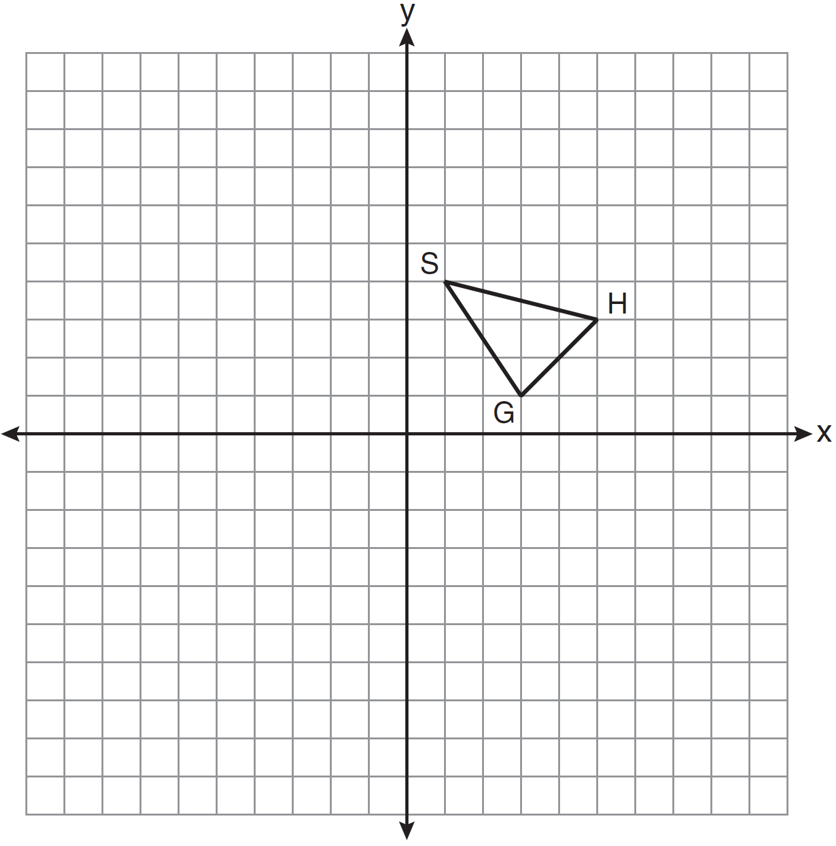

9 Triangle ABC has vertices , and . State and label the coordinates of the vertices of , the image of , following the composite transformation . [The use of the set of axes below is optional.]

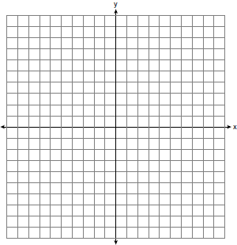

10 The coordinates of the vertices of parallelogram SWAN are , , , and . State and label the coordinates of parallelogram , the image of SWAN after the transformation . [The use of the set of axes below is optional.]

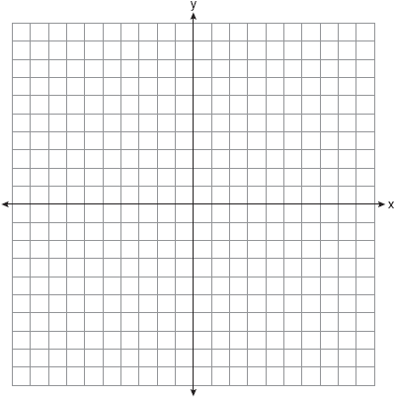

11 Triangle ABC has coordinates , , and .
a On the grid below, graph and label .
b Graph and state the coordinates of , the image of after a half-turn .
c Graph and state the coordinates of , the image of after .
d What is the ratio of the area of to the area of ?

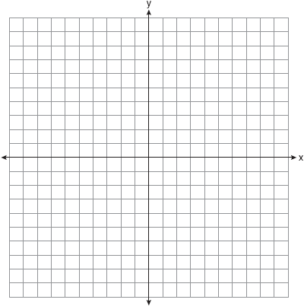

12 The coordinates of the vertices of , and . On the grid below, graph and label , the result of the composite transformation . State the coordinates of , , and .



13 The coordinates of the endpoints of are and . Is the image the same if it is reflected in the x-axis, then dilated by as the image is if it is dilated by , then reflected in the x-axis? Justify your answer. (The use of the accompanying grid is optional.)

14 Triangle ABC has vertices , , and . On the accompanying grid, draw and label . Graph and state the coordinates of , the image of after the composition .



15 Farmington, New York, has plans for a new triangular park. If plotted on a coordinate grid, the vertices would be , , and . However, a tract of land has become available that would enable the planners to increase the size of the park, which is based on the following transformation of the original triangular park, . On the grid below, graph and label both the original park and its image, the new park , following the transformation.

16 a Triangle ABC has coordinates , , and . On the graph below, draw and label triangle ABC.
b Reflect the graph drawn in part a in the origin. State the coordinates of A', B', and C', the images of A, B, and C.
c Dilate the graph drawn in part b using . State the coordinates of A", B", C", the images of A', B', and C'.
d Translate the graph drawn in part c using . State the coordinates of A"', B''', and C''', the images of A", B", and C".

17 On the graph below, sketch the triangle formed by points , , and . On the same set of axes, graph and state the coordinates of
a , the image of after the rotation .
b , the image of after the translation .
c , the image of after the dilation .
Is the composite transformation an isometry? Explain your answer.

1 ANS: 4 REF: 081514geo

2 ANS: 2 REF: 011702geo

3 ANS: 4 REF: 061608geo

4 ANS: 4 REF: 081609geo

5 ANS: 3 REF: 011903geo

6 ANS: 3 REF: 060908ge

7 ANS:
Triangle is the image of after a rotation about point Z such that coincides with . Since rotations preserve angle measure, coincides with , and corresponding angles X and Y, after the rotation, remain congruent, so . Then, dilate by a scale factor of with its center at point Z. Since dilations preserve parallelism, maps onto . Therefore, .

REF: spr1406geo

8 ANS:
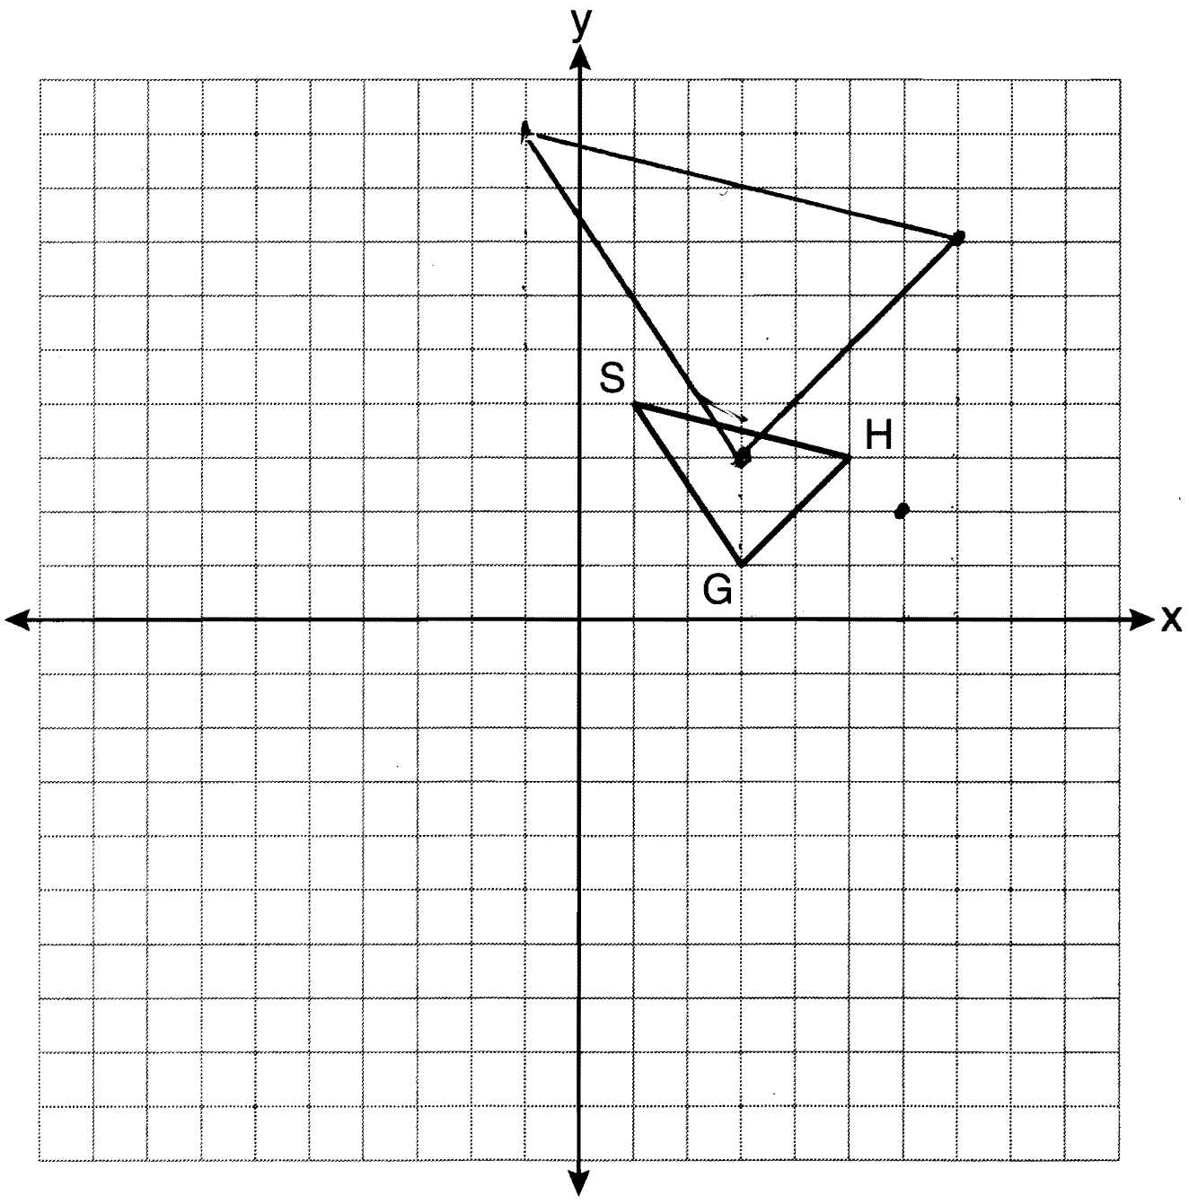

REF: 081136ge

9 ANS:
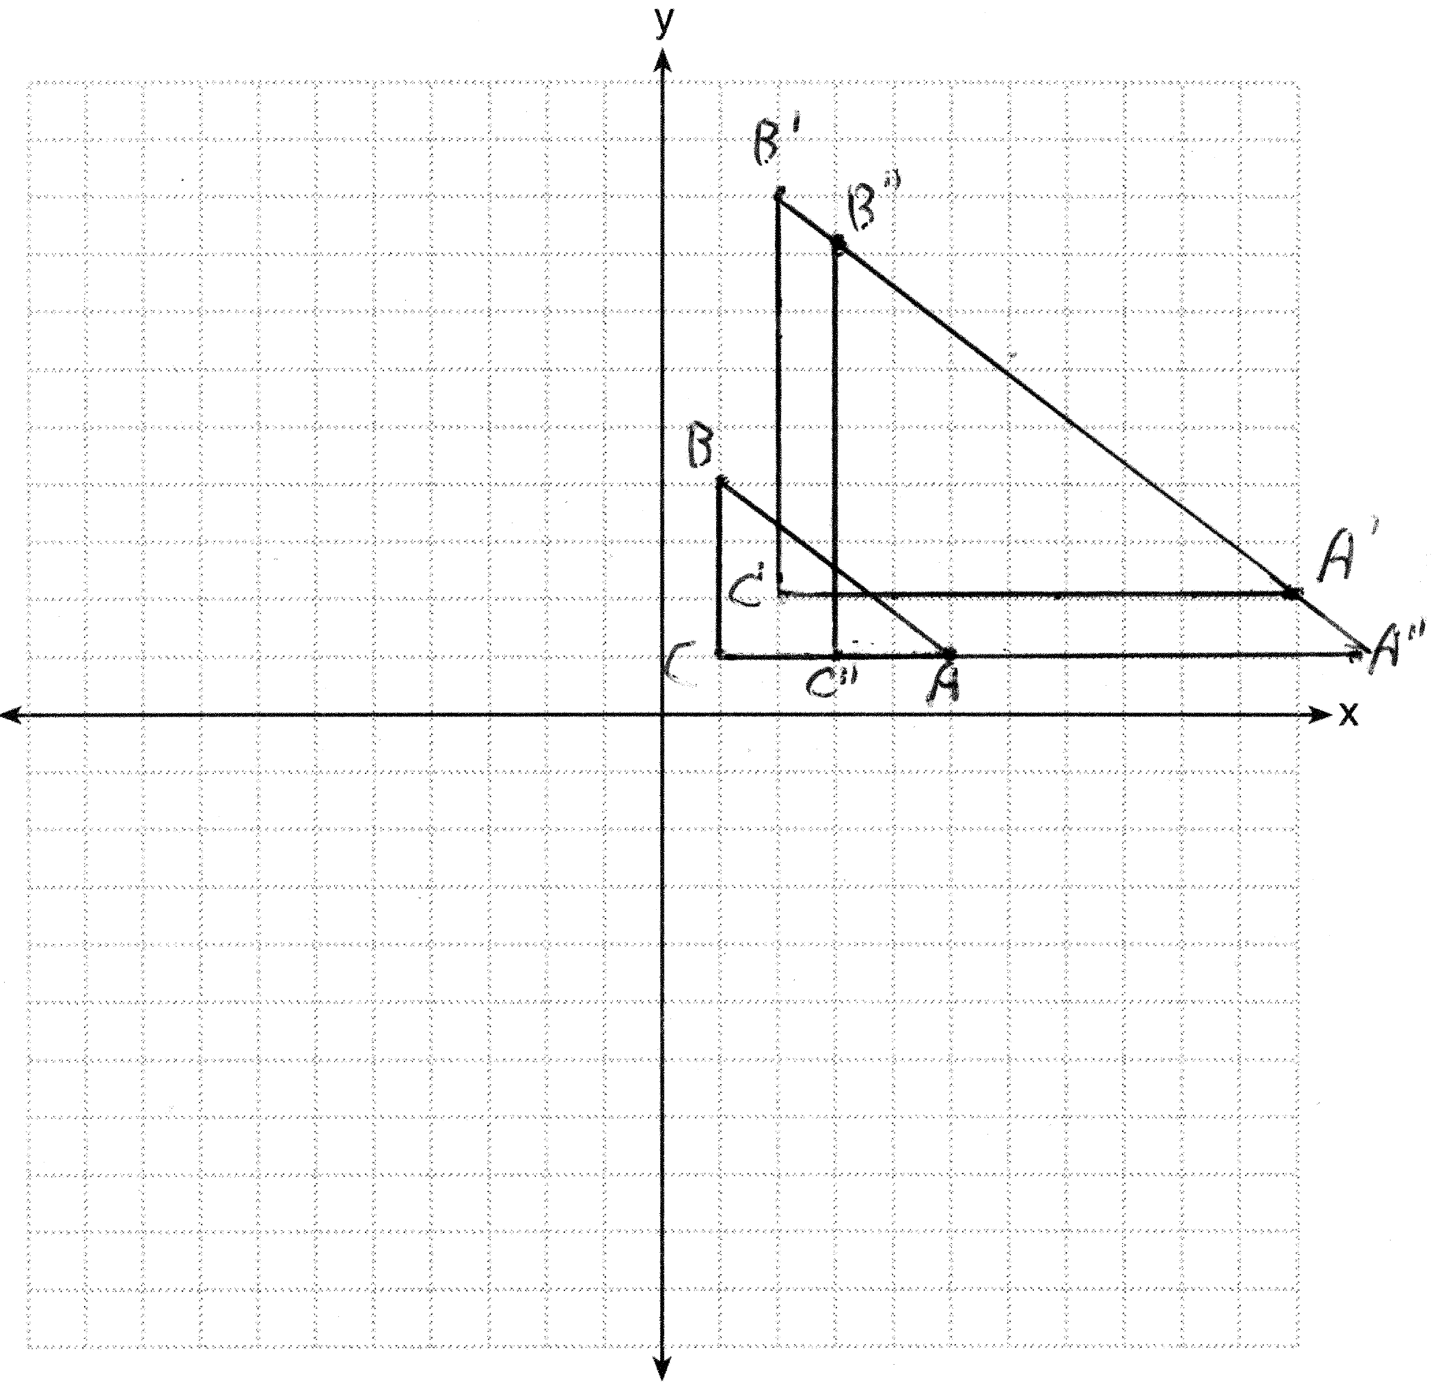

REF: 011336ge

10 ANS:
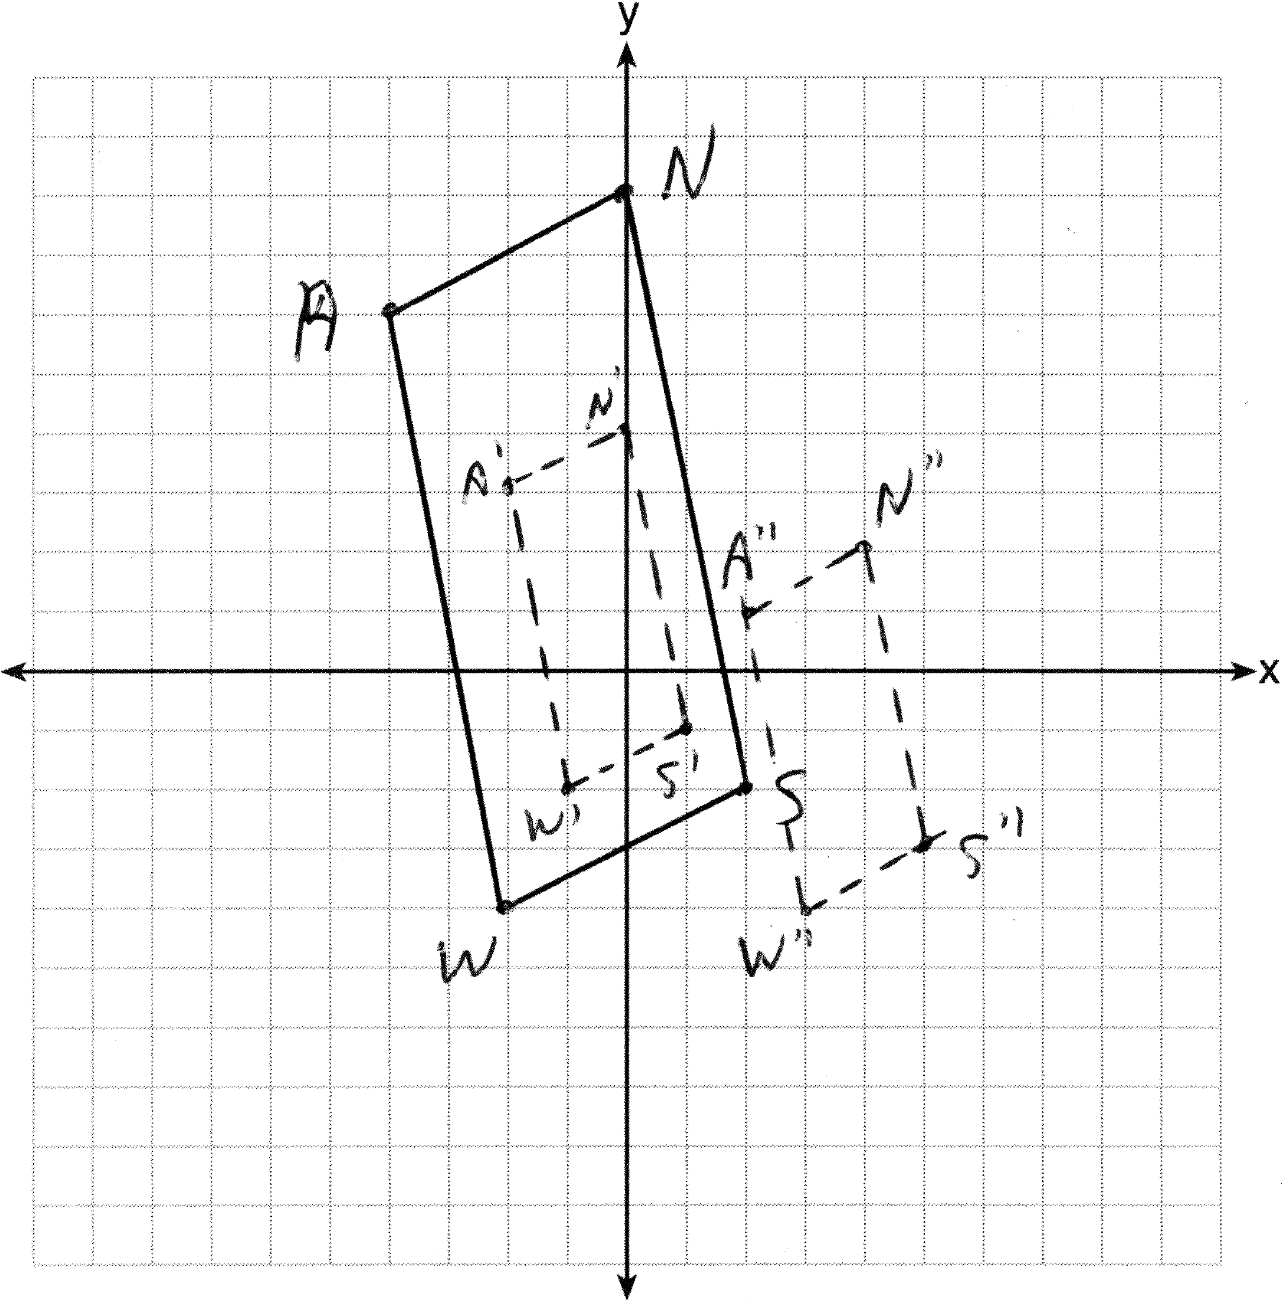 , , , and

REF: 061335ge

11 ANS:
; ;

REF: 089437siii

12 ANS:
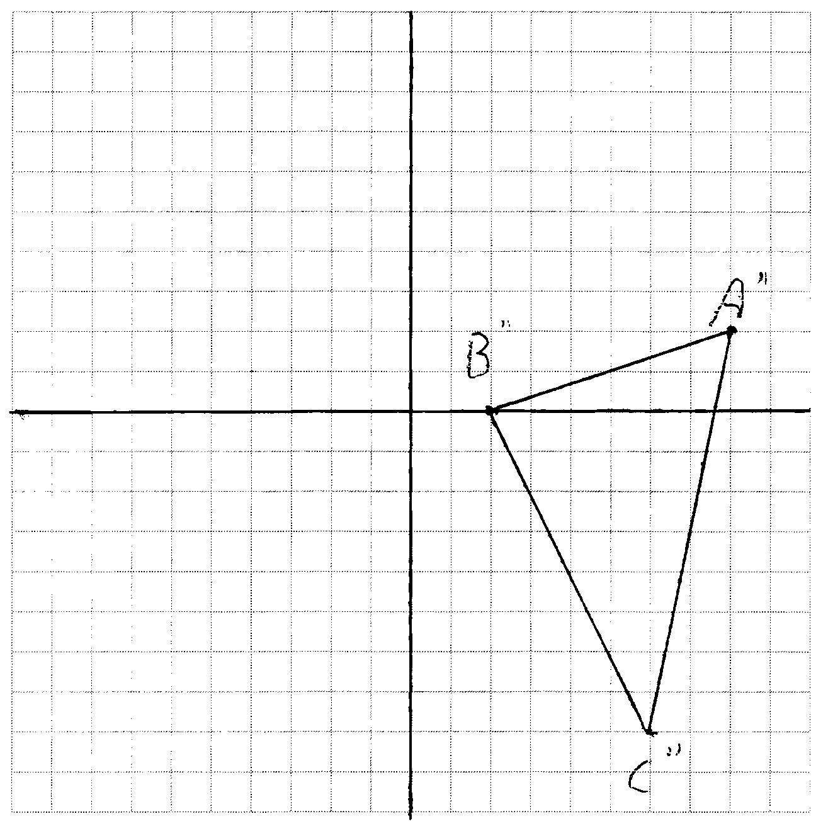

REF: 081036ge

13 ANS:
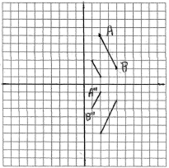 If is reflected first, the coordinates of the endpoints of are and . When the reflection is dilated, the coordinates of the endpoints of are and . If is dilated first, the coordinates of the endpoints of are and . When the dilation is reflected, the coordinates of the endpoints of are and . The images are the same.
REF: 080028a

14 ANS:
REF: 068941siii

15 ANS:
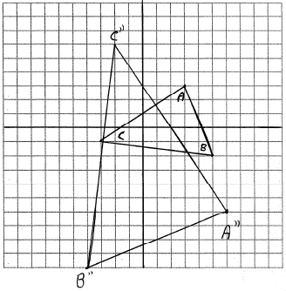
REF: 010930b

16 ANS:
; ;
REF: 069038siii

17 ANS:
; ; ; No, length is not preserved.
REF: 069938siii

