1 Line is mapped onto line m by a dilation centered at the origin with a scale factor of 2. The equation of line is . Determine and state an equation for line m.

2 Line AB is dilated by a scale factor of 2 centered at point A.

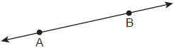

Evan thinks that the dilation of will result in a line parallel to , not passing through points A or B. Nathan thinks that the dilation of will result in the same line, . Who is correct? Explain why.

3 The coordinates of the endpoints of are and . Determine the length of , the image of , after a dilation of centered at the origin. [The use of the set of axes below is optional.]

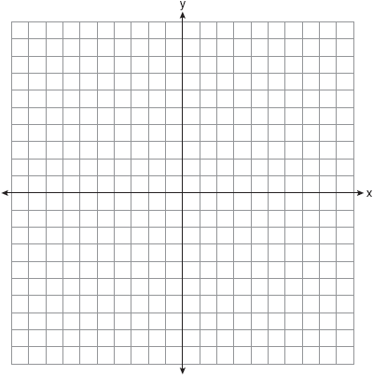

4 Aliyah says that when the line is dilated by a scale factor of 2 centered at the point , the equation of the dilated line is 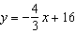. Is Aliyah correct? Explain why. [The use of the set of axes below is optional.]

5 Line n is represented by the equation . Determine and state the equation of line p, the image of line n, after a dilation of scale factor centered at the point . [The use of the set of axes below is optional.] Explain your answer.

1 ANS:
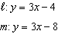

REF: 011631geo

2 ANS:
Nathan, because a line dilated through a point on the line results in the same line.

REF: 082331geo

3 ANS:
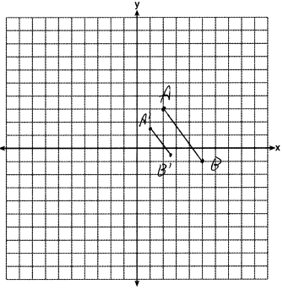

REF: 081729geo

4 ANS:
No, The line passes through the center of dilation, so the dilated line is not distinct. 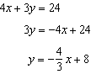

REF: 081830geo

5 ANS:
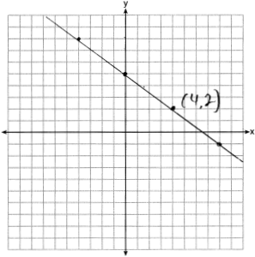 The line is on the center of dilation, so the line does not change.

REF: 061731geo

