1 On the set of axes below, is dilated by a scale factor of centered at point P.
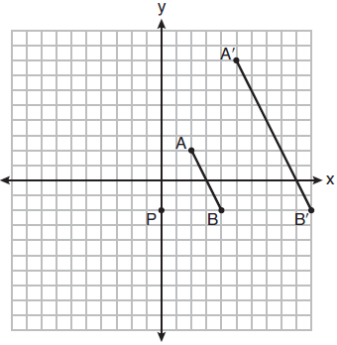
Which statement is always true?
1)
2)
3)
4) | 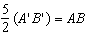

2 A line segment is dilated by a scale factor of 2 centered at a point not on the line segment. Which statement regarding the relationship between the given line segment and its image is true?
1) | The line segments are perpendicular, and the image is one-half of the length of the given line segment.
2) | The line segments are perpendicular, and the image is twice the length of the given line segment.
3) | The line segments are parallel, and the image is twice the length of the given line segment.
4) | The line segments are parallel, and the image is one-half of the length of the given line segment.

3 The line whose equation is is dilated by a scale factor of centered at the origin. Which statement is correct?
1) | The image of the line has the same slope as the pre-image but a different y-intercept.
2) | The image of the line has the same y-intercept as the pre-image but a different slope.
3) | The image of the line has the same slope and the same y-intercept as the pre-image.
4) | The image of the line has a different slope and a different y-intercept from the pre-image.

4 If the line represented by 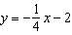 is dilated by a scale factor of 4 centered at the origin, which statement about the image is true?
1) | The slope is and the y-intercept is .
2) | The slope is and the y-intercept is .
3) | The slope is and the y-intercept is .
4) | The slope is and the y-intercept is .

5 A line that passes through the points whose coordinates are and is dilated by a scale factor of 3 and centered at the origin. The image of the line
1) | is perpendicular to the original line
2) | is parallel to the original line
3) | passes through the origin
4) | is the original line

6 A line is dilated by a scale factor of centered at a point on the line. Which statement is correct about the image of the line?
1) | Its slope is changed by a scale factor of .
2) | Its y-intercept is changed by a scale factor of .
3) | Its slope and y-intercept are changed by a scale factor of .
4) | The image of the line and the pre-image are the same line.

7 An equation of line p is 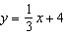. An equation of line q is 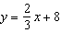. Which statement about lines p and q is true?
1) | A dilation of centered at the origin will map line q onto line p.
2) | A dilation of 2 centered at the origin will map line p onto line q.
3) | Line q is not the image of line p after a dilation because the lines are not parallel.
4) | Line q is not the image of line p after a dilation because the lines do not pass through the origin.

8 The line is transformed by a dilation centered at the origin. Which linear equation could represent its image?
1) | 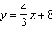
2) | 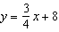
3) | 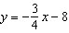
4) | 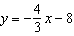

9 The line is transformed by a dilation centered at the origin. Which linear equation could be its image?
1)
2)
3)
4)

10 The line represented by the equation is transformed by a dilation centered at the origin. Which linear equation could represent its image?
1)
2)
3)
4)

1 ANS: 2 REF: 081901geo

2 ANS: 3 REF: 061706geo

3 ANS: 1 REF: 011814geo

4 ANS: 1
A dilation by a scale factor of 4 centered at the origin preserves parallelism and .

REF: 081910geo

5 ANS: 2 REF: 011610geo

6 ANS: 4 REF: 062223geo

7 ANS: 3 REF: 082212geo

8 ANS: 2
The slope of is .

REF: 061907geo

9 ANS: 1
The line does not pass through the center of dilation, so the dilated line will be distinct from . Since a dilation preserves parallelism, the line and its image are parallel, with slopes of .

REF: 061522geo

10 ANS: 1
Since a dilation preserves parallelism, the line and its image are parallel, with slopes of .

REF: 081710geo

