1 The rectangular prism shown below has a length of 3.0 cm, a width of 2.2 cm, and a height of 7.5 cm.

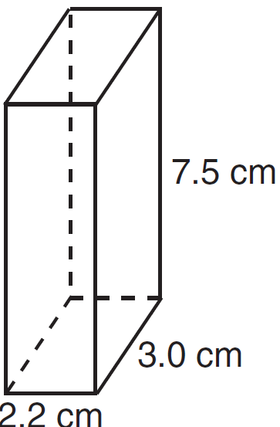

What is the surface area, in square centimeters?
1) | 45.6
2) | 49.5
3) | 78.0
4) | 91.2

2 If the volume of a cube is 8 cubic centimeters, what is its surface area, in square centimeters?
1) | 32
2) | 24
3) | 12
4) | 4

3 The volume of a cube is 64 cubic inches. Its total surface area, in square inches, is
1) | 16
2) | 48
3) | 96
4) | 576

4 Mrs. Ayer is painting the outside of her son’s toy box, including the top and bottom. The toy box measures 3 feet long, 1.5 feet wide, and 2 feet high. What is the total surface area she will paint?
1)
2)
3)
4)

5 How many square inches of wrapping paper are needed to entirely cover a box that is 2 inches by 3 inches by 4 inches?
1) | 18
2) | 24
3) | 26
4) | 52

6 A gallon of paint will cover approximately 450 square feet. An artist wants to paint all the outside surfaces of a cube measuring 12 feet on each edge. What is the least number of gallons of paint he must buy to paint the cube?
1) | 1
2) | 2
3) | 3
4) | 4

7 The length and width of the base of a rectangular prism are 5.5 cm and 3 cm. The height of the prism is 6.75 cm. Find the exact value of the surface area of the prism, in square centimeters.

8 A plastic storage box in the shape of a rectangular prism has a length of , a width of , and a height of 5. Represent the surface area of the box as a trinomial in terms of x.

9 Find the volume, in cubic centimeters, and the surface area, in square centimeters, of the rectangular prism shown below.

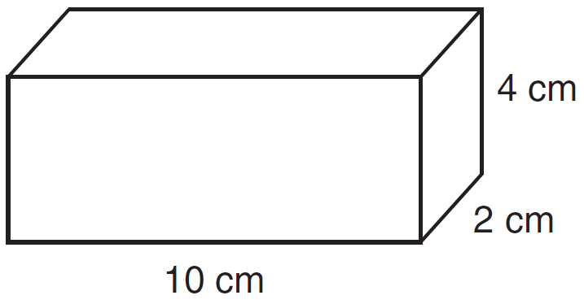

10 The base of a closed right circular cylinder has a diameter of 5 cm. If the height of the cylinder is 8 cm, what is the surface area of the cylinder, to the nearest square centimeter?
1) | 157
2) | 165
3) | 408
4) | 628

11 The surface area of a sphere is 2304π square inches. The length of a radius of the sphere, in inches, is
1) | 12
2) | 24
3) | 288
4) | 576

12 If the surface area of a sphere is 144 square centimeters, what is the length of the diameter of the sphere, in centimeters?
1) | 36
2) | 18
3) | 12
4) | 6

13 The diameter of a sphere is 5 inches. Determine and state the surface area of the sphere, to the nearest hundredth of a square inch.

14 Tim is going to paint a wooden sphere that has a diameter of 12 inches. Find the surface area of the sphere, to the nearest square inch.
1 ANS: 4

REF: 081216ia

2 ANS: 2
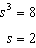.

REF: 081325ia

3 ANS: 3
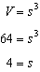. .

REF: 080007a

4 ANS: 4

REF: 060827ia

5 ANS: 4

REF: 011029ia

6 ANS: 2
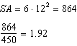

REF: 061519geo

7 ANS:
147.75

REF: 011231ia

8 ANS:
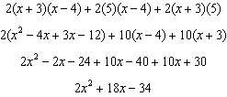

REF: 061136ia

9 ANS:
80, 136

REF: 081035ia

10 ANS: 2

REF: 061514ia

11 ANS: 2
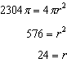

REF: 011606ge

12 ANS: 3
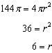

REF: 061415ge

13 ANS:

REF: 011429ge

14 ANS:
452.

REF: 061029ge

