1 The second side of a triangle is two more than the first side, and the third side is three less than the first side. Which expression represents the perimeter of the triangle?
1)
2)
3)
4)

2 What is the perimeter of a square whose diagonal is ?
1) | 18
2) | 12
3) | 9
4) | 6

3 The perimeter of a square is 56. Express the length of a diagonal of the square in simplest radical form.

4 What is the perimeter of a rhombus whose diagonals are 16 and 30?
1) | 92
2) | 68
3) | 60
4) | 17

5 The lengths of the sides of home plate in a baseball field are represented by the expressions in the accompanying figure.

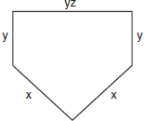

Which expression represents the perimeter of the figure?
1)
2)
3)
4)

6 The Pentagon building in Washington, D.C., is shaped like a regular pentagon. If the length of one side of the Pentagon is represented by , its perimeter would be represented by
1)
2)
3)
4)

7 Pentagon ABCDE is similar to pentagon FGHIJ. The lengths of the sides of ABCDE are 8, 9, 10, 11, and 12. If the length of the longest side of pentagon FGHIJ is 18, what is the perimeter of pentagon FGHIJ?
1) | 50
2) | 56
3) | 75
4) | 100

8 In the accompanying diagram, is an altitude of . If , , and , find the perimeter of in simplest radical form.

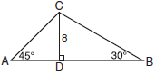

9 In the accompanying diagram, the perimeter of is equal to the perimeter of square ABCD. If the sides of the triangle are represented by , , and , and one side of the square is represented by , find the length of a side of the square.

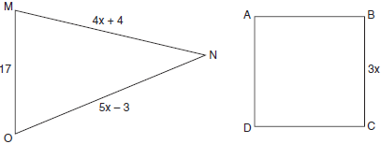

10 The plan of a parcel of land is represented by trapezoid ABCD in the accompanying diagram. If the area of is 600 square feet, find the minimum number of feet of fence needed to completely enclose the entire parcel of land, ABCD.

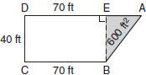

11 Manuel plans to install a fence around the perimeter of his yard. His yard is shaped like a square and has an area of 40,000 square feet. The company that he hires charges $2.50 per foot for the fencing and $50.00 for the installation fee. What will be the cost of the fence, in dollars?

12 An engineer measured the dimensions for a rectangular site by using a wooden pole of unknown length x. The length of the rectangular site is 2 pole measures increased by 3 feet, while the width is 1 pole measure decreased by 4 feet. Write an algebraic representation, in terms of x, for the perimeter of the site.

13 Mr. James wanted to plant a garden that would be in the shape of a rectangle. He was given 80 feet of fencing to enclose his garden. He wants the length to be 10 feet more than twice the width. What are the dimensions, in feet, for a rectangular garden that will use exactly 80 feet of fencing?
1 ANS: 3
First side: x
Second side: x + 2. x + x + 2 + x – 3 = 3x - 1
Third side: x – 3

REF: 060611a

2 ANS: 2
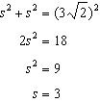

REF: 011420ge

3 ANS:
. The length of each side of the square is 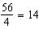.

REF: 010736a

4 ANS: 2

REF: 061326ge

5 ANS: 4 REF: 010603a

6 ANS: 1

REF: 089905a

7 ANS: 3
The perimeter of ABCDE is 50 (8 + 9 + 10 + 11 + 12). FGHIJ is 1.5 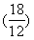 times larger than ABCDE.

REF: 080814a

8 ANS:
. 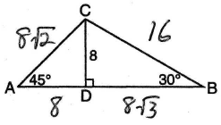. Because is an isosceles right triangle, the ratio of its hypotenuse to its legs is Because is a 30°-60°-90° triangle, the ratio of its hypotenuse to its legs is

REF: 060931b

9 ANS:
18. 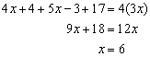.

REF: 080537a

10 ANS:
260. If CD = 40, then BE = 40, which is the base of the shaded triangle. To find the height, or the length of , 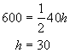. is a multiple of the 3-4-5 triangle, with legs of 30 and 40 and a hypotenuse of 50. The perimeter of trapezoid ABCD is .

REF: 060134a

11 ANS:
2,050. If the yard has an area of 40000 square feet, the length of one side of the square yard is 200 feet. The yard has a perimeter of 800 feet.

REF: 080639a

12 ANS:
. 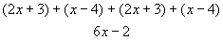

REF: 080124a

13 ANS:
. 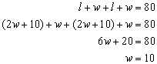. 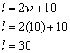

REF: 060536a

