1 As shown in the diagram below, a landscaper uses a cylindrical lawn roller on a lawn. The roller has a radius of 9 inches and a width of 42 inches.

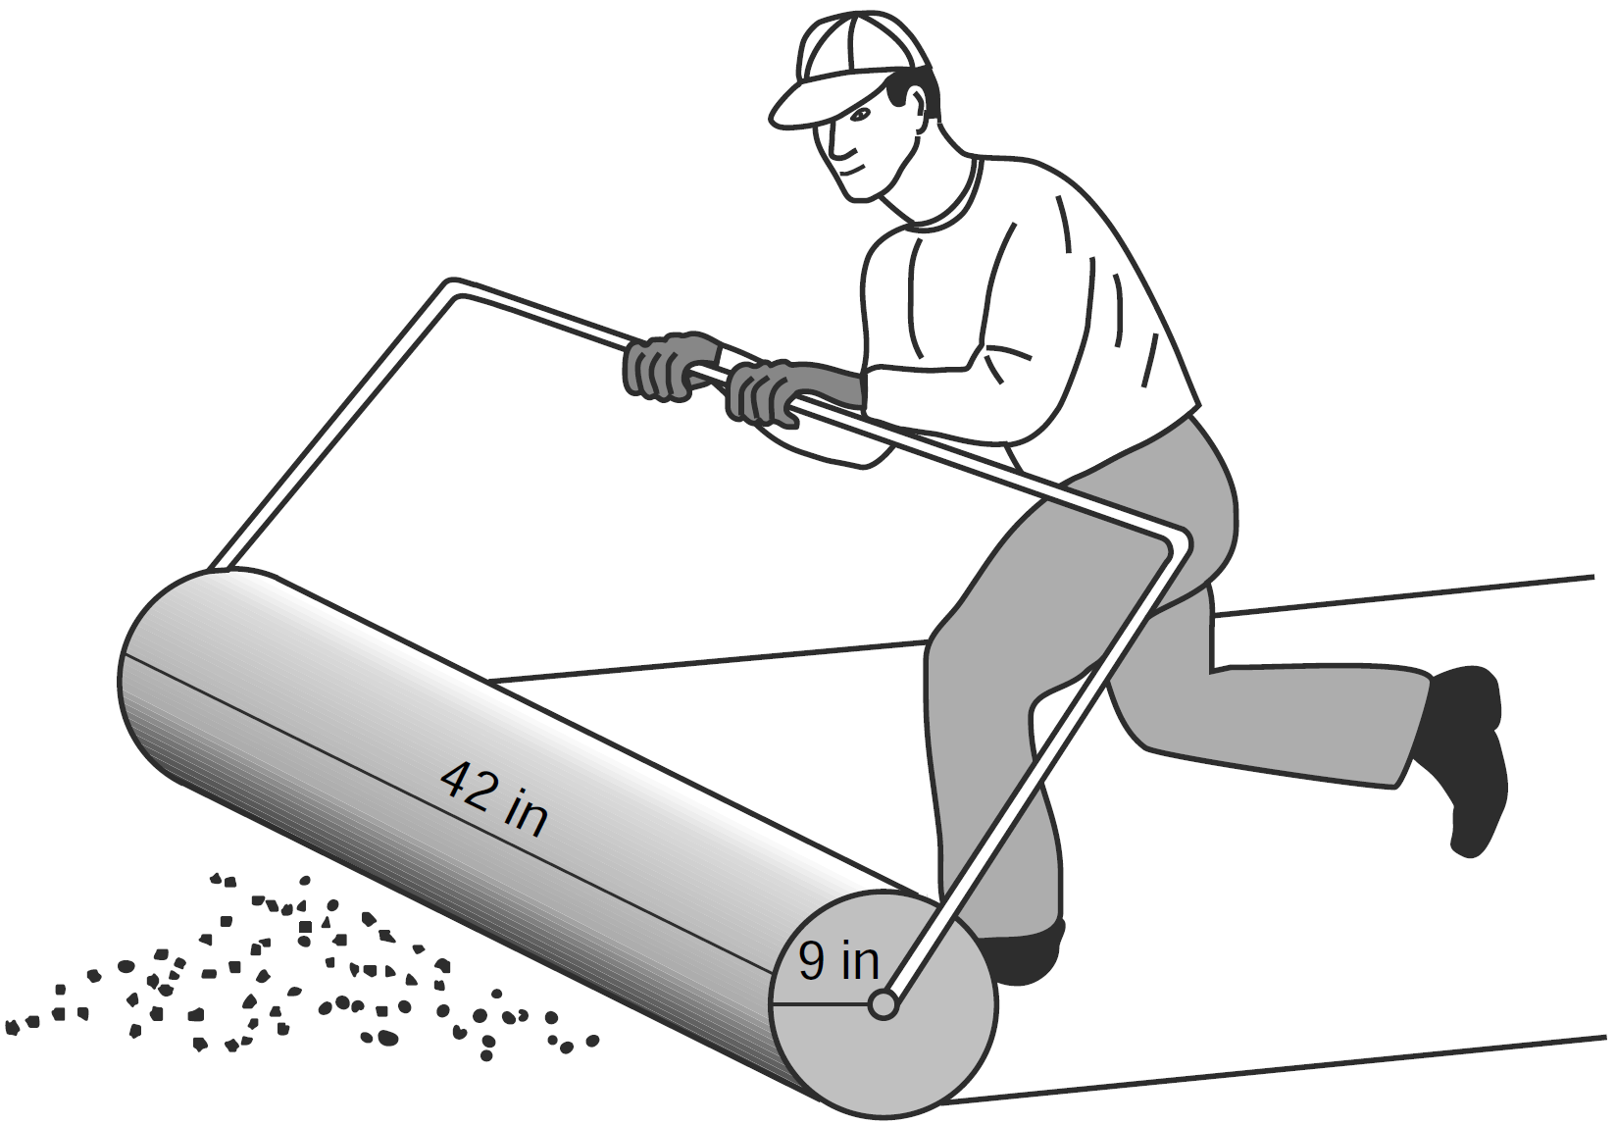

To the nearest square inch, the area the roller covers in one complete rotation is
1) | 2,374
2) | 2,375
3) | 10,682
4) | 10,688

2 A right circular cylinder has an altitude of 11 feet and a radius of 5 feet. What is the lateral area, in square feet, of the cylinder, to the nearest tenth?
1) | 172.7
2) | 172.8
3) | 345.4
4) | 345.6

3 The diameter of the base of a right circular cylinder is 6 cm and its height is 15 cm. In square centimeters, the lateral area of the cylinder is
1) | 180
2) | 135
3) | 90
4) | 45

4 The cylindrical tank shown in the diagram below is to be painted. The tank is open at the top, and the bottom does not need to be painted. Only the outside needs to be painted. Each can of paint covers 600 square feet. How many cans of paint must be purchased to complete the job?

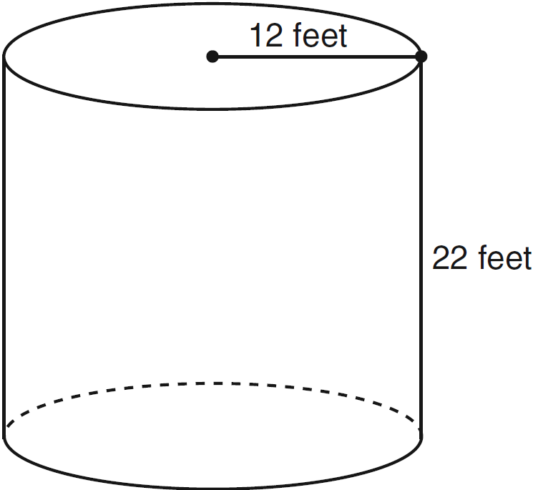

5 A right circular cylinder has a height of 7 inches and the base has a diameter of 6 inches. Determine the lateral area, in square inches, of the cylinder in terms of .

6 A right circular cylinder with a height of 5 cm has a base with a diameter of 6 cm. Find the lateral area of the cylinder to the nearest hundredth of a square centimeter. Find the volume of the cylinder to the nearest hundredth of a cubic centimeter.

7 A paint can is in the shape of a right circular cylinder. The volume of the paint can is 600π cubic inches and its altitude is 12 inches. Find the radius, in inches, of the base of the paint can. Express the answer in simplest radical form. Find, to the nearest tenth of a square inch, the lateral area of the paint can.

8 The lateral area of a right circular cone is equal to . If the base of the cone has a diameter of 24 cm, what is the length of the slant height, in centimeters?
1) | 2.5
2) | 5
3) | 10
4) | 15.7

9 A right circular cone has an altitude of 10 ft and the diameter of the base is 6 ft as shown in the diagram below. Determine and state the lateral area of the cone, to the nearest tenth of a square foot.

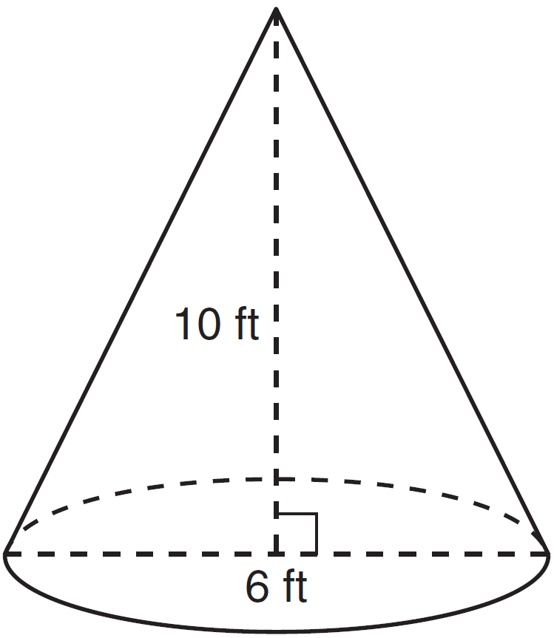

10 As shown in the diagram below, a right circular cone has a height of 12 and a radius of 5.

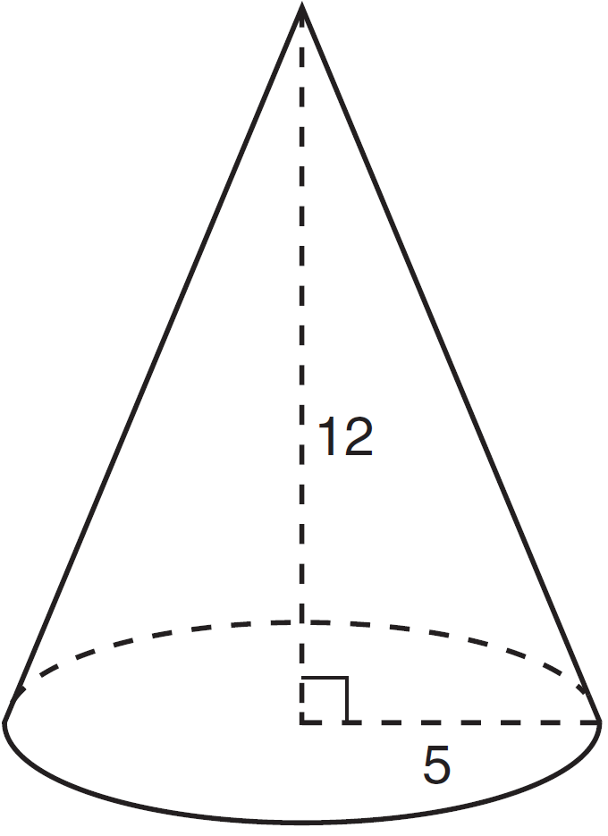

Determine, in terms of , the lateral area of the right circular cone.

11 A right circular cone has a base with a radius of 15 cm, a vertical height of 20 cm, and a slant height of 25 cm. Find, in terms of' , the number of square centimeters in the lateral area of the cone.
1 ANS: 2
REF: 011418ge

2 ANS: 4
REF: 061006ge

3 ANS: 3
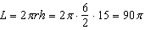
REF: 061405ge

4 ANS:
. 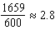. 3 cans are needed.
REF: 061233ge

5 ANS:
REF: 061329ge

6 ANS:
.
REF: 011335ge

7 ANS:
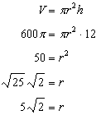.
REF: 011236ge

8 ANS: 3
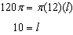
REF: 081314ge

9 ANS:
REF: 081436ge

10 ANS:
REF: 061531ge

11 ANS:
REF: 081030ge

