1 A garden in the shape of an equilateral triangle has sides whose lengths are 10 meters. What is the area of the garden?
1)
2)
3)
4)

2 The accompanying diagram shows a triangular plot of land located in Moira’s garden.
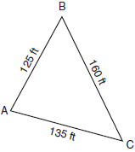
Find the area of the plot of land, and round your answer to the nearest hundred square feet.

3 A triangular plot of land has sides that measure 5 meters, 7 meters, and 10 meters. What is the area of this plot of land, to the nearest tenth of a square meter?

4 The Bermuda Triangle on a map is a section of the Atlantic Ocean bordered by line segments stretching from Miami to Bermuda to Puerto Rico and back to Miami. The distance from Miami to Bermuda is 1042 miles; the distance from Bermuda to Puerto Rico is 2057 miles; and the distance from Puerto Rico to Miami is 1127 miles. Find the area contained within the Bermuda Triangle, to the nearest square mile.

5 A farmer has determined that a crop of strawberries yields a yearly profit of $1.50 per square yard. If strawberries are planted on a triangular piece of land whose sides are 50 yards, 75 yards, and 100 yards, how much profit, to the nearest hundred dollars, would the farmer expect to make from this piece of land during the next harvest?

6 A farmer has a triangular field with sides of 240 feet, 300 feet, and 360 feet. He wants to apply fertilizer to the field. If one 40-pound bag of fertilizer covers 6,000 square feet, how many bags must he buy to cover the field?
1 ANS: 2
An equilateral triangle with sides whose lengths are 10 has a perimeter of 30 and a semi-perimeter of 15.

REF: 010417b

2 ANS:
8,200.

REF: 060933b

3 ANS:
16.2. 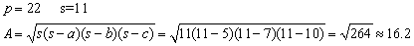

REF: 060634b

4 ANS:
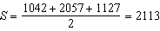

REF: 081639a2

5 ANS:
2700. .

REF: 060333b

6 ANS:
6.

REF: 080734b

