1 In the accompanying figure, ACDH and BCEF are rectangles, , , , and .

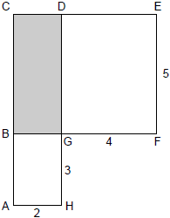

What is the area of BCDG?
1) | 6
2) | 8
3) | 10
4) | 20

2 The accompanying diagram shows a square with side y inside a square with side x.

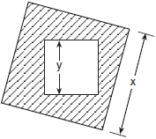

Which expression represents the area of the shaded region?
1)
2)
3)
4)

3 The accompanying diagram represents a scale drawing of the property where Brendan's business is located. He needs to purchase rock salt to melt the ice on the parking lot (shaded area) around his building. A bag of rock salt covers an area of 1,500 square feet. How many bags of rock salt does Brendan need to purchase to salt the entire parking lot?

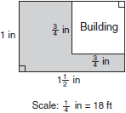

4 In the figure below, the large rectangle, ABCD, is divided into four smaller rectangles. The area of rectangle , the area of rectangle , the area of rectangle , segment , and segment .

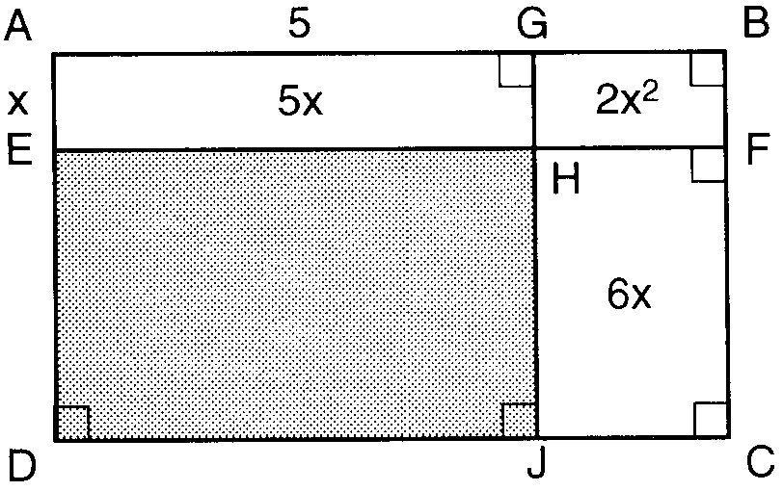

a Find the area of the shaded region.
b Write an expression for the area of the rectangle ABCD in terms of x.

5 Keesha wants to tile the floor shown in the accompanying diagram. If each tile measures 1 foot by 1 foot and costs $2.99, what will be the total cost, including an 8% sales tax, for tiling the floor?

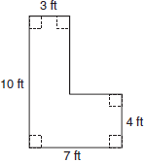

6 A corner is cut off a 5” by 5” square piece of paper. The cut is x inches from a corner as shown below.
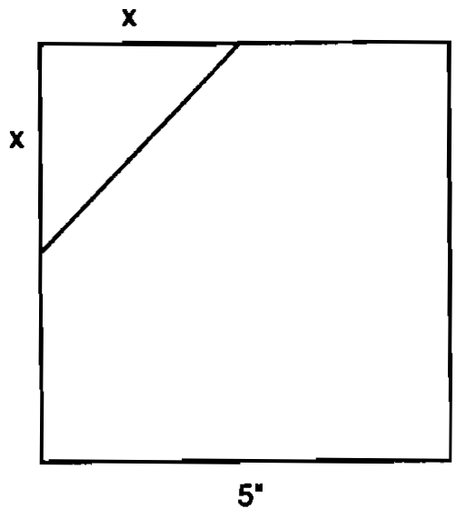
(a) Write an equation, in terms of x, that represents the area, A, of the paper after the corner is removed.
(b) What value of x will result in an area that is of the area of the original square piece of paper? Show how you arrived at your answer.

7 In the accompanying diagram, a circle with radius 4 is inscribed in a square.
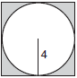

What is the area of the shaded region?
1)
2)
3)
4)

8 Ms. Brown plans to carpet part of her living room floor. The living room floor is a square 20 feet by 20 feet. She wants to carpet a quarter-circle as shown below.

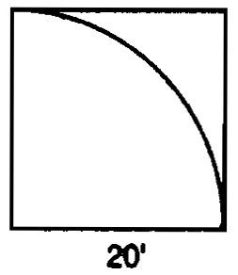

Find, to the nearest square foot, what part of the floor will remain uncarpeted. Show how you arrived at your answer.

9 Mr. Petri has a rectangular plot of land with length = 20 feet and width = 10 feet. He wants to design a flower garden in the shape of a circle with two semicircles at each end of the center circle, as shown in the accompanying diagram. He will fill in the shaded area with wood chips. If one bag of wood chips covers 5 square feet, how many bags must he buy?

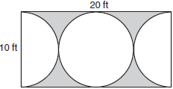

10 A target shown in the accompanying diagram consists of three circles with the same center. The radii of the circles have lengths of 3 inches, 7 inches, and 9 inches.

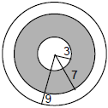

a What is the area of the shaded region to the nearest tenth of a square inch?
b To the nearest percent, what percent of the target is shaded?

11 If asphalt pavement costs $0.78 per square foot, determine, to the nearest cent, the cost of paving the shaded circular road with center O, an outside radius of 50 feet, and an inner radius of 36 feet, as shown in the accompanying diagram.

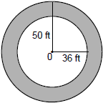

12 As shown in the accompanying diagram, radio station KMA is increasing its radio listening radius from 40 miles to 50 miles. How many additional square miles of listening area, to the nearest tenth, will the radio station gain?

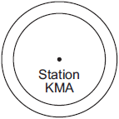

13 In the accompanying diagram, right triangle ABC is inscribed in circle O, diameter , and . Find, to the nearest square unit, the area of the shaded region.

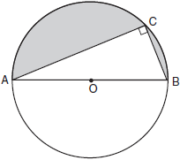
1 ANS: 3
If AH=2, then BG=2. If FE=5, then GD=5. The area of BCDG is 10.

REF: 069916a

2 ANS: 4 REF: 060302a

3 ANS:
4. On the scale drawing, Brandon’s property measures 1 by 1½ inches. Using the scale ¼ inch = 18 feet, this means Brandon’s property measures 72 by 108 feet, for an area of 7776 square feet. On the scale drawing, the building measures ¾ by ¾ inch, or 54 by 54 feet, for an area of 2916 square feet. The total area of the parking lot is 4860 (7776-2916) square feet, and will require Brandon to purchase 4 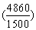bags of rock salt.

REF: 080738a

4 ANS:
15, . If AG = 5, then EH = 5. If AE = x, then GH = x. If the area of rectangle GHFB = and GH = x, then GB = 2x. If GB = 2x, then HF = 2x. If the area of rectangle HJCF = 6x and HF = 2x, then HJ = 3. So the area of the shaded region is The length of segment AB may be expressed as The length of segment BC may be expressed as So the area of the rectangle ABCD may be expressed as

REF: 010028a

5 ANS:
$148.54. Divide the floor into two separate rectangles. The left portion is 30 square feet and the right portion is 16 square feet for a total of 46 square feet, .

REF: 060132a

6 ANS:
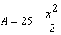, 2.5. 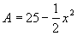. 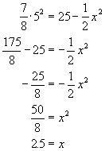

REF: spring9835a

7 ANS: 1
The circle’s radius is 4, its diameter is 8, as is a side of the square. The area of the square is 64. The area of the circle is Area of shaded region = area of square – unshaded area. 64 – 16π

REF: 080105a

8 ANS:
86. Area of square–area of quarter circle = 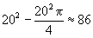

REF: spring9830a

9 ANS:
9. There are two circles and the radius of each is 5. The area of the shaded region = area of rectangle – area of circles = 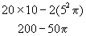. 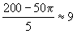

REF: 080539a

10 ANS:
125.7, 49%. The area of the shaded region = area of middle circle – area of inner circle. . 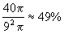

REF: 069931a

11 ANS:
$2,950.33. The area of the shaded region = area of outer circle – unshaded area. 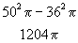.

REF: 089932a

12 ANS:
2,827.4. .

REF: 060228a

13 ANS:
145. The area of the circle is The area of the unshaded semicircle is 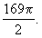 The triangle inscribed in the semicircle is a multiple of the 5, 12, 13 triangle (), so The area of the triangle is 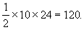 The area of the shaded region = area of circle – unshaded area. 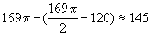

REF: 080438a

