1 Francisco needs the three pieces of glass shown below to complete a stained glass window. The shapes, two triangles and a trapezoid, are measured in inches.
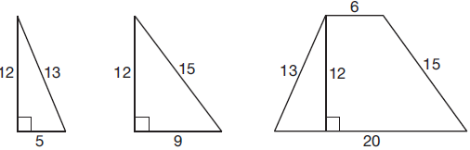
Glass can be purchased in rectangular sheets that are 12 inches wide. What is the minimum length of a sheet of glass, in inches, that Francisco must purchase in order to have enough to complete the window?
1) | 20 | 3) | 29
2) | 25 | 4) | 34

2 In the diagram below, MATH is a rectangle, , , and .
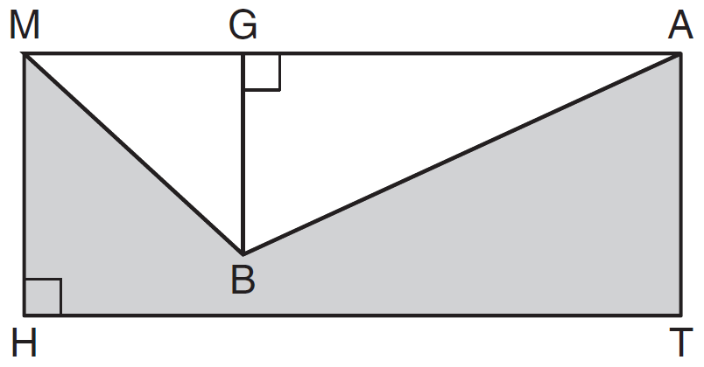
What is the area of polygon MBATH?
1) | 34.5 | 3) | 90.0
2) | 55.5 | 4) | 124.5

3 Luis is going to paint a basketball court on his driveway, as shown in the diagram below. This basketball court consists of a rectangle and a semicircle.
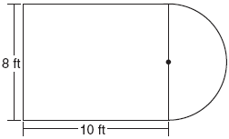

Which expression represents the area of this basketball court, in square feet?
1) | 80 | 3) | 80 + 16π
2) | 80 + 8π | 4) | 80 + 64π

4 A figure is made up of a rectangle and a semicircle as shown in the diagram below.

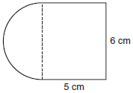

What is the area of the figure, to the nearest tenth of a square centimeter?
1) | 39.4 | 3) | 48.8
2) | 44.1 | 4) | 58.3

5 In the figure below, ABCD is a square and semicircle O has a radius of 6.

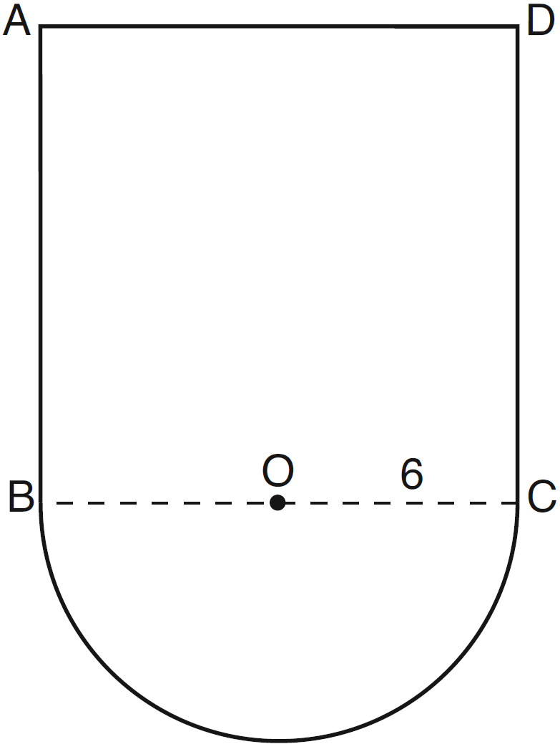

What is the area of the figure?
1) |  | 3)
2) |  | 4)

6 The figure shown below is composed of two rectangles and a quarter circle.

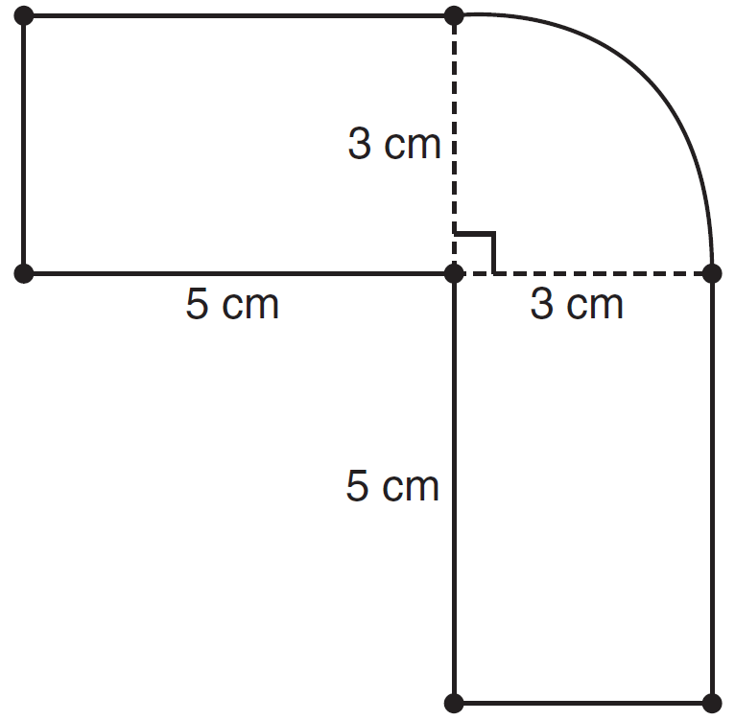

What is the area of this figure, to the nearest square centimeter?
1) | 33 | 3) | 44
2) | 37 | 4) | 58

7 In the diagram below, circle O is inscribed in square ABCD. The square has an area of 36.

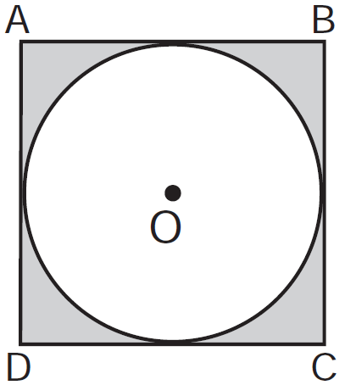

What is the area of the circle?
1) |  | 3)
2) |  | 4)

8 A figure consists of a square and a semicircle, as shown in the diagram below.
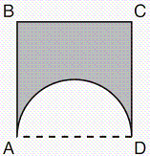

If the length of a side of the square is 6, what is the area of the shaded region?
1) |  | 3)
2) |  | 4)

9 A countertop for a kitchen is modeled with the dimensions shown below. An 18-inch by 21-inch rectangle will be removed for the installation of the sink.

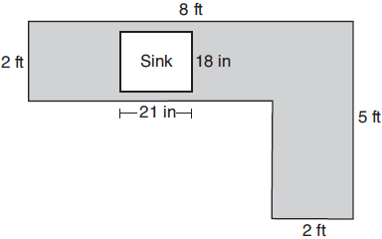

What is the area of the top of the installed countertop, to the nearest square foot?
1) | 26 | 3) | 22
2) | 23 | 4) | 19

10 A patio consisting of two semicircles and a square is shown in the diagram below. The length of each side of the square region is represented by . Write an expression for the area of the entire patio, in terms of x and .

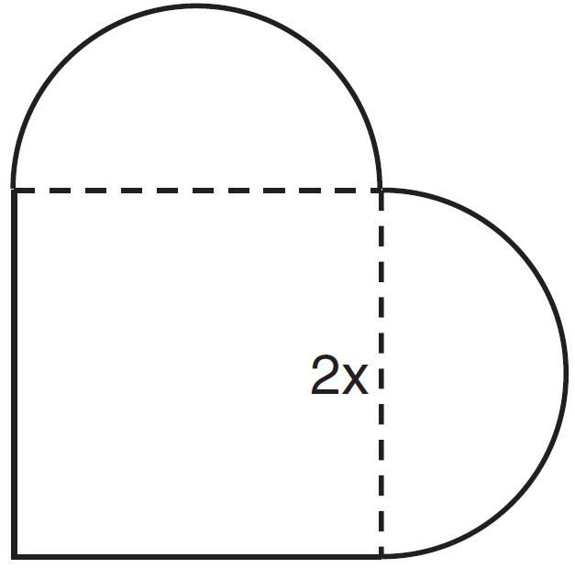

11 A designer created the logo shown below. The logo consists of a square and four quarter-circles of equal size.

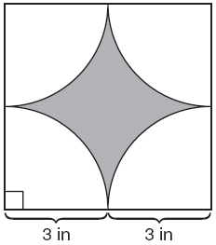

Express, in terms of π, the exact area, in square inches, of the shaded region.

12 In the diagram below of rectangle AFEB and a semicircle with diameter , inches, , and inches. Find the area of the shaded region, to the nearest hundredth of a square inch.

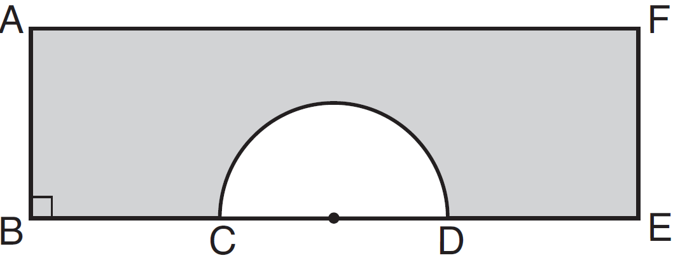

13 The Rock Solid Concrete Company has been asked to pave a rectangular area surrounding a circular fountain with a diameter of 8 feet, as shown in the diagram.

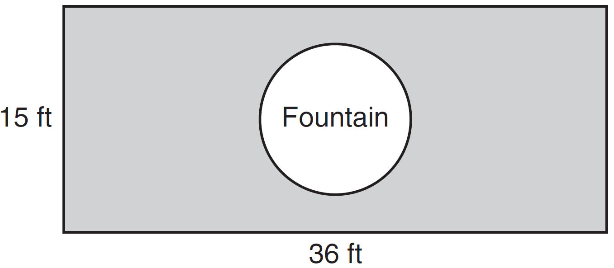

Find the area, to the nearest square foot, that must be paved. Find the cost, in dollars, of paving the area if the Rock Solid Concrete Company charges $8.95 per square foot.

14 A walking path at a local park is modeled on the grid below, where the length of each grid square is 10 feet. The town needs to submit paperwork to pave the walking path. Determine and state, to the nearest square foot, the area of the walking path.

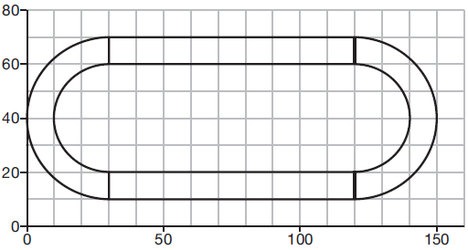

15 A man is spray-painting the tops of 10 patio tables. Five tables have round tops, with diameters of 4 feet, and five tables have rectangular tops, with dimensions of 4 feet by 6 feet. A can of spray paint covers 25 square feet. How many cans of spray paint must be purchased to paint all of the tabletops?
1 ANS: 1 REF: 011918geo

2 ANS: 2
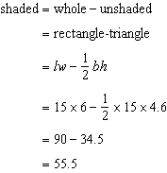

REF: 081019ia

3 ANS: 2 REF: 080815ia

4 ANS: 2
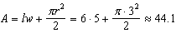

REF: 061029ia

5 ANS: 3 REF: 011315ia

6 ANS: 2
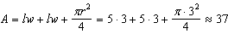

REF: 011123ia

7 ANS: 1
If the area of the square is 36, a side is 6, the diameter of the circle is 6, and its radius is 3.

REF: 011217ia

8 ANS: 2
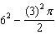

REF: 011407ia

9 ANS: 4
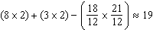

REF: 081917geo

10 ANS:

REF: 061431ia

11 ANS:
Area of square–area of 4 quarter circles.

REF: 060832ia

12 ANS:
Area of rectangle minus area of semicircle: 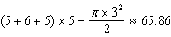

REF: 061339ia

13 ANS:

REF: 011537ia

14 ANS:

REF: 011931geo

15 ANS:
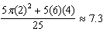 8 cans

REF: 082328geo

