1 As shown below, polygon ABCGFED consists of two squares, ABCD and CGFE, and an equilateral triangle CED. The length of is cm. Determine the perimeter of polygon ABCGFED in radical form.

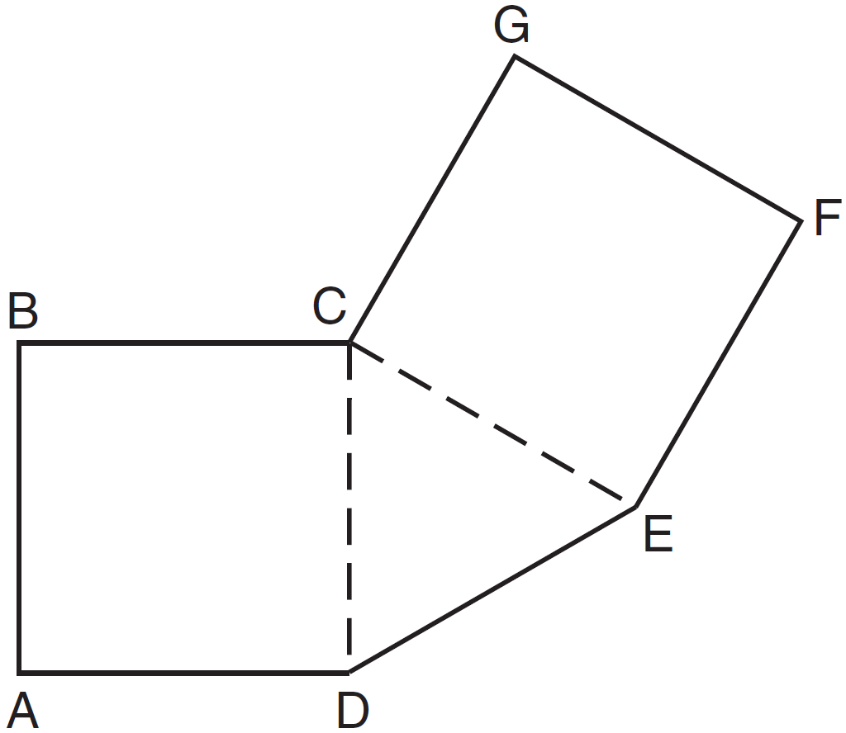

2 A garden is in the shape of an isosceles trapezoid and a semicircle, as shown in the diagram below. A fence will be put around the perimeter of the entire garden.

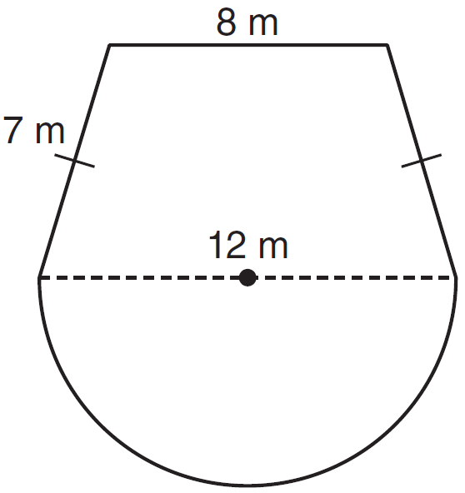

Which expression represents the length of fencing, in meters, that will be needed?
1)
2)
3)
4)

3 What is the perimeter of the figure shown below, which consists of an isosceles trapezoid and a semicircle?

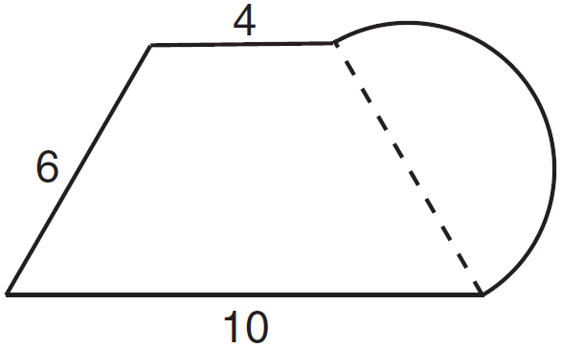
1)
2)
3)
4)

4 A playground in a local community consists of a rectangle and two semicircles, as shown in the diagram below.

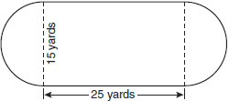

Which expression represents the amount of fencing, in yards, that would be needed to completely enclose the playground?
1)
2)
3)
4)

5 Serena’s garden is a rectangle joined with a semicircle, as shown in the diagram below. Line segment AB is the diameter of semicircle P. Serena wants to put a fence around her garden.

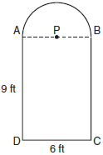

Calculate the length of fence Serena needs to the nearest tenth of a foot.

6 A window is made up of a single piece of glass in the shape of a semicircle and a rectangle, as shown in the diagram below. Tess is decorating for a party and wants to put a string of lights all the way around the outside edge of the window.

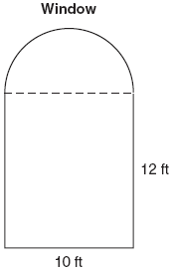

To the nearest foot, what is the length of the string of lights that Tess will need to decorate the window?

7 Ross is installing edging around his pool, which consists of a rectangle and a semicircle, as shown in the diagram below.

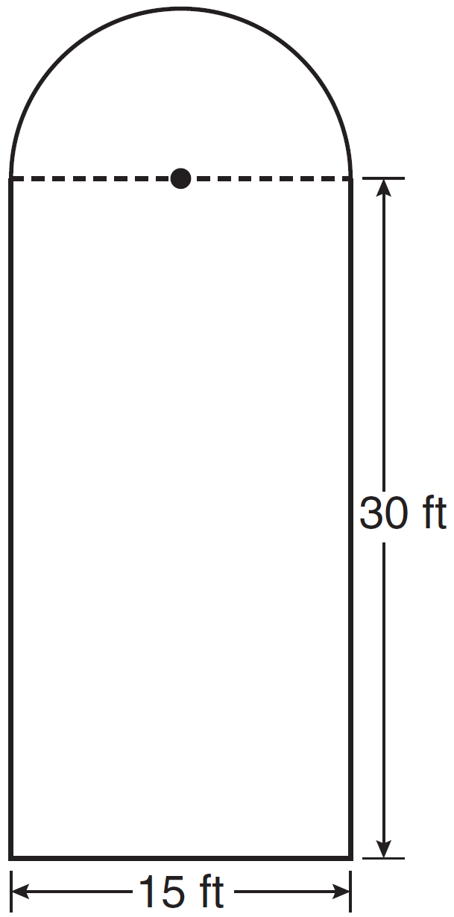

Determine the length of edging, to the nearest tenth of a foot, that Ross will need to go completely around the pool.

8 The diagram below consists of a square with a side of 4 cm, a semicircle on the top, and an equilateral triangle on the bottom. Find the perimeter of the figure to the nearest tenth of a centimeter.

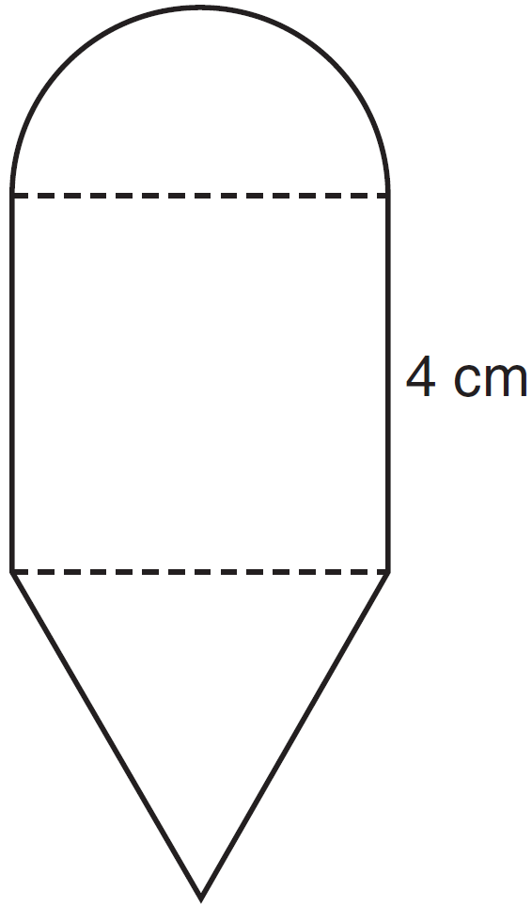

9 A designer created a garden, as shown in the diagram below. The garden consists of four quarter-circles of equal size inside a square. The designer put a fence around both the inside and the outside of the garden.

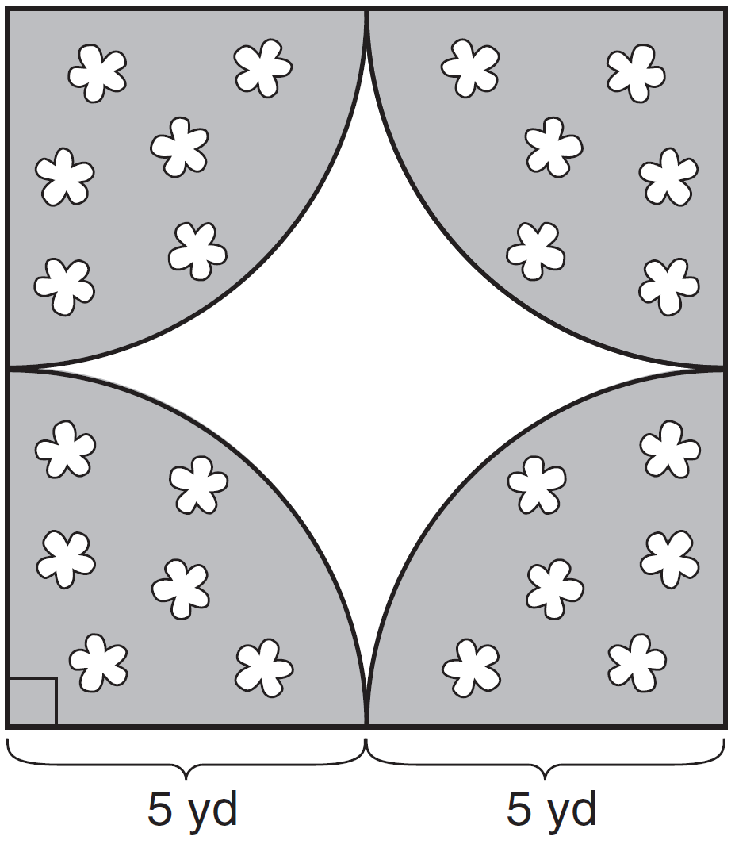

Which expression represents the amount of fencing, in yards, that the designer used for the fence?
1)
2)
3)
4)

1 ANS:

REF: 061532ia

2 ANS: 1
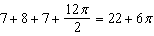

REF: 081128ia

3 ANS: 1
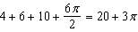

REF: 081228ia

4 ANS: 1 REF: 080924ia

5 ANS:
33.4. Serena needs 24 feet of fencing to surround the rectangular portion of the garden. The length of the fencing needed for the semicircular portion of the garden is 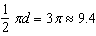 feet.

REF: fall0733ia

6 ANS:
50. 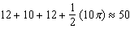

REF: 010931ia

7 ANS:
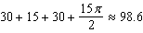

REF: 061433ia

8 ANS:

REF: 081432ia

9 ANS: 1

REF: 081326ia

