1 If the base of a triangle is represented by and the height is represented by 2x, which expression represents the area of the triangle?
1)
2)
3) | 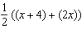
4) | 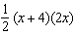

2 Mr. Gonzalez owns a triangular plot of land BCD with yards and yards. He wishes to purchase the adjacent plot of land in the shape of right triangle ABD, as shown in the accompanying diagram, with yards. If the purchase is made, what will be the total number of square yards in the area of his plot of land, ?

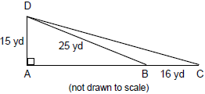

3 A rectangular garden is going to be planted in a person’s rectangular backyard, as shown in the accompanying diagram. Some dimensions of the backyard and the width of the garden are given. Find the area of the garden to the nearest square foot.

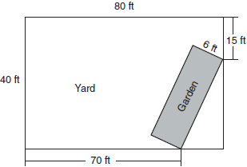

4 In the accompanying diagram of , altitude and . Find the area of the triangle to the nearest tenth of a square unit.

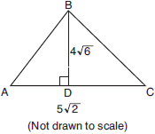

5 The length of a side of a square window in Jessica's bedroom is represented by . Which expression represents the area of the window?
1)
2)
3)
4)

6 If the area of a square garden is 48 square feet, what is the length, in feet, of one side of the garden?
1)
2)
3)
4)

7 What is the area of a square whose perimeter is represented by ?
1)
2)
3)
4)

8 Determine the area, in square feet, of the smallest square that can contain a circle with a radius of 8 feet.

9 Keira has a square poster that she is framing and placing on her wall. The poster has a diagonal 58 cm long and fits exactly inside the frame. The width of the frame around the picture is 4 cm.

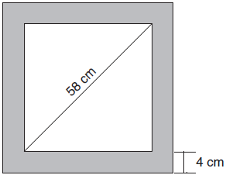

Determine and state the total area of the poster and frame to the nearest tenth of a square centimeter.

10 The surface of the roof of a house is modeled by two congruent rectangles with dimensions 40 feet by 16 feet, as shown below.

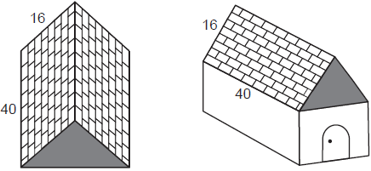

Roofing shingles are sold in bundles. Each bundle covers square feet. What is the minimum number of bundles that must be purchased to completely cover both rectangular sides of the roof?
1) | 20
2) | 2
3) | 39
4) | 4

11 A farmer has 64 feet of fence to enclose a rectangular vegetable garden. Which dimensions would result in the biggest area for this garden?
1) | the length and the width are equal
2) | the length is 2 more than the width
3) | the length is 4 more than the width
4) | the length is 6 more than the width

12 The dimensions of a rectangle are 4 and 16. What is the smallest integral value that could be the side of a square that has an area larger than that of the rectangle?
1) | 8
2) | 9
3) | 64
4) | 81

13 Kerry is planning a rectangular garden that has dimensions of 4 feet by 6 feet. Kerry wants one-half of the garden to have roses, and she says that the rose plot will have dimensions of 2 feet by 3 feet. Is she correct? Explain.

14 Mr. Santana wants to carpet exactly half of his rectangular living room. He knows that the perimeter of the room is 96 feet and that the length of the room is 6 feet longer than the width. How many square feet of carpeting does Mr. Santana need?

15 Express both the perimeter and the area of the rectangle shown in the accompanying diagram as polynomials in simplest form.

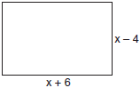

16 The equation 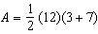 is used to find the area of a trapezoid. Which calculation would not result in the correct area?
1) | 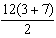
2)
3)
4) | 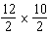

17 In the figure shown below, each dot is one unit from an adjacent horizontal or vertical dot.

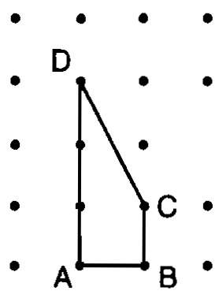

Find the number of square units in the area of quadrilateral ABCD. Show how you arrived at your answer.

18 In the diagram below, the circumference of circle O is 16π inches. The length of is three-quarters of the length of diameter and inches. Calculate the area, in square inches, of trapezoid ABCD.

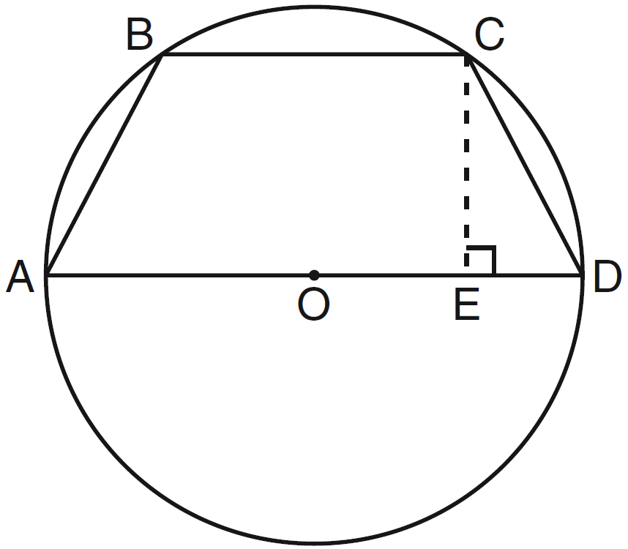
1 ANS: 4
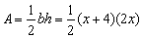
REF: 060713a

2 ANS:
270. is a multiple of the 3-4-5 Pythagorean triple, so that AB = 20. Therefore AC = 36 (20 + 16), which is the base of 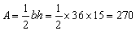.
REF: 089934a

3 ANS:
162. The legs of the triangle formed by the garden in the corner of the rectangular backyard are 10 (80-70) feet and 25 (40-15) feet. Use Pythagoras to determine the length of the garden. 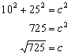. .
REF: 010330a

4 ANS:
34.6. 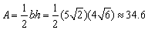
REF: 010833a

5 ANS: 4
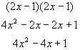
REF: 060527a

6 ANS: 2
If the area of a square garden is 48 square feet, the length of one side is
REF: 080206a

7 ANS: 2
If the perimeter of a square is 12x, one side is 3x. Then the area is
REF: 010212a

8 ANS:
256. A circle with a radius of 8 feet has a diameter of 16 feet. Such a circle could fit into a square with a side of 16, or an area of 256 square feet.
REF: 060631a

9 ANS:
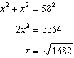
REF: 081734geo

10 ANS: 3
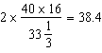
REF: 012404geo

11 ANS: 1
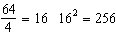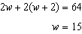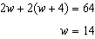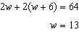
REF: 011708geo

12 ANS: 2
The area of the rectangle is 64 (16 x 4). The next highest perfect square is 81. The side of a square with an area of 81 is 9.
REF: 060818a

13 ANS:
Kerry is not correct. She wants half of the garden to have roses. If the total area of the garden is 24 square feet, half of this area is 12 square feet, not 6 (2 by 3).
REF: 080023a

14 ANS:
284. 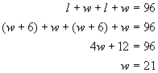. If w=21, then l=27. So the area of the room is 567 square feet. To carpet half the room, Mr. Santana needs 283.5 square feet of carpeting.
REF: 080031a

15 ANS:
, . 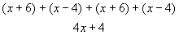. 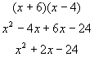
REF: 060437a

16 ANS: 4 REF: 010608a

17 ANS:
2. 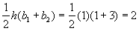
REF: spring9822a

18 ANS:
56. If the circumference of circle O is inches, the diameter, , is 16 inches and the length of is 12 inches 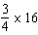. The area of trapezoid ABCD is 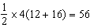.
REF: 060934ia

