1 Which pair of edges is not coplanar in the cube shown below?

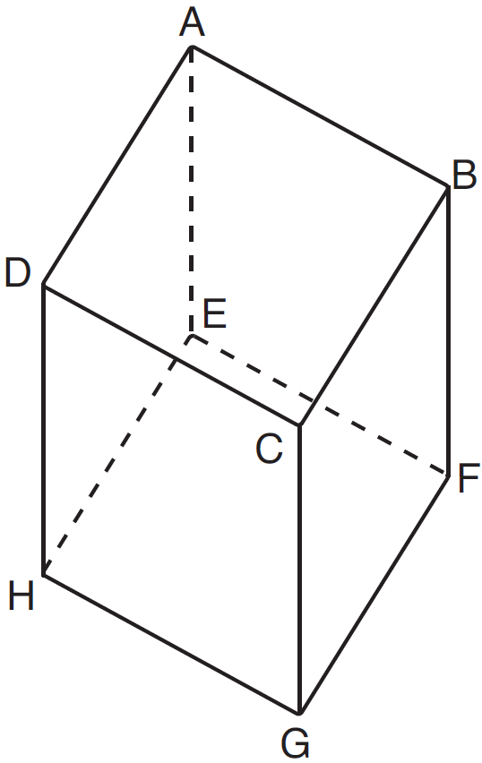
1) | and
2) | and
3) | and
4) | and

2 A right rectangular prism is shown in the diagram below.

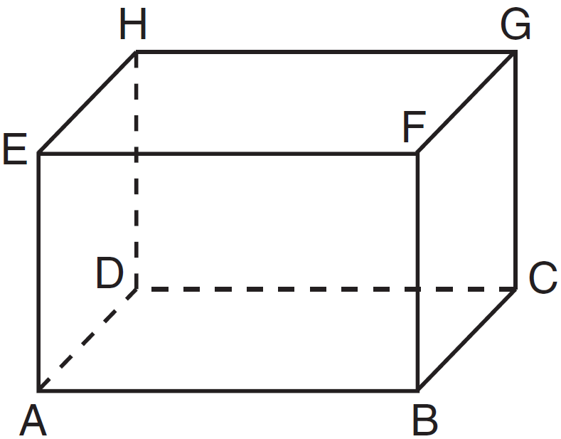

Which line segments are coplanar?
1) | and
2) | and
3) | and
4) | and

3 The diagram below shows a rectangular prism.

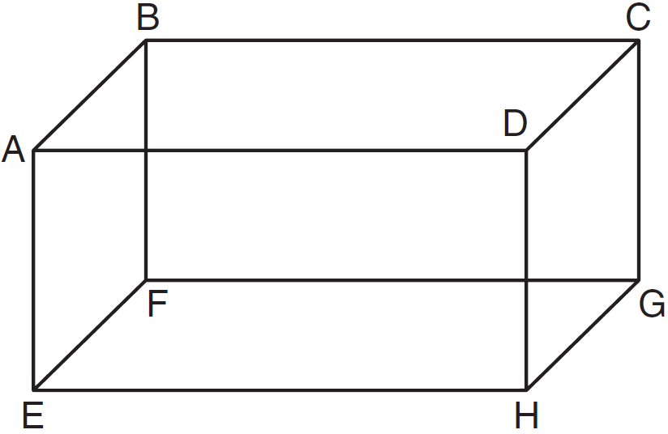

Which pair of edges are segments of lines that are coplanar?
1) | and
2) | and
3) | and
4) | and

4 A rectangular right prism is shown in the diagram below.

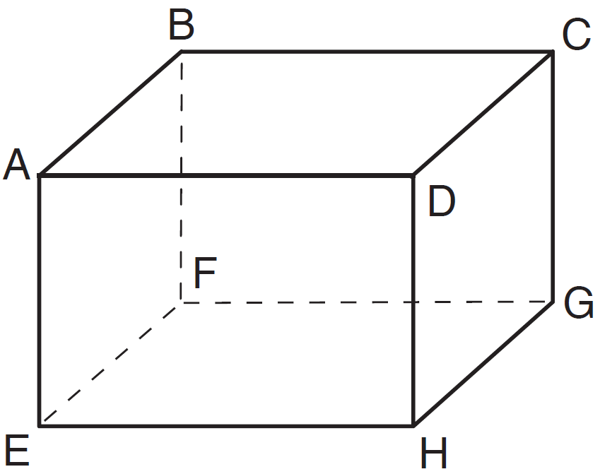

Which pair of edges are not coplanar?
1) | and
2) | and
3) | and
4) | and

5 A rectangular prism is shown in the diagram below.

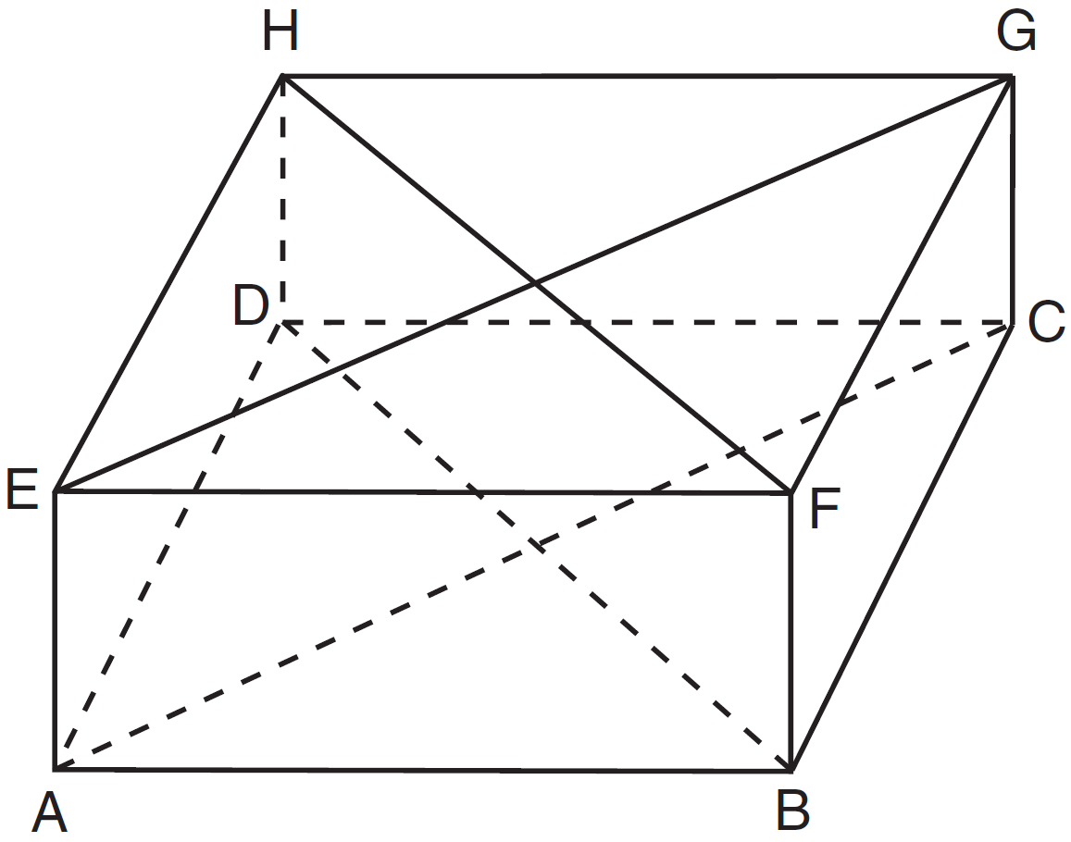

Which pair of line segments would always be both congruent and parallel?
1) | and
2) | and
3) | and
4) | and

6 The diagram below represents a rectangular solid.

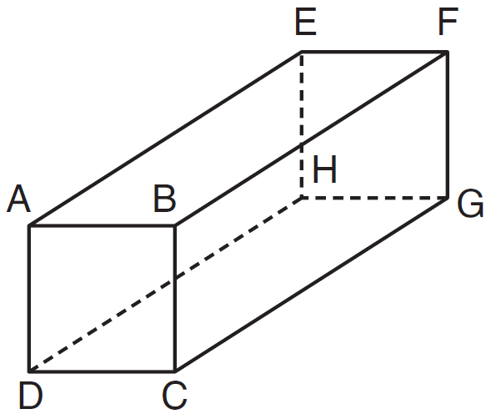

Which statement must be true?
1) | and are coplanar
2) | and are coplanar
3) | and are skew
4) | and are skew

7 A straw is placed into a rectangular box that is 3 inches by 4 inches by 8 inches, as shown in the accompanying diagram. If the straw fits exactly into the box diagonally from the bottom left front corner to the top right back corner, how long is the straw, to the nearest tenth of an inch?

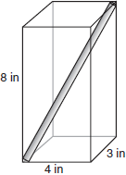

8 The figure in the diagram below is a triangular prism.

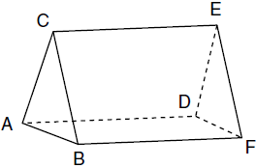

Which statement must be true?
1)
2)
3)
4)

9 The bases of a right triangular prism are and . Angles A and D are right angles, , , and . What is the length of edge ?
1) | 10
2) | 12
3) | 14
4) | 16

10 The bases of a prism are right trapezoids, as shown in the diagram below.

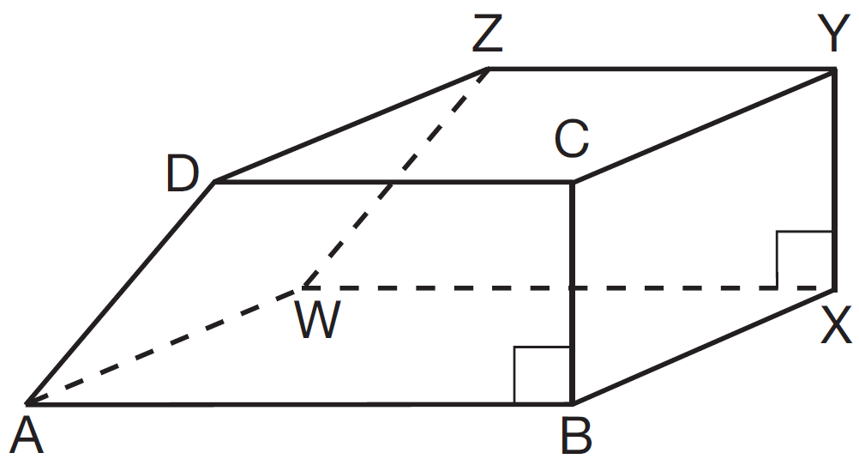

Which two edges do not lie in the same plane?
1) | and
2) | and
3) | and
4) | and

11 The diagram below shows a right pentagonal prism.

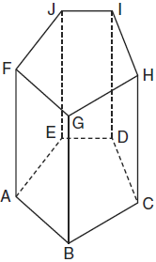

Which statement is always true?
1)
2)
3)
4)

12 A roll of candy is shown in the accompanying diagram.

The shape of the candy is best described as a
1) | rectangular solid
2) | pyramid
3) | cone
4) | cylinder

13 The lateral faces of a regular pyramid are composed of
1) | squares
2) | rectangles
3) | congruent right triangles
4) | congruent isosceles triangles

14 Which piece of paper can be folded into a pyramid?
1) | 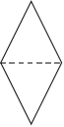
2) | 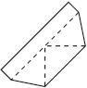
3) | 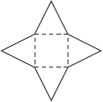
4) | 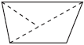

15 As shown in the diagram below, a right pyramid has a square base, ABCD, and is the slant height.

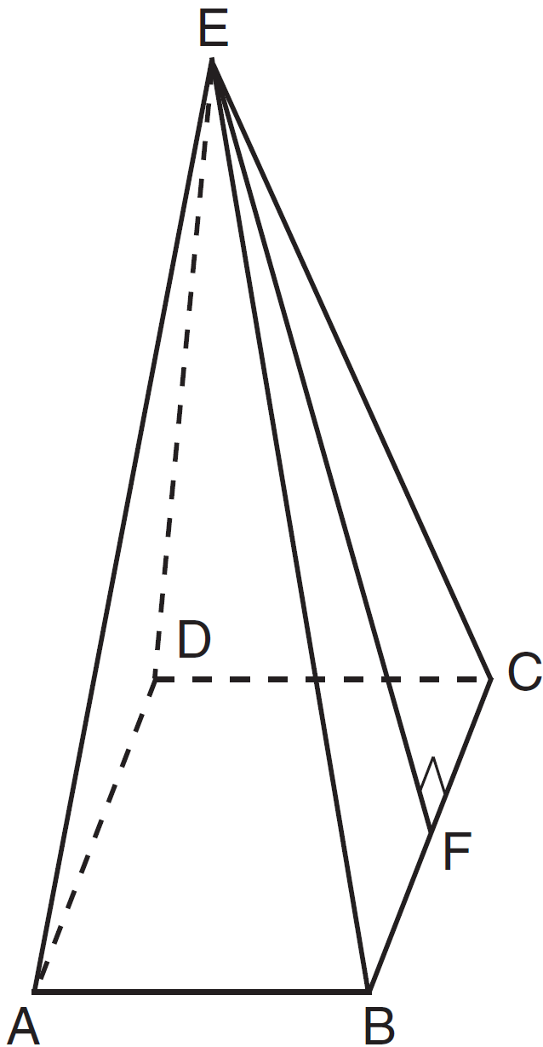

Which statement is not true?
1)
2)
3)
4) | is isosceles

16 The bases of a right prism are triangles in which . If , , and , what is the length of ?
1) | 9
2) | 12
3) | 15
4) | 18

1 ANS: 1 REF: 081508ge

2 ANS: 4 REF: 061503ge

3 ANS: 3 REF: 011105ge

4 ANS: 4 REF: 011406ge

5 ANS: 4 REF: 081401ge

6 ANS: 1 REF: 011221ge

7 ANS:
9.4. Looking at the bottom of the box two-dimensionally, diagonal because of the Pythagorean triple. Looking at the box three dimensionally, and are the legs of a triangle, with the straw as the hypotenuse, or 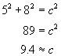 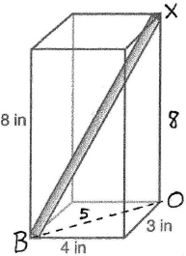

REF: 060334a

8 ANS: 3
The lateral edges of a prism are parallel.

REF: fall0808ge

9 ANS: 2 REF: 081311ge

10 ANS: 1 REF: 011526ge

11 ANS: 4 REF: 061003ge

12 ANS: 4 REF: 089901a

13 ANS: 4 REF: 060904ge

14 ANS: 3 REF: 080215a

15 ANS: 2 REF: 061315ge

16 ANS: 4 REF: 011621ge

