1 Triangle ABC has vertices at , , and . Find the length of in simplest radical form.

2 Square ABCD has vertices , , , and . What is the length of a side of the square?
1)
2)
3)
4)

3 The vertices of square RSTV have coordinates , , , and . What is the perimeter of RSTV?
1)
2)
3)
4)

4 Rhombus STAR has vertices , , , and . What is the perimeter of rhombus STAR?
1)
2)
3)
4)

5 The endpoints of one side of a regular pentagon are and . What is the perimeter of the pentagon?
1)
2)
3)
4)

6 Triangle ABC has coordinates , , and . Find the perimeter of the triangle. Express your answer in simplest radical form. [The use of the grid below is optional.]

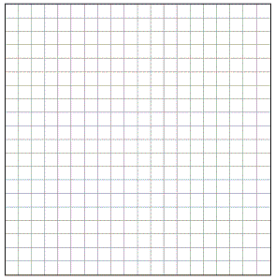

7 Hexagon ABCDEF with coordinates at , , , , , and is graphed on the set of axes below.

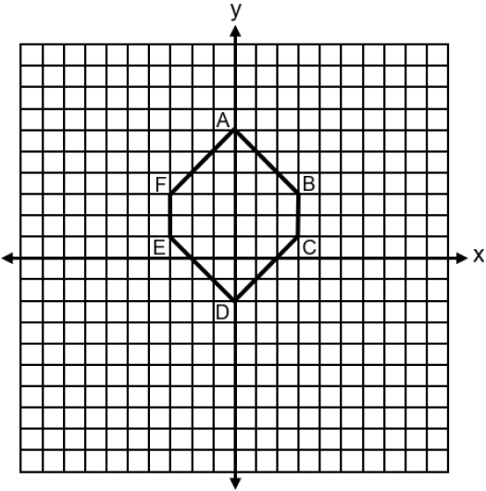

Determine and state the perimeter of ABCDEF in simplest radical form.

8 On the set of axes below, the vertices of have coordinates , , and .

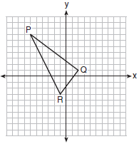

What is the area of ?
1) | 10
2) | 20
3) | 25
4) | 50

9 On the set of axes below, has vertices with coordinates , , and .

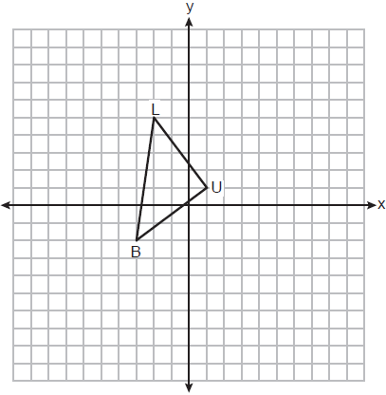

What is the area of ?
1) | 11
2) | 12.5
3) | 14
4) | 17.1

10 Triangle RST is graphed on the set of axes below.

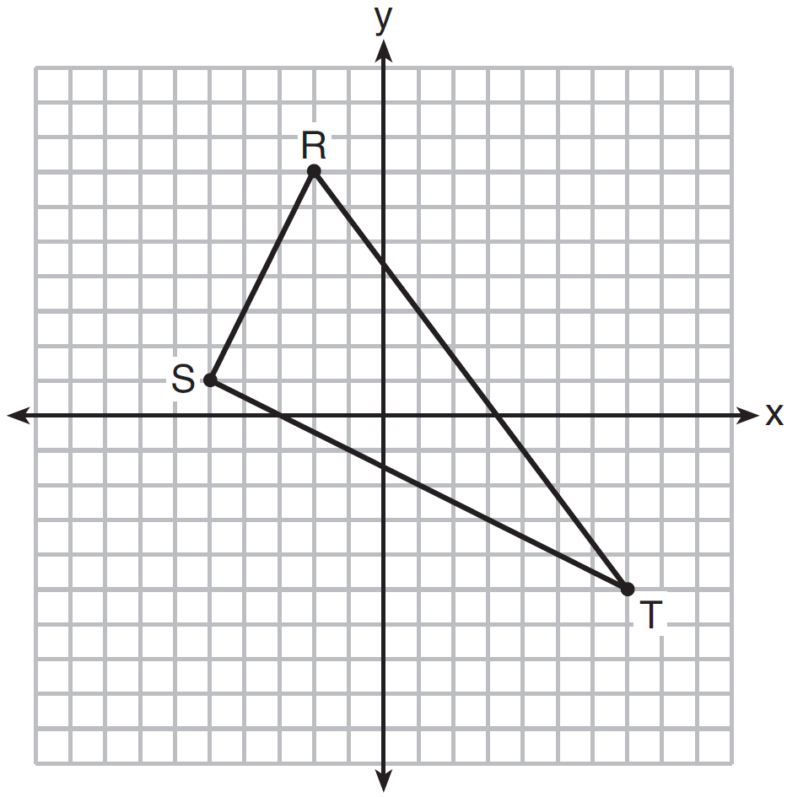

How many square units are in the area of ?
1)
2)
3) | 45
4) | 90

11 Triangle DAN is graphed on the set of axes below. The vertices of have coordinates , , and .

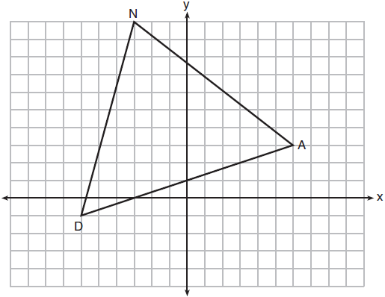

What is the area of ?
1) | 60
2) | 120
3)
4)

12 On the set of axes below, rectangle WIND has vertices with coordinates , , , and .
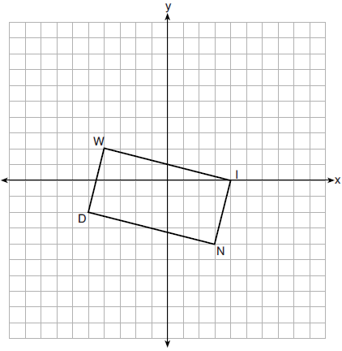

What is the area of rectangle WIND?
1) | 17
2) | 31
3) | 32
4) | 34

13 On the set of axes below, rhombus ABCD has vertices whose coordinates are , , , and .
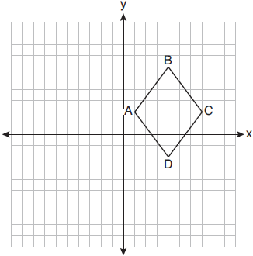
What is the area of rhombus ABCD?
1) | 20
2) | 24
3) | 25
4) | 48

14 The coordinates of vertices A and B of are and . If the area of is 24 square units, what could be the coordinates of point C?
1)
2)
3)
4)

15 Triangle ABC with coordinates , , and is graphed on the set of axes below.

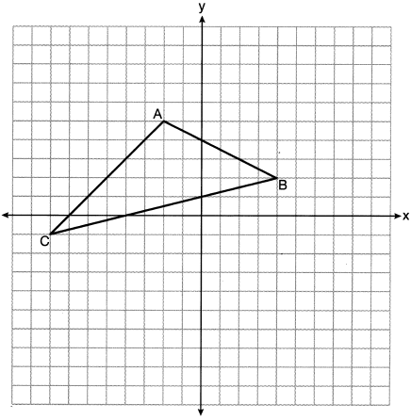

Determine and state the area of .

16 On the set of axes below, is drawn with vertices that have coordinates , , and .

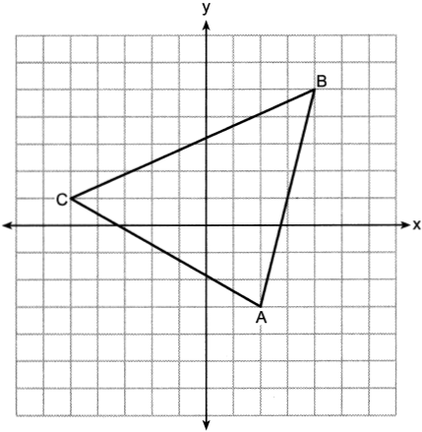

Determine and state the area of .

17 The vertices of have coordinates , , and . Determine and state the area of . [The use of the set of axes below is optional.]

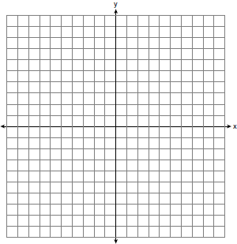

18 Determine and state the area of triangle PQR, whose vertices have coordinates , , and . [The use of the set of axes below is optional.]

19 Triangle MAX has vertices with coordinates , , and . Determine and state the area of . [The use of the set of axes below is optional.]

20 On the accompanying set of axes, graph and label the following lines:
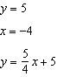
Calculate the area, in square units, of the triangle formed by the three points of intersection.

1 ANS:

REF: 061331ge

2 ANS: 2

REF: 011313ge

3 ANS: 3

REF: 081703geo

4 ANS: 4

REF: 081808geo

5 ANS: 2

REF: 011615geo

6 ANS:
. 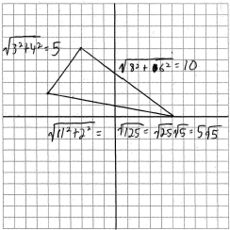

REF: 060936ge

7 ANS:

REF: spr2408geo

8 ANS: 3 REF: 061702geo

9 ANS: 2
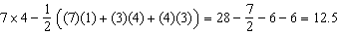

REF: 012407geo

10 ANS: 3
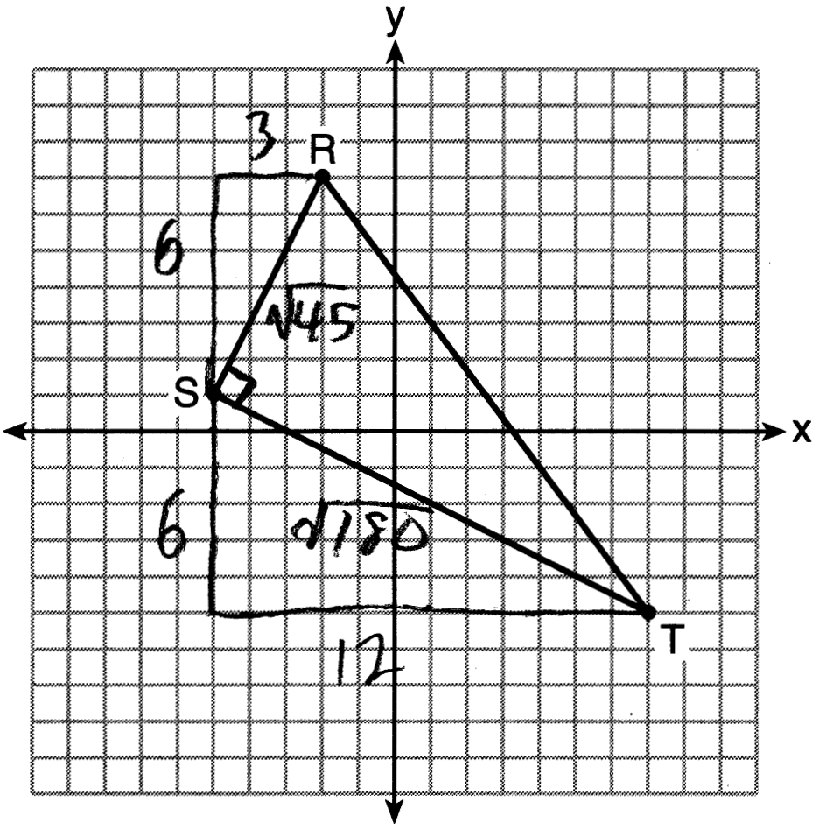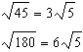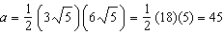

REF: 061622geo

11 ANS: 1
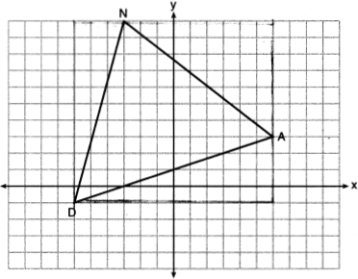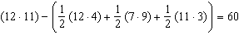

REF: 061815geo

12 ANS: 4
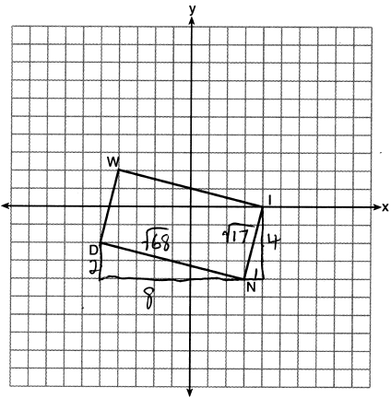

REF: 082214geo

13 ANS: 2
Create two congruent triangles by drawing , which has a length of 8. Each triangle has an area of 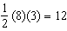.

REF: 012018geo

14 ANS: 3
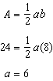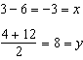

REF: 081615geo

15 ANS:
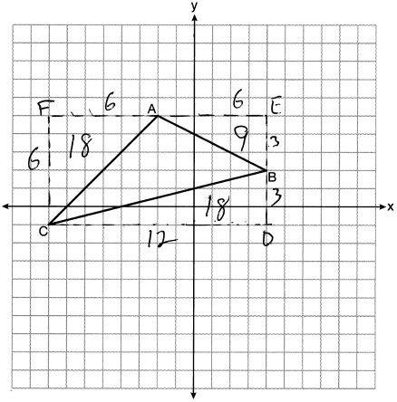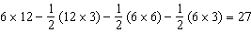

REF: 012331geo

16 ANS:
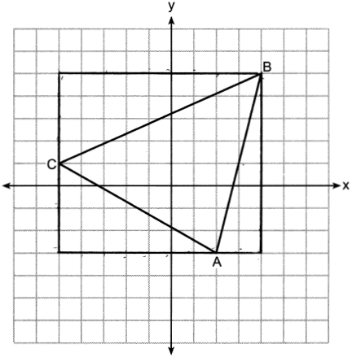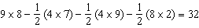

REF: 062430geo

17 ANS:
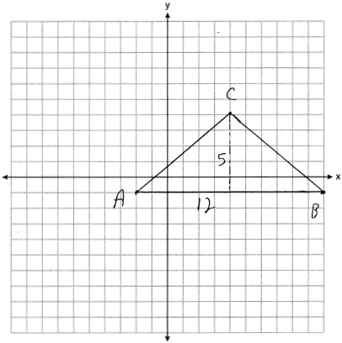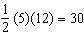

REF: 081928geo

18 ANS:
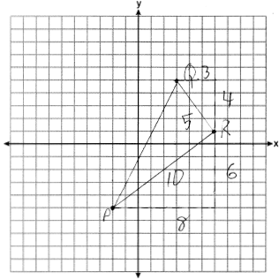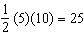

REF: 061926geo

19 ANS:
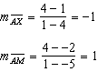 is an altitude. 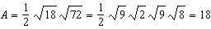

REF: 082427geo

20 ANS:
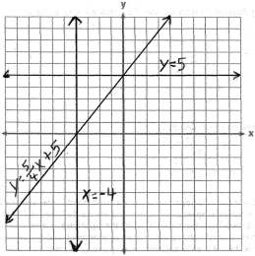. 10. 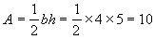

REF: 010335a

