1 In the diagram below, has endpoints with coordinates and .
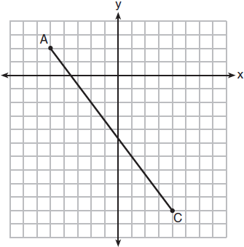
If B is a point on and , what are the coordinates of B?
1)
2) | 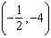
3) | 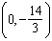
4)

2 What are the coordinates of point C on the directed segment from to that partitions the segment such that is 2:1?
1)
2)
3)
4)

3 The coordinates of the endpoints of are and . Point R is on such that QR:RS is in the ratio of 1:2. What are the coordinates of point R?
1)
2)
3)
4)

4 The coordinates of the endpoints of are and . If point M is on , what are the coordinates of M such that SM:MC is 1:2?
1)
2)
3)
4) | 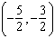

5 Point M divides so that . If A has coordinates and B has coordinates , the coordinates of M are
1)
2) | 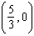
3)
4) | 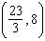

6 The endpoints of directed line segment PQ have coordinates of and . What are the coordinates of point A, on , that divide into a ratio of 1:3?
1)
2)
3)
4)

7 Line segment APB has endpoints and . What are the coordinates of P if is in the ratio ?
1) | (-2,2)
2)
3)
4)

8 The endpoints of are and . Point P is on such that . What are the coordinates of point P?
1)
2)
3)
4)

9 Point Q is on such that . If M has coordinates and N has coordinates , the coordinates of Q are
1)
2)
3)
4)

10 Directed line segment AJ has endpoints whose coordinates are and . Point E is on such that is . What are the coordinates of point E?
1)
2)
3)
4)

11 Line segment RW has endpoints and . Point P is on such that is 2:3. What are the coordinates of point P?
1)
2)
3)
4)

12 Directed line segment DE has endpoints and . Point F divides such that is 2:3. What are the coordinates of F?
1)
2)
3)
4)

13 Point P divides the directed line segment from point to point in the ratio . The coordinates of point P are
1)
2)
3)
4)

14 The coordinates of the endpoints of directed line segment ABC are and . If , the coordinates of B are
1)
2)
3)
4)

15 Directed line segment KC has endpoints and . Point E divides such that is . What are the coordinates of point E?
1)
2)
3)
4)

16 What are the coordinates of the point on the directed line segment from to that partitions the segment into a ratio of 3 to 2?
1)
2)
3) | 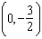
4)

17 Point P is on the directed line segment from point to point and divides the segment in the ratio . What are the coordinates of point P?
1) | 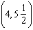
2)
3) | 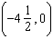
4) | 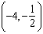

18 The coordinates of the endpoints of are and . Point P is on . What are the coordinates of point P, such that is 3:5?
1)
2)
3)
4)

19 The coordinates of the endpoints of are and . Point P is on . Determine and state the coordinates of point P, such that is . [The use of the set of axes below is optional.]

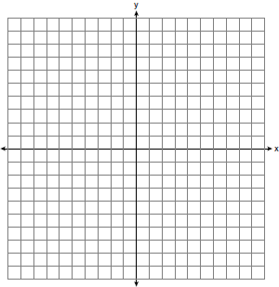

20 Line segment PQ has endpoints and , and point R is on . Determine and state the coordinates of R, such that . [The use of the set of axes below is optional.]

21 Directed line segment PT has endpoints whose coordinates are and . Determine the coordinates of point J that divides the segment in the ratio 2 to 1. [The use of the set of axes below is optional.]

22 Directed line segment AB has endpoints whose coordinates are and . Determine and state the coordinates of P, the point which divides the segment in the ratio 3:2. [The use of the set of axes below is optional.]

23 The endpoints of are and . Determine and state the coordinates of point E, if .

24 Point P is on segment AB such that is . If A has coordinates , and B has coordinates , determine and state the coordinates of P.
1 ANS: 1

REF: 011806geo

2 ANS: 4
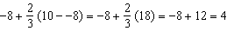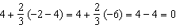

REF: 061919geo

3 ANS: 3
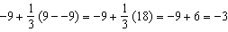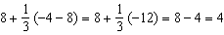

REF: 081903geo

4 ANS: 1
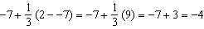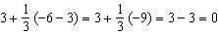

REF: 082213geo

5 ANS: 1
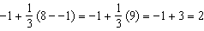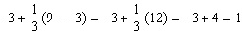

REF: 011915geo

6 ANS: 4
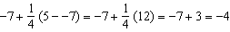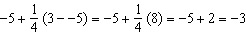

REF: 012005geo

7 ANS: 1
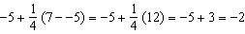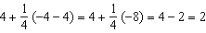

REF: 062418geo

8 ANS: 4
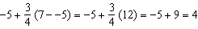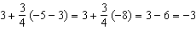

REF: 082302geo

9 ANS: 1
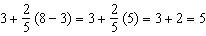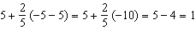

REF: 011720geo

10 ANS: 4
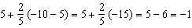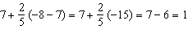

REF: 012410geo

11 ANS: 2
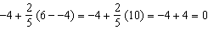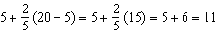

REF: 061715geo

12 ANS: 2
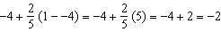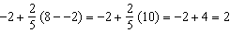

REF: 061814geo

13 ANS: 2
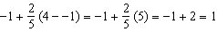

REF: 062222geo

14 ANS: 1
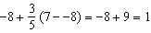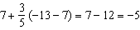

REF: 081815geo

15 ANS: 1
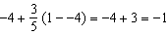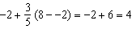

REF: 082402geo

16 ANS: 4
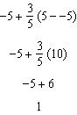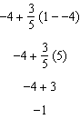

REF: spr1401geo

17 ANS: 4

REF: 081618geo

18 ANS: 1
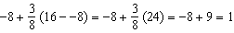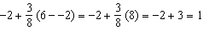

REF: 081717geo

19 ANS:
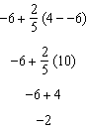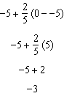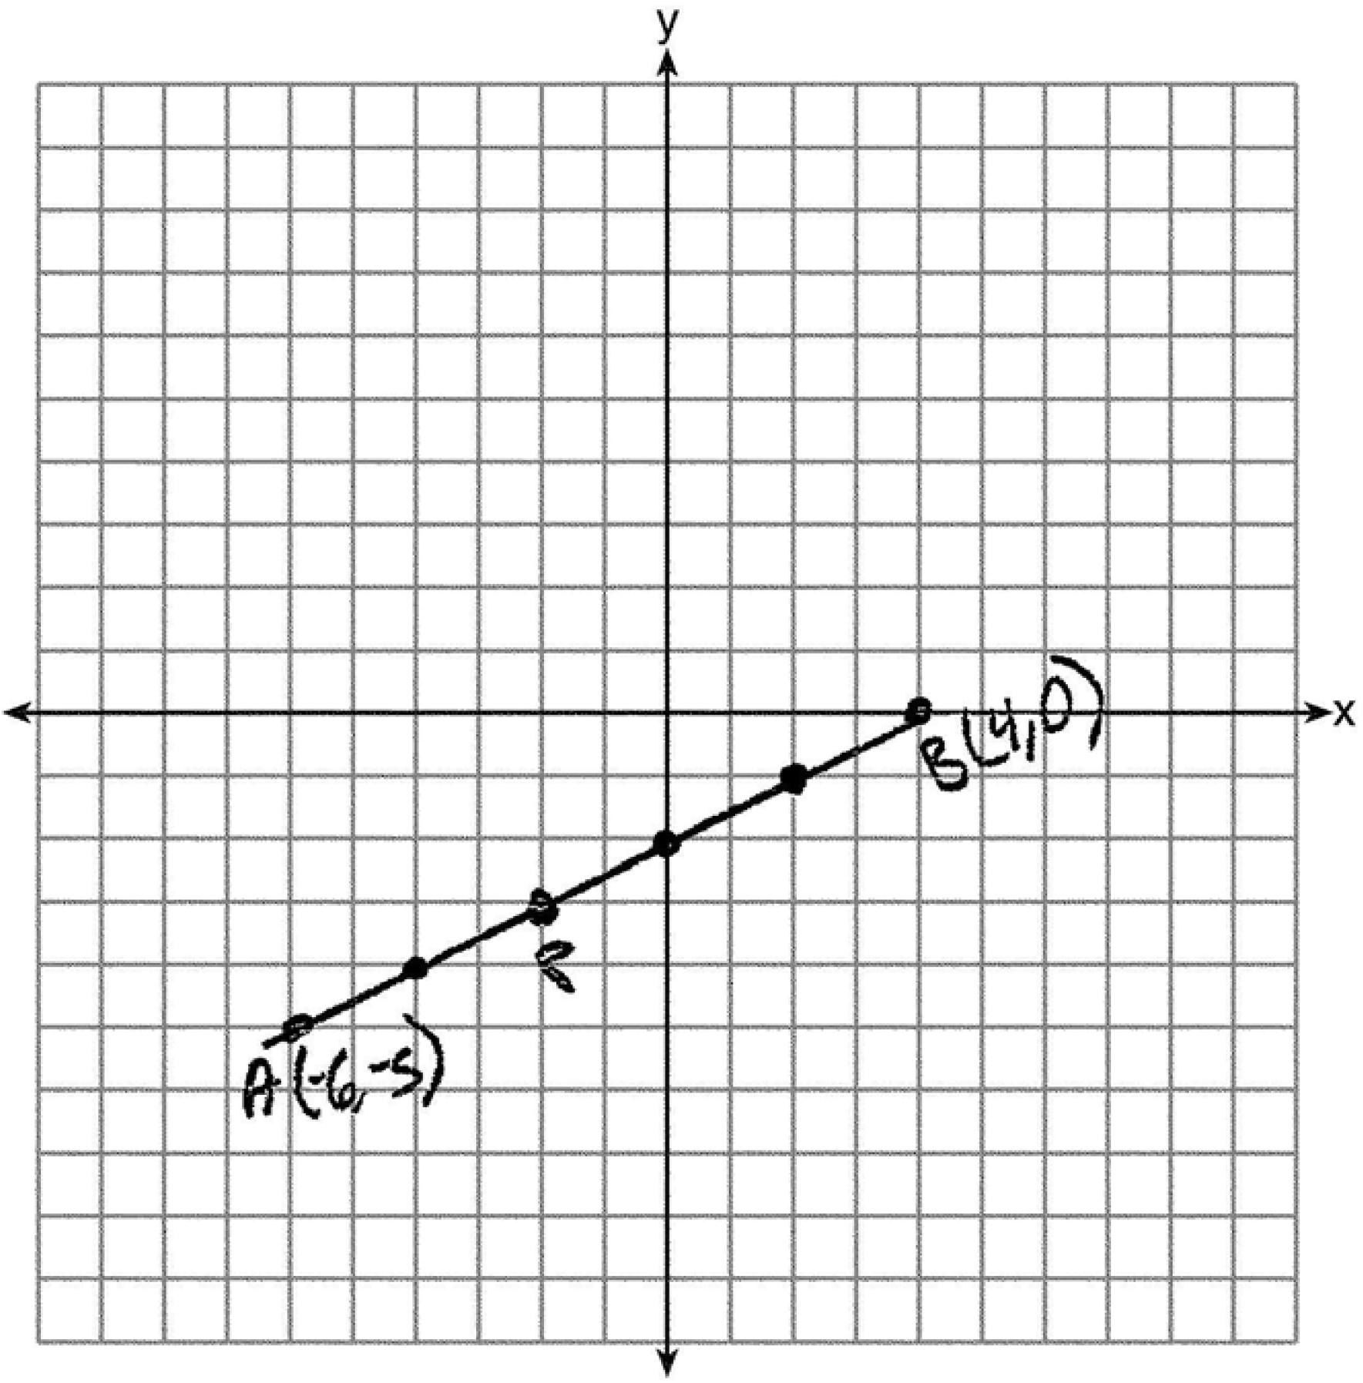

REF: 061527geo

20 ANS:
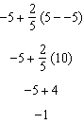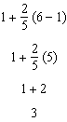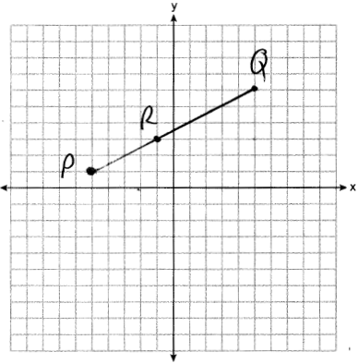

REF: 062327geo

21 ANS:
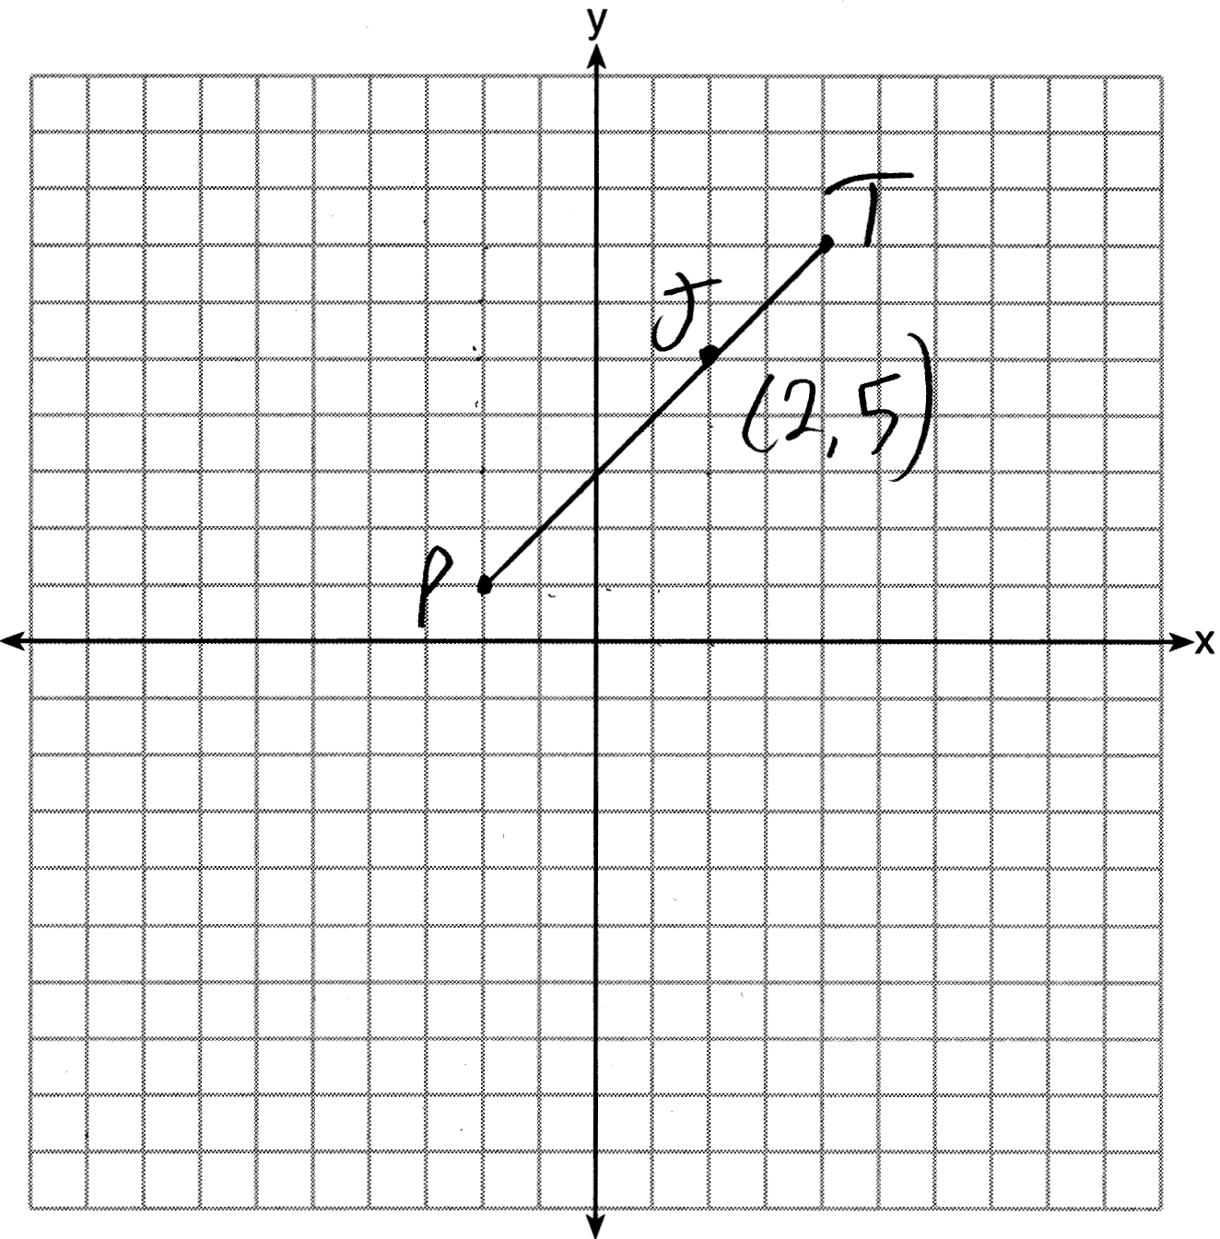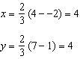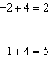

REF: 011627geo

22 ANS:
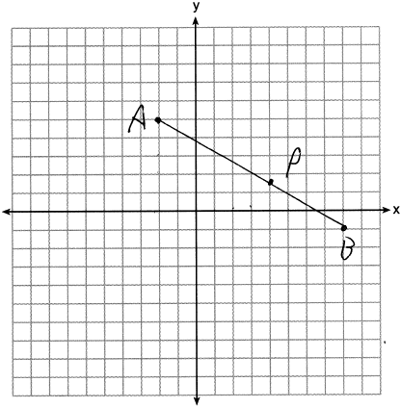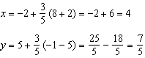

REF: 012328geo

23 ANS:
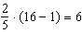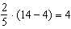

REF: 081531geo

24 ANS:
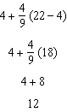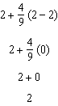

REF: 061626geo

